Project Design Phase-II
Technology Stack (Architecture & Stack)
Date | 31 January 2025
Team ID
Project Name | Importing & Securing Data in ServiceNow
Maximum Marks | 4 Marks

Technical Architecture:
The architectural diagram and the information per Table-1 and Table-2 are below.
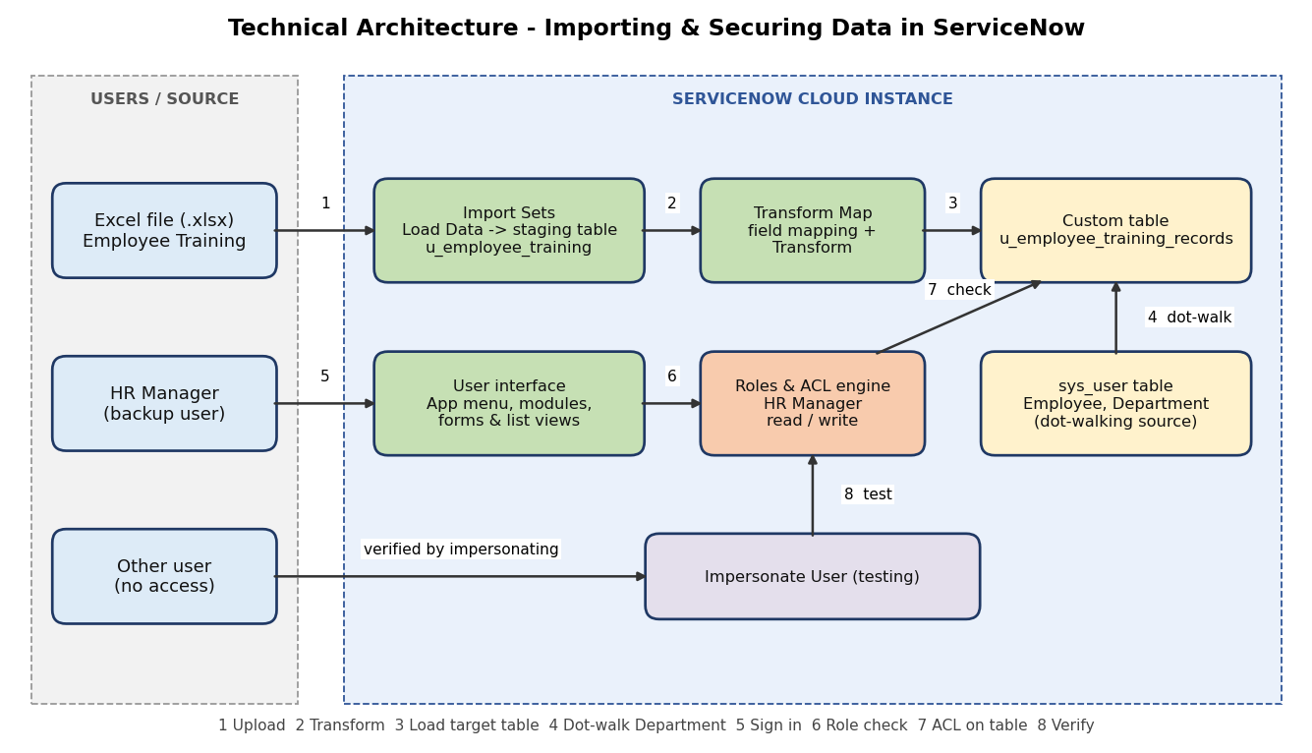

Table-1: Components & Technologies:
S.No | Component | Description | Technology
1 | User Interface | How the user interacts with the application | ServiceNow platform UI (forms, list views, application menu and modules)
2 | Application Logic-1 | Bulk data load and field mapping | Import Sets, Load Data, Transform Maps
3 | Application Logic-2 | Show employee details on training records | Dot-walking, Form Layout configuration
4 | Application Logic-3 | Role-based access to the table | Roles, Access Control Rules (ACLs), Impersonate User
5 | Database | Custom table u_employee_training_records, staging table u_employee_training and sys_user | ServiceNow platform database tables
6 | Cloud Database | Database service on cloud | ServiceNow cloud instance
7 | File Storage | Source Excel file uploaded for import | Excel (.xlsx) uploaded via Load Data
8 | External API-1 | Not used in this project | N/A
9 | External API-2 | Not used in this project | N/A
10 | Machine Learning Model | Not applicable | N/A
11 | Infrastructure (Server / Cloud) | Application deployment on cloud | ServiceNow cloud instance (Local Server Configuration: N/A; Cloud Server Configuration: ServiceNow-hosted instance)
Table-2: Application Characteristics:
S.No | Characteristics | Description | Technology
1 | Open-Source Frameworks | No open-source framework used; built with ServiceNow platform features | ServiceNow low-code platform
2 | Security Implementations | Role-based access, read and write ACLs, restricted menu and modules, security_admin elevation, access verified by impersonation | Roles, ACLs, Elevate Role, Impersonate User
3 | Scalable Architecture | Single cloud platform; data volume grows through repeated imports and role assignment | ServiceNow cloud platform
4 | Availability | Hosted and managed on the ServiceNow cloud instance | ServiceNow cloud
5 | Performance | Bulk import instead of manual entry; dot-walking instead of duplicated data | Import Sets, Transform Maps, dot-walking

