[**Automatic Staircase Light**](https://circuitdigest.com/microcontroller-projects/automatic-staircase-lighting-using-avr-microcontroller) **USING ATMEGA32**

**REPORT:**

**INTRODUCTION:**

We all know that one of the places where power wastage occurs most in homes and offices is at staircases. We usually turn on light at stairs and leave it in a hurry. In this project we are going to design a stair case lamp which works on battery and only turn on the lights only when someone is present at there. This circuit can be used to save power and it can be used as an emergency backup light.

The circuit works on two conditions - one is presence of light in its location and second is presence of human being, only when these two conditions are met, the controller turns the backup light ON.

These two conditions are tested by two sensors one is LDR and other is PIR Motion sensor module. The LDR senses the presence of light and Motion sensor detects the presence of a human being in its range.

The image on the left side shows the sensor LDR (Light Dependent Resistor) and the picture on the right side show the PIR Sensor or Motion Sensor Module. PIR Sensor is basically an IR (Infrared Receiver). It consists of sensitive IR receives which detects the IR (Infra Red) rays in its region.We know that every living organism emits IR rays and so the human body. Whenever a there is a human in the sensor module region it detects the presence of IR rays.

Whenever a human present in the sensing region of module, the sensor picks up IR changes as human body emits IR rays, so now these changes of IR picked up by module are filtered by electronics in the module and as of signaling the changes in IR, A pulse is generated by the module. This pulse is of duration 5sec by default.

So whenever a human crosses the sensing region of module, it generates a pulse of 5 sec. So presence of human is detected by IR rays by this module.

The motion sensor module will have two pots or presets one of them is to adjust the sensing region of the module and the second is for varying the time of high pulse output on detection of motion. The duration of pulse can be adjusted from few second to few minutes. You can understand more about it by this PIR sensor circuit.

The LDR in this circuit works as a variable resistor. The resistor of the LDR changes based on the light intensity. When the light falling on the LDR is low the resistance of the LDR will be high. When the light falling on LDR is high the resistance across terminals of LDR will be very low compared to low light resistance.

### ****Components Required****

**Hardware used:**

ATMEGA32

Power supply (5v),

100uF capacitor

LED

220Ω, 1KΩ resistors

LDR(Light Dependent Resistor)

100KΩ pot or preset,

Any motion sensor module (HC-SR501)

2WATT LED

TIP122 transistor.

**Software used:**

**SimulIDE**

**ATMEGA 32:**

The AVR microController is based on the advanced Reduced Instruction Set Computer (RISC) architecture. ATmega32 microController is a low power CMOS technology based controller. Due to RISC architecture AVR microcontroller can execute 1 million of instructions per second if cycle frequency is 1 MHz provided by crystal oscillator.

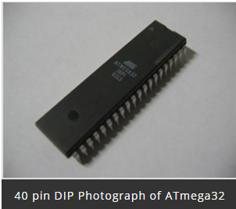

**Key Features:**

Consider some general features of ATmega32 microcontroller is:-

* 2 Kilo bytes of internal Static RAM
* 32 X 8 general working purpose registers
* 32 Kilo bytes of in system self programmable flash program memory.
* 1024 bytes EEPROM
* Programmable serial USART
* 8 Channel, 10 bit ADC
* One 16-bit timer/counter with separate prescaler, compare mode and capture mode.
* Available in 40 pin DIP, 44-pad QFN/MLF and 44-lead QTFP
* Two 8-bit timers/counters with separate prescalers and compare modes
* 32 programmable I/O lines
* In system programming by on-chip boot program
* Master/slave SPI serial interface
* 4 PWM channels
* Programmable watch dog timer with separate on-chip oscillator

**ATmega32 Microcontroller Pin Diagram**

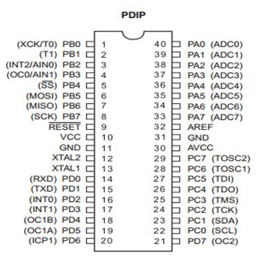

**LED**

**LED**stands for **light emitting diode**. LED lighting products produce light up to 90% more efficiently than incandescent light bulbs. How do they work? An electrical current passes through a microchip, which illuminates the tiny light sources we call LEDs and the result is visible light. To prevent performance issues, the heat LEDs produce is absorbed into a heat sink.

**LDR sensor:**

An **LDR sensor (Light Dependent Resistor)**is a device that is used to detect light.

It has a (variable) resistance that changes with the light intensity that falls upon it. This allows them to be used in light sensing circuits.

They are used in many consumer products to determine the intensity of light.

An LDR or light dependent resistor is also known as a photoresistor, photocell, photoconductor.

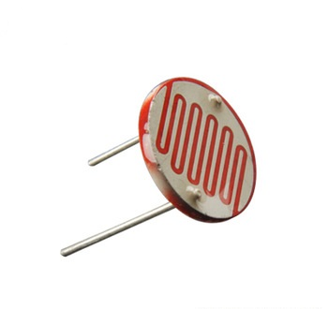

It is one type of resistor whose resistance varies depending on the amount of light falling on its surface. When the light falls on the resistor, the resistance changes. To sense the presence of light these resistors are often used.

These resistors have many functions and resistances.

For instance, when the LDR is in darkness, then it can be used to turn ON the light or to turn OFF the light when it is in the light.

**SOFTWARE USED:**

SimulIDE

SimulIDE is a simple real time electronic circuit simulator, intended for hobbyist or students to learn and experiment with simple electronic circuits and microcontrollers, supporting PIC, AVR and Arduino.  
  
This is not an accurate simulator for circuit analysis, it aims to be fast, simple and easy to use, this means simple and not very accurate electronic models and limited features.  
  
Simplicity and ease of use are the key features of this simulator.  
You can create, simulate and interact with your circuits within minutes, just drag components from the list, drop into the circuit, connect them and push power button to see how it works.  
  
SimulIDE also features a code Editor and Debugger for GcBasic, Arduino, PIC asm and AVR asm. It is still in it's firsts stages of development, with basic functionalities, but it is possible to write, compile and basic debugging with breakpoints, watch registers and global variables.



**Block diagram:**

**LDR**

**LED**

**MOTION SENSOR**

**ATMEGA 32**

**Circuit diagram:**

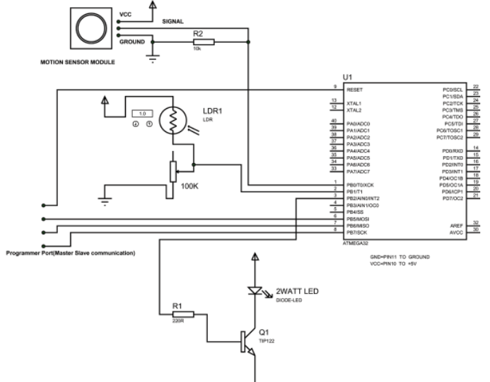

**CIRCUIT EXPLAINATION:**

As shown in the above automatic staircase lighting circuit, there is no need to connect an external crystal here. Because the ATMEGA works on internal 1MHz, Resistor-Capacitor oscillator on default. Only when the accuracy of clock is needed, as application of high precision counting, external crystal is attaches. When the controller is first bought, it is fused to work on internal crystal by default.

The controller will here will be always checking two things:

Presence of darkness

Detection on motion

As we discussed when the light is low the resistance of LDR will be high, now on observation we can tell there is a voltage divider formed by LDR and 100K pot, the middle joint of voltage divider is taken as reference and is connected to PB1 of controller. You can learn more about the working principle of LDR in this LDR circuit.

Now if there is low light the resistance of LDR will be high and so the voltage share in the voltage divider branch changes, Because of high resistance, the voltage across LDR will be higher than that of 100K pot, and because of this the voltage at midpoint drops drastically and this drop is easily sensed by controller. So whenever darkness comes the controller picks up a signal. This signal satisfies the first condition. Understand more about LDRs in this dark detector circuit.

With the presence of motion, there will be pulse at PB0 of controller which is generated by motion sensor module as we discussed earlier.

Once these two conditions are met, the controller is instructed to signal the NPN transistor to drive the power LED.

**CODE:**

#include <avr/io.h> //header to enable data flow control over pins

#define F_CPU 1000000 //telling controller crystal frequency

#include <util/delay.h> //header to enable delay function in program

int main(void)

{

DDRB = 0b11111100; //PB0,PB1 are used as inputs and reset are used as outputs

int x=0; // taking a integer

while(1)

{

if (bit_is_clear(PINB,1)) // In presence of darkness (When there is darkness pin goes low)

{

if (bit_is_set(PINB,0)) //When there is motion (motion sensor gives high output on presence of human being)

{

x=1; //set x when both conditions are satified

}

}

if (x==1) //when x is set

{

PORTB |=(1<<PINB2); //trigger transistor to drive power led

_delay_ms(220); //wait 220ms (can be changed for higher duartion)

PORTB &=~(1<<PINB2); //turn on transistor trigger

x=0; // reset x

}

}

}