***Welcome to ATM_Project***

***Below are the Artifacts of the Project***

***Initial Project Run****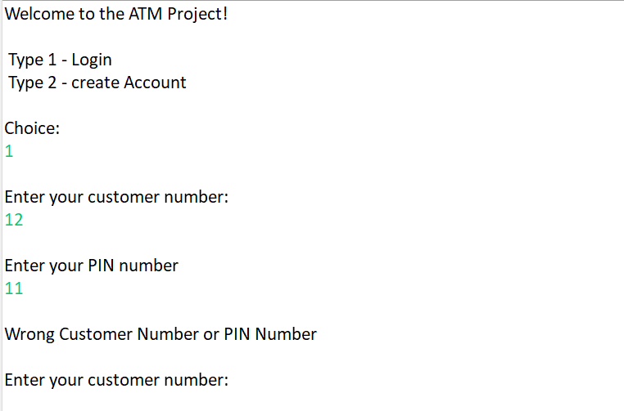*

***Case 1: Login with wrong Account Number***



***Case 2: Entering wrong Character***

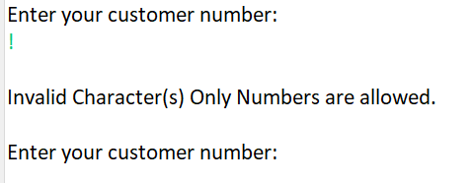

***Case 3: Entering Existing Customer No***

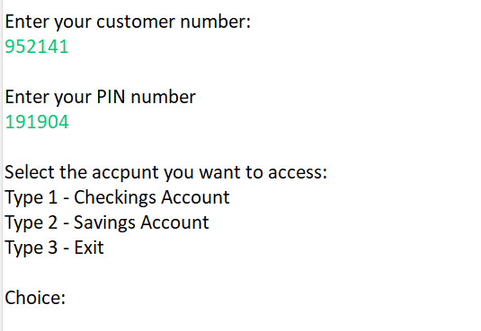

***Case 4: 1st Customer Checking Account***

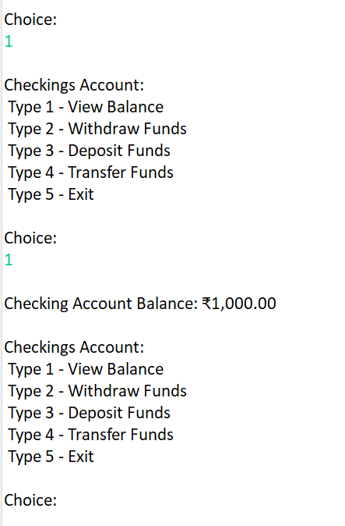

***Case 5 : 1st customer account balance***

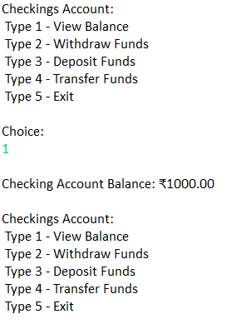

***Case 6: 1st customer Transfer Funds***

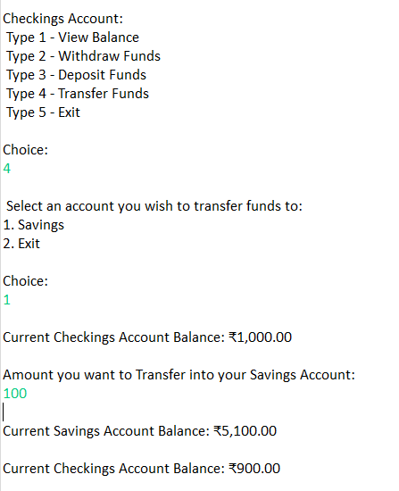

***Case 7:1st customer-withdraw funds***

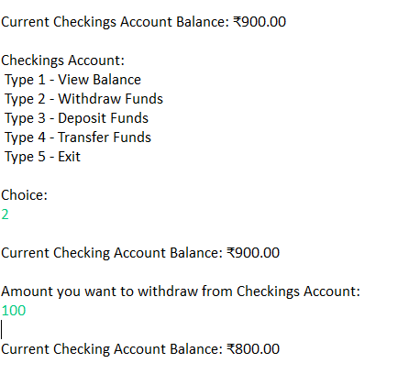

***Case 8: 1st customer deposit funds***

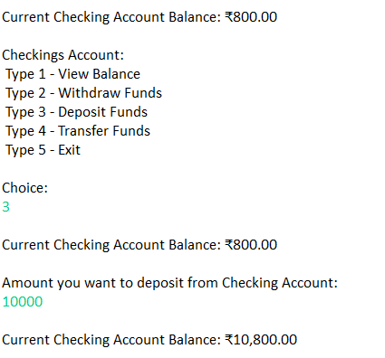

***Case 9: 1st customer exit***

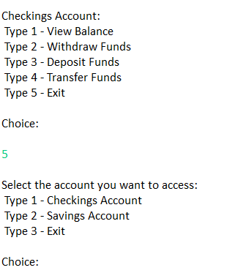

***Case 10: 1st customer saving account view balance***

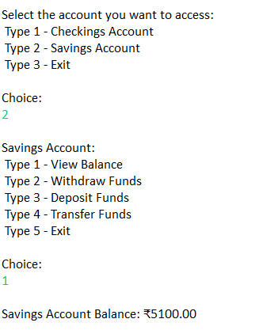

***Case 11: 1st customer saving account withdraw funds***

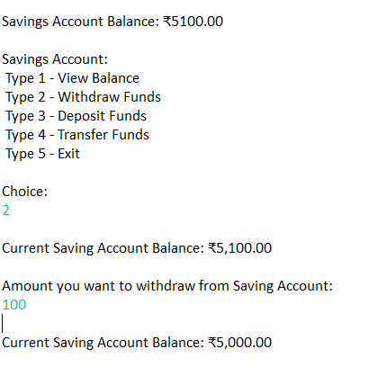

***Case 12: 1st customer saving account Deposit Funds***

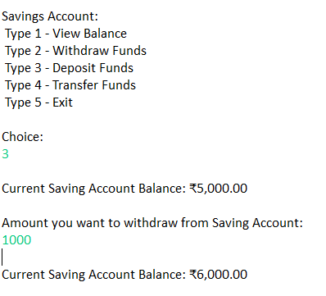  
***Case 13: 1st customer saving account Transfer Funds***

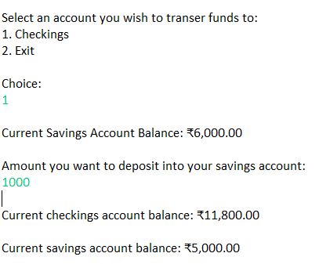

***Case 14: 1st customer saving account exit***

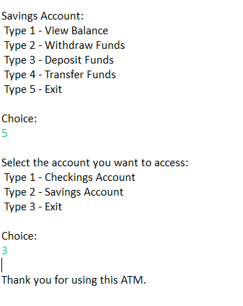

***Case 15: Entering second Customer No***

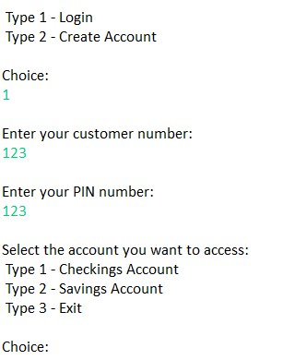

***Case 16: 2nd Customer Checking Account***



***Case 17:2nd customer account balance***

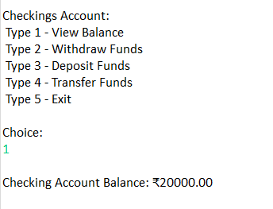

***Case 18: 2nd customer Transfer Funds***

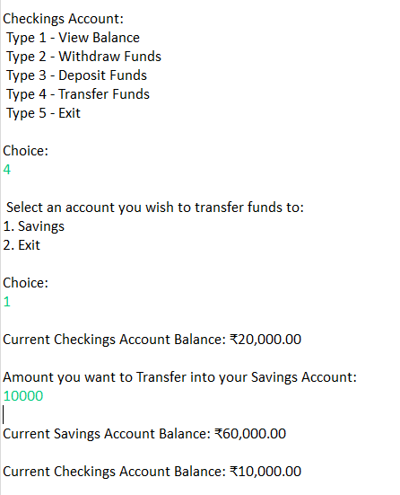

***Case 19: 2nd customer-withdraw funds***

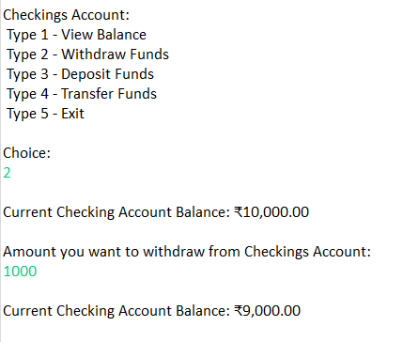

***Case 20: 2nd customer deposit funds***

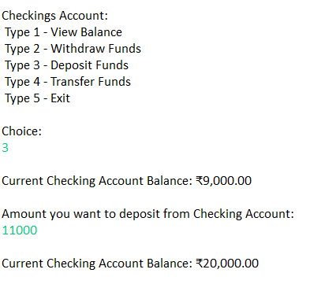

***Case 21: 2nd customer exit***

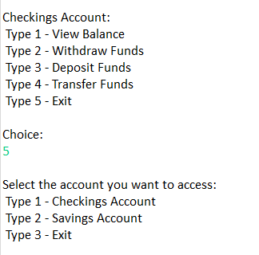

***Case 22: 2nd customer saving account view balance***

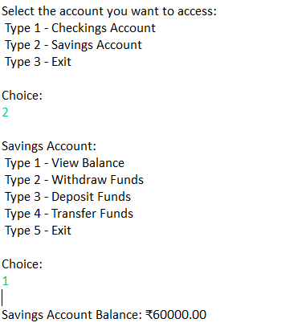

***Case 23: 2nd customer saving account withdraw funds***

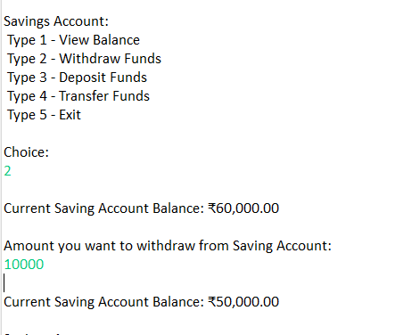

***Case 24: 2nd customer saving account Deposit Funds***

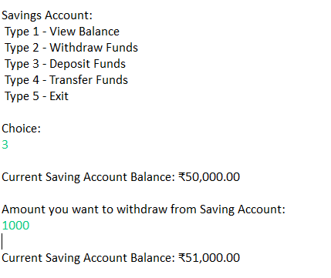

***Case 25: 2nd customer saving account Transfer Funds***

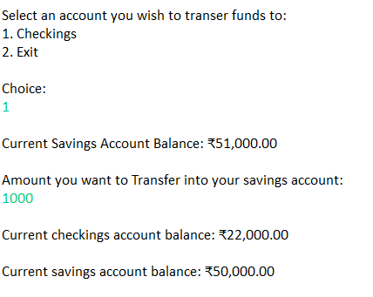

***Case 26: 2nd customer saving account exit***

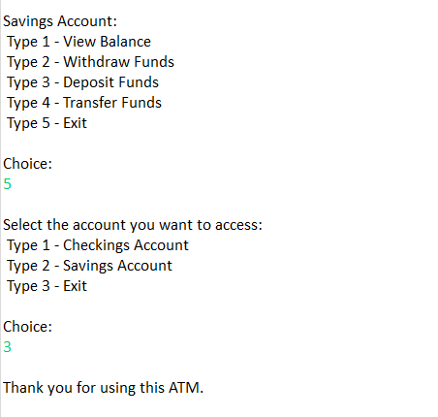

***Case 27: Creating a new Account***

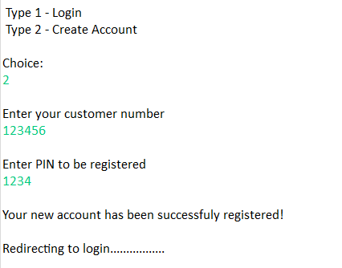

***Case 28: Entering newly created user id and password***

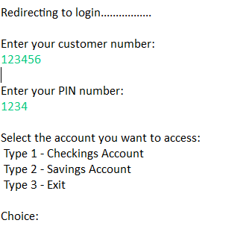

***Case 29: Viewing Checking account Balance***

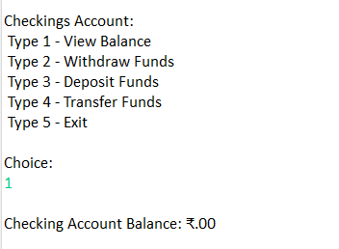

***Case 30: Depositing into Checking account Balance***

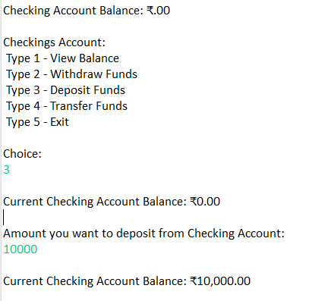

***Case 31: withdrawing from Checking Account***

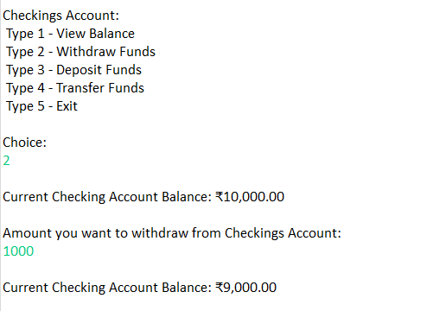

***Case 32: Transferring from Checking Account***

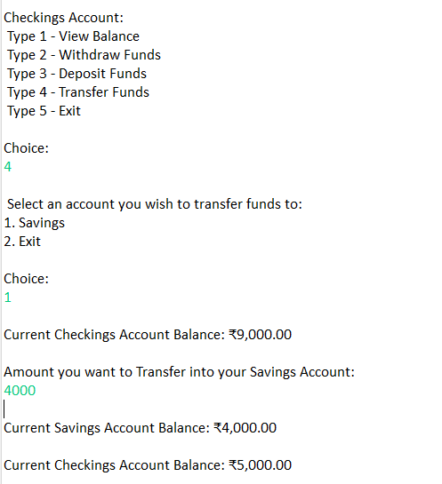

***Case 33: Exiting from Checking Account***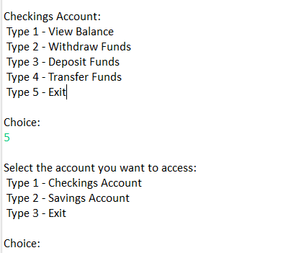

***Case 34: Entering into Saving Account***

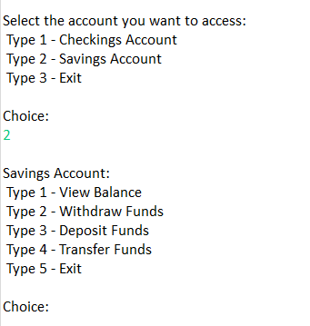

***Case 35: Viewing Balance in Saving Account***

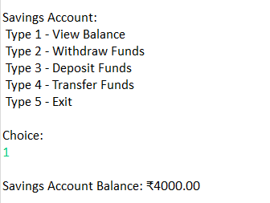

***Case 36: Depositing funds in Saving Account***

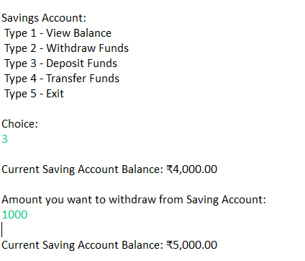

***Case 37: Withdrawing from Saving Account***

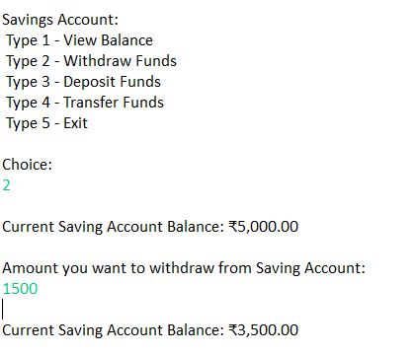

***Case 38: Transferring from Saving Account***

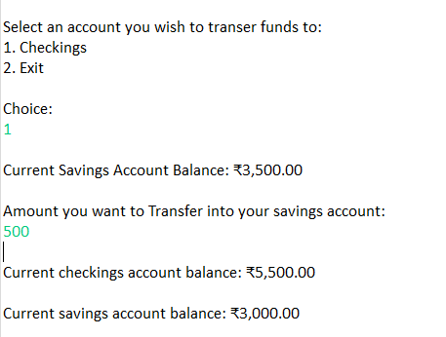

***Case 39: Exiting from Saving Account***

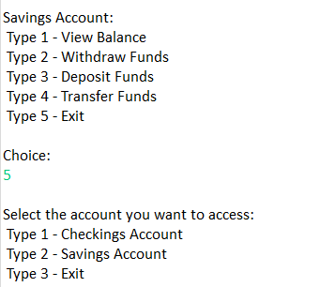

***Case 40: Exiting from Project***

