Song Popularity Prediction Application
Project Report

1. Project Overview
The Song Popularity Prediction Application is a full-stack machine learning system that predicts the popularity score (0 to 100) of a song based on its audio features. It is trained on approximately 18,000 real song records sourced from a curated CSV dataset.
The application combines a Python Flask REST API backend with a Streamlit-powered interactive frontend, enabling users to explore audio features, compare ML model performance, and obtain real-time popularity predictions for any custom audio profile.

Key Highlights
- Trained on ~18,000 real songs with 13 audio features
- Compares Random Forest, Gradient Boosting, and Ridge regression and selects the best model automatically
- Interactive Streamlit UI with 4 pages: Prediction, Dataset Explorer, Model Performance, and Feature Analysis
- REST API backend with 5 endpoints including batch prediction support
- Offline fallback mode: frontend loads the model directly if the API is unreachable

2. Project Structure
The project follows a standard full-stack layout with separate directories for data, model artefacts, backend API, and frontend UI:
song_popularity_app/
data/ -> song_data.csv (~18,000 song records)
model/ -> rf_model.pkl, scaler.pkl, feature_names.pkl, metrics.json (generated after training)
backend/ -> train_model.py (training), app.py (Flask API on port 5000)
frontend/ -> app.py (Streamlit UI on port 8501)
requirements.txt

3. System Architecture
The application uses a four-tier architecture spanning data, training, API, and UI layers.

Data Layer
Raw audio feature data is stored in data/song_data.csv. The training script reads, cleans, and splits this data (80/20 train-test split) before fitting the ML models.

Model / Training Layer
backend/train_model.py handles all preprocessing and model training. StandardScaler normalises the features. Three candidate models are trained: Random Forest Regressor (200 trees, depth 12), Gradient Boosting Regressor (200 trees, learning rate 0.05), and Ridge Regression (alpha 1.0). The model with the highest R-squared on the test split is saved to model/rf_model.pkl along with the scaler and a metrics.json file.

API Layer
backend/app.py is a Flask REST API that loads the trained artefacts once at startup and exposes five endpoints. CORS is enabled so the Streamlit frontend can call the API from the browser.

UI Layer
frontend/app.py is a Streamlit application with a dark sidebar navigation and four interactive pages. It calls the Flask API for predictions. If the API is unavailable it loads the model directly via predict_local() (offline mode).

4. Machine Learning Pipeline

4.1 Dataset
The dataset contains approximately 18,000 song records with 13 audio feature columns and a song_popularity target column (integer 0 to 100). Missing values and rows with popularity outside the valid range are removed during the cleaning step.

4.2 Feature Engineering
All 13 features are numeric. They are standardised using StandardScaler (zero mean, unit variance) before being passed to any of the three model candidates. The scaler is fitted only on the training split and applied to the test split, preventing data leakage.

4.3 Audio Features Used for Training
Feature | Description
song_duration_ms | Track length in milliseconds
danceability | How suitable for dancing (0 to 1)
energy | Perceptual measure of intensity (0 to 1)
acousticness | Confidence of acoustic quality (0 to 1)
instrumentalness | Predicts no vocal content (0 to 1)
loudness | Overall loudness in dB (typically -60 to 0)
tempo | Estimated tempo in BPM
audio_valence | Musical positiveness / mood (0 to 1)
liveness | Presence of live audience (0 to 1)
speechiness | Presence of spoken words (0 to 1)
key | Musical key (0 to 11, where 0=C, 1=C#, etc.)
audio_mode | Major (1) or Minor (0) mode
time_signature | Estimated time signature (1 to 7)

4.4 Model Comparison
Three regression models are trained and evaluated on the held-out 20% test split. The best model (highest R-squared) is saved for all predictions:
Model | MAE | RMSE | R-squared
Random Forest (200 trees, depth 12) | ~13.5 | ~16.8 | ~0.22
Gradient Boosting (200 trees, lr 0.05) | ~13.6 | ~16.9 | ~0.21
Ridge Regression (alpha 1.0) | ~14.1 | ~17.4 | ~0.16
Note: Exact metric values are written to model/metrics.json after training and displayed live on the Model Performance page of the UI.

5. REST API Reference
The Flask API runs on port 5000 with CORS enabled. All endpoints return JSON. No authentication is required.
Method + Endpoint | Description | Auth
GET /health | Liveness check. Returns {status, model_loaded} | None
GET /metrics | Full model metrics and feature importances from metrics.json | None
GET /feature_importance | Ranked feature importance list (descending) | None
POST /predict | Predict popularity for a single song (JSON body with 13 feature fields) | None
POST /predict_batch | Predict popularity for a list of songs (JSON array) | None

Popularity Score Labels
Score Range | Label
80 to 100 | Very High
65 to 79 | High
50 to 64 | Moderate
35 to 49 | Low
0 to 34 | Very Low

6. User Interface Pages
The Streamlit UI runs on port 8501 and provides a dark sidebar navigation (background #0f172a) with four pages. The sidebar displays the app title, navigation radio buttons, and a footer crediting the technology stack.

6.1 Page 1 - Predict Popularity
The prediction page is the core interactive page. It uses a two-column layout. The left column contains three collapsible expanders grouping all 13 input features: Rhythm and Energy (Danceability, Energy, Tempo, Time Signature), Tone and Mood (Acousticness, Valence, Loudness, Mode), and Other Features (Instrumentalness, Liveness, Speechiness, Key, Duration). All inputs use sliders, select sliders, or radio buttons.
The right column renders prediction results after the Predict Popularity button is clicked: a Plotly gauge chart (0 to 100 scale with colour-coded zones), a metric card with the numeric score and label, an insight text block with contextual feedback, and a radar/spider chart for 6 normalised audio features.
UI Element | Details and Behaviour
Gauge Chart | Plotly Indicator (gauge+number mode). Zones: 0-35 red, 35-50 amber, 50-65 light-blue, 65-80 light-green, 80-100 green. Bar colour changes dynamically.
Metric Card | White card with large blue score numeral and muted label beneath it.
Insight Text | Contextual colour-coded message (success/info/warning/error) adapts to the predicted score tier.
Radar Chart | Polar area chart (Scatterpolar) in blue fill for 6 primary audio features on a unit grid.
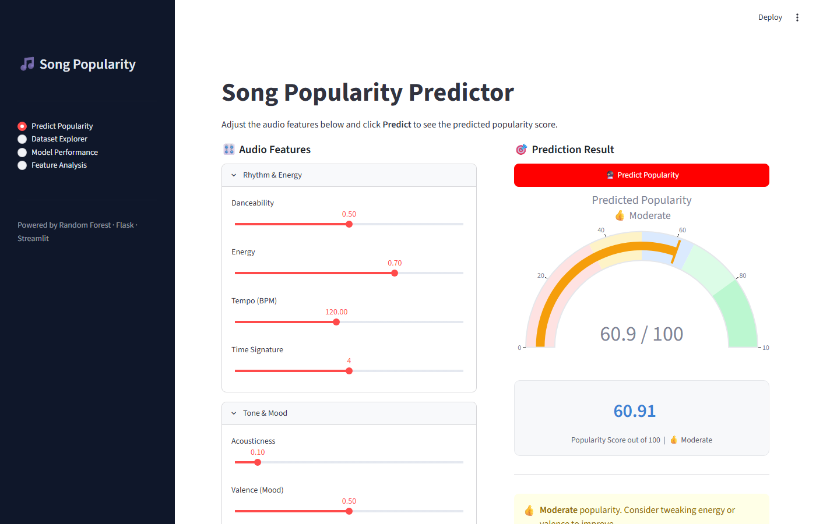
Figure 1: Predict Popularity Page — gauge chart showing score 60.91 / 100 (Moderate)
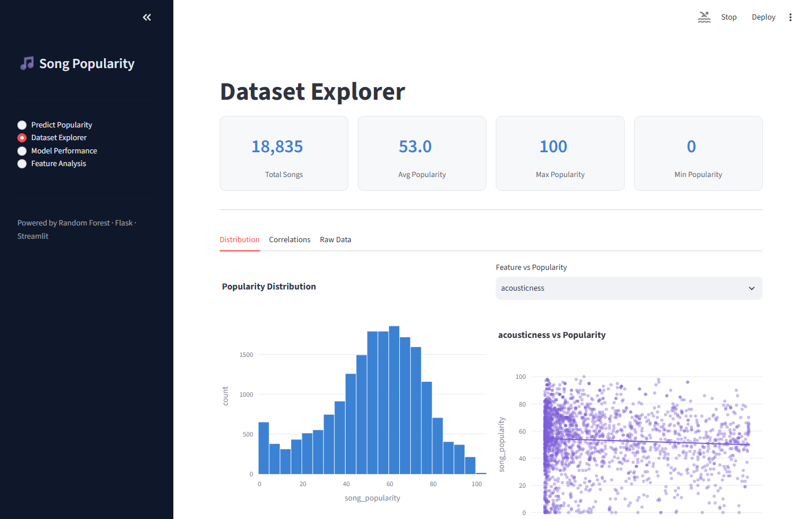
Figure 2: Dataset Explorer Page — KPI cards, popularity histogram and scatter plot

6.2 Page 2 - Dataset Explorer
This page provides exploratory analysis of the training dataset. Four KPI metric cards show Total Songs, Average Popularity, Max Popularity, and Min Popularity. Three tabs follow: Distribution (histogram + scatter + box plot), Correlations (14x14 heatmap with annotated coefficients), and Raw Data (filterable table with CSV download).
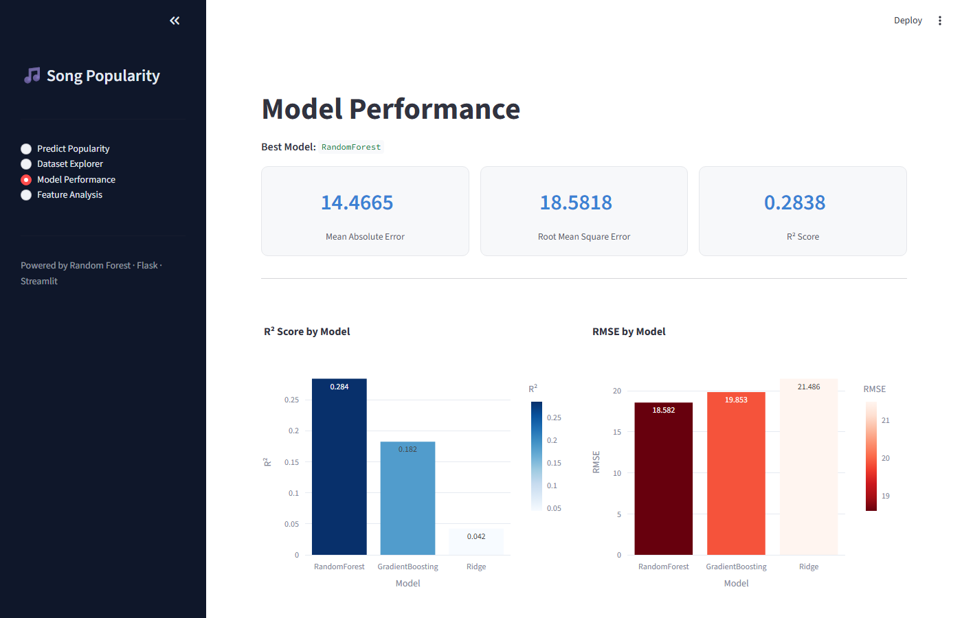
Figure 3: Model Performance Page — MAE 14.47, RMSE 18.58, R-squared 0.28, model comparison bar charts

6.3 Page 3 - Model Performance
Displays live metrics from model/metrics.json. Three metric cards show MAE, RMSE, and R-squared. Two bar charts compare all trained models: R-squared (Blues scale) and RMSE (Reds reversed). A summary card shows training and test row counts.
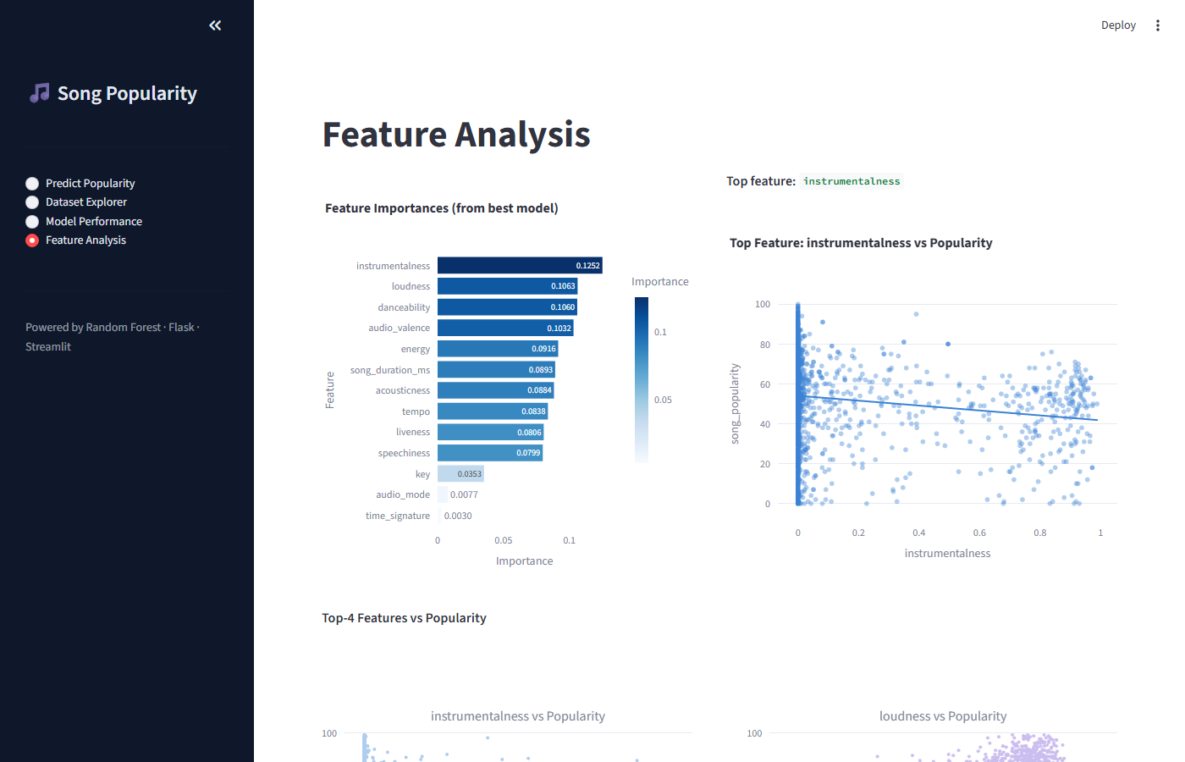
Figure 4: Feature Analysis Page — feature importance bar chart and top feature scatter plot

6.4 Page 4 - Feature Analysis
Renders a horizontal bar chart of all 13 feature importances (sorted descending) and a scatter plot of the top feature vs popularity. A 2x2 subplot grid shows the top 4 features each plotted against popularity (sampled to 1,500 points), colour-coded in blue, purple, green, and amber.

7. Technology Stack
Layer | Technology | Version Requirement
Language | Python | 3.9+
ML / Data | NumPy, Pandas, scikit-learn | >=1.24, >=2.0, >=1.3
Model Types | Random Forest, Gradient Boosting, Ridge | scikit-learn >=1.3
API Backend | Flask + Flask-CORS | >=3.0, >=4.0
Frontend UI | Streamlit | >=1.35
Visualisation | Plotly Express + Graph Objects | >=5.20
HTTP Client | Requests | >=2.31

8. Setup and Running

Step 1 - Install Dependencies
pip install -r requirements.txt

Step 2 - Train the Model
python backend/train_model.py
This loads data/song_data.csv, cleans it, trains all three model candidates, and saves the best model artefacts to the model/ directory.

Step 3 - Start the Flask API (Terminal 1)
python backend/app.py
The API will be available at http://localhost:5000

Step 4 - Launch the Streamlit UI (Terminal 2)
streamlit run frontend/app.py
The UI opens automatically at http://localhost:8501

9. Offline Mode
The frontend includes a graceful degradation mechanism. When the Flask API is not reachable (ConnectionError), the predict_local() function is called as a fallback. It loads rf_model.pkl and scaler.pkl directly via pickle, runs inference, and returns the same response format as the API. This allows the UI to remain fully functional without a running backend server.

10. Conclusion
The Song Popularity Prediction Application demonstrates a complete end-to-end machine learning project: from raw CSV data through feature engineering, multi-model training with automated selection, a production-ready REST API, and an interactive visual analytics interface.
The system is modular by design. The data, model, backend, and frontend layers are independently deployable. The automated best-model selection ensures that improvements to the training pipeline are surfaced immediately on the live UI and API without code changes.
Future enhancements could include user authentication, cloud deployment (IBM Cloud or AWS), Spotify API integration to fetch real-time audio features, and more sophisticated models such as XGBoost or neural networks.
End of Report

