Practical Assignment No: 1
Program Name: Write a Python program to find the length of an array without using a built-in function.
Roll No: MC2527077
Student Name: Varsha Sandip Gawali
Date:
PROGRAM:
arr = [10, 20, 30, 40, 50]
count = 0
for i in arr:
count += 1
print("Length of array:", count)
Output:

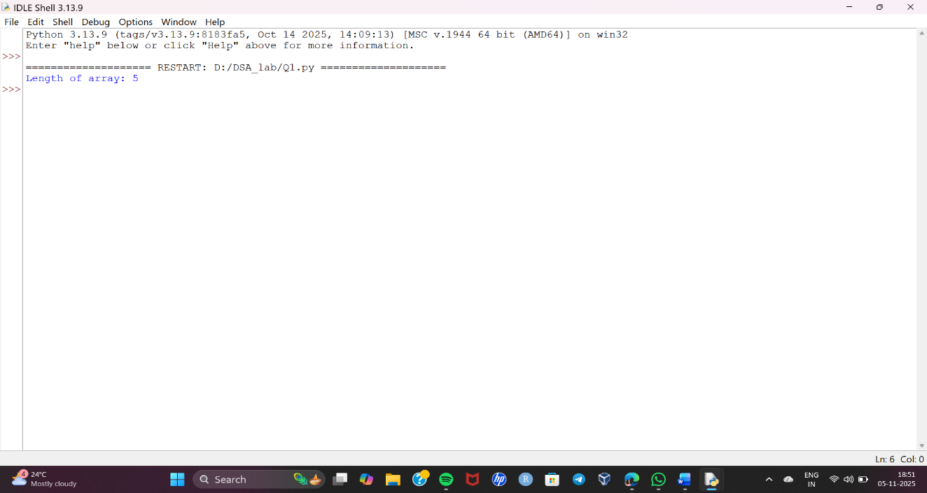

Practical Assignment No: 2
Program Name: Write a Python program to find the Minimum & Maximum element from Array.
Roll No: MC2527077
Student Name: Varsha Sandip Gawali
Date:
PROGRAM:
arr = [12, 45, 7, 23, 89, 34]
min_ele = arr[0]
max_ele = arr[0]
for i in arr:
if i < min_ele:
min_ele = i
if i > max_ele:
max_ele = i
print("Minimum element:", min_ele)
print("Maximum element:", max_ele)
Output: 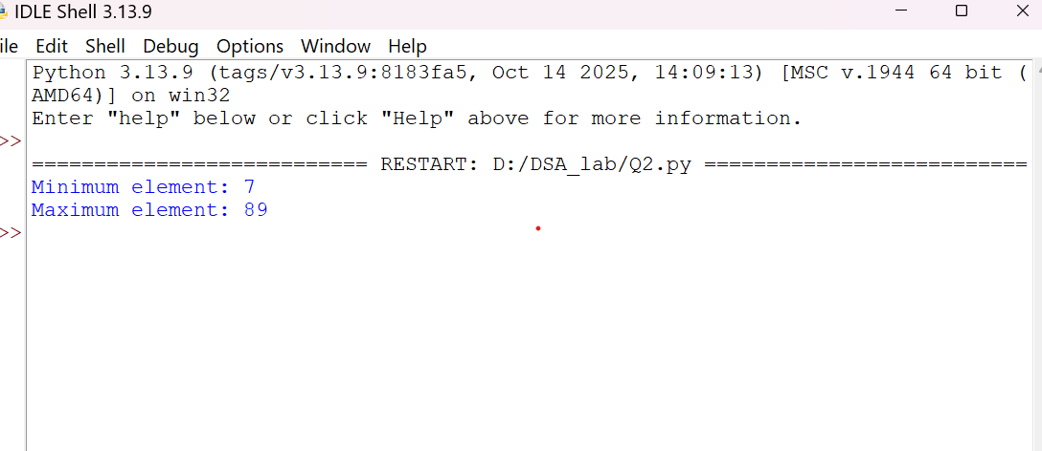

Practical Assignment No: 3
Program Name: Write a Python program to print the row wise sum and column wise sum of given 3*3 matrix.
Roll No: MC2527077
Student Name: Varsha Sandip Gawali
Date:
PROGRAM:
matrix = [
[1, 2, 3],
[4, 5, 6],
[7, 8, 9]
]
# Row-wise sum
for i in range(3):
row_sum = 0
for j in range(3):
row_sum += matrix[i][j]
print("Sum of Row", i + 1, "=", row_sum)
# Column-wise sum
for j in range(3):
col_sum = 0
for i in range(3):
col_sum += matrix[i][j]
print("Sum of Column", j + 1, "=", col_sum)
Output: 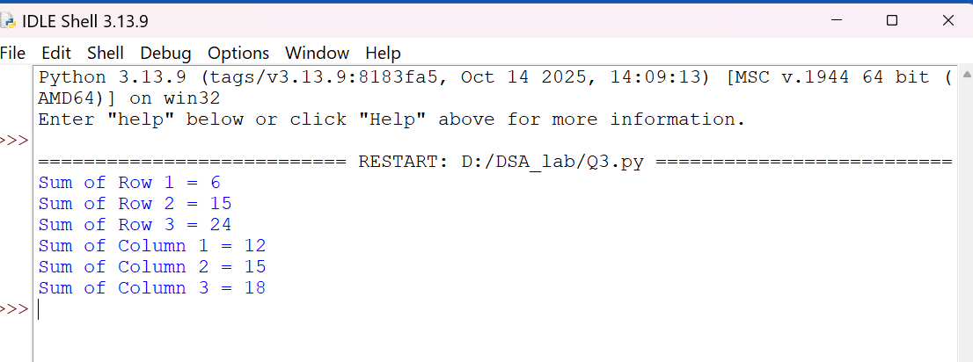

Practical Assignment No: 4
Program Name: Write a Python program to count the number of nodes in a singly linked list.
Roll No: MC2527077
Student Name: Varsha Sandip Gawali
Date:
PROGRAM:
class Node:
def __init__(self, data):
self.data = data
self.next = None

class LinkedList:
def __init__(self):
self.head = None

def append(self, data):
new_node = Node(data)
if not self.head:
self.head = new_node
return
temp = self.head
while temp.next:
temp = temp.next
temp.next = new_node

def count_nodes(self):
count = 0
temp = self.head
while temp:
count += 1
temp = temp.next
print("Number of nodes:", count)
# Example
ll = LinkedList()
ll.append(10)
ll.append(20)
ll.append(30)
ll.count_nodes()
Output:
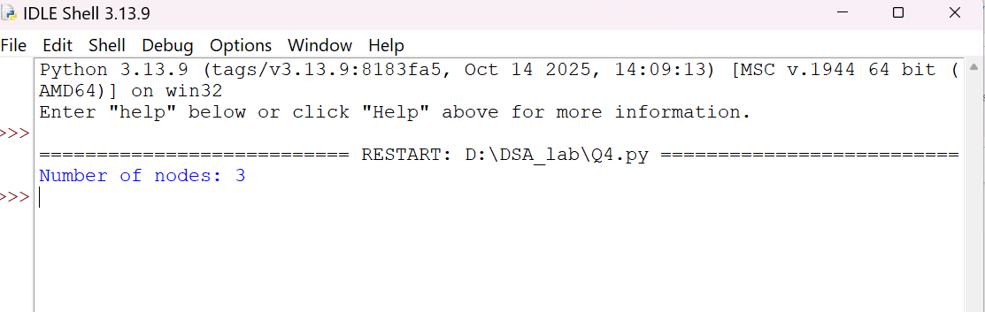

Practical Assignment No: 5
Program Name: Write a Python program to implement Singly Linked List
Roll No: MC2527077
Student Name: Varsha Sandip Gawali
Date:
PROGRAM:
class Node:
def __init__(self, data):
self.data = data
self.next = None
class SinglyLinkedList:
def __init__(self):
self.head = None
def insert_end(self, data):
new_node = Node(data)
if self.head is None:
self.head = new_node
else:
temp = self.head
while temp.next:
temp = temp.next
temp.next = new_node
def display(self):
temp = self.head
while temp:
print(temp.data, end=" -> ")
temp = temp.next
print("None")
# Example
sll = SinglyLinkedList()
sll.insert_end(10)
sll.insert_end(20)
sll.insert_end(30)
sll.display()
Output:
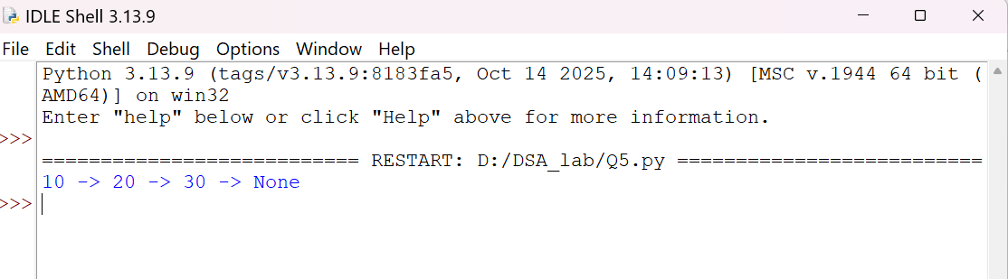

Practical Assignment No: 6
Program Name: Write a Python program to implement Doubly Linked List
Roll No: MC2527077
Student Name: Varsha Sandip Gawali
Date:
PROGRAM:
class Node:
def __init__(self, data):
self.data = data
self.prev = None
self.next = None
class DoublyLinkedList:
def __init__(self):
self.head = None
def insert_end(self, data):
new_node = Node(data)
if not self.head:
self.head = new_node
return
temp = self.head
while temp.next:
temp = temp.next
temp.next = new_node
new_node.prev = temp
def display_forward(self):
temp = self.head
while temp:
print(temp.data, end=" <-> ")
temp = temp.next
print("None")
# Example
dll = DoublyLinkedList()
dll.insert_end(10)
dll.insert_end(20)
dll.insert_end(30)
dll.display_forward()
Output: 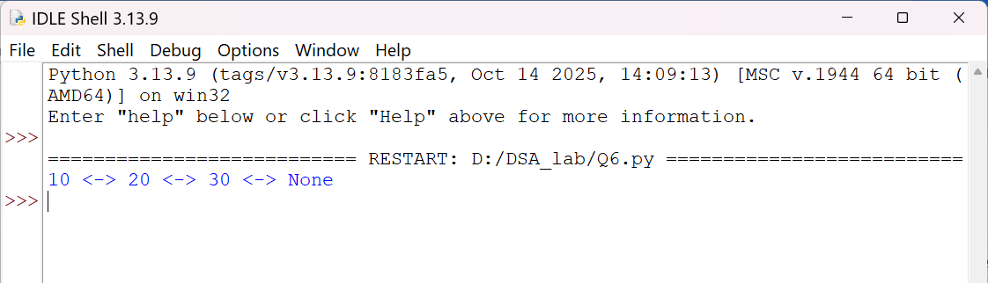

Practical Assignment No: 7
Program Name: Write a Python program to implement Stack with Array
Roll No: MC2527077
Student Name: Varsha Sandip Gawali
Date:
PROGRAM:
class Stack:
def __init__(self): # should be __init__ (double underscores)
self.stack = []
def is_empty(self):
return len(self.stack) == 0
def push(self, item):
self.stack.append(item)
def pop(self):
if not self.is_empty():
return self.stack.pop()
else:
print("Stack is empty. Cannot pop.")
return None
def peek(self):
if not self.is_empty():
return self.stack[-1]
else:
print("Stack is empty. Cannot peek.")
return None
def size(self):
return len(self.stack)

# Example usage
st = Stack()
st.push("1")
st.push("2")
st.push("3")
print("Stack is:", st.stack)
print("Pop:", st.pop())
print("Peek:", st.peek())
print("Size:", st.size())
Output: 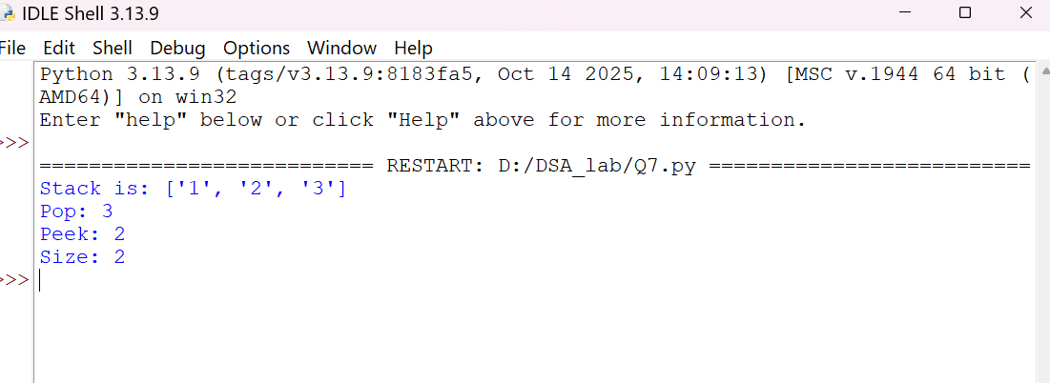

Practical Assignment No: 8
Program Name: Write a Python program to implement Stack using linked list – Push, Pop, Display operations
Roll No: MC2527077
Student Name: Varsha Sandip Gawali
Date:
PROGRAM:
#stack implementation using linked list
class Node:
def __init__(self,value):
self.value=value
self.next=None

class Stack:
def __init__(self):
self.head=None
self.size=0
def push(self,value):
new_node=Node(value)
if self.head:
new_node.next=self.head
self.head=new_node
self.size+=1
def pop(self):
if self.isEmpty():
return"Stack is empty"
popped_node=self.head
self.head=self.head.next
return popped_node.value
def peek(self):
if self.isEmpty():
return "stack is empty"
return self.head.value
def isEmpty(self):
return self.size==0
def stackSize(self):
return self.size
def display(self):
if self.isEmpty():
print("Stack is empty")
else:
current = self.head
print("Stack elements (top → bottom): ", end="")
while current:
print(current.value, end=" ")
current = current.next
print()

s1=Stack()
s1.push("A")
s1.push("B")
s1.push("C")
s1.push("D")
s1.push("E")
print("Stack:",s1.display())
print("pop:",s1.pop())
print("peek:",s1.peek())
print("isEmpty:",s1.isEmpty())
print("Size:",s1.stackSize())
Output:
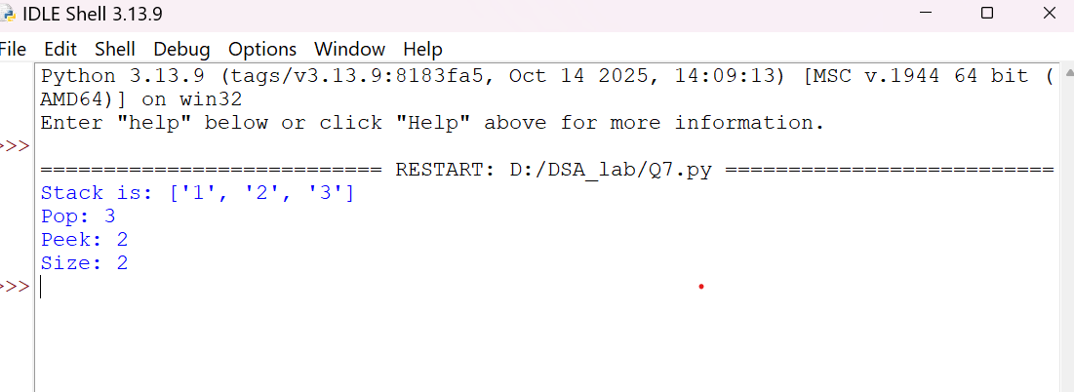

Practical Assignment No: 9
Program Name: Write a Python program to reverse the string using stack
Roll No: MC2527077
Student Name: Varsha Sandip Gawali
Date:
PROGRAM:
stack = []
s = "Hello"
for ch in s:
stack.append(ch)
rev = ""
while stack:
rev += stack.pop()
print("Original:", s)
print("Reversed:", rev)
Output:
