Practical Assignment No: 16
Program Name: Write a Python program to implement AVL Tree
Roll No: MC2527077
Student Name: Varsha Sandip Gawali
Date:
PROGRAM: class Node:
def __init__(self, key):
self.key = key
self.left = None
self.right = None
self.height = 1
def height(root):
if not root:
return 0
return root.height
def rightRotate(y):
x = y.left
T2 = x.right
x.right = y
y.left = T2
y.height = 1 + max(height(y.left), height(y.right))
x.height = 1 + max(height(x.left), height(x.right))
return x
def leftRotate(x):
y = x.right
T2 = y.left
y.left = x
x.right = T2
x.height = 1 + max(height(x.left), height(x.right))
y.height = 1 + max(height(y.left), height(y.right))
return y
def getBalance(root):
if not root:
return 0
return height(root.left) - height(root.right)
def insert(root, key):
if not root:
return Node(key)
if key < root.key:
root.left = insert(root.left, key)
else:
root.right = insert(root.right, key)
root.height = 1 + max(height(root.left), height(root.right))
balance = getBalance(root)
if balance > 1 and key < root.left.key:
return rightRotate(root)
if balance < -1 and key > root.right.key:
return leftRotate(root)
# LR
if balance > 1 and key > root.left.key:
root.left = leftRotate(root.left)
return rightRotate(root)
# RL
if balance < -1 and key < root.right.key:
root.right = rightRotate(root.right)
return leftRotate(root)

return root
def preorder(root):
if root:
print(root.key, end=" ")
preorder(root.left)
preorder(root.right)
root = None
nums = [10, 20, 30, 40, 50, 25]
for num in nums:
root = insert(root, num)
print("Preorder Traversal of AVL Tree:")
preorder(root) 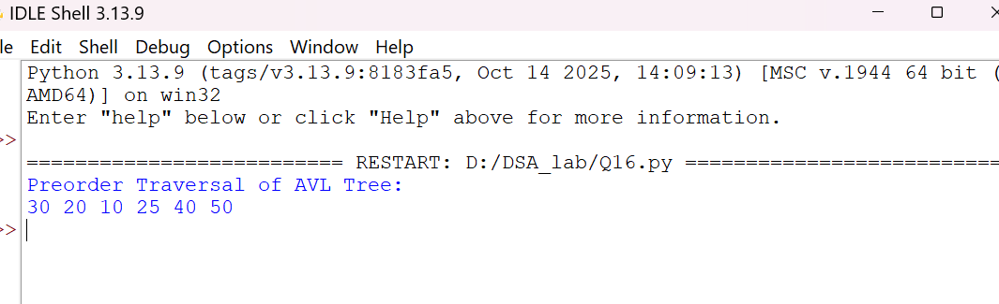

Practical Assignment No: 17
Program Name: Write a Python program to implement Graph Traversal (BFS & DFS)
Roll No: MC2527077
Student Name: Varsha Sandip Gawali
Date:
PROGRAM: from collections import deque
graph = {
'A': ['B', 'C'],
'B': ['D', 'E'],
'C': ['F'],
'D': [],
'E': ['F'],
'F': []
}
def bfs(start):
visited = set()
queue = deque([start])
while queue:
node = queue.popleft()
if node not in visited:
print(node, end=" ")
visited.add(node)
queue.extend(graph[node])
def dfs(start, visited=None):
if visited is None:
visited = set()
print(start, end=" ")
visited.add(start)
for n in graph[start]:
if n not in visited:
dfs(n, visited)
print("BFS Traversal:")
bfs('A')
print("\nDFS Traversal:")
dfs('A') 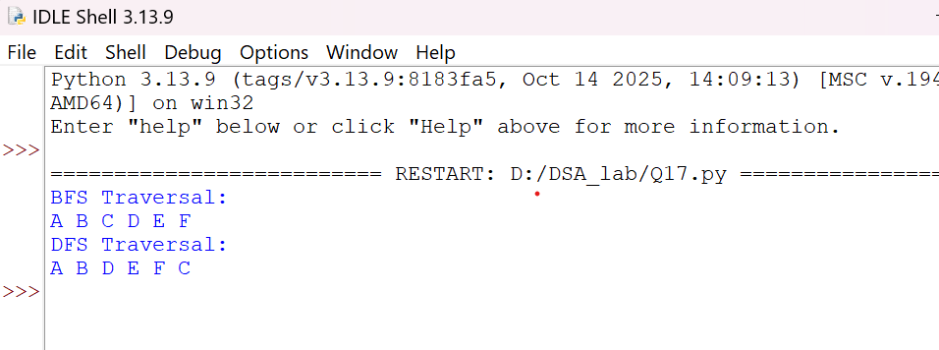

Practical Assignment No: 18
Program Name: Write a Python program to implement Binary Search
Roll No: MC2527077
Student Name: Varsha Sandip Gawali
Date:
PROGRAM: def binary_search(arr, target):
low, high = 0, len(arr) - 1
while low <= high:
mid = (low + high) // 2
if arr[mid] == target:
return mid
elif arr[mid] < target:
low = mid + 1
else:
high = mid - 1
return -1
arr = [10, 20, 30, 40, 50]
x = 30
pos = binary_search(arr, x)
if pos != -1:
print("Element found at index:", pos)
else:
print("Element not found.") 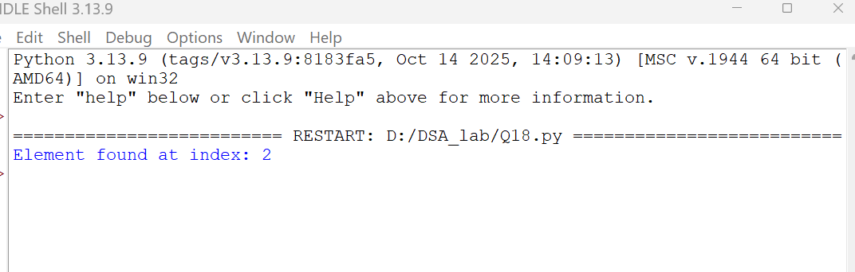

Practical Assignment No: 19
Program Name: Write a Python program to implement Hashing
Roll No: MC2527077
Student Name: Varsha Sandip Gawali
Date:
PROGRAM: size = 10
hash_table = [None] * size
def hash_function(key):
return key % size
def insert(key):
index = hash_function(key)
while hash_table[index] is not None:
index = (index + 1) % size
hash_table[index] = key
keys = [23, 43, 13, 27]
for k in keys:
insert(k)
print("Hash Table:", hash_table)
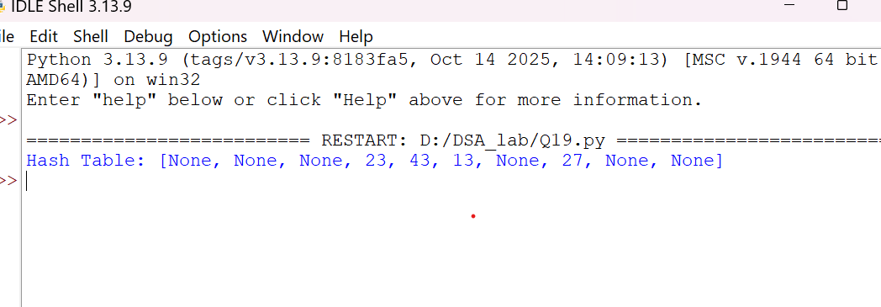

Practical Assignment No:20
Program Name: Write a Python program for Quick Sort
Roll No: MC2527077
Student Name: Varsha Sandip Gawali
Date:
PROGRAM: def quick_sort(arr):
if len(arr) <= 1:
return arr
pivot = arr[len(arr) // 2]
left = [x for x in arr if x < pivot]
middle = [x for x in arr if x == pivot]
right = [x for x in arr if x > pivot]
return quick_sort(left) + middle + quick_sort(right)
arr = [10, 7, 8, 9, 1, 5]
print("Sorted array:", quick_sort(arr))
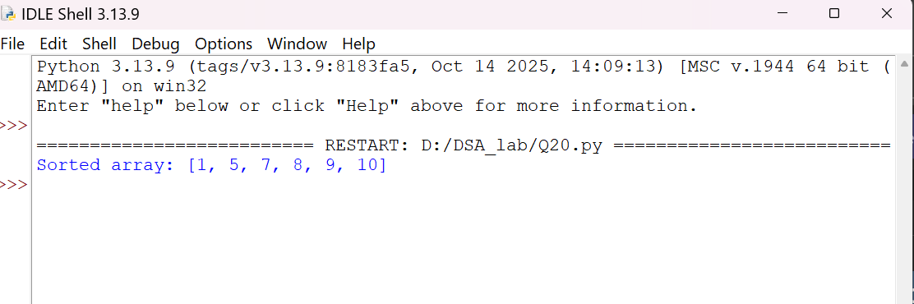

Practical Assignment No:21
Program Name: Write a Python program for Bubble Sort
Roll No: MC2527077
Student Name: Varsha Sandip Gawali
Date:
PROGRAM: def bubble_sort(arr):
n = len(arr)
for i in range(n):
for j in range(0, n - i - 1):
if arr[j] > arr[j + 1]:
arr[j], arr[j + 1] = arr[j + 1], arr[j]
arr = [64, 34, 25, 12, 22, 11, 90]
bubble_sort(arr)
print("Sorted array:", arr)

