Practical Assignment No: 1
Student Name: Varsha Sandip Gawali
Roll No: MC2527077
Class :MCA DIV:B
Subject: Python Programming Pratical

Q1. Write a python program to print the following string in a specific format
Twinkle, twinkle, little star,
How I wonder what you are!
Up above the world so high,
Like a diamond in the sky.
Twinkle, twinkle, little star,
How I wonder what you are

PROGRAM:
print("Twinkle, twinkle, little star,\n"
"How I wonder what you are!\n"
"Up above the world so high,\n"
"Like a diamond in the sky.\n"
"Twinkle, twinkle, little star,\n"
"How I wonder what you are")
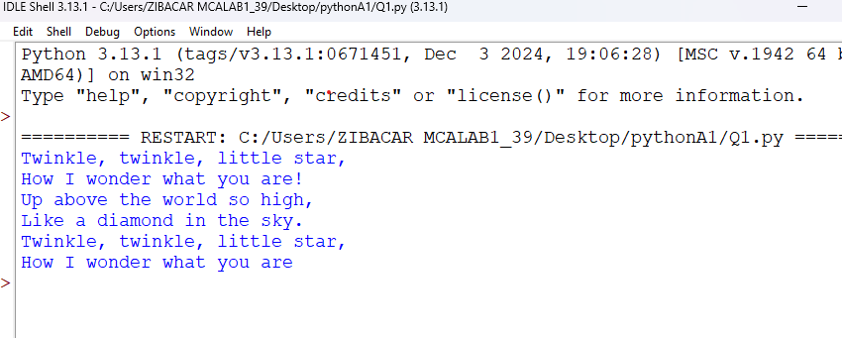

Q2. Write a program to perform arithmetic operations.
PROGRAM:
a = 10
b = 5

print("Addition =", a + b)
print("Subtraction =", a - b)
print("Multiplication =", a * b)
print("Division =", a / b)
print("Modulus =", a % b)
print("Exponent =", a ** b)
print("Floor Division =", a // b)

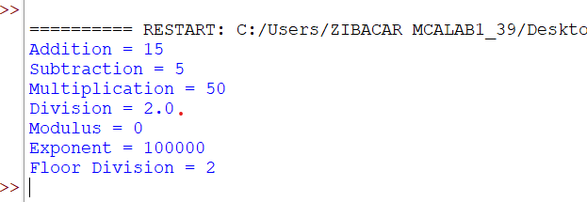

Q3. Write a program using list to perform: Slicing, Concatenation, Repetition
PROGRAM:

lst = [10, 20, 30, 40, 50]
print("Slicing:", lst[1:4])
print("Concatenation:", lst + [60, 70])
print("Repetition:", lst * 2)
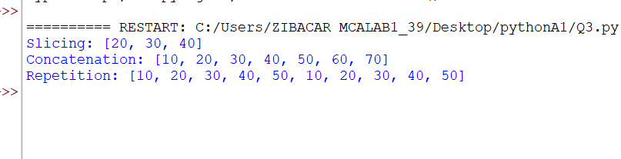

Q4. Write a program using tuple: Slicing, Concatenation, Repetition
PROGRAM:
t = (1, 2, 3, 4, 5)
print("Slicing:", t[0:3])
print("Concatenation:", t + (6, 7))
print("Repetition:", t * 3)
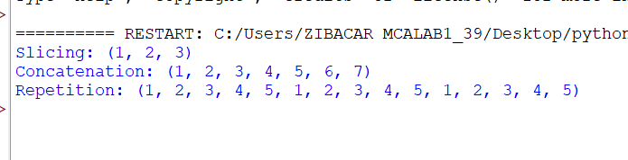

Q5. Write a program using dictionary to access value using keys.
PROGRAM:
student = {"name": "John", "age": 20, "course": "Python"}
print(student["name"])
print(student["age"])
print(student["course"])

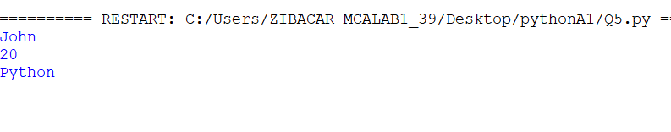Q6. Write a program using set: create, assign, add, remove
PROGRAM:
s = set() # empty set
s = {1, 2, 3} # assign values
s.add(4) # add element
s.remove(2) # remove element

print(s)
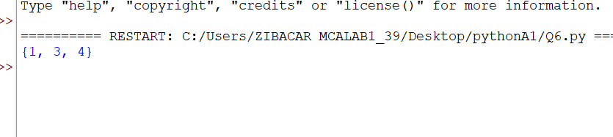

Q7. Write a program to get the largest number from the given list.
PROGRAM:
lst = [12, 34, 6, 78, 55]
print("Largest number:", max(lst))
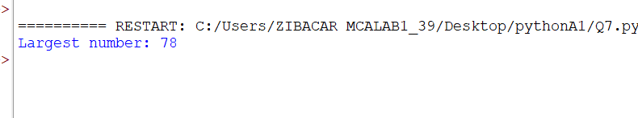

Q8. Write a program to find factorial of a given number.
PROGRAM:
num = int(input("Enter number: "))
fact = 1

for i in range(1, num + 1):
fact *= i

print("Factorial:", fact)

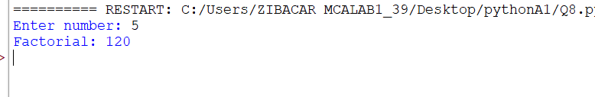

Q9. Write a program to find given number is prime or not.
PROGRAM:
num = int(input("Enter number: "))

if num > 1:
for i in range(2, num):
if num % i == 0:
print("Not Prime")
break
else:
print("Prime")
else:
print("Not Prime")
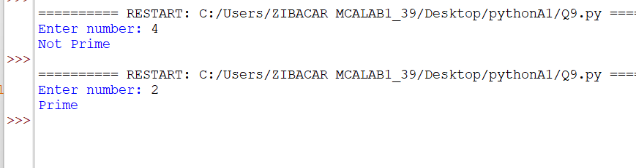

Q10. Write a program to identify total number of digits in a number
PROGRAM:
num = input("Enter number: ")
print("Total digits:", len(num))
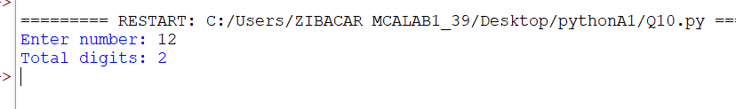

Q11. Write a program to display Fibonacci series using range.
PROGRAM:
n = int(input("Enter limit: "))
a, b = 0, 1

for i in range(n):
print(a, end=" ")
a, b = b, a + b

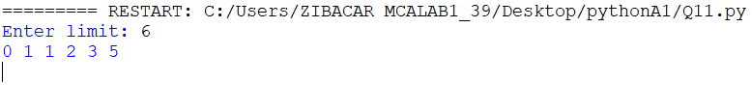

Q12 Write a program using for loop with: String, Integer, Enumerate, List, Nested For, Dictionary, Tuple, Zip()
PROGRAM:
# String
for ch in "Python":
print(ch)
# Integer range
for i in range(5):
print(i)
# Enumerate
for index, value in enumerate(["a", "b", "c"]):
print(index, value)
# List
lst = [10, 20, 30]
for x in lst:
print(x)
# Nested for
for i in range(2):
for j in range(3):
print(i, j)
# Dictionary
d = {"a": 1, "b": 2}
for key, value in d.items():
print(key, value)
# Tuple
t = (1, 2, 3)
for x in t:
print(x)
# Zip
names = ["John", "Sara"]
marks = [90, 85]
for n, m in zip(names, marks):
print(n, m)
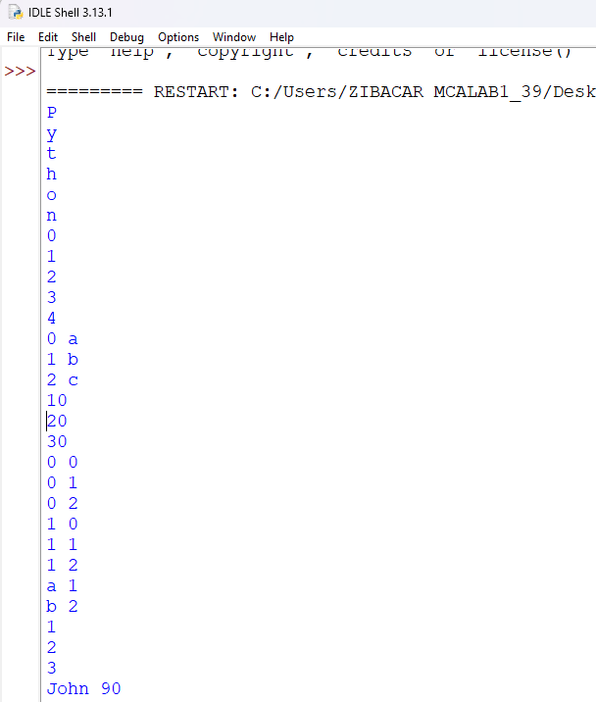

Q13. Loop manipulation using pass, continue, break, and else
PROGRAM:
# Loop manipulation using pass, continue, break and else
for i in range(1, 10):
if i == 2:
pass # Does nothing, just a placeholder
if i == 5:
continue # Skips the value 5
if i == 8:
break # Loop stops when i = 8
print(i)
else:
print("Loop completed successfully")

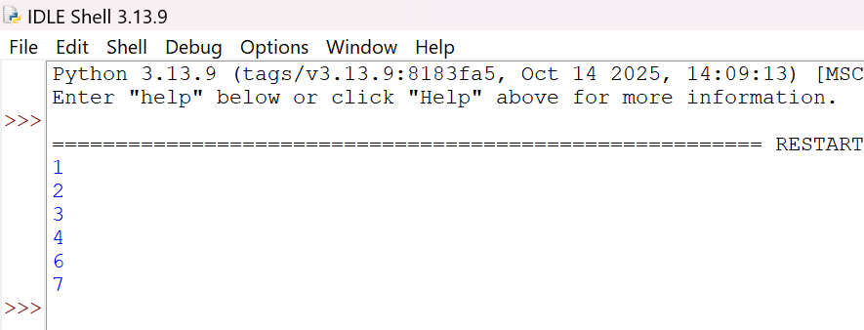

Q14. Program for List & Dictionary Comprehensions
PROGRAM:
# List Comprehension: squares of numbers
squares = [x*x for x in range(1, 6)]
print("Squares:", squares)

# Dictionary Comprehension: number and its cube
cubes = {x: x**3 for x in range(1, 6)}
print("Cubes Dictionary:", cubes)

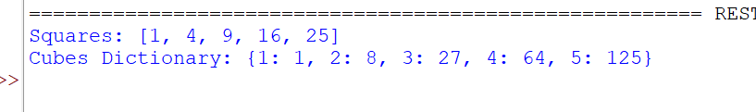

Q15. Find all numbers from 1–500 that contain the digit 3
PROGRAM: # Numbers from 1 to 500 that have digit '3'
nums = [i for i in range(1, 501) if '3' in str(i)]
print(nums)

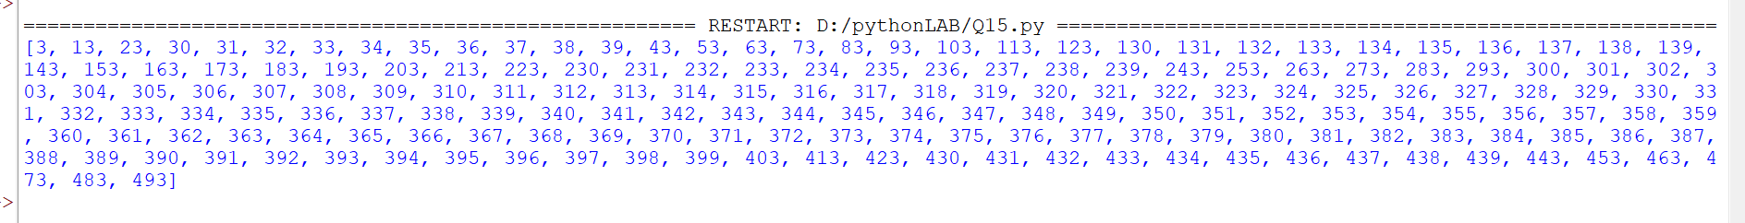

Q16. Write a python program for numbers=range(20) produce a list containing the word "even" if the number is even or the word "odd" if the number is odd
PROGRAM:
numbers = range(20)
result = ["even" if n % 2 == 0 else "odd" for n in numbers]
print(result)

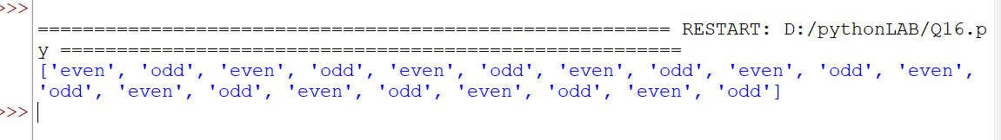

Q17. Find the common numbers in two list 1[1,3,4,5,6,7] 2[5,2,8,7,1,3]
PROGRAM:
list1 = [1, 3, 4, 5, 6, 7]
list2 = [5, 2, 8, 7, 1, 3]
common = [x for x in list1 if x in list2]
print("Common numbers:", common)

