Practical Assignment No: 2
Student Name: Varsha Sandip Gawali
Roll No: MC2527077
Class :MCA DIV:B
Subject: Python Programming Pratical

Q1. Implement a nested function that calculates compound interest using non-local variables

def compound_interest():
principal = 0
rate = 0
time = 0

def set_values(p, r, t):
nonlocal principal, rate, time
principal = p
rate = r
time = t
def calculate():
amount = principal * (1 + rate/100) ** time
return amount
set_values(1000, 5, 2) # Example: P=1000, R=5%, T=2 years
return calculate()

result = compound_interest()
print("Compound Interest Amount:", result)

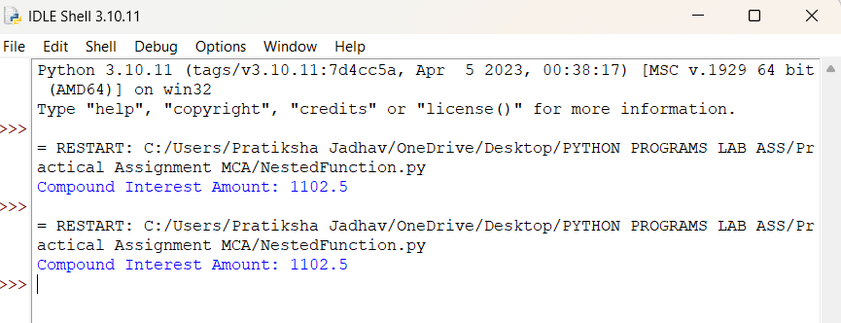

Q2. Write a program using lambda to filter even numbers from a list

numbers = [1, 2, 3, 4, 5, 6, 7, 8, 9, 10]
print("Numbers :",numbers)
even_numbers = list(filter(lambda x: x % 2 == 0, numbers))
print("Even Numbers:", even_numbers)

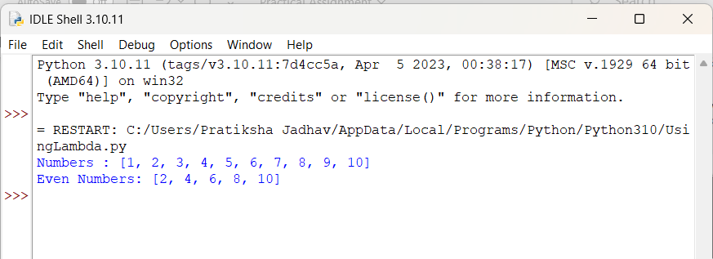

Q3. Write a program using lambda to find area of triangle

area = lambda base, height: 0.5 * base * height
b = float(input("Enter base: "))
h = float(input("Enter height: "))
print("Area of Triangle:", area(b, h))

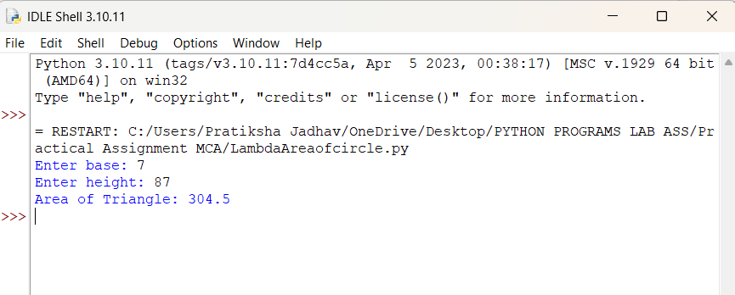
Q4. Create a generator function to yield Fibonacci numbers up to a certain limit

def fibonacci(limit):
a, b = 0, 1
while a <= limit:
yield a
a, b = b, a + b
limit = int(input("Enter limit: "))
for num in fibonacci(limit):
print(num, end=" ")

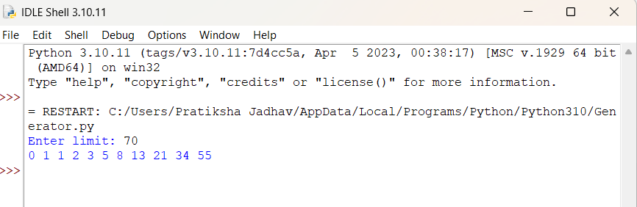

Q5. Develop a custom Python module with functions for basic statistical operations (mean,median,mode) .

# mystats.py
# Custom module for basic statistical operations

def mean(data):
return sum(data) / len(data)

def median(data):
sorted_data = sorted(data)
n = len(sorted_data)

mid = n // 2
if n % 2 == 0:
return (sorted_data[mid - 1] + sorted_data[mid]) / 2
else:
return sorted_data[mid]

def mode(data):
frequency = {}
for num in data:
frequency[num] = frequency.get(num, 1) + 1
max_count = max(frequency.values())
modes = [key for key, value in frequency.items() if value == max_count]

if len(modes) == 1:
return modes[0]
else:
return modes # multiple modes

# main.py

import mystats
numbers = [1, 2, 2, 3, 4, 5]
print("Mean:", mystats.mean(numbers))
print("Median:", mystats.median(numbers))
print("Mode:", mystats.mode(numbers))

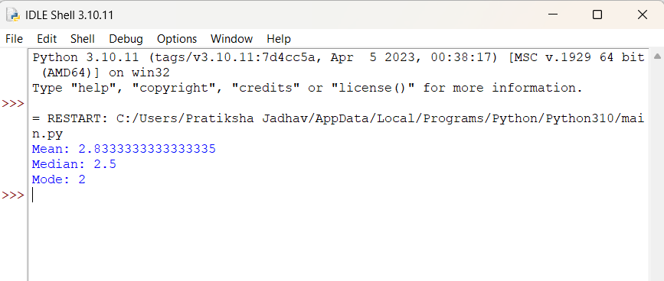

Q6. Write a program to handle file reading errors and log them to a separate file

def read_file(filename):
try:
with open(filename, "r") as file:
data = file.read()
print("File Content:\n", data)

except FileNotFoundError as e:
log_error(f"FileNotFoundError: {e}")

except PermissionError as e:
log_error(f"PermissionError: {e}")

except Exception as e:
log_error(f"Other Error: {e}")

def log_error(message):
with open("error_log.txt", "a") as log:
log.write(message + "\n")
print("Error logged:", message)

filename = input("Enter file name to read: ")
read_file(filename)

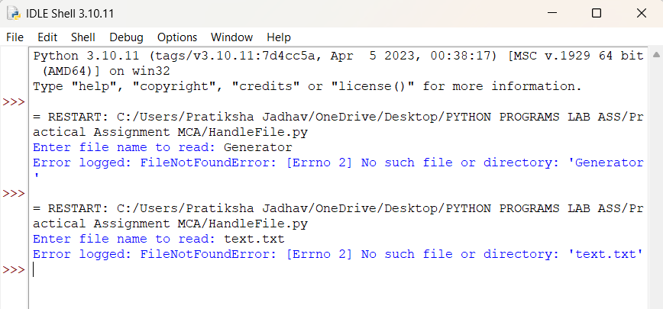

Q7. Create a custom exception class AgeException and use it to validate user input

class AgeException(Exception):
pass # custom exception class
try:
age = int(input("Enter your age: "))
if age < 0:
raise AgeException("Age cannot be negative")
elif age < 18:
raise AgeException("Age must be 18 or above")
print("Age is valid!")
except AgeException as e:
print("Age Error:", e)

except ValueError:
print("Invalid input! Please enter a number.")

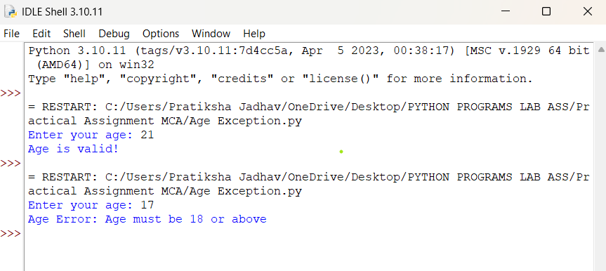

Assignment No : 3
Student Name: Varsha Sandip Gawali
Roll No: MC2527077
Class :MCA DIV:B
Subject: Python Programming Pratical

Q1. Write a simple Python class named Student and display its type. Also display the dict attribute keys and values of the_module_attribute of the Student class.

class Student:
def __init__(self, name, roll):
self.name = name
self.roll = roll
s = Student("Alice", 101)
print("Type of s:", type(s))
print("\nObject __dict__ attributes:")
for key, value in s.__dict__.items():
print(key, ":", value)
# display the __dict__ attribute of the class
print("\nClass __dict__ attributes:")
for key, value in Student.__dict__.items():
print(key, ":", value)
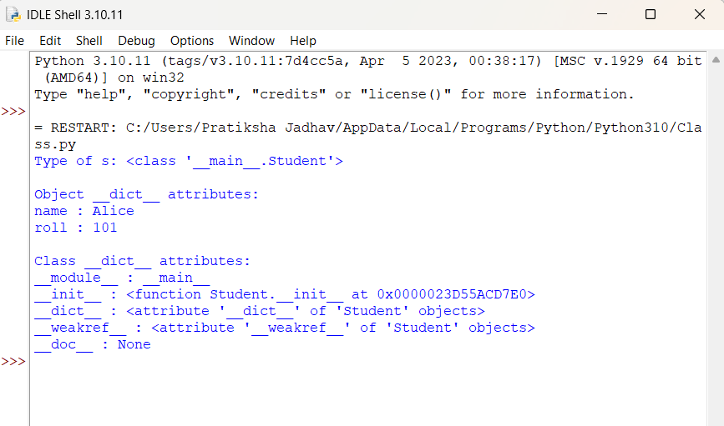
Q2. Write a Python class Student with two attributes, student_name and marks. Modify any attribute value of the class and show the original and modified values of attributes.

class Student:
def __init__(self, student_name, marks):
self.student_name = student_name
self.marks = marks
# create object
s = Student("Pratiksha", 85)
# show original values
print("Original Values:")
print("Name:", s.student_name)
print("Marks:", s.marks)
# modify attributes
s.student_name = "varsha"
s.marks = 80
print("\nModified Values:")
print("Name:", s.student_name)
print("Marks:", s.marks)
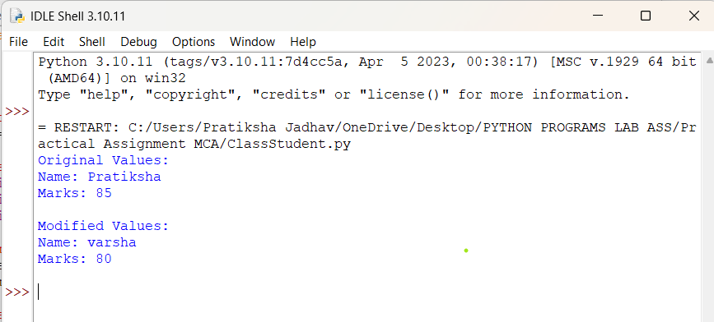
Q3. Write a Python class to convert an integer to a Roman numeral.

class IntegerToRoman:
def __init__(self, number):
self.number = number
def convert(self):
val = [
1000, 900, 500, 400,
100, 90, 50, 40,
10, 9, 5, 4, 1
]
syms = [
"M", "CM", "D", "CD",
"C", "XC", "L", "XL",
"X", "IX", "V", "IV", "I"
]
num = self.number
roman = ""
for i in range(len(val)):
while num >= val[i]:
roman += syms[i]
num -= val[i]
return roman
# Example usage
n = int(input("Enter an integer: "))
converter = IntegerToRoman(n)
print("Roman numeral:", converter.convert())
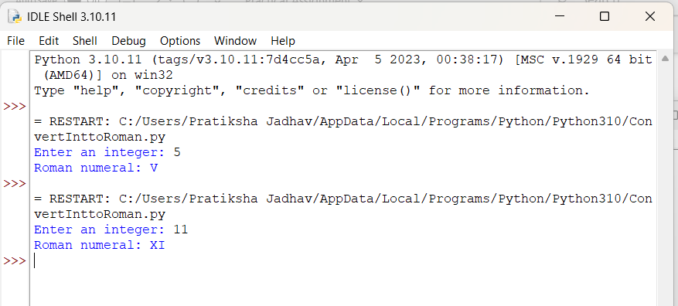

Q4. Write a Python class to convert a Roman numeral to an integer.

class RomanToInteger:
def __init__(self, roman):
self.roman = roman\
def convert(self):
roman_values = {
'I': 1, 'V': 5, 'X': 10, 'L': 50,
'C': 100, 'D': 500, 'M': 1000
}

total = 0
prev_value = 0
for char in reversed(self.roman):
value = roman_values[char]
if value < prev_value:
total -= value
else:
total += value
prev_value = value
return total
roman = input("Enter a Roman numeral: ").upper()
converter = RomanToInteger(roman)
print("Integer:", converter.convert())

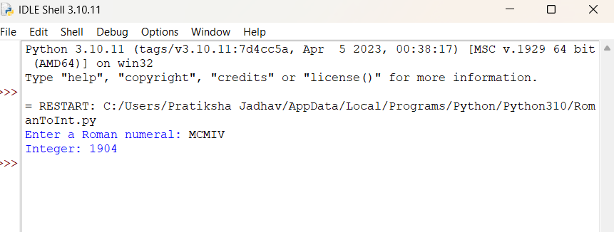

Q5. Write a program to create a class Shape with methods called get_perimeter and get area. Create a subclass called Circle that overrides the get_perimeter and get_area methods to calculate the area and perimeter of a circle.

import math
class Shape:
def get_perimeter(self):
return "Perimeter formula not defined"

def get_area(self):
return "Area formula not defined"

class Circle(Shape):
def __init__(self, radius):
self.radius = radius

def get_perimeter(self):
return 2 * math.pi * self.radius # circumference

def get_area(self):
return math.pi * (self.radius ** 2)

# Example usage
r = float(input("Enter radius of the circle: "))
c = Circle(r)

print("Perimeter of Circle:", c.get_perimeter())
print("Area of Circle:", c.get_area())

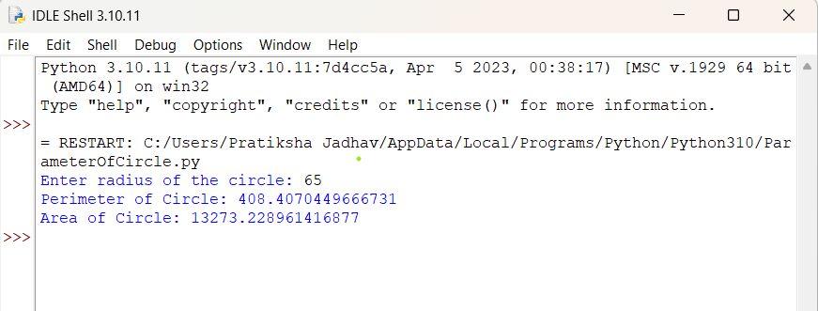

Q6. Write a program to create a Vehicle class hierarchy. The base class should be Vehicle, with subclasses Truck, Car, and Motorcycle. Each subclass should have properties such as make, model, year, and fuel_type. Implement methods for calculating fuel efficiency, distance traveled, and maximum speed.

class Vehicle:
def __init__(self, make, model, year, fuel_type):
self.make = make
self.model = model
self.year = year
self.fuel_type = fuel_type

def fuel_efficiency(self):
return "Fuel efficiency not defined"

def distance_traveled(self, hours, speed):
return hours * speed

def max_speed(self):
return "Max speed not defined"

class Car(Vehicle):
def fuel_efficiency(self):
return 15 # km per liter (example)

def max_speed(self):
return 180 # km/h

class Truck(Vehicle):
def fuel_efficiency(self):
return 8 # km per liter (example)

def max_speed(self):
return 120 # km/h

class Motorcycle(Vehicle):
def fuel_efficiency(self):
return 35 # km per liter (example)
def max_speed(self):
return 160 # km/h

# Example usage
car = Car("Toyota", "Corolla", 2020, "Petrol")
truck = Truck("Volvo", "FH16", 2019, "Diesel")
bike = Motorcycle("Yamaha", "R15", 2023, "Petrol")

print("\n--- Car Info ---")
print("Fuel Efficiency:", car.fuel_efficiency(), "km/l")
print("Max Speed:", car.max_speed(), "km/h")
print("Distance in 2 hours at 80 km/h:", car.distance_traveled(2, 80), "km")

print("\n--- Truck Info ---")
print("Fuel Efficiency:", truck.fuel_efficiency(), "km/l")
print("Max Speed:", truck.max_speed(), "km/h")
print("Distance in 3 hours at 60 km/h:", truck.distance_traveled(3, 60), "km")

print("\n--- Motorcycle Info ---")
print("Fuel Efficiency:", bike.fuel_efficiency(), "km/l")
print("Max Speed:", bike.max_speed(), "km/h")
print("Distance in 1.5 hours at 70 km/h:", bike.distance_traveled(1.5, 70), "km")

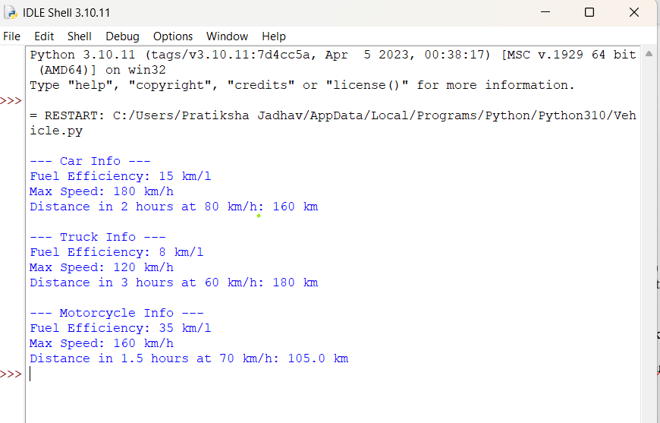
Q7. Implement a class BankAccount with methods for deposit, withdrawal, and displaying the account balance.

class BankAccount:
def __init__(self, account_holder, balance=0):
self.account_holder = account_holder
self.balance = balance

def deposit(self, amount):
self.balance += amount
print(f"Deposited: {amount}")

def withdraw(self, amount):
if amount > self.balance:
print("Insufficient balance!")
else:
self.balance -= amount
print(f"Withdrawn: {amount}")

def display_balance(self):
print(f"Account Holder: {self.account_holder}")
print(f"Current Balance: {self.balance}")

name = input("Enter account holder name: ")
acc = BankAccount(name, 1000)

acc.display_balance()
acc.deposit(500)
acc.withdraw(800)
acc.display_balance()

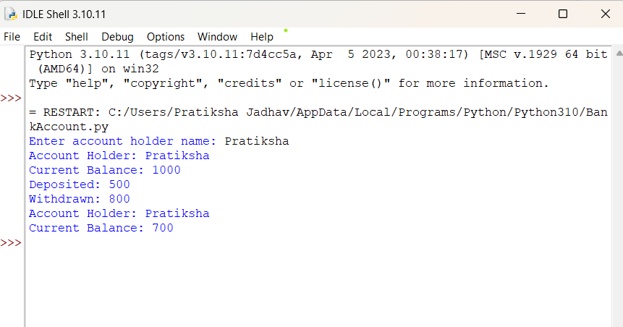
Q8. Develop a hierarchy of shapes (e.g., Shape, Circle, Rectangle) with area and perimeter methods.Student class.

import math

class Shape:
def area(self):
return "Area not defined"

def perimeter(self):
return "Perimeter not defined"

class Circle(Shape):
def __init__(self, radius):
self.radius = radius

def area(self):
return math.pi * self.radius ** 2

def perimeter(self):
return 2 * math.pi * self.radius

class Rectangle(Shape):
def __init__(self, length, width):
self.length = length
self.width = width

def area(self):
return self.length * self.width

def perimeter(self):
return 2 * (self.length + self.width)
# Example usage
c = Circle(5)
r = Rectangle(10, 4)

print("Circle Area:", c.area())
print("Circle Perimeter:", c.perimeter())
print("Rectangle Area:", r.area())
print("Rectangle Perimeter:", r.perimeter())

class Student:
def __init__(self, name, roll_no, marks):
self.name = name
self.roll_no = roll_no
self.marks = marks
def display(self):
print("Student Name:", self.name)
print("Roll Number:", self.roll_no)
print("Marks:", self.marks)
s = Student("Rahul", 101, 89)
s.display()

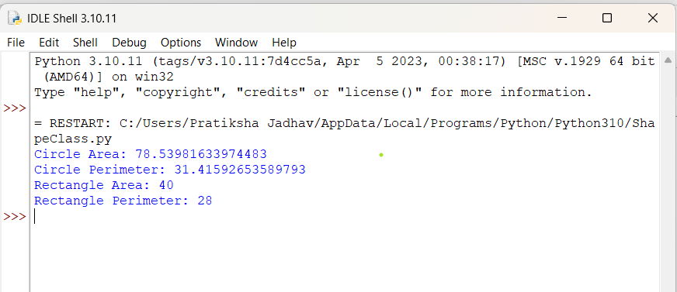
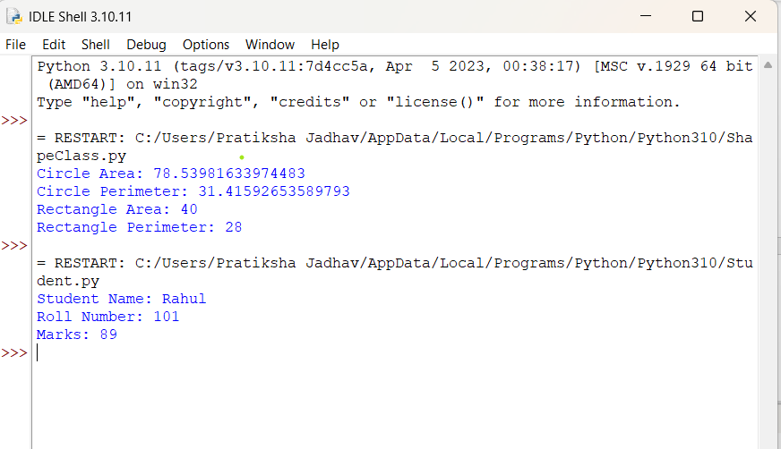

Q9. Overload the + operator for concatenating two custom string objects

class CustomString:
def __init__(self, text):
self.text = text

def __add__(self, other):
return CustomString(self.text + other.text)

def __str__(self):
return self.text

# Example usage
s1 = CustomString("Hello ")
s2 = CustomString("World!")

s3 = s1 + s2 # Using overloaded + operator

print("Concatenated String:", s3)

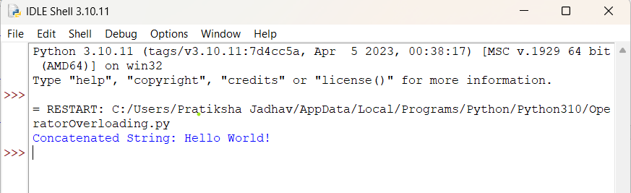

Q10. Create a static method to validate user credentials (e.g., email format, password length).

import re
class Validator:
@staticmethod
def validate_email(email):
pattern = r'^[\w\.-]+@[\w\.-]+\.\w+$'
return re.match(pattern, email) is not None

@staticmethod
def validate_password(password):
return len(password) >= 8

email = input("Enter email: ")
password = input("Enter password: ")

if Validator.validate_email(email):
print("Valid Email")
else:
print("Invalid Email")

if Validator.validate_password(password):
print("Valid Password")
else:
print("Password must be at least 8 characters long")

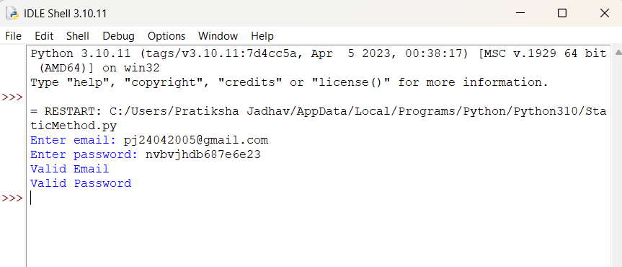
Q 11. Implement a class Library containing a list of Book objects

class Book:
def __init__(self, title, author, year):
self.title = title
self.author = author
self.year = year
def display(self):
print(f"Title: {self.title}, Author: {self.author}, Year: {self.year}")
class Library:
def __init__(self):
self.books = [] # list of Book objects
def add_book(self, book):
self.books.append(book)
print(f"Book '{book.title}' added to library.")

def show_books(self):
if not self.books:
print("No books in library.")
else:
print("\nBooks in Library:")
for book in self.books:
book.display()
b1 = Book("Python Programming", "John Doe", 2020)
b2 = Book("Data Science", "Jane Smith", 2022)

lib = Library()
lib.add_book(b1)
lib.add_book(b2)
lib.show_books()
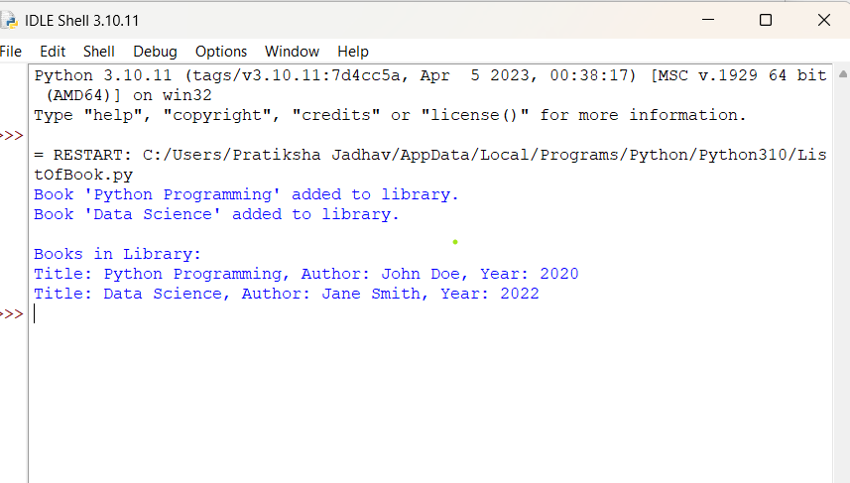
Q12. Demonstrate method overriding in a superclass-subclass relationship for a payment system (e.g., Payment, CardPayment).

class Payment:
def process_payment(self, amount):
print(f"Processing a generic payment of ₹{amount}")

class CardPayment(Payment):
def process_payment(self, amount):
print(f"Processing card payment of ₹{amount}")
print("Payment successful using Debit/Credit Card")

p = Payment()
cp = CardPayment()

print("---- Payment ----")
p.process_payment(500)

print("\n---- Card Payment ----")
cp.process_payment(500)

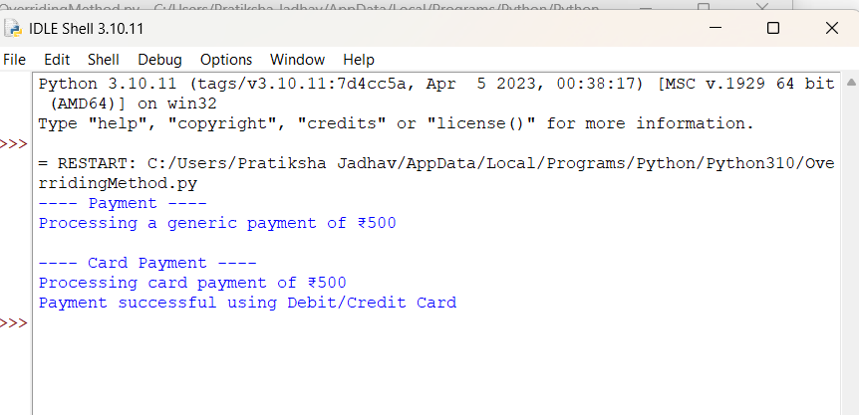

Q 13. Write a program to validate a password that meets certain criteria (length, uppercase, digit, special character).

import re

def validate_password(password):
if len(password) < 8:
return "Password must be at least 8 characters long."

if not re.search(r"[A-Z]", password):
return "Password must contain at least one uppercase letter."

if not re.search(r"[0-9]", password):
return "Password must contain at least one digit."

if not re.search(r"[!@#$%^&*(),.?\":{}|<>]", password):
return "Password must contain at least one special character."

return "Password is valid."

password = input("Enter password: ")
print(validate_password(password))

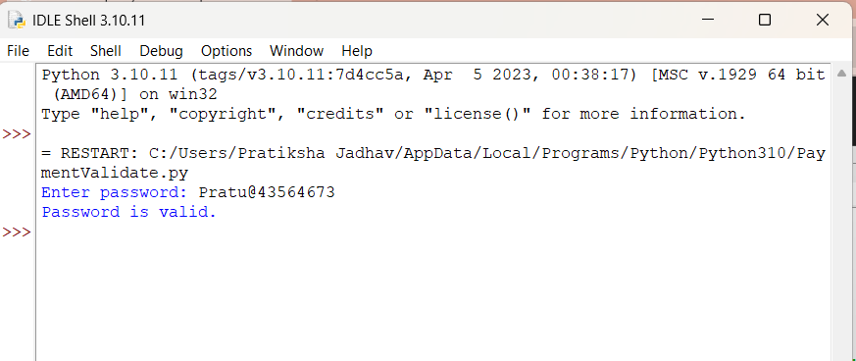

Q 14. Parse email addresses from a given text and classify them by domain.

import re

def classify_emails(text):
pattern = r'[a-zA-Z0-9._%+-]+@[a-zA-Z0-9.-]+\.[a-zA-Z]{2,}'
emails = re.findall(pattern, text)
domain_dict = {}

for email in emails:
domain = email.split("@")[1]
if domain not in domain_dict:
domain_dict[domain] = []
domain_dict[domain].append(email)

return domain_dict
text = """
Contact us at support@gmail.com or sales@yahoo.com.
You can also reach admin@company.com and hr@company.com
for further queries. Backup: user123@gmail.com
"""
result = classify_emails(text)

print("Classified Emails by Domain:")
for domain, email_list in result.items():
print(f"{domain}: {email_list}")

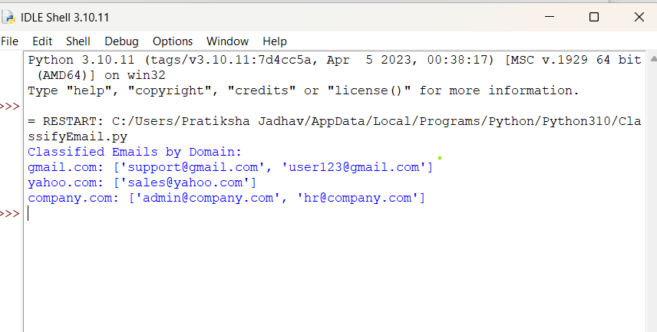
Q15. Create threads to perform independent tasks such as downloading multiple files Simultaneously

import threading
import time

def download_file(filename):
print(f"Starting download: {filename}")
time.sleep(2) # Simulate download time
print(f"Finished downloading: {filename}")

# List of files
files = ["file1.jpg", "file2.mp4", "file3.pdf", "file4.png"]

threads = []

# Create and start threads
for file in files:
t = threading.Thread(target=download_file, args=(file,))
threads.append(t)
t.start()

# Wait for all threads to finish
for t in threads:
t.join()
print("All downloads completed.")

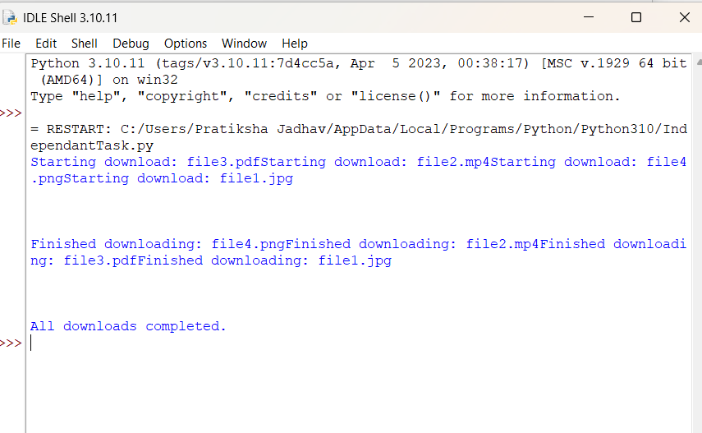
Q 16. Write a Python program to create two threads. The first thread will print even numbers, and the second thread will print odd numbers. Demonstrate the concept of multithreading.

import threading
import time
def print_even():
for i in range(0, 21, 2):
print("Even:", i)
time.sleep(0.2)
def print_odd():
for i in range(1, 21, 2):
print("Odd :", i)
time.sleep(0.2)

t1 = threading.Thread(target=print_even)
t2 = threading.Thread(target=print_odd)
t1.start()
t2.start()
t1.join()
t2.join()
print("Both threads finished execution.")

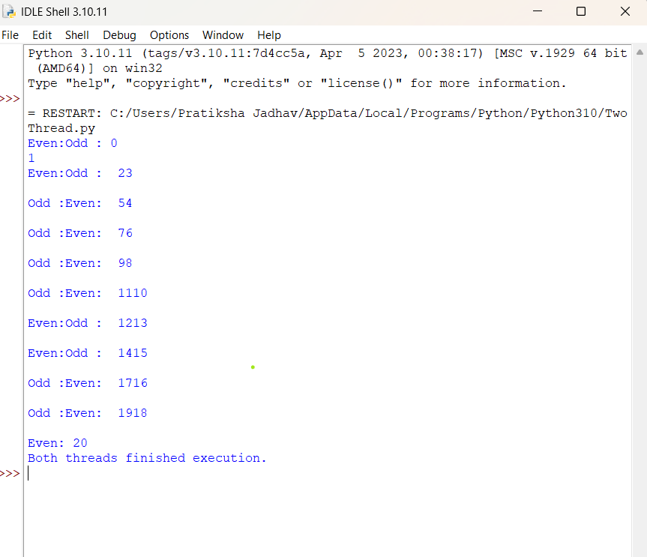

Q17. Use multithreading to compute factorials of multiple numbers and log the results into a file.

import threading
import math

def compute_factorial(n):
result = math.factorial(n)
with open("factorial_log.txt", "a") as file:
file.write(f"Factorial of {n} = {result}\n")
print(f"Computed factorial of {n}")

numbers = [5, 7, 10, 12, 15]

threads = []

# Create and start threads
for num in numbers:
t = threading.Thread(target=compute_factorial, args=(num,))
threads.append(t)
t.start()
for t in threads:
t.join()
print("All factorials computed and logged.")

