Practical Assignment No: 4
Student Name: Varsha Sandip Gawali
Roll No: MC2527077
Class: MCA DIV: B
Subject: Python Programming Practical
Q1. Develop a python program to create, read, update and delete document in a MangoDB collection.
Program:
from pymongo import MongoClient
# Connect to MongoDB
client = MongoClient("mongodb://localhost:27017/")
db = client["assignment4"]
collection = db["demo_collection"]
# ---- CREATE ----
document = {"name": "Amit", "age": 25, "city": "Pune"}
collection.insert_one(document)
print("Document Inserted")
# ---- READ ----
print("\nAll Documents:")
for doc in collection.find():
print(doc)
# ---- UPDATE ----
collection.update_one({"name": "Amit"}, {"$set": {"age": 30}})
print("\nAfter Update:")
print(collection.find_one({"name": "Amit"}))
# ---- DELETE ----
collection.delete_one({"name": "Amit"})
print("\nAfter Delete:")
for doc in collection.find():
print(doc)

Output:

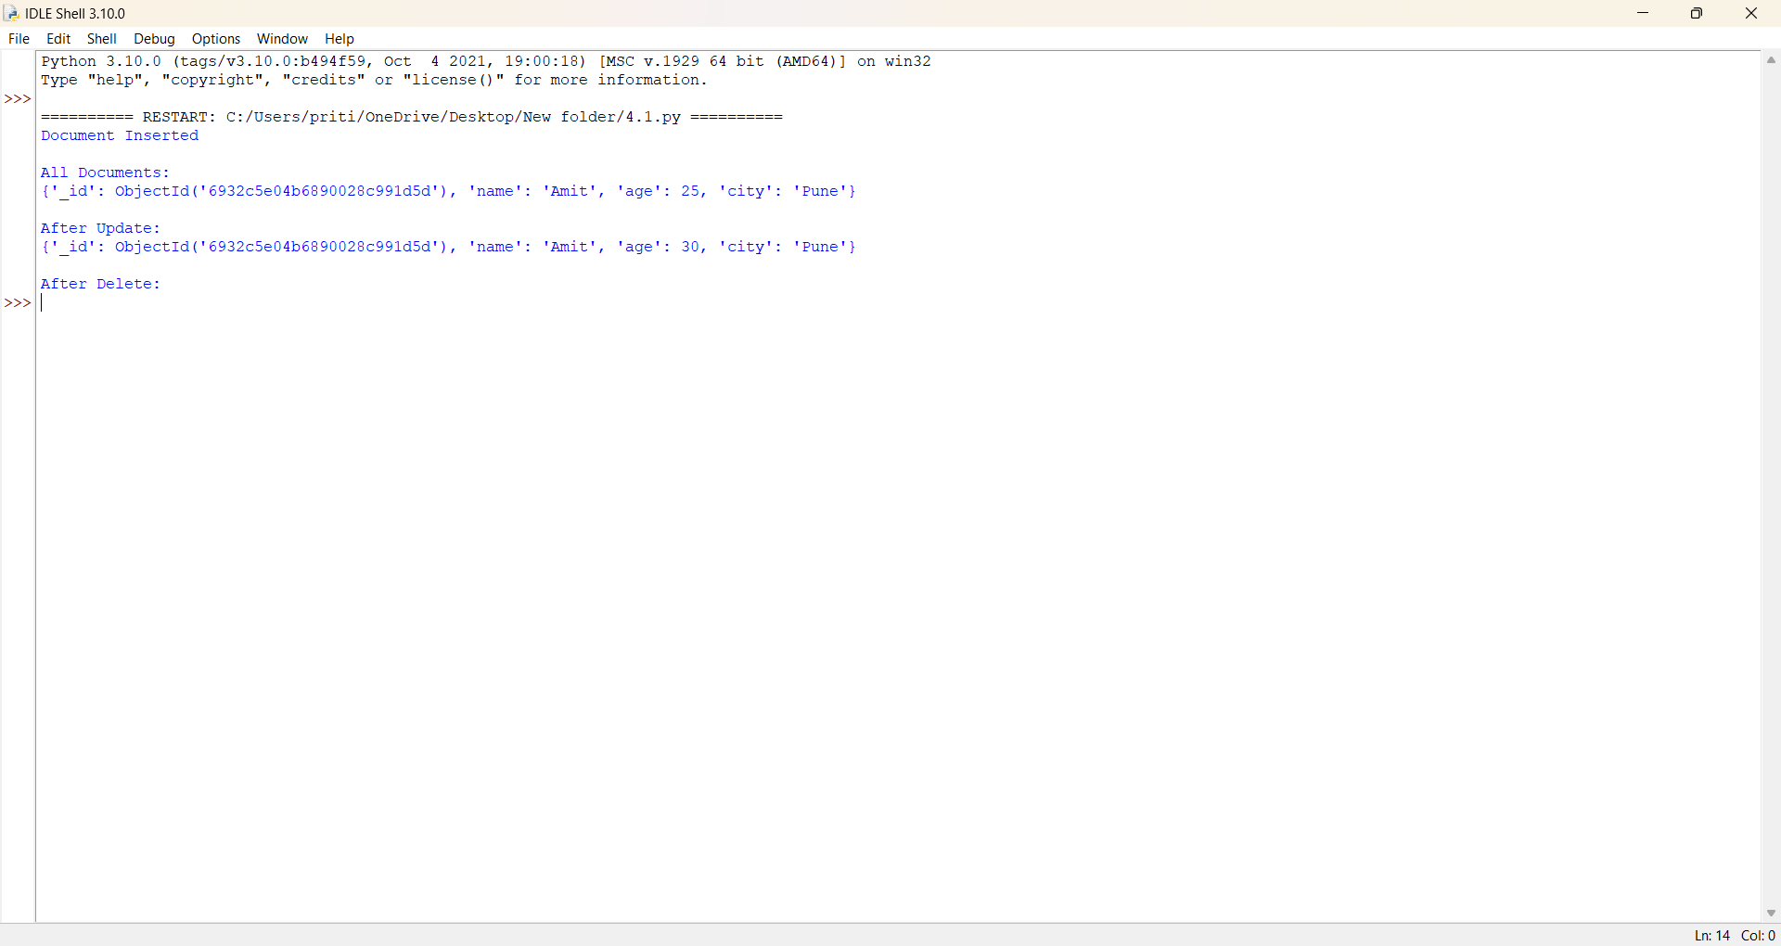

Q2. Write a Program to insert valid data into MangoDB using exception handling for errors.
Program:
from pymongo import MongoClient, errors
client = MongoClient("mongodb://localhost:27017/")
db = client["assignment4"]
collection = db["student_records"]
data = {"name": "Riya", "age": 20}

try:
if not isinstance(data["age"], int):
raise ValueError("Age must be a number")

collection.insert_one(data)
print("Data Inserted Successfully")
except ValueError as ve:
print("Validation Error:", ve)
except errors.PyMongoError as pe:
print("MongoDB Error:",pe)
Output:
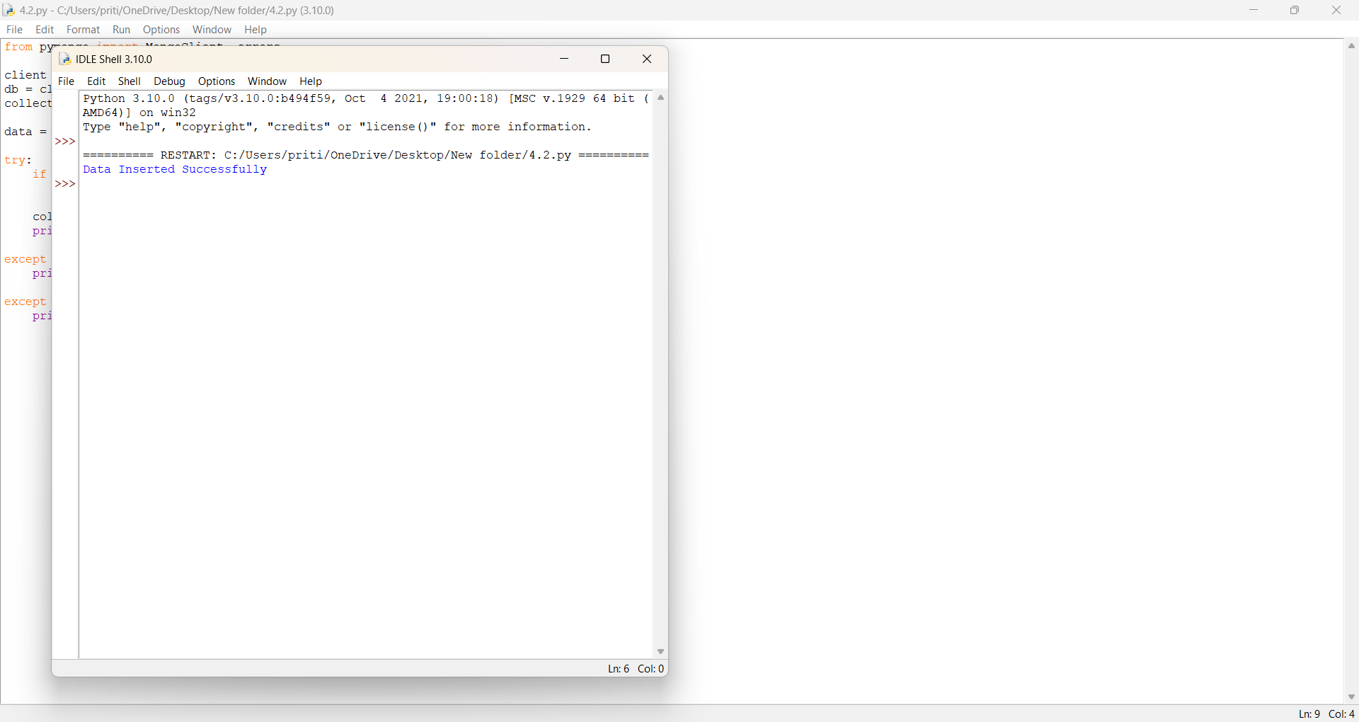

Q3. Use MangoDB aggregation pipeline to find the average salary of employees in a collection.
Program:
client = MongoClient("mongodb://localhost:27017/")
db = client["assignment4"]
collection = db["employees"]
# Sample Data (Run once only)
sample = [
{"name": "John", "salary": 40000},
{"name": "Sara", "salary": 50000},
{"name": "Amit", "salary": 45000},
]
collection.insert_many(sample)

pipeline = [
{"$group": {"_id": None, "avg_salary": {"$avg": "$salary"}}}
]
result = list(collection.aggregate(pipeline))
print("Average Salary:", result[0]["avg_salary"])
Output:
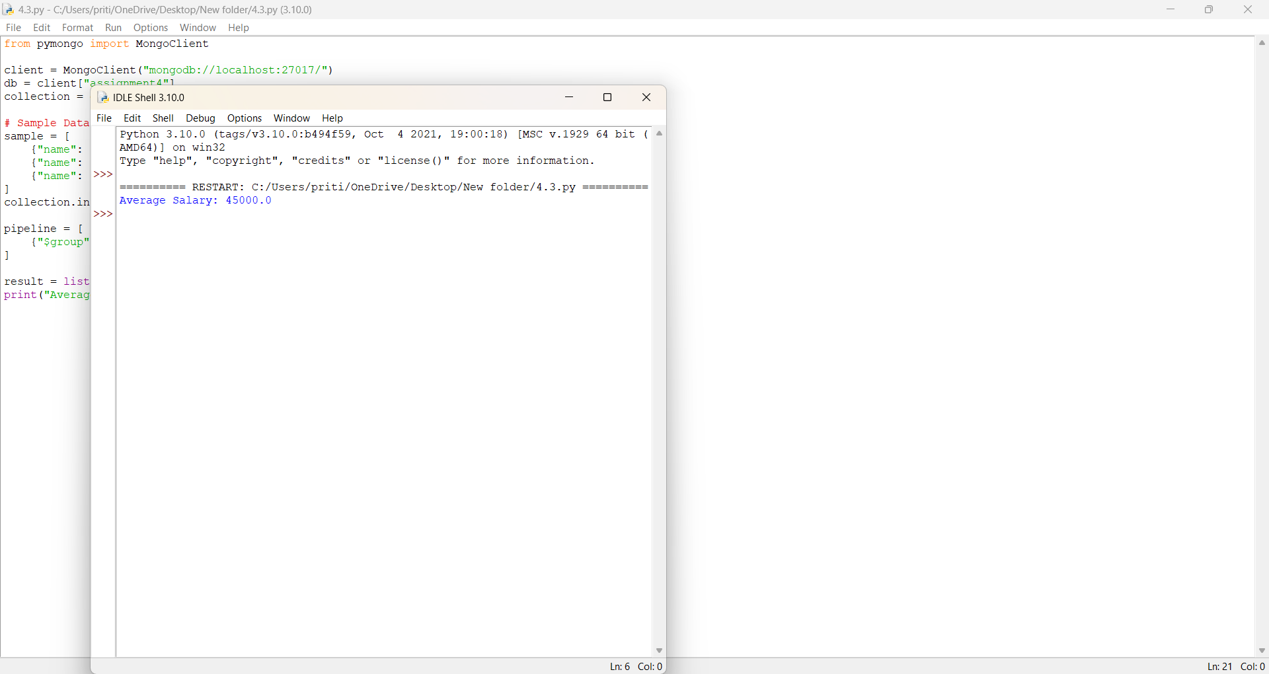

Q4. Develop a python program to create a database name employee, with the collection name empinfo. Add 5 documents in the collection. Perform read, update and delete operation on documents in MangoDB.
Program:

from pymongo import MongoClient
client = MongoClient("mongodb://localhost:27017/")
db = client["employee"]
collection = db["empinfo"]
# Add 5 documents
employees = [
{"empid": 1, "name": "Amit", "salary": 45000},
{"empid": 2, "name": "Riya", "salary": 55000},
{"empid": 3, "name": "Neha", "salary": 60000},
{"empid": 4, "name": "Karan", "salary": 50000},
{"empid": 5, "name": "Sanjay", "salary": 47000}
]

collection.insert_many(employees)
print("5 Employee Records Inserted")

# ---- READ ----
print("\nAll Employees:")
for emp in collection.find():
print(emp)

# ---- UPDATE ----
collection.update_one({"empid": 3}, {"$set": {"salary": 65000}})
print("\nAfter Update empid=3:")
print(collection.find_one({"empid": 3}))

# ---- DELETE ----
collection.delete_one({"empid": 5})
print("\nAfter Deleting empid=5:")
for emp in collection.find():
print(emp)

Output:
