Practical Assignment No: 5
Student Name: Varsha Sandip Gawali
Roll No: MC2527077
Class :MCA DIV:B
Subject: Python Programming Pratical

Q1. Create a Django project with models for Product and Category, along with views to display them on a webpage.
PROGRAM:
1️⃣ Create Django Project
django-admin startproject myproject
cd myproject
2️⃣ Create App
python manage.py startapp shop
3️⃣ Add App in settings.py
Open myproject/settings.py → add:
INSTALLED_APPS = [
...
'shop',
]
4️⃣ Create Models
Open shop/models.py:
class Category(models.Model):
name = models.CharField(max_length=100)

class Product(models.Model):
category = models.ForeignKey(Category, on_delete=models.CASCADE)
name = models.CharField(max_length=100)
price = models.FloatField()
description = models.TextField()
5️⃣ Make Migrations
python manage.py makemigrations
python manage.py migrate
6️⃣ Create View
Open shop/views.py:
def product_list(request):
products = Product.objects.all()
return render(request, 'product_list.html', {'products': products})
7️⃣ Create Template
Create file:
shop/templates/product_list.html
Add:
<h1>Product List</h1>
{% for p in products %}
<p>{{ p.name }} - ₹{{ p.price }} - {{ p.category.name }}</p>
{% endfor %}
8️⃣ Create shop/urls.py
from django.urls import path
from .views import product_list

urlpatterns = [
path('', product_list),
]
9️⃣ Add URL in project urls.py
Open myproject/urls.py:
from django.urls import path, include

urlpatterns = [
path('', include('shop.urls')),
]
🔟 Run Server
python manage.py runserver
Open in browser:
http://127.0.0.1:8000/
You will see the Product List Page.
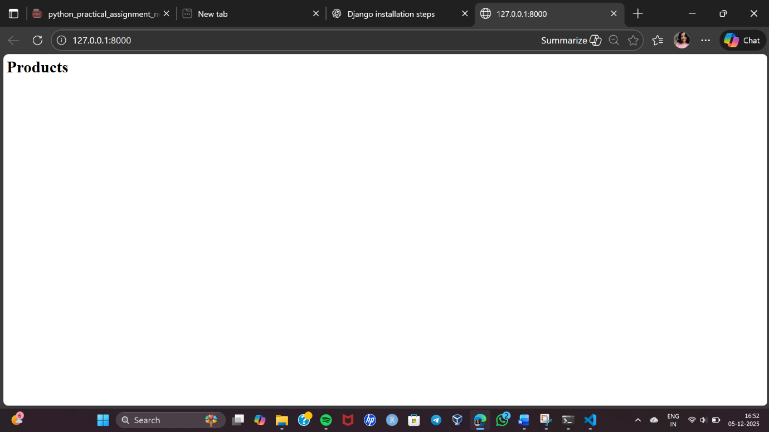

Q2. Implement user login, logout, and registration functionality in Django.
PROGRAM:
Step 1: Create Django Project & App
"C:\Program Files\Python310\python.exe" -m django startproject myproject
cd authproject
python manage.py startapp accounts
Add the app in settings.py
INSTALLED_APPS = [
...
'accounts',
]
Step 2: Create Registration Form
Use Django’s built-in UserCreationForm.
accounts/forms.py
from django.contrib.auth.forms import UserCreationForm
from django.contrib.auth.models import User
class RegisterForm(UserCreationForm):
class Meta:
model = User
fields = ['username', 'password1', 'password2']
Step 3: Create Views for Register, Login & Logout
accounts/views.py
from django.shortcuts import render, redirect
from django.contrib.auth import authenticate, login, logout
from django.contrib.auth.forms import AuthenticationForm
from .forms import RegisterForm
# Register User
def register_user(request):
if request.method == 'POST':
form = RegisterForm(request.POST)
if form.is_valid():
form.save()
return redirect('login_user')
else:
form = RegisterForm()
return render(request, 'register.html', {'form': form})
# Login User
def login_user(request):
if request.method == 'POST':
form = AuthenticationForm(request, data=request.POST)
if form.is_valid():
username = form.cleaned_data.get('username')
password = form.cleaned_data.get('password')
user = authenticate(username=username, password=password)
if user:
login(request, user)
return redirect('home')
else:
form = AuthenticationForm()
return render(request, 'login.html', {'form': form})
# Logout User
def logout_user(request):
logout(request)
return redirect('login_user')
Step 4: Create URLs
authproject/urls.py
from django.contrib import admin
from django.urls import path
from accounts import views

urlpatterns = [
path('admin/', admin.site.urls),
path('', views.login_user, name='home'), # default page
path('register/', views.register_user, name='register_user'),
path('login/', views.login_user, name='login_user'),
path('logout/', views.logout_user, name='logout_user'),
]
Step 5: Create Templates
Create folder:
📁 accounts/templates/
Inside create:
- register.html
- login.html
register.html
<h2>Register</h2>
<form method="POST">
{% csrf_token %}
{{ form.as_p }}
<button type="submit">Register</button>
</form>
<a href="{% url 'login_user' %}">Already have an account? Login</a>

login.html
<h2>Login</h2>
<form method="POST">
{% csrf_token %}
{{ form.as_p }}
<button type="submit">Login</button>
</form>
<a href="{% url 'register_user' %}">Create new account</a>

Step 6: Run Server
python manage.py migrate
python manage.py runserver
Open in browser:
http://127.0.0.1:8000/

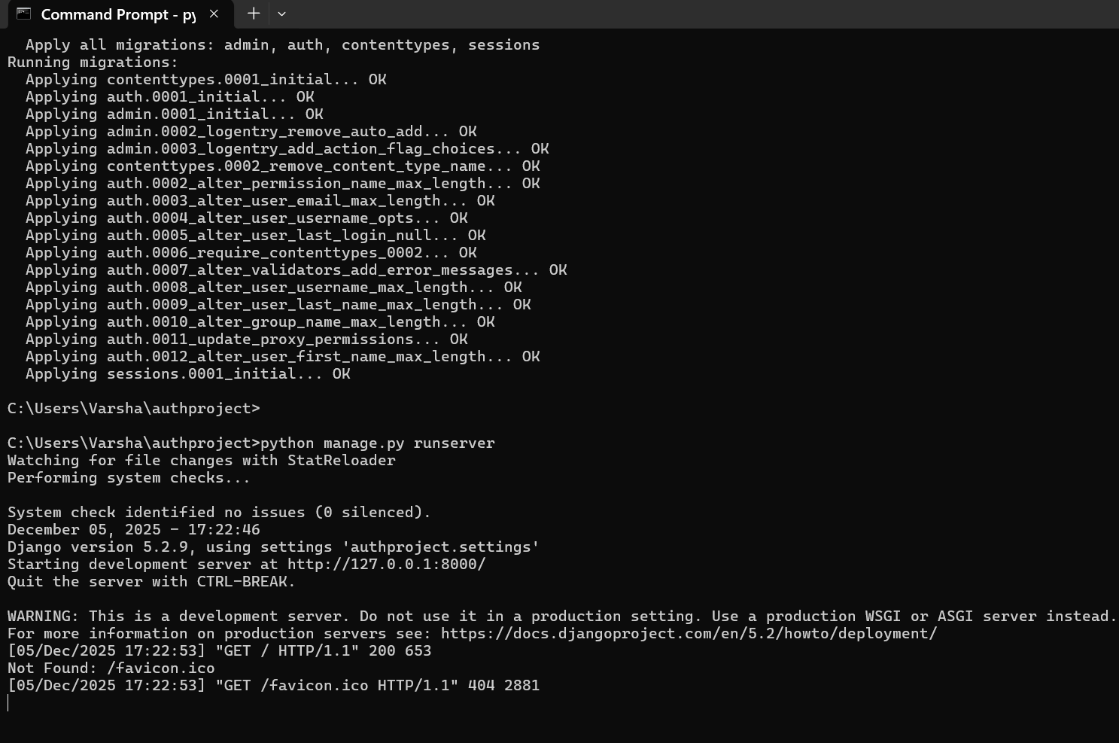

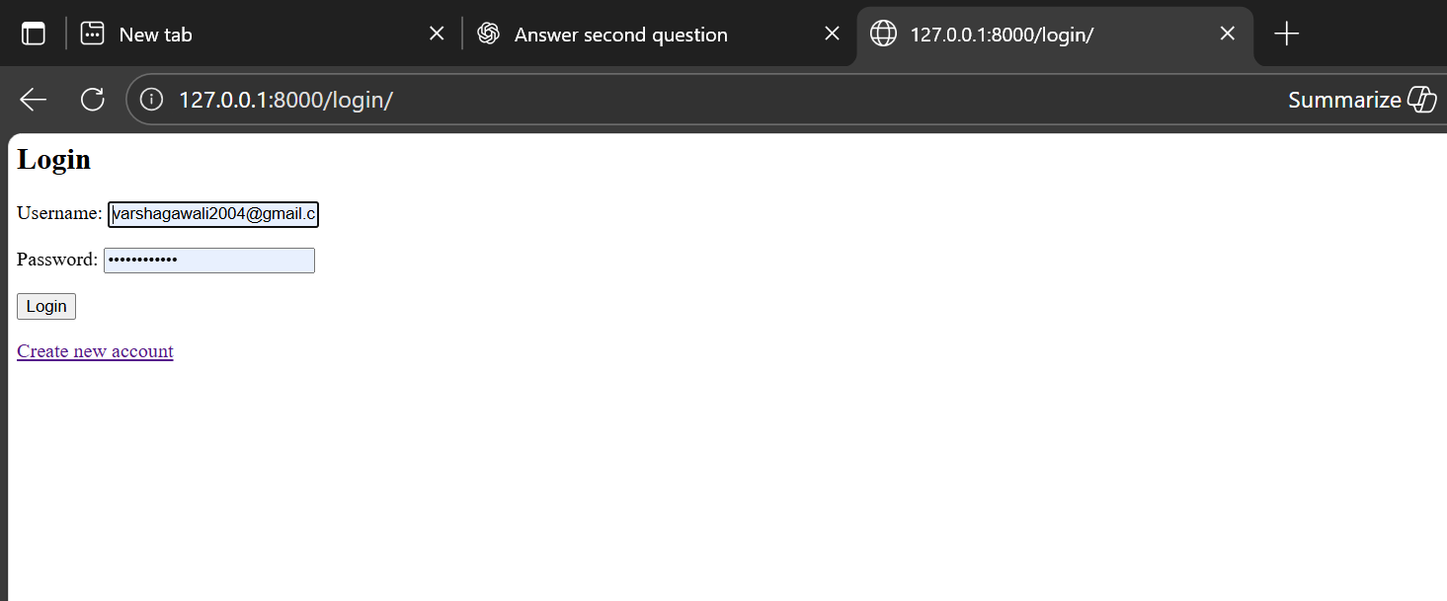

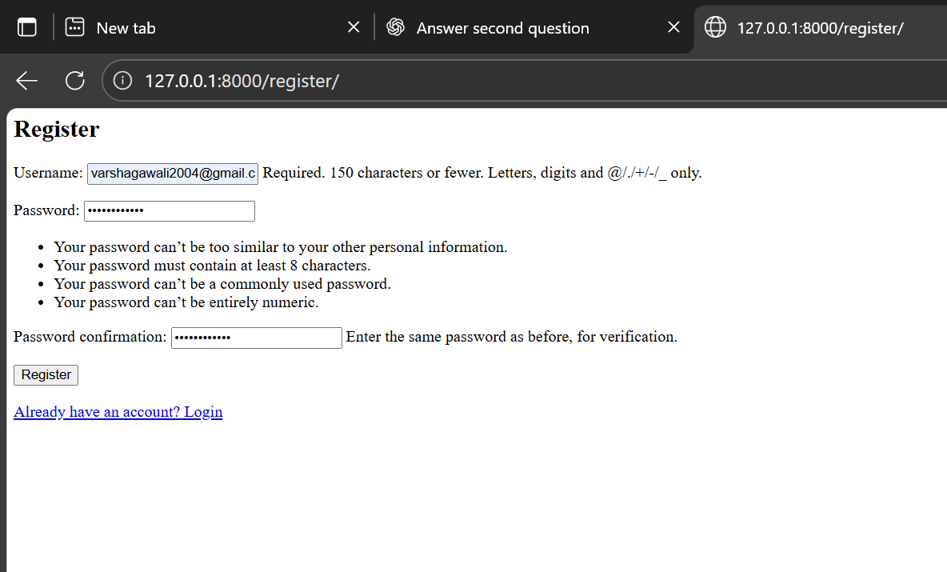

Q3. Build a REST API for a task management system where users can create, update, and delete tasks.
PROGRAM:
1. Install Django and DRF
pip install django djangorestframework

2. Create Django project and app
django-admin startproject taskmanager
cd taskmanager
python manage.py startapp tasks

3. Add apps to settings.py
INSTALLED_APPS = [
...
'rest_framework',
'tasks',
]

4. Create Task model (tasks/models.py)
from django.db import models
from django.contrib.auth.models import User

class Task(models.Model):
user = models.ForeignKey(User, on_delete=models.CASCADE)
title = models.CharField(max_length=200)
description = models.TextField(blank=True)
completed = models.BooleanField(default=False)
created_at = models.DateTimeField(auto_now_add=True)

def __str__(self):
return self.title

5. Make migrations
python manage.py makemigrations
python manage.py migrate

6. Create a Serializer (tasks/serializers.py)
from rest_framework import serializers
from .models import Task

class TaskSerializer(serializers.ModelSerializer):
class Meta:
model = Task
fields = '__all__'

7. Create API Views (tasks/views.py)
from rest_framework import viewsets, permissions
from .models import Task
from .serializers import TaskSerializer

class TaskViewSet(viewsets.ModelViewSet):
queryset = Task.objects.all()
serializer_class = TaskSerializer
permission_classes = [permissions.IsAuthenticated]

def get_queryset(self):
return self.queryset.filter(user=self.request.user)

def perform_create(self, serializer):
serializer.save(user=self.request.user)

8. Set up URLs (tasks/urls.py)
from django.urls import path, include
from rest_framework.routers import DefaultRouter
from .views import TaskViewSet

router = DefaultRouter()
router.register(r'tasks', TaskViewSet, basename='task')

urlpatterns = [
path('', include(router.urls)),
]

9. Include app URLs in project (taskmanager/urls.py)
from django.contrib import admin
from django.urls import path, include

urlpatterns = [
path('admin/', admin.site.urls),
path('api/', include('tasks.urls')),
]

10. Create superuser & run server
python manage.py createsuperuser
python manage.py runserver

