Homework – 4 2025115154
- Implement a Stack using Queue
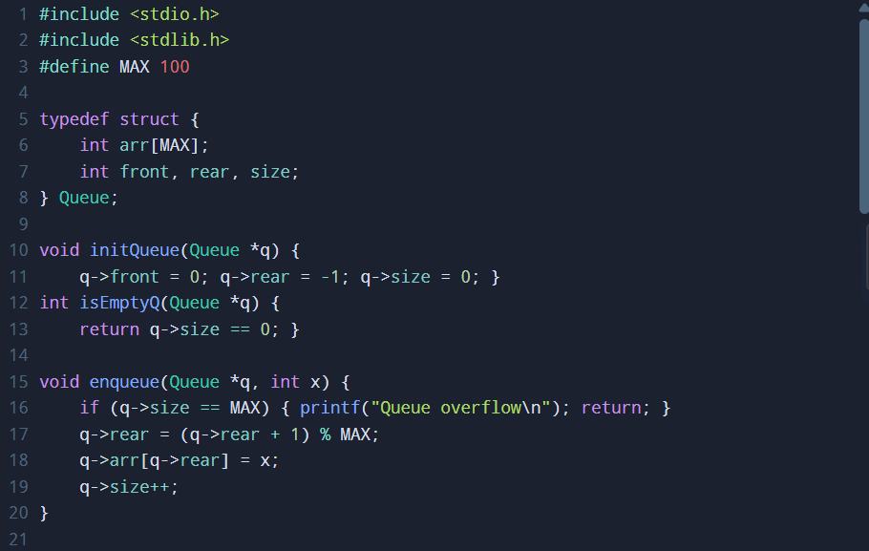
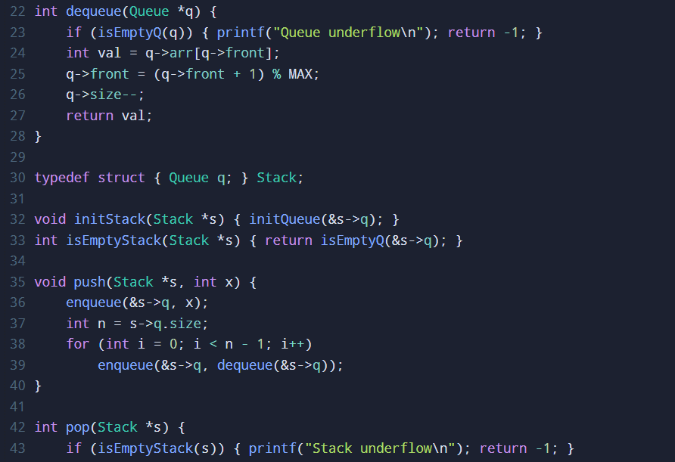
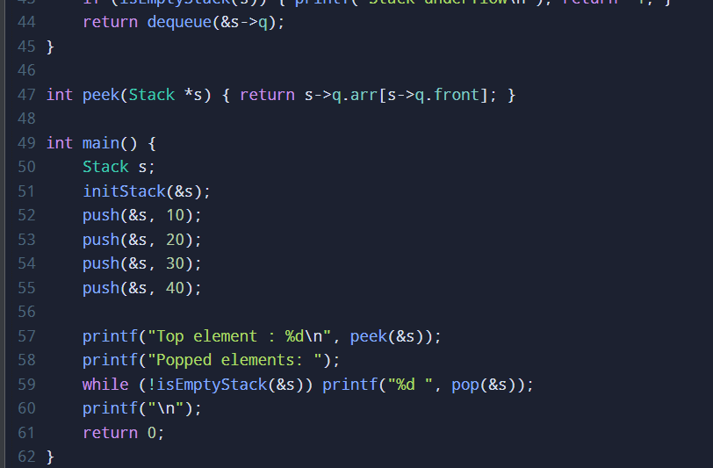

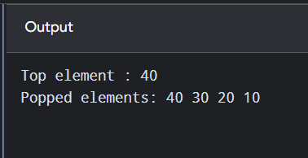

- Implement a Queue using Stack data structures
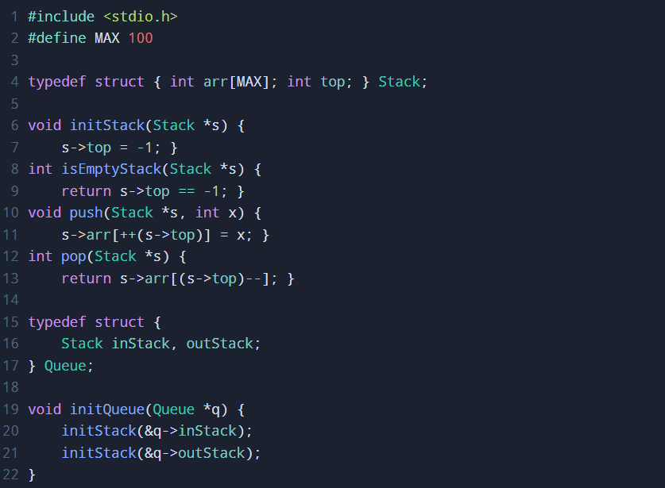
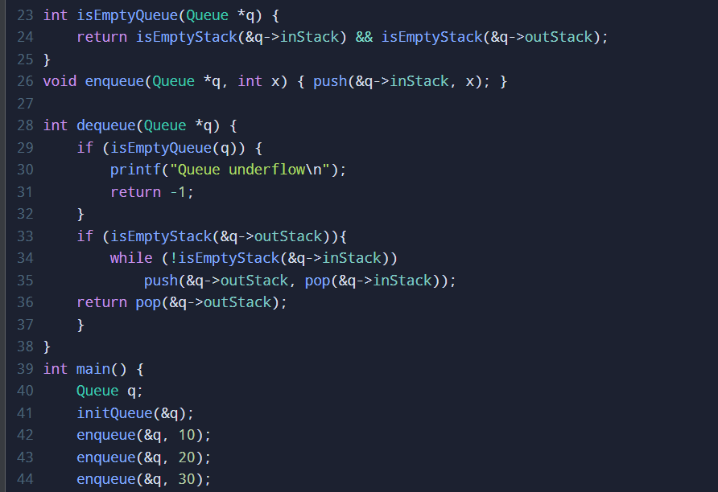

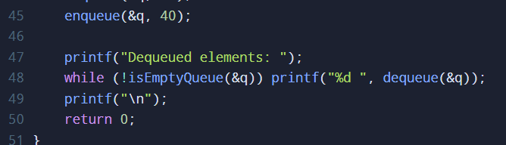

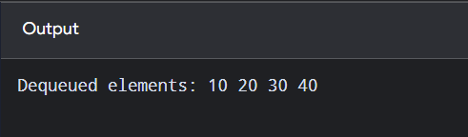
- Write a C program using stack data structures to implement managing the history of web pages visited.
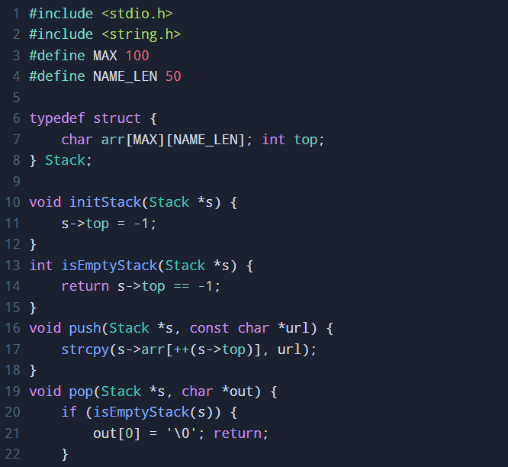

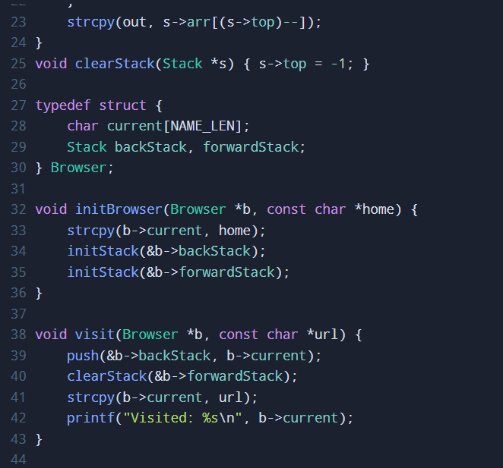
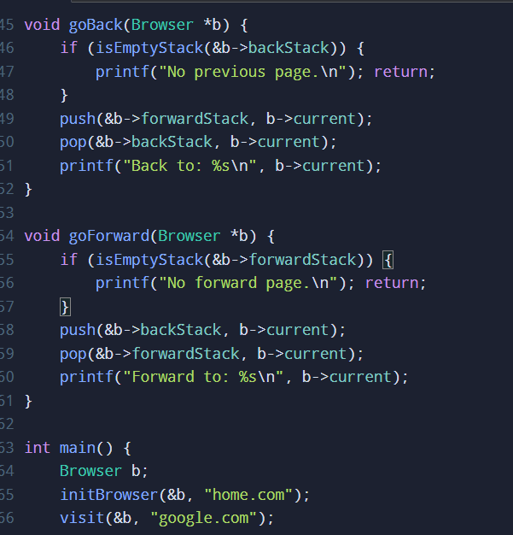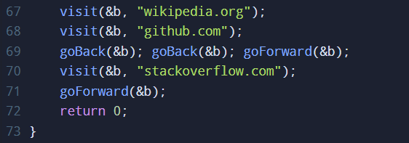
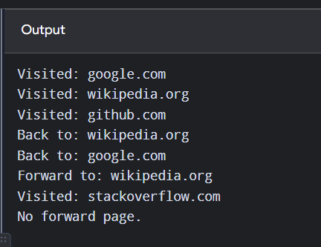

- Write a C program to sort a stack using a temporary stack

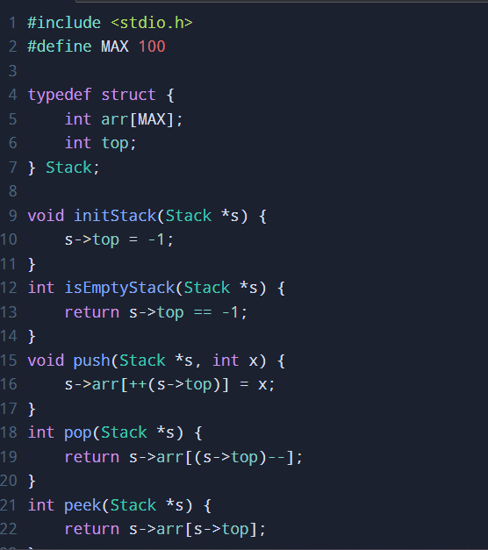
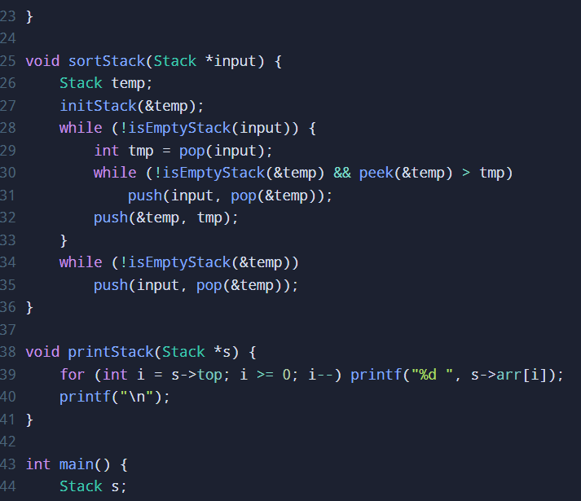

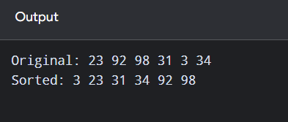
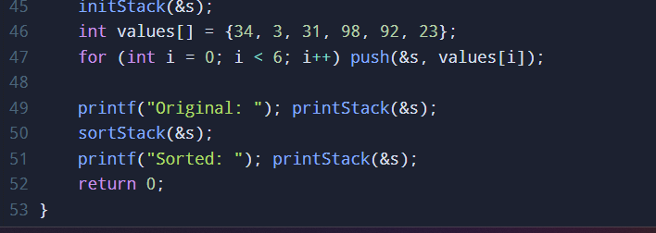
- The stock span problem is a financial problem where we have a series of daily price quotes for a stock denoted by an array and the task is to calculate the span of the stock's price for all days. The span of a stock's price for the iᵗʰ day gives the maximum number of consecutive days leading up to i-th day (including current day) where the stock's price is less than or equal to the price on day i.
eg: I/P: [100, 80, 60, 70, 60, 75, 85]
O/P: [1, 1, 1, 2, 1, 4, 6]
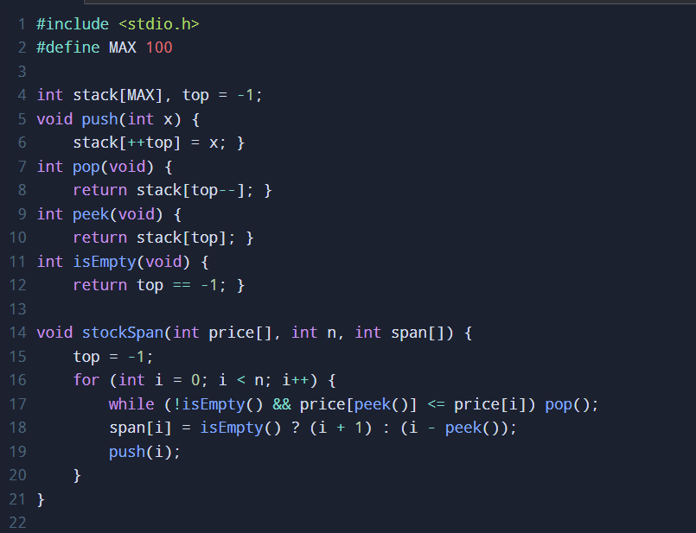
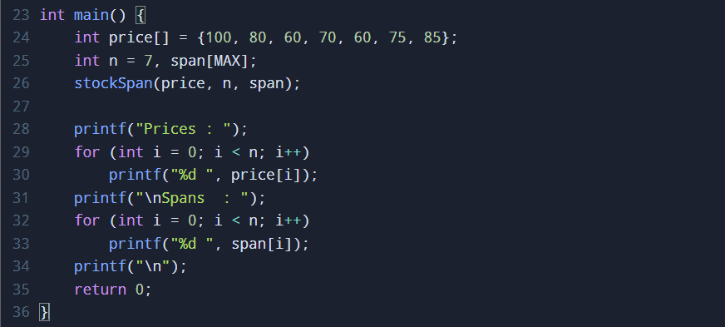
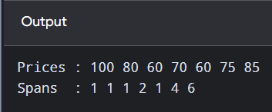

- Given an array, for each element find the nearest element to its right that has a higher frequency than the current element. If no such element exists, set value to -1. Implement using stack.
I/P: [2, 1, 1, 3, 2, 1].
O/P: [1, -1, -1, 2, 1, -1].
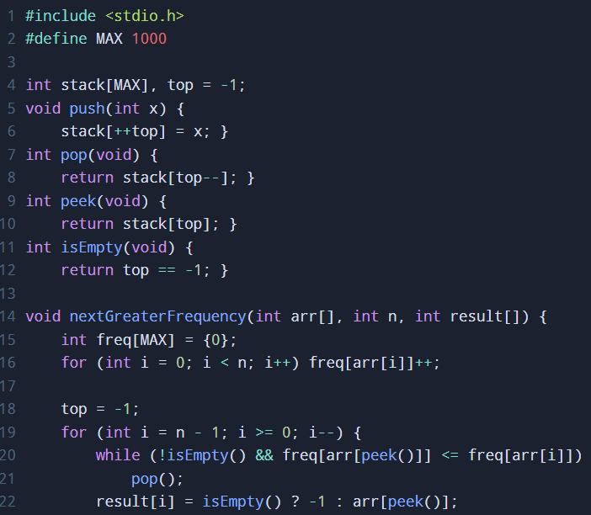
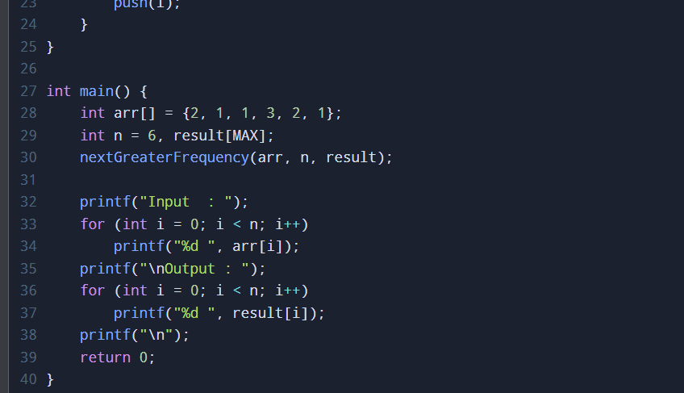
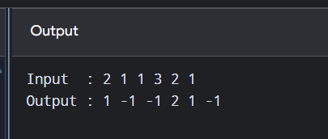

- Given a pattern containing only I's and D's. I for Increasing and D for decreasing. Devise an algorithm using stack to print the smallest number following that pattern. Digits from 1-9 and digits can't repeat.
I/P: D O/P: 21.
I/P: DIDI O/P: 21435.
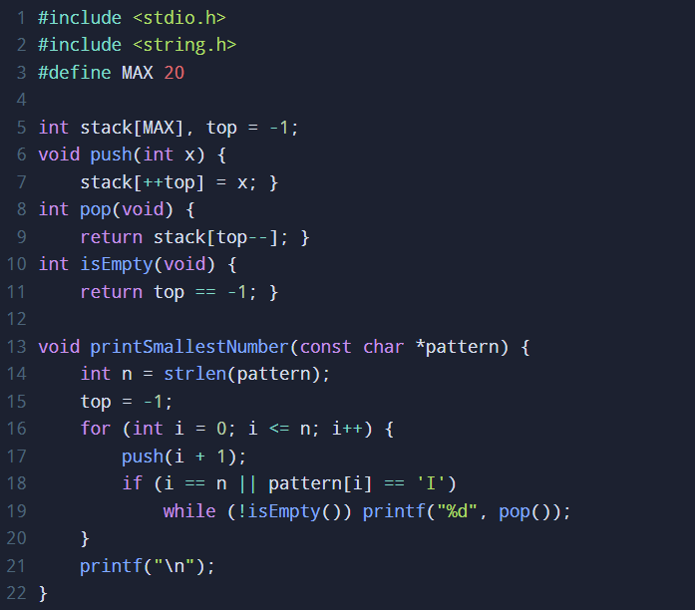
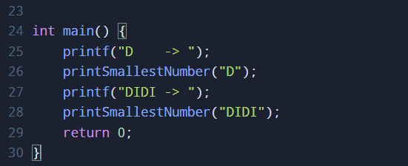
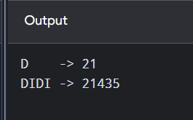

- Given an array of digits (values are from 0 to 9) find the minimum possible sum of two numbers formed from digits of the array. All digits of given array must be used to form the two numbers. Use queue for implementation.
I/P: [6, 8, 4, 5, 2, 3].
O/P: 604. (min. sum formed by no's 358 and 246).

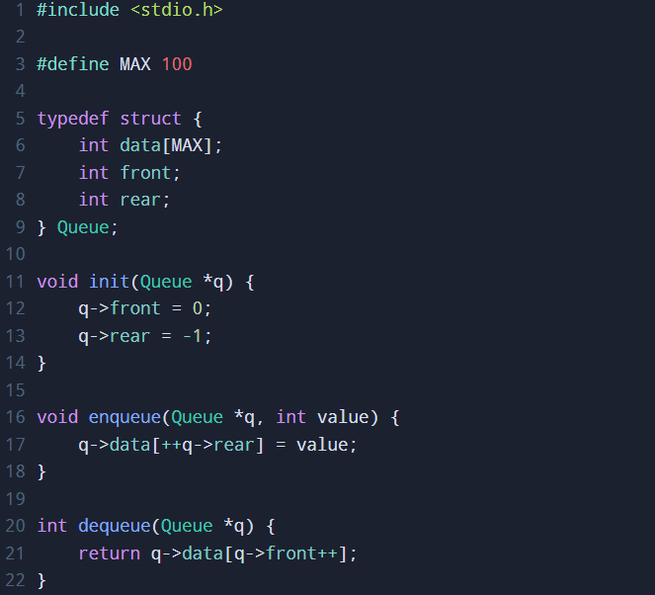
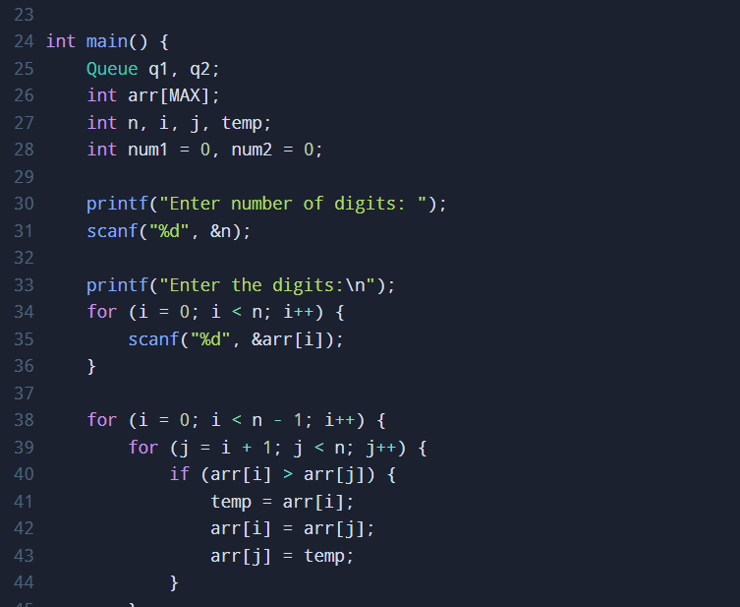
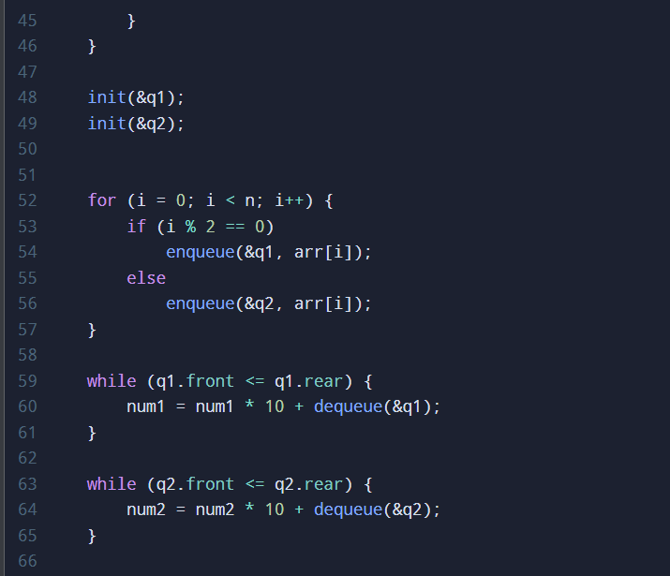
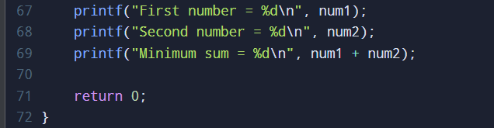
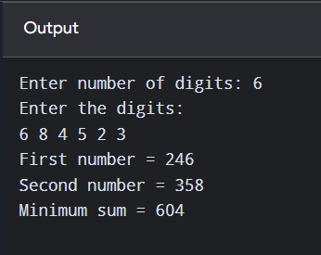

- Given an array and a positive integer k, find the first negative integer for each window (contiguous subarray) of size k. If a window does not contain a negative integer, then print 0 for that window. Implement using queue.
eg: I/P: [-8, 2, 3, -6, 1] k=2.
O/P: [-8, 0, -6, -6].
First negative integer for each window of size 2:
[-8, 2] = -8
[2, 3] = 0 (no negative)
[3, -6] = -6
[-6, 1] = -6

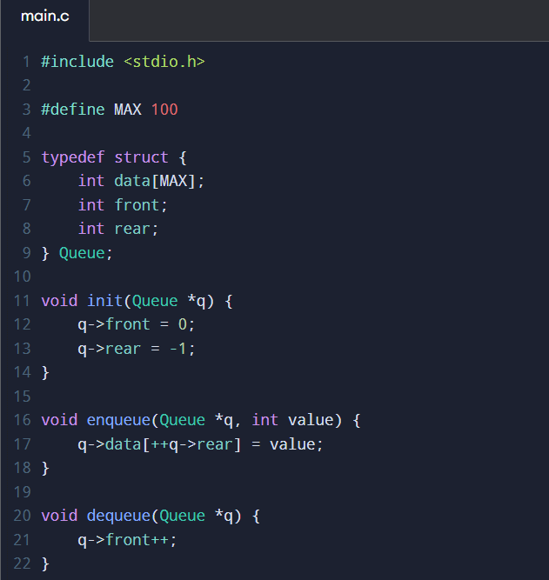
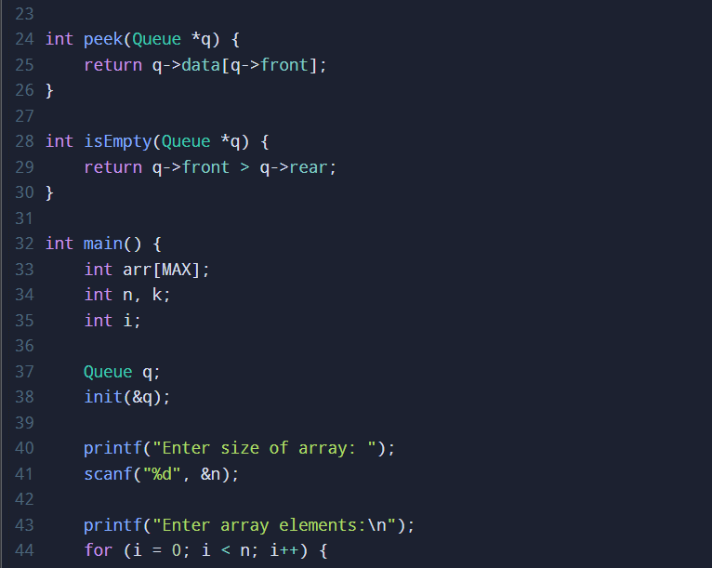
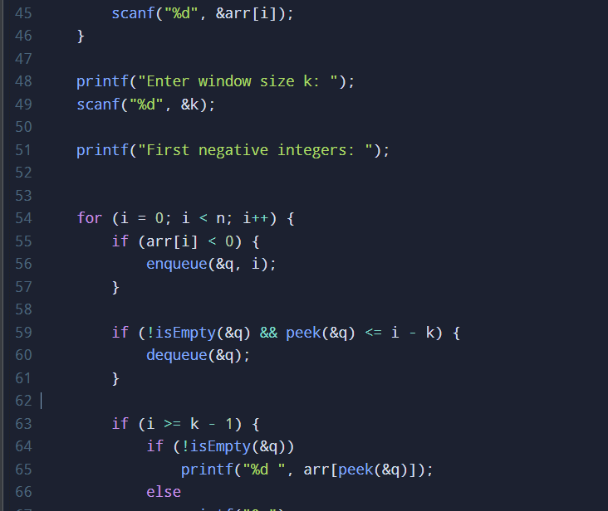
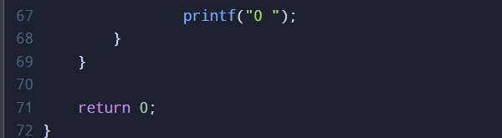
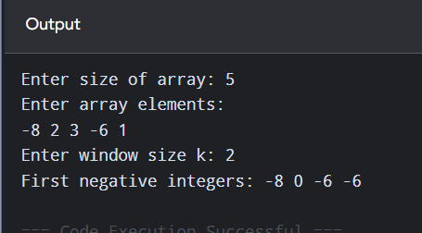

- Given a matrix of dimension MxN where each cell in the matrix can have values 0, 1, or 2 which has the following meaning:
0: empty cell.
1: cells having fresh oranges
2: cells having rotten oranges.
The task is to find the minimum time required so that all oranges become rotten. A rotten orange at index (i,j) can rot fresh oranges which are its neighbours (up, down, left and right). If it is not possible to rot every orange then return -1. Use queue for implementation.
eg: I/P: [2,1,0,2,1] [1,0,1,2,1] [1,0,0,2,1]
O/P: 2.
Explanation: At 0ᵗʰ frame, at 1st frame, at 2nd frame [matrix states shown progressing to all 2's].
