**Analysis of the Kickstarter Campaign’s outcome based on the Goal**

The Kickstarter Campaign data below is based on the “plays” subcategory alone. The “plays” were either successful in reaching the goal amount or beyond. In some case the “plays” failed to reach the goal amount that had been set against it. The sample data however does not show that any of the “plays” were canceled due to any reason. We have not included the “plays “which are currently in live outcome.

Key Points and Insight based on the data:

1. More than 70% of the plays with the goal amount up to $4999 were successful.
2. The plays with the goal range between $5000 - $19999 had a success rate of 50%.
3. The plays with the goal range between $20000 - $34999 had a decline up to 20% in success rate.
4. The plays with the goal range between $35000 -$44999 had an exponential increase in success rate of more than 60 %

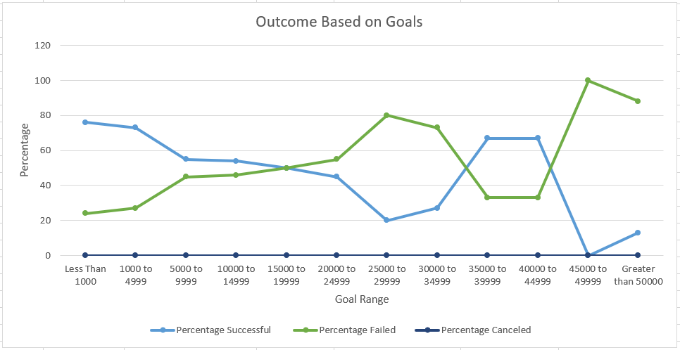

Conclusion:

1. Based on the above chart the goal amount for the plays up to $19999 have a success rate of more than 50% in the play category. We can increase the number plays in this goal range to benefit the campaign. The lower goal is more achievable and will have higher success rate (up to $4999). Hence, by increasing the population in this segment will in turn result in benefiting the campaign.
2. We do notice that the plays with higher goal amount (range between $35000-$44999) have the success rate of more than 60% but the number of plays is very less. The success in this range might be based on the other factors like the quality of the play, audience it targeted and other factors.
3. The outcome-based goals chart shows that plays with goal amount of range $20000-$34999 have the failure rate of more than 50% but the number of plays is very less.

**Analysis of the Kickstarter Campaign’s outcome based on the Launch Date**

The theater campaign data shown below includes all the subcategory “musical, plays and space”. We have not included the live theater campaign.

Key Points and Insight based on the data:

1. The number of successful theater campaign has been higher when they are launched between the month of April-August. May shows the highest number of successful campaigns being launched in this month.
2. The number of failed campaigns went up between the months of Sep- Nov.

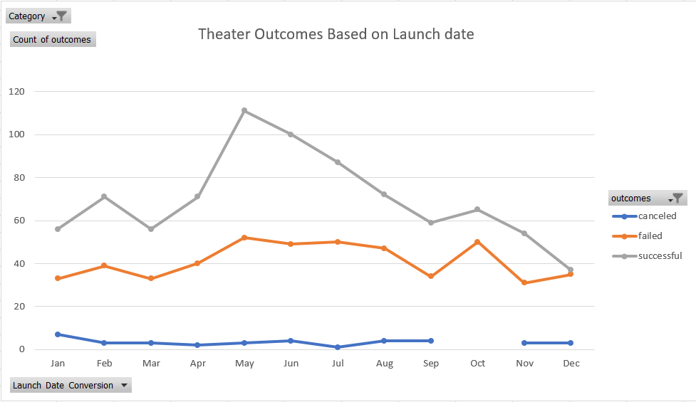

Conclusion:

1. The duration between April – July are most favorable months for the theater campaign to be successful.
2. The duration between Sep – Nov are **not** favorable for the theater campaign to be successful.

Overall Limitation:

1. The above graphs do not capture the length of the campaign along with its outcome and goal.
2. In order to determine the whether the length of the campaign impacts the success or not, we need to include the deadline date and percentage funded.
3. We need to include more categories for example “film and video” etc. in the graph to determine the overall effect of the length of the campaign.