

Varsha pal

- EXPLORE A TECHNOLOGY DOMAIN &CREATE A CARRER PATHWAYS REPORT
Name: Varsha Pal
Roll No.: 2501410023
Course Name: Computer Science Fundamentals & Career Pathways
Domain Selected: Cybersecurity
Submitted To: Mr. Feroz Ahmed
Programme: B.Tech (Cybersecurity)
Institution: K.R Mangalam University, Sohna

- Introduction
- Cybersecurity is the practice of protecting computer systems, networks, data, and digital infrastructure from cyberattacks. As technology continues to grow, cyber threats have also increased—ranging from malware and phishing to ransomware, identity theft, and data breaches.
- In today’s digital world, almost every industry relies on secure systems, including banking, healthcare, education, government, and e-commerce. This has made cybersecurity one of the most important and fastest-growing fields in computing.
- This report explores the core technologies, applications, real-world use cases, and career opportunities in the domain of cybersecurity, along with a personal reflection on how this field aligns with my academic and career goals.
- 1 Key Technologies and Concepts in Cybersecurity
              - Network Security
- Protecting internal networks from unauthorized access using firewalls, intrusion detection systems, and secure protocols.
- b) Encryption & Cryptography
- Converting data into unreadable formats to maintain confidentiality. Used in banking, messaging apps, and secure transactions.
- c) Ethical Hacking
- Authorized testing of systems to find vulnerabilities before attackers do. Involves penetration testing and security assessments.
- d) Cloud Security
- Securing cloud-based platforms like AWS, Azure, and Google Cloud using identity management, encryption, and security policies.
- e) Application Security
- Protecting software from threats such as SQL injection, cross-site scripting (XSS), and insecure APIs.
- f) Incident Response & Threat Detection
- Monitoring systems to detect cyberattacks and responding quickly to reduce damage.

- 2 Real-World Applications and Use Cases
              - Banking & Finance
- Fraud detection
- Securing online transactions
- Protecting customer data
- b) Healthcare
- Securing patient records
- Protecting medical devices from attacks
- Preventing hospital ransomware attacks
- c) E-commerce
- Securing payment gateways
- Preventing identity theft
- Protecting user information
- d) Government & Defense
- Protecting national security systems
- Preventing cyber espionage
- Maintaining secure communication channels
- e) Education & Institutions
- Securing student information
- Preventing unauthorized access to portals
- Protecting research data

- 2.3 Career Opportunities in Cybersecurity
              - Job Roles
- Cybersecurity Analyst
- Ethical Hacker / Penetration Tester
- Security Operations Center (SOC) Analyst
- Network Security Engineer
- Incident Response Specialist
- Cloud Security Engineer
- Digital Forensic Expert
- Cybersecurity Consultant
- b) Required Skills
- Networking basics (TCP/IP, DNS, VPN)
- Linux & Windows security
- Programming (Python, Bash, JavaScript basics)
- Understanding of firewalls, SIEM tools
- Problem-solving & analytical thinking
- c) Industries Hiring Cybersecurity Professionals
- IT & Software Companies
- Banks & Financial Institutions
- Healthcare Organizations
- Government & Defense
- E-commerce Platforms
- Cloud Service Providers
Wireshark, Metasploit, and firewalls.
3.Virtual Artifact;

- 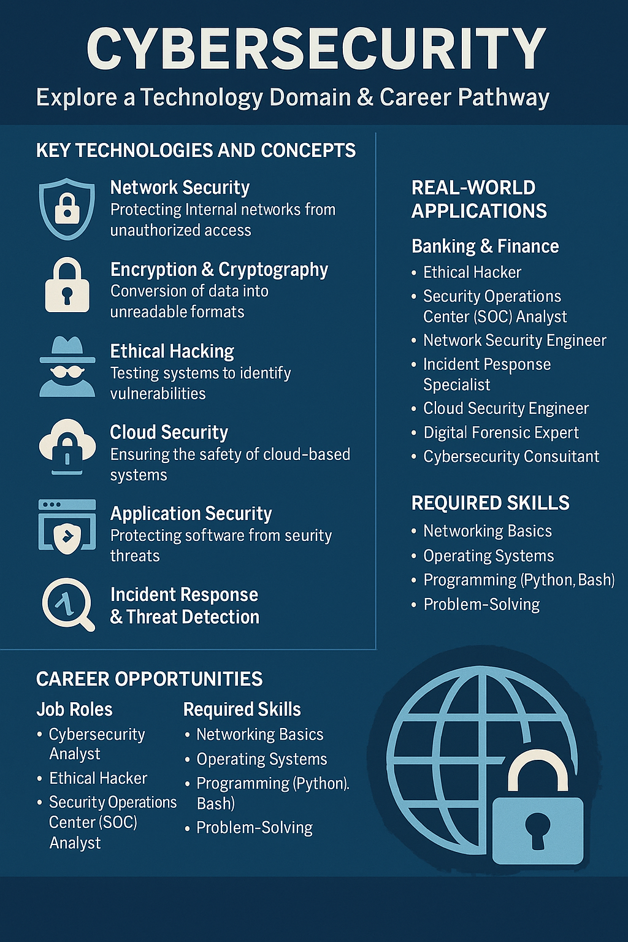
3. Reflection :
- Cybersecurity strongly aligns with my academic interests and career goals because it combines technology, problem-solving, and real-world impact. As someone interested in protecting systems and understanding how technology works at a deeper level, this field gives me an opportunity to contribute to digital safety. With the increasing number of cyber threats globally, the demand for skilled professionals is rising, making cybersecurity a stable and future-proof career choice.
- I already possess some relevant skills such as basic knowledge of programming, curiosity about how systems work, and the ability to analyze problems logically. My interest in technology and willingness to learn new tools give me a strong foundation. Additionally, I have awareness of common online threats such as phishing, malware, and insecure networks, which helps me understand the importance of cybersecurity.
- However, to build a career in this field, I aim to develop several new skills. These include gaining deeper knowledge of network security, learning Linux systems, practicing ethical hacking, and getting familiar with tools such as Wireshark, Metasploit, and firewalls. I also hope to earn cybersecurity certifications in the future. By developing these skills, I aim to become a cybersecurity professional capable of protecting systems, responding to cyber incidents, and contributing to a safer digital world.
4.References:
https://www.kaspersky.com
https://www.ibm.com/security
https://www.netacad.com
https://owasp.org

THANKYOU

