**PERSONAL BLOG ON IBM CLOUD STATIC WEB APPS**

**TABLE OF CONTENTS:**

* Introduction
* Technology Stack
* Creating Content
* Building the travel blog website
* Setting up IBM Cloud account
* Upload content to IBM Cloud object storage
* Deploy the website to IBM Cloud
* Test the website
* Monitoring and maintenance
* Conclusion

**INTRODUCTION:**

A travel blog on IBM Cloud Static Web Apps involves hosting your blog's static web content on IBM's cloud infrastructure. It offers fast loading times, security, and scalability for your travel-related articles, photos, and videos, making it easily accessible to readers worldwide.

**TECHNOLOGY STACK:**

A technology stack for a travel blog typically includes

* HTML/CSS for design
* JavaScript for interactivity
* Hosting services like AWS S3 or Netlify
* SSL/TLS for security
* Analytics tools like Google Analytics track visitor data
* Regular backups and version control systems ensure data protection and code management

**CREATING CONTENT:**

Creating content for a travel blog involves sharing engaging and informative stories, photos, and tips about your travel experiences, destinations, and adventures. It should inspire, entertain, and provide valuable information to readers who are looking for travel inspiration and advice.

**BUILDING THE TRAVEL BLOG WEBSITE:**

**Html code:**

<!DOCTYPE html>

<html>

<head>

    <meta charset="UTF-8">

    <title>Travel Blog</title>

    <link rel="stylesheet" type="text/css" href="personal blog.css">

</head>

<body>

    <header>

        <h1>My Travel Adventures</h1>

    </header>

    <nav>

        <ul>

            <li><a href="#">Home</a></li>

            <li><a href="#">Destinations</a></li>

            <li><a href="#">Blog</a></li>

            <li><a href="#">Contact</a></li>

        </ul>

    </nav>

    <main>

        <section class="blog-post">

            <h2>Exploring a New City</h2>

            <p>Enjoyed a fantastic day exploring a new city. The local cuisine was amazing, and the architecture was stunning.</p>

            <img src="https://encrypted-tbn0.gstatic.com/images?q=tbn:ANd9GcQeGW719hVuslYuS-VAad3Cik62zt1wF7j9ig&usqp=CAU" alt="City View">

        </section>

        <section class="blog-post">

            <h2>Hiking in the Mountains</h2>

            <p>Spent the weekend hiking in the beautiful mountains. The views were breathtaking, and the weather was perfect.</p>

            <img src="https://encrypted-tbn0.gstatic.com/images?q=tbn:ANd9GcSU6uuzqk75gin-iia7-ZPwmOJmoHrY8Kki5w&usqp=CAU" alt="Mountain Landscape">

        </section>

    </main>

    <footer>

        <p>&copy; 2023 My Travel Blog</p>

    </footer>

    <script src="script.js"></script>

</body>

</html>

**Css**

body {

    font-family: Arial, sans-serif;

}

header {

    background-color: #333;

    color: white;

    text-align: center;

    padding: 10px;

}

nav {

    background-color: #444;

    text-align: center;

    padding: 10px;

}

nav ul {

    list-style-type: none;

}

nav ul li {

    display: inline;

    margin-right: 10px;

}

main {

    max-width: 800px;

    margin: 0 auto;

    padding: 20px;

}

.blog-post {

    margin-bottom: 20px;

}

footer {

    background-color: #333;

    color: white;

    text-align: center;

    padding: 10px;

}

**Js**

<!-- Include this script at the bottom of your HTML body -->

<script>

    // Get all the blog post titles

    const postTitles = document.querySelectorAll('.blog-post h2');

    // Add a click event listener to each blog post title

    postTitles.forEach(title => {

        title.addEventListener('click', () => {

            // Toggle the visibility of the next sibling element (the blog post text)

            const postText = title.nextElementSibling;

            postText.style.display = (postText.style.display === 'none' || postText.style.display === '') ? 'block' : 'none';

        });

    });

</script>

**SETTING UP IBM CLOUD ACCOUNT:**

Signing up for an IBM Cloud account, includes verifying email and setting up billing (if required). There is free tier availability for hosting static websites.

**UPLOAD CONTENT TO IBM CLOUD OBJECT STORAGE:**

Creating a bucket in IBM Cloud object storage for hosting your website files. The process of uploading blog content such as HTML files, images, and videos.

**DEPLOY THE WEBSITE TO IBM CLOUD:**

Deploy static website to IBM Cloud using cloud foundry, explaining how to create a manifest file for configuration and set up SSL/TLS to ensure secure browsing**.**

**TEST THE WEBSITE:**

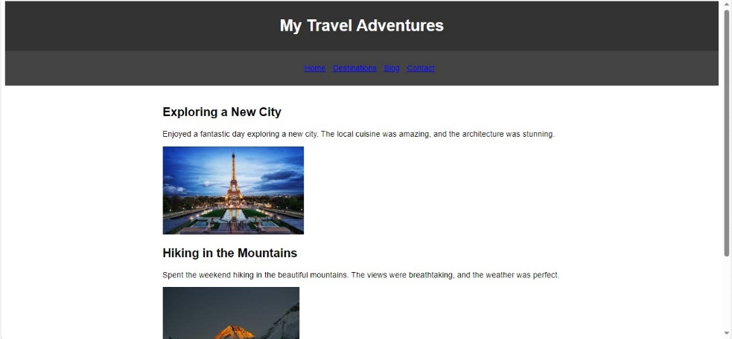

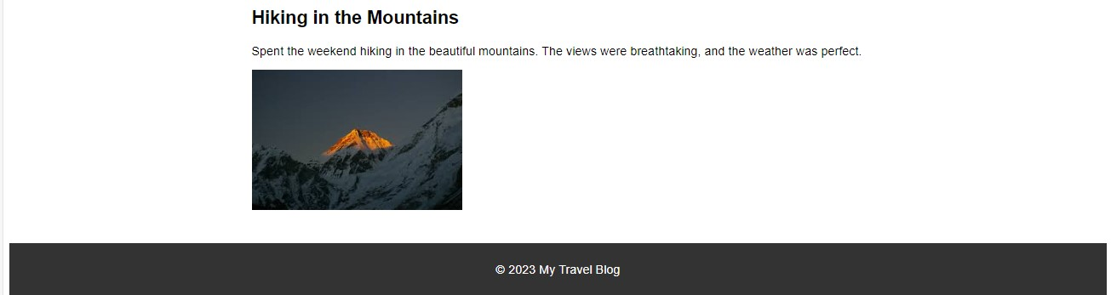

**MOINTORING AND MAINTAINENCE:**

Regularly updating content, monitoring website performance, and making backups to prevent data loss.

**CONCLUSION AND NEXT STEP:**

Key takeaways from the guide. Next steps such as promoting the blog on social media, engaging with readers, and expanding content.