AI-ASSISTED THREAT DETECTION DASHBOARD

High-Level GCP Architecture

Overview
The AI-Assisted Threat Detection Dashboard is a cloud-based cybersecurity monitoring and analytics platform designed to help security analysts identify, analyze, prioritize, and respond to potential cyber threats. The system leverages Google Cloud Platform (GCP) services, machine learning algorithms, threat intelligence sources, and interactive visualization techniques to provide real-time security insights.
The architecture follows a layered approach where security data is collected from multiple sources, processed using cloud-based data pipelines, analyzed using AI/ML models, and presented through an intelligent dashboard with automated recommendations.
Users
|
↓
Presentation Layer
|
↓
Application Layer
|
↓
Data Processing Layer
|
↓
GCP Cloud Infrastructure
|
↓
AI & Intelligence Layer
|
↓
Visualization & Reporting Layer
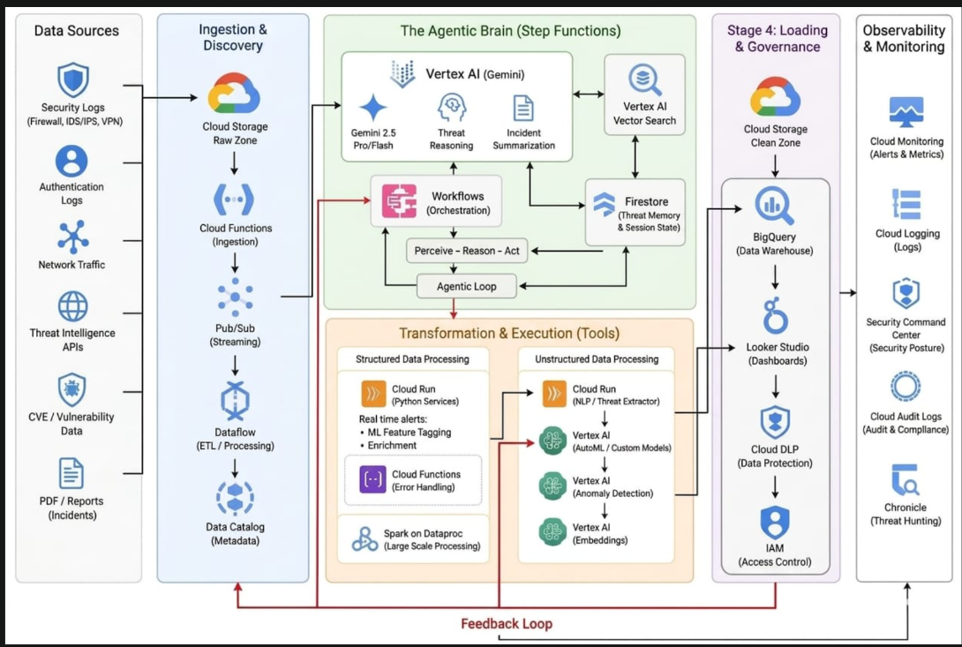

1. User Layer

Description:
This layer represents the end users who interact with the cybersecurity platform.

Users:
- Security Analysts
- SOC (Security Operations Center) Teams
- IT Administrators
- Cybersecurity Researchers

Responsibilities:
- Upload security logs and datasets
- Monitor threats
- View analytics dashboards
- Receive AI-generated recommendations
- Generate security reports

User Inputs:
- CSV security logs
- Network traffic data
- System event logs
- Threat intelligence files
- Vulnerability reports

2. Presentation Layer (Frontend Dashboard)

Description:
The presentation layer provides an interactive interface where users can monitor security events and communicate with the AI assistant.

Technologies:
- React.js / TypeScript
- Streamlit / Dash
- Plotly
- HTML, CSS, JavaScript

Components:

Authentication Module
- User login
- Signup functionality
- User profile management
- Secure access control

Threat Monitoring Dashboard
Displays:
- Threat severity levels
- Attack trends
- Security score
- Anomaly alerts
- Risk distribution
- Vulnerability status

AI Cybersecurity Assistant
An intelligent chatbot that helps users:
- Explain detected threats
- Summarize security events
- Answer cybersecurity queries
- Suggest mitigation steps

3. Application Layer

Description:
This layer contains the core business logic and manages communication between the dashboard, AI models, and cloud services.

Components:

API Gateway
Handles:
- User requests
- Data upload requests
- Communication with backend services
Technology:
- Google Cloud API Gateway

Threat Management Service
Functions:
- Receives security events
- Classifies threats
- Assigns risk scores
- Maintains threat history

File Processing Service
Supports:
- CSV files
- Excel files
- JSON logs
- PDF reports
- Network data
Functions:
- File validation
- Data extraction
- Data transformation

Risk Scoring Engine
Calculates threat priority using:
- Severity level
- Attack behavior
- Vulnerability score
- Historical incidents
Output:
Low Risk
Medium Risk
High Risk
Critical Risk

4. Data Processing Layer

Description:
This layer prepares raw cybersecurity data for AI analysis.

Technologies:
- Python
- Pandas
- NumPy
- Apache Beam
- Dataflow

Data Ingestion
Collects data from:
- Firewall logs
- IDS/IPS systems
- Cloud logs
- Endpoint security tools
- Threat intelligence feeds

Data Cleaning
Operations:
- Remove duplicate records
- Handle missing values
- Normalize data formats
- Convert raw logs into structured data

Feature Engineering
Creates important security features:
Examples:
- Number of failed login attempts
- IP reputation score
- Traffic frequency
- Abnormal user behavior
- Attack patterns

5. Google Cloud Platform Layer

Cloud Storage

Purpose:
Stores raw and processed cybersecurity data.
Stores:
- Uploaded files
- Security logs
- Reports
- Model outputs

BigQuery

Purpose:
Cloud data warehouse for large-scale security analytics.
Used for:
- Querying security events
- Historical threat analysis
- Trend identification
- Dashboard data retrieval

Cloud Functions

Purpose:
Runs lightweight backend processes automatically.
Examples:
- Trigger analysis after file upload
- Start ML prediction
- Generate alerts

Cloud Run

Purpose:
Hosts containerized applications.
Used for:
- Backend APIs
- AI assistant service
- ML inference service

Dataflow

Purpose:
Provides real-time and batch data processing.
Used for:
- Log streaming
- Data transformation
- Security event pipelines

Cloud Logging & Monitoring
Monitors:
- System activities
- Application health
- Security events

6. AI & Intelligence Layer

Description:
This is the core intelligence component that detects and predicts cybersecurity threats.

Machine Learning Engine

Technologies:
- Scikit-learn
- TensorFlow
- XGBoost
- PyTorch

Anomaly Detection Model
Purpose:
Detect unusual activities.
Examples:
- Abnormal login behavior
- Suspicious network traffic
- Data access anomalies
Algorithms:
- Isolation Forest
- Random Forest
- Autoencoders

Threat Classification Model
Classifies attacks into categories:
Examples:
- Malware
- Phishing
- DDoS
- Data Breach
- Unauthorized Access
Models:
- XGBoost
- Random Forest
- Neural Networks

Threat Prediction Model
Predicts:
- Future attack possibility
- Threat probability
- Risk level
Output Example:
Threat Detected:
Ransomware Activity

Confidence:
94%

Risk:
Critical

Threat Intelligence Integration
Uses:
- MITRE ATT&CK Framework
- CVE Vulnerability Database
- IP Reputation Data
Provides:
- Attack technique mapping
- Vulnerability information
- Recommended actions

7. Visualization & Reporting Layer

Description:
Provides security insights through interactive dashboards.

Technologies:
- Plotly
- Power BI
- Tableau
- React Charts

Dashboard Analytics
Displays:

Threat Analytics
- Number of detected threats
- Attack frequency
- Threat categories

Risk Analytics
- Risk score distribution
- Vulnerability analysis
- Security posture

Attack Trends
- Daily attacks
- Monthly trends
- Geographic attack sources

Automated Reports
Generates:
- Security summary reports
- Threat analysis reports
- Incident reports
Formats:
- PDF
- Excel
- Dashboard export

Complete Data Flow
Security Data Sources
|
↓
File Upload / Log Collection
|
↓
Cloud Storage (GCP)
|
↓
Data Processing Pipeline
(Dataflow + Python)
|
↓
BigQuery Data Warehouse
|
↓
AI/ML Threat Detection Engine
|
↓
Risk Scoring + Prediction
|
↓
Dashboard Visualization
|
↓
AI Security Assistant
|
↓
Threat Response Recommendations

Security Features

Authentication & Authorization
- Secure login
- Role-based access control

Data Protection
- Encryption at rest
- Encryption during transfer

Monitoring
- Cloud Logging
- Security alerts

Threat Intelligence
- CVE analysis
- MITRE ATT&CK mapping

