Project Submission : url : https://github.com/varshasangave61/Week4Assesment.git

1 ) Push STS code to git

Individual Backend code GITHUB URL : https://github.com/varshasangave61/Week4Assesment.git

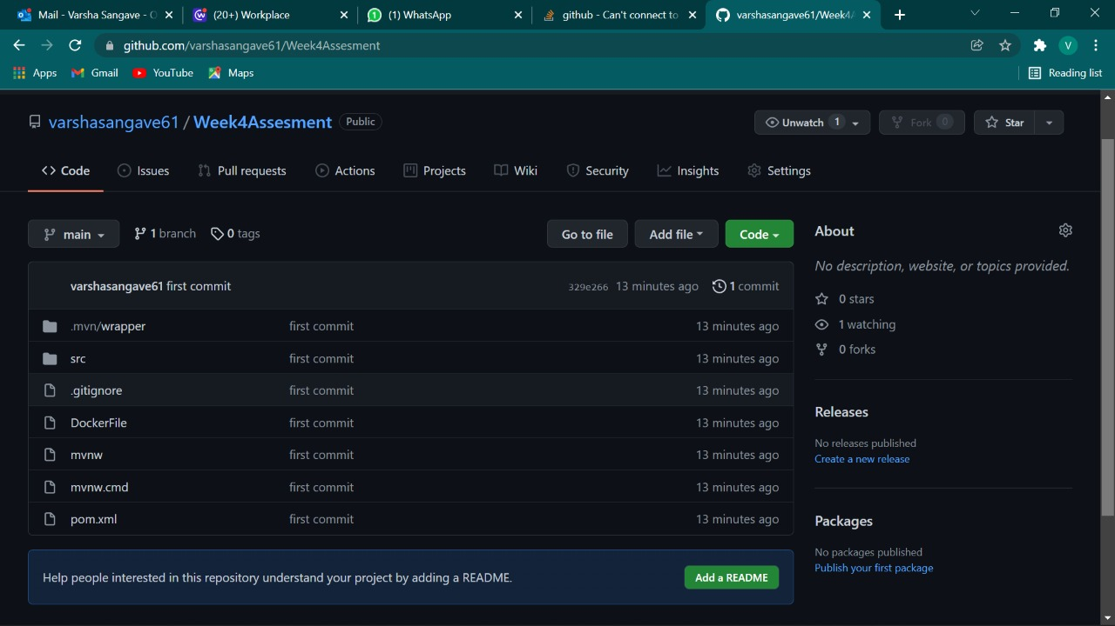

2 ) Push Angular code to github

Individual frontend code GITHUB URL <https://github.com/varshasangave61/Week4Assesment.git>



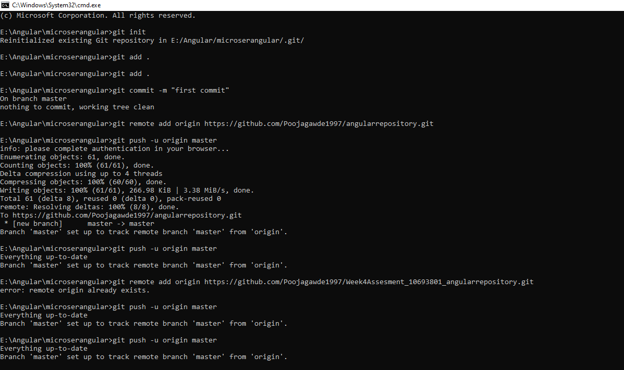

3 ) Junit Test Cases

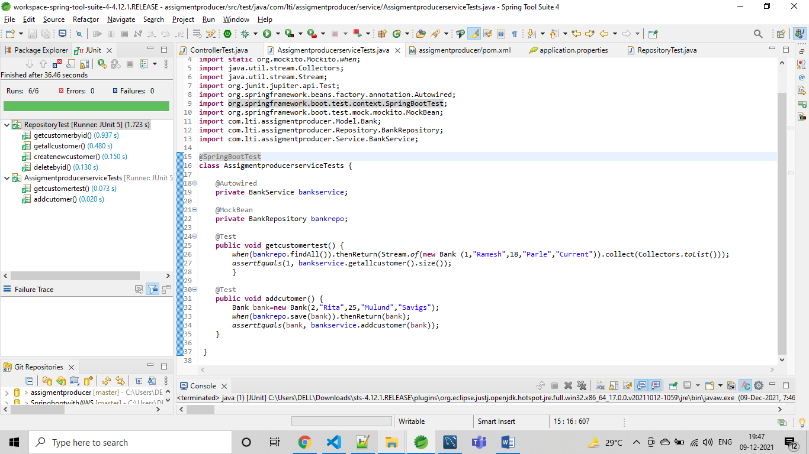

4 ) Code Coverage

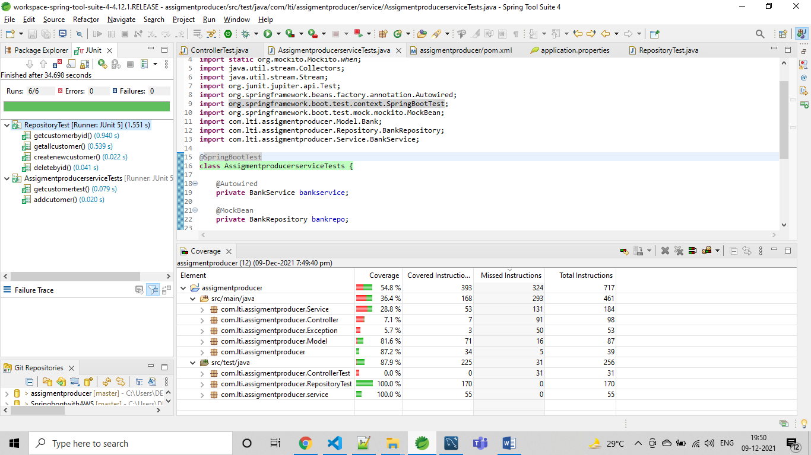

5 ) Log4j implementation

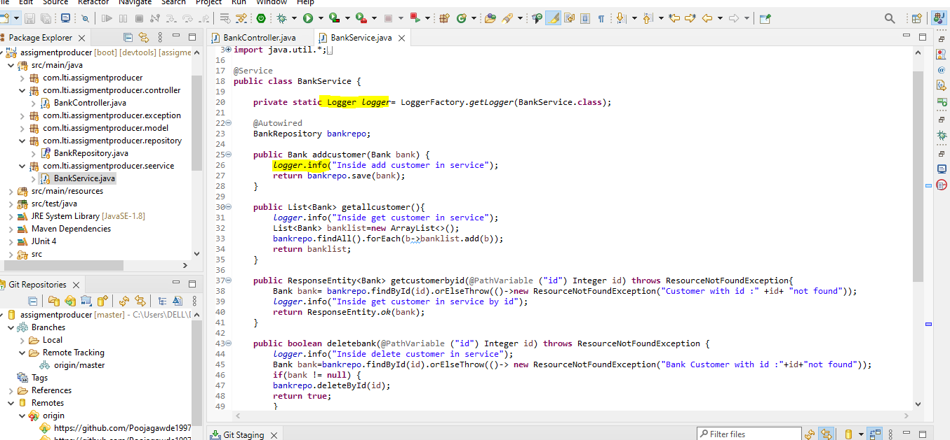

6 )Debugging

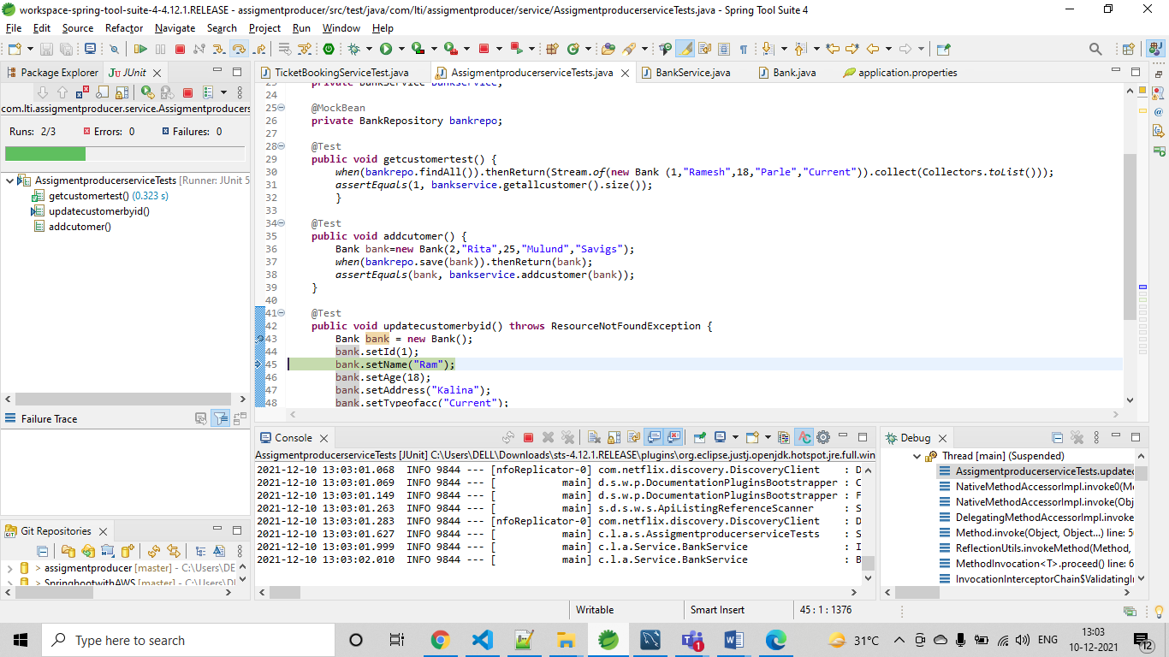

7 ) Code quality using Sonarlint

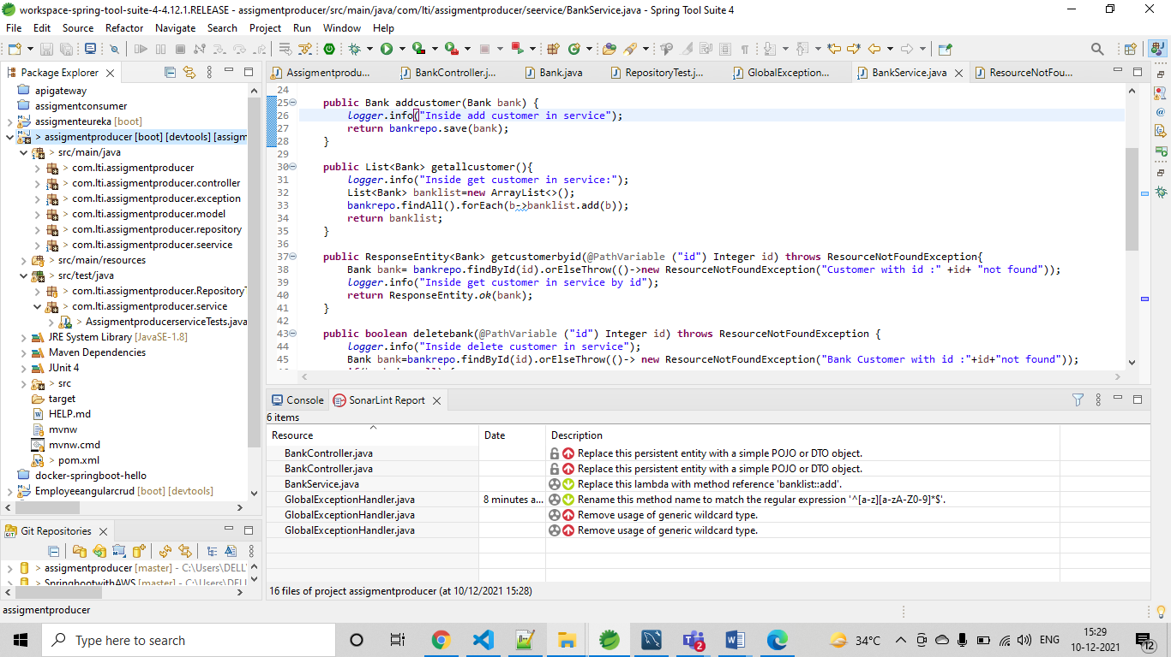

8 ) SonarQube

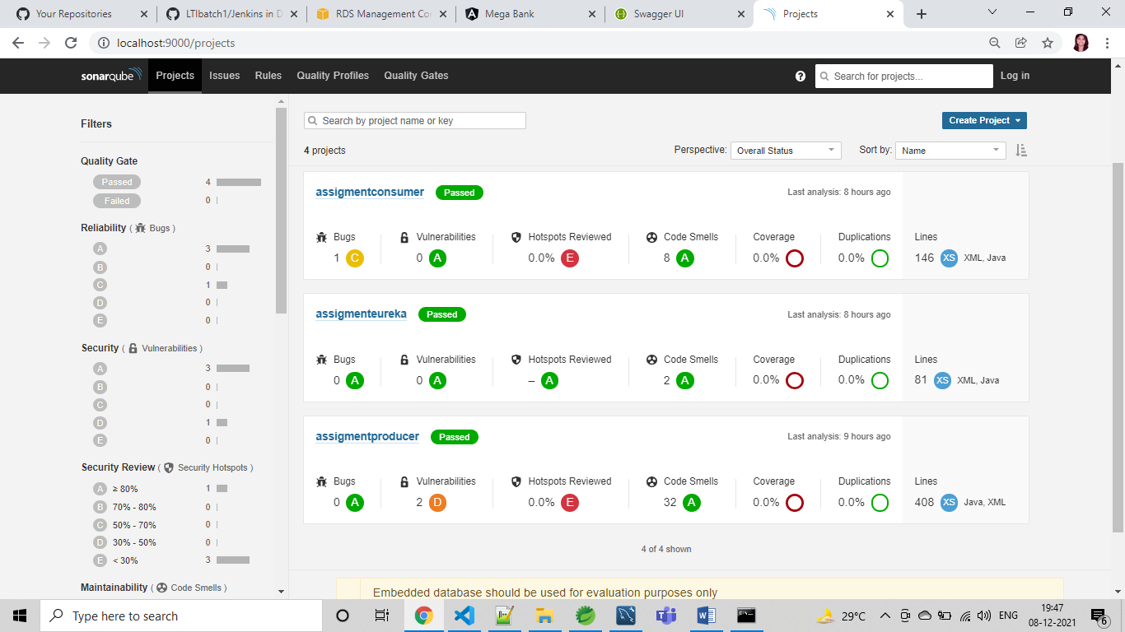

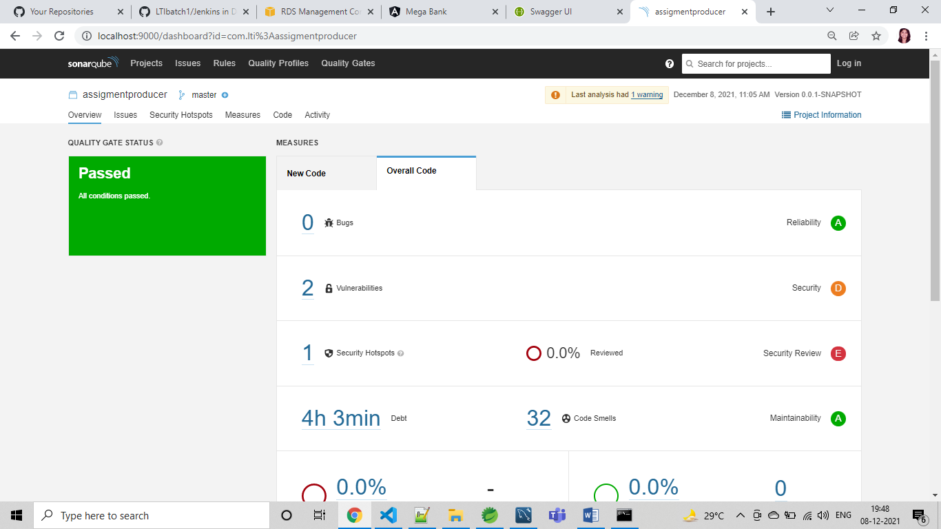

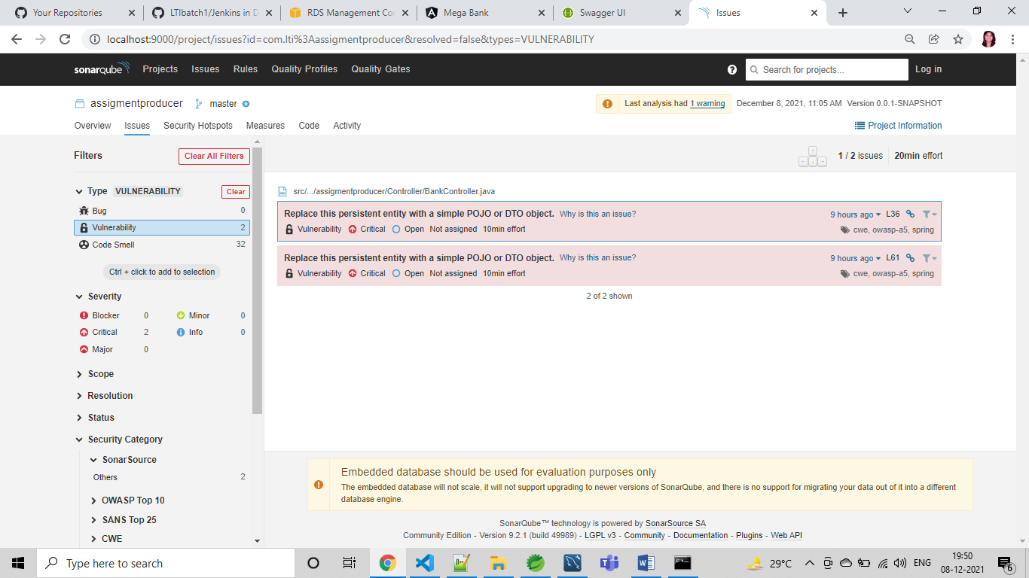

9 ) Maven build

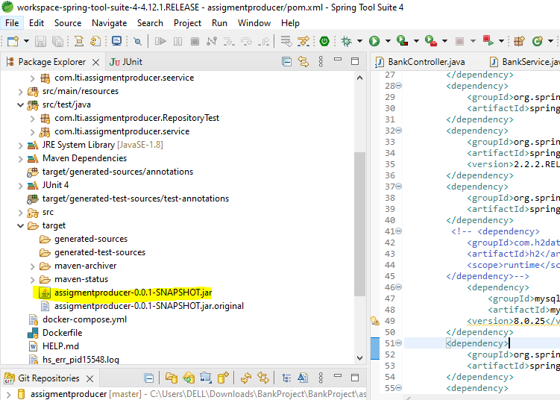

Swagger screenshot

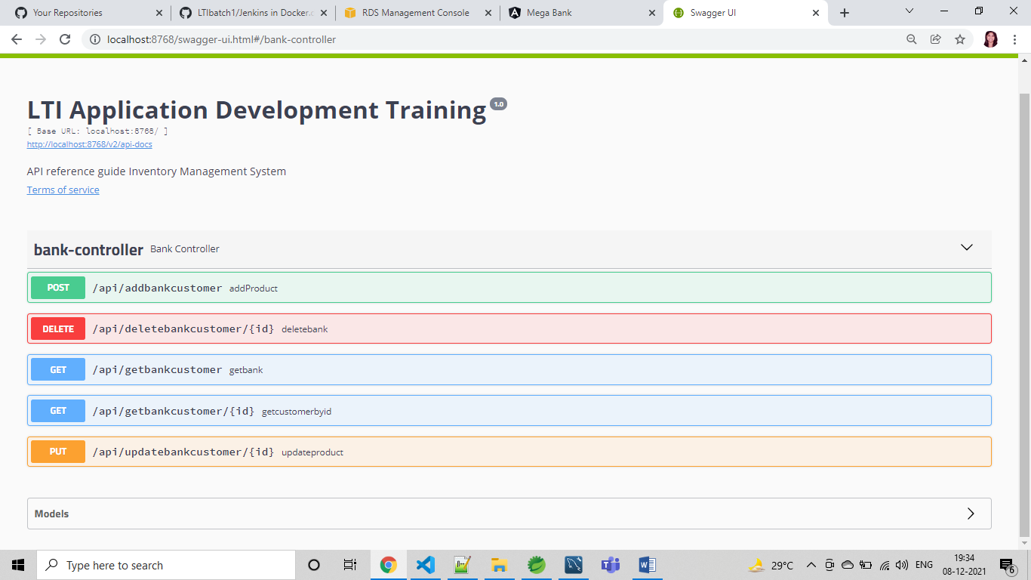

10 ) Docker image and container using docker compose

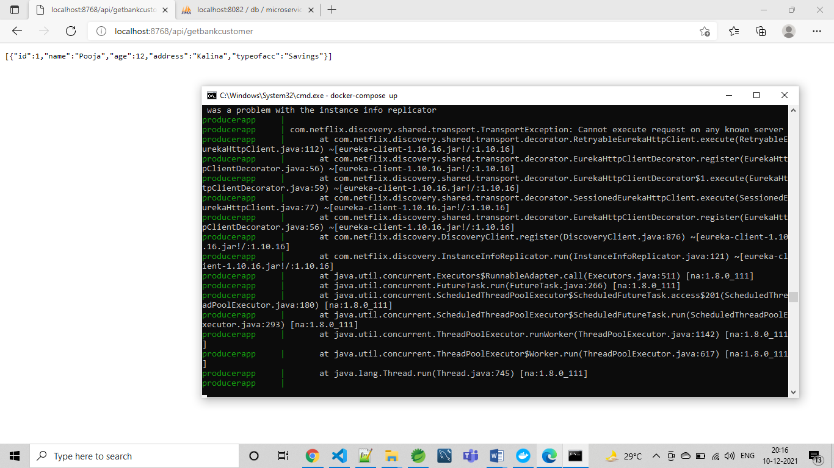

AWS

12 ) S3 to deploy frontend

URL : <http://producerbkt.s3-website.ap-south-1.amazonaws.com>

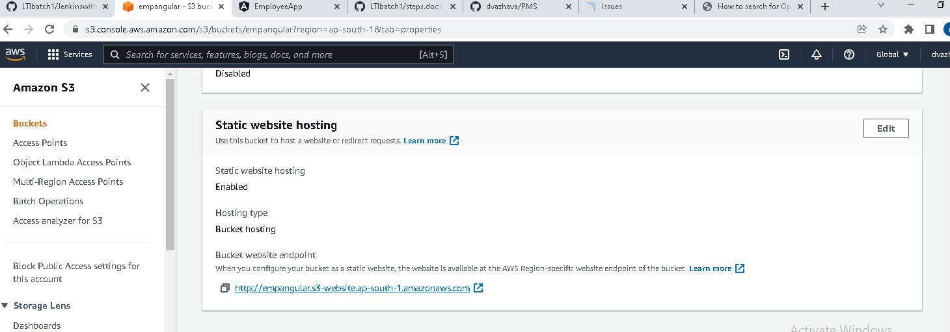

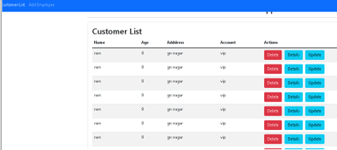

13 ) RDS instance connectivity

RDS URL : jdbc:mysql://database-1.cl8i54z9c811.ap-south-1.rds.amazonaws.com:3306/microservices

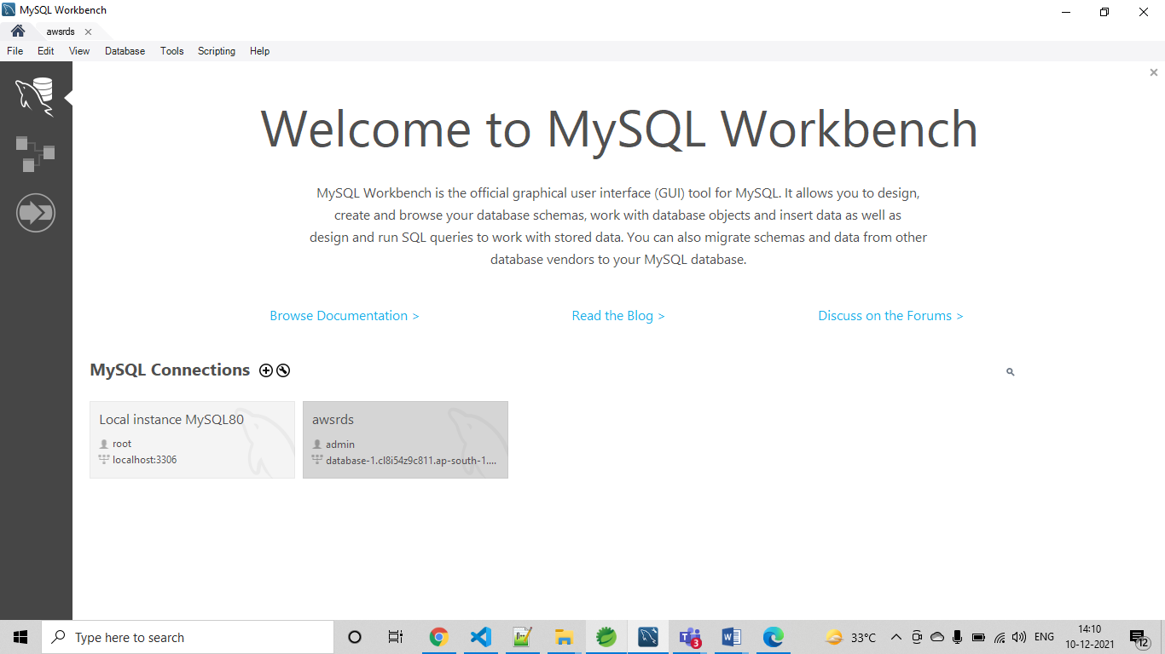

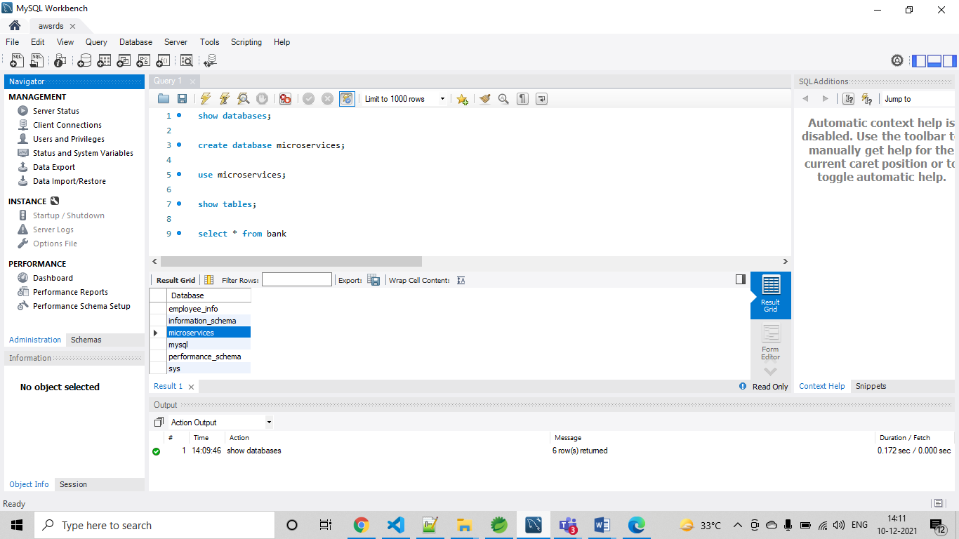

14 ) Jenkins pipeline

