**DataBase : (movie_booking)**

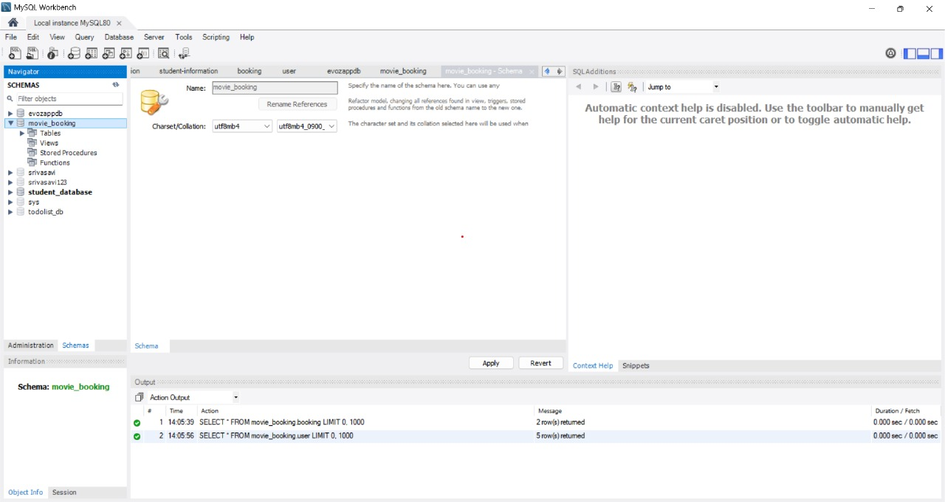

**Tables Structure:(booking,movie,shows,theatre,user)**

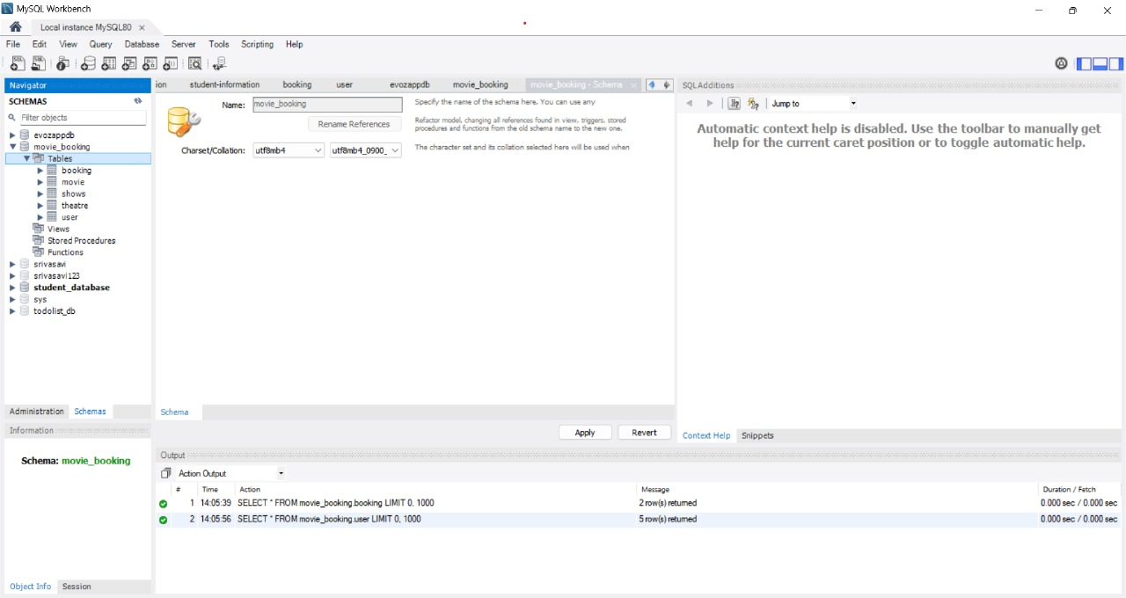

**Userdata:**

**Query-SELECT*FROM movie_booking.user;**

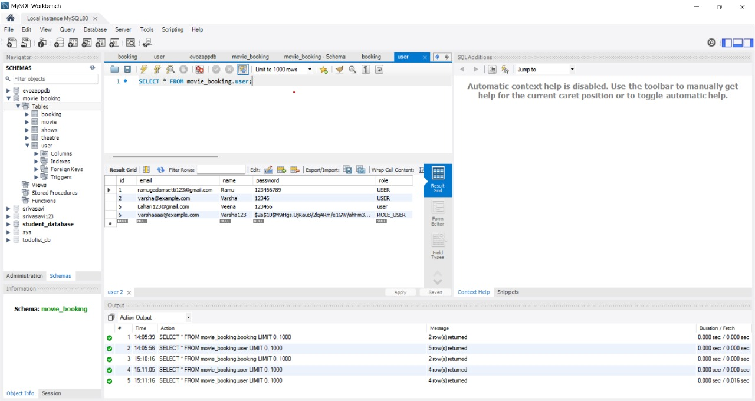

**TheatreData:**

**Query-SELECT*FROM movie_bokking.theatre;**

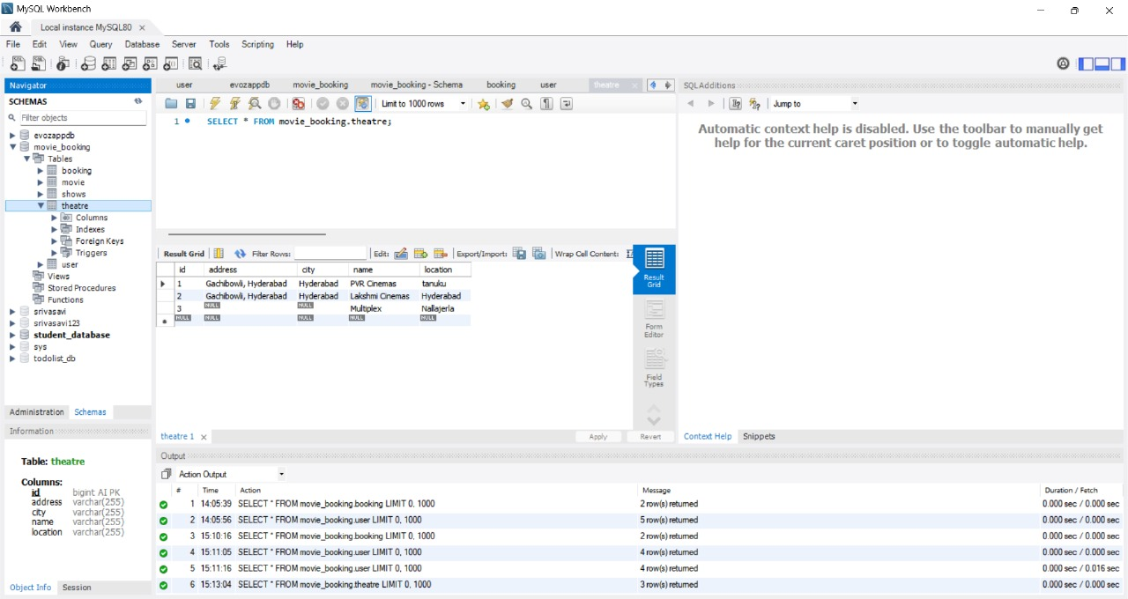

**ShowsData:**

**Query-SELECT*FROM movie_booking.shows;**

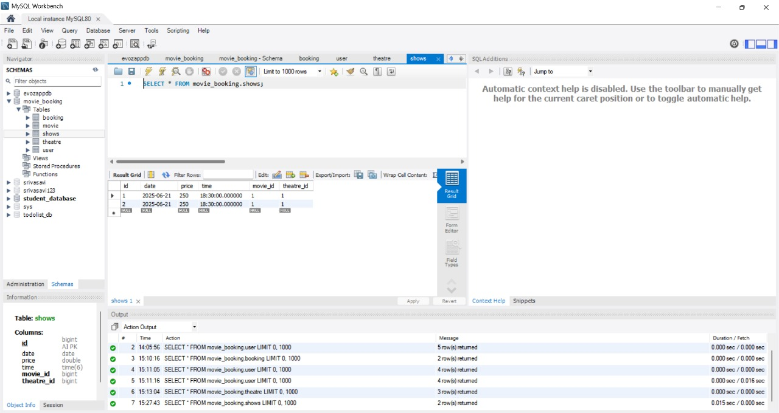

**MovieData:**

**Query-SELECT*FROM movie_booking.movie**

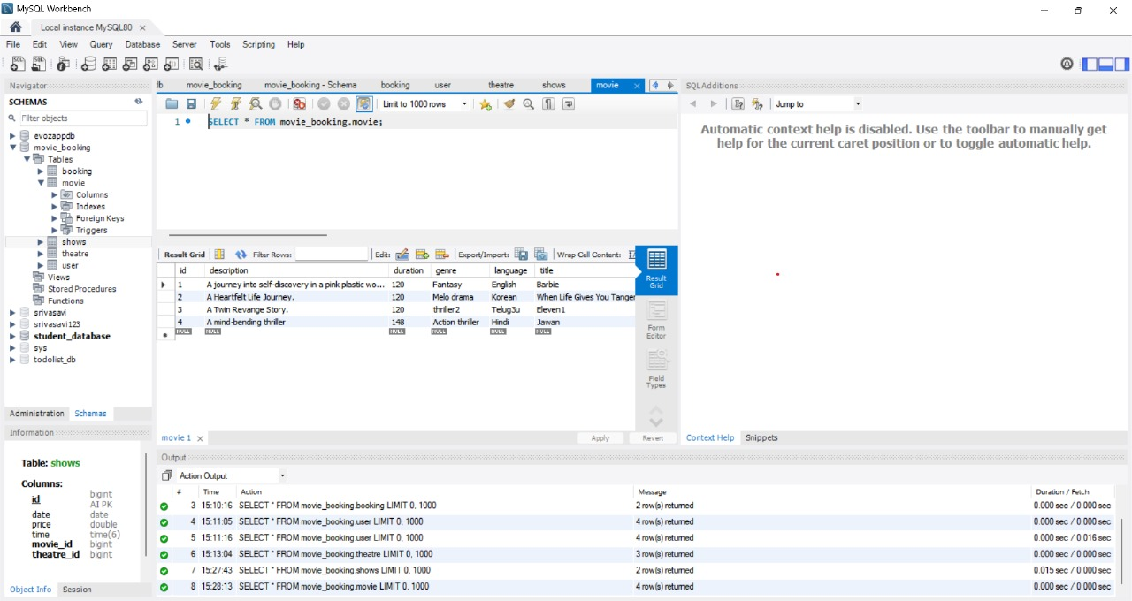

**BookingData:**

**Query-SELECT*FROM movie_booking.booking;**

