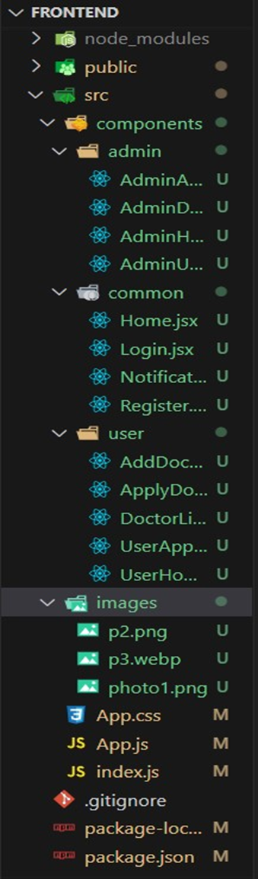

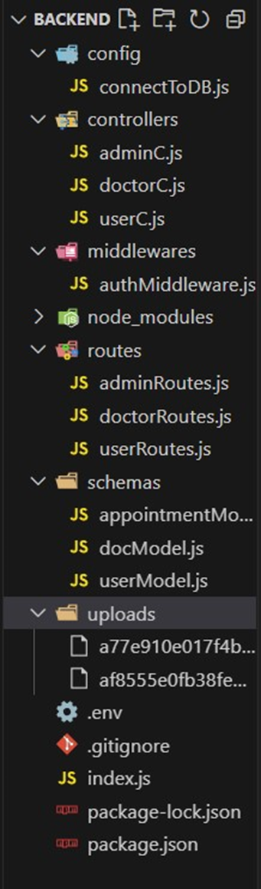

Landing page

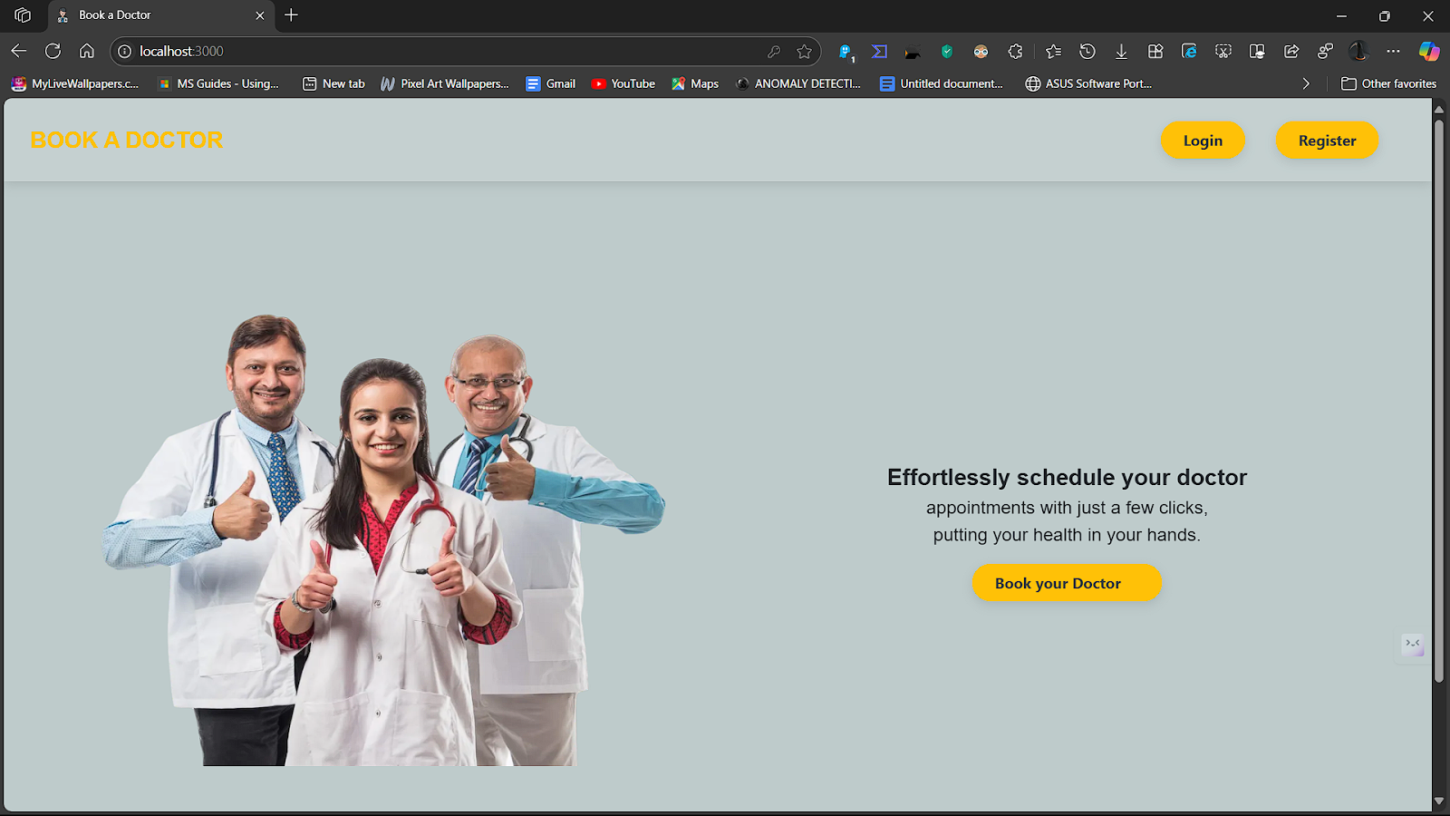

Register page:

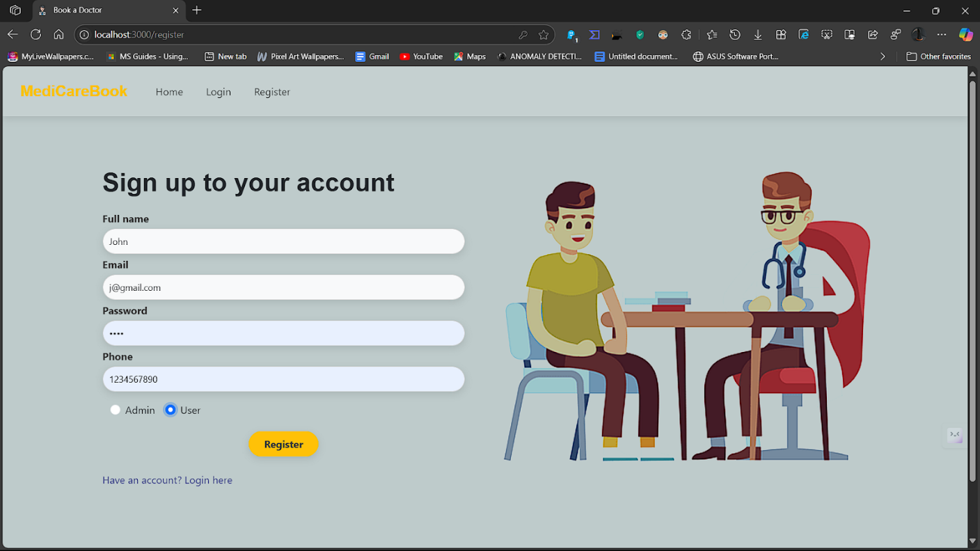

Login page

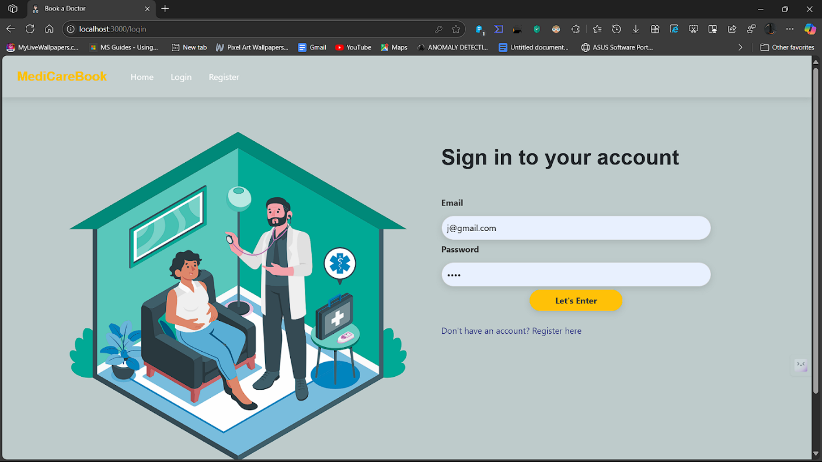

Admin dash board :

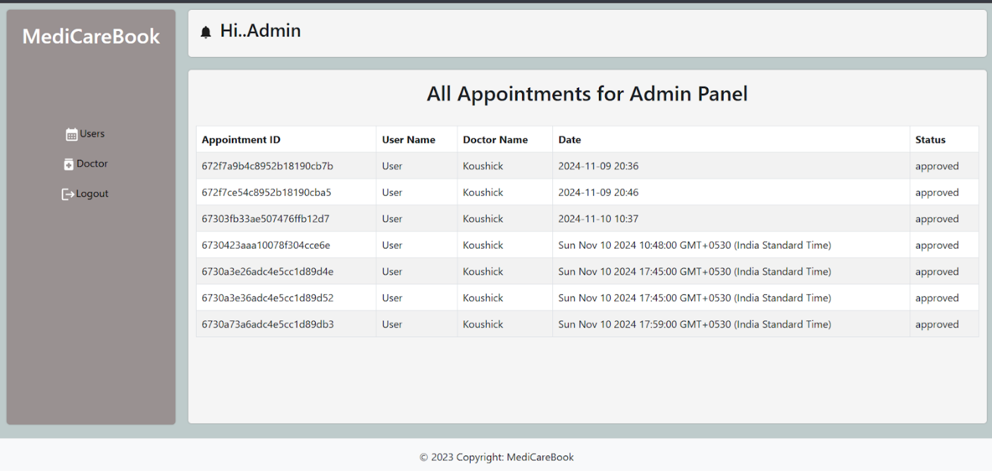

**Doctor dashboard**

**Doctor dashboard:**

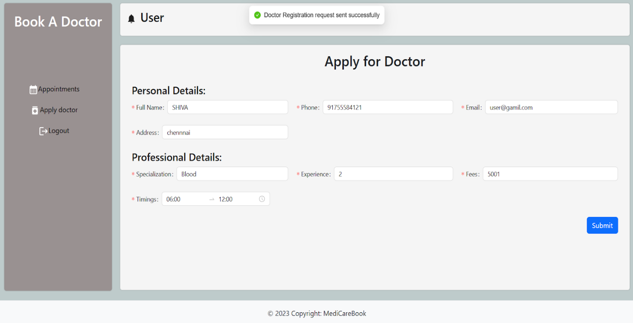

**Admin approve doctor:** 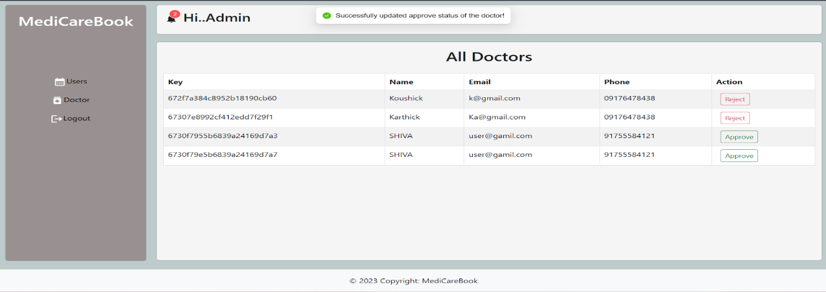

**BOOK DOCTOR  :  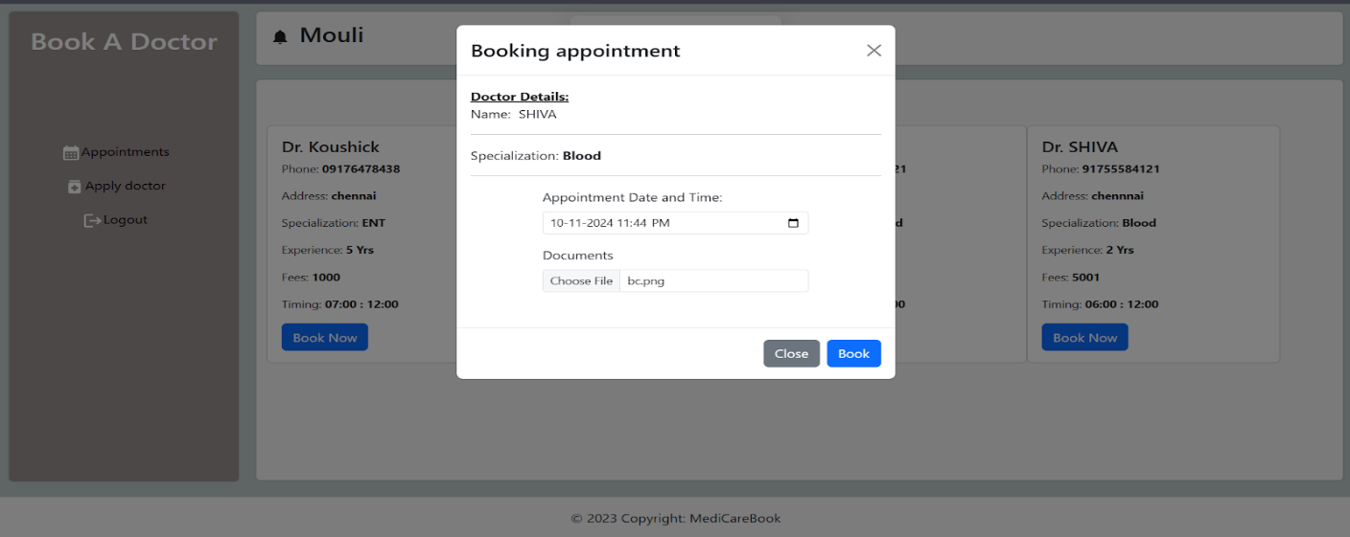**

**ALL HISTORY :**

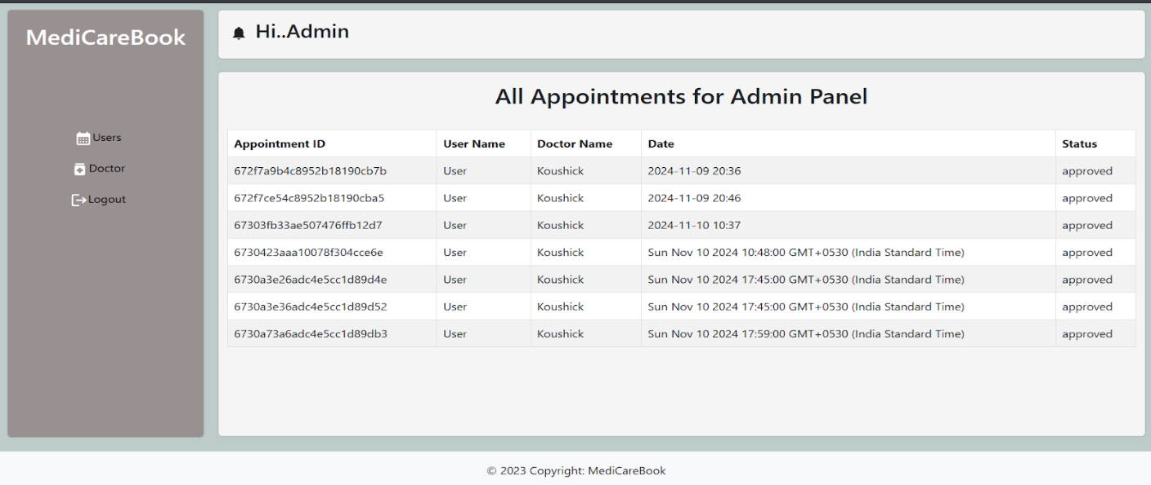

**User dashboard**

**User dashboard:**

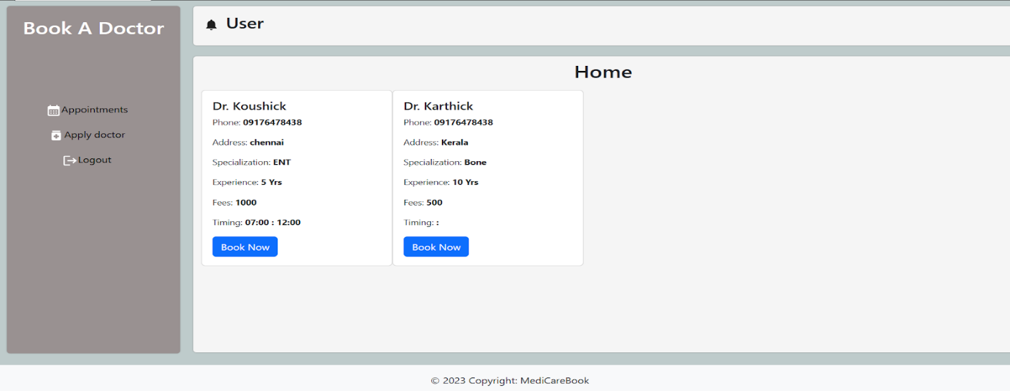

**Note: For code drive, click on** [link](https://drive.google.com/drive/folders/16oyhL-9AkKVS3nIzOMBzzCzHeYd-YwO8?usp=drive_link) and demo link, click on [link](https://drive.google.com/file/d/1E5QQ5BtWtGIR_9y4ZK5Zkjp2QQek3loJ/view?usp=drive_link)