



**Department of Computer Science**

**CERTIFICATE**

Roll No. 30

This is to certify that Miss VARSHA SUJITH KUMAR of Grade 12 Section A has carried out the required project work in Computer Science prescribed by the Central Board of Secondary Education, New Delhi during the academic year 2020 – 2021.

________________

Teacher-in-charge

Date: ______________

________________ ________________

External Examiner Internal Examiner



|  |  |
| --- | --- |
| **SL.NO.** | **CONTENT** |
| 1. | **Acknowledgement** |
| 2. | **Problem definition** |
| 3. | **Hardware and Software requirements** |
| 4. | **Binary file data** |
| 5. | **Algorithm** |
| 6. | **Program listing** |
| 7. | **Input and output samples** |
| 8. | **Bibliography** |

**INDEX**

**ACNOWLEDGEMENTS**

I would like to express my utmost gratitude towards my Computer Science teacher Miss Monika Somadder, who gave me the opportunity to do this project on the topic ‘Cosmetic Shop Management’. This project helped me to understand the topics learnt in my school better, as I gained more knowledge about the various commands in Python. The completion of this project required the guidance of not only my teacher but also my peers who willingly aided in the places where I found myself helpless.

**PROBLEM DEFINITION**

Every ordinary retail store requires a certain technology system for appropriate functioning and smooth management. This project on Cosmetic Store Management focuses on fulfilling the same with the help of a basic menu – structured Python program.

A Cosmetic Shop requires keeping track of the items in their store, adding new items to their store directory, modifying entered data, and if necessary, deleting records. They also need to have an apt method of dealing with transactions in both forms – retail and wholesale.

Without a proper approach, the operating of the entire store could be in turmoil. Keeping track of records would be complicated and could result in utter chaos.

The created program performs standard necessary functions, achieving the vital tasks with just a few clicks.

**HARDWARE AND SOFTWARE REQUIREMENTS**

**HARDWARE** :

* Monitor
* Keyboard
* Printer
* IBM CO CPU
* Mouse

**SOFTWARE** :

* Microsoft word 2013
* Python 3.7
* Notepad
* Thonny

BINARY FILE DATA

|  |  |  |  |
| --- | --- | --- | --- |
| **ITEM**  **NO** | **ITEM**  **TYPE** | **DESCRIPTION** | **PRICE** |
| **100** | SKINCARE | FENTY BEAUTY FOUNDATION | 175 |
| **101** | SKINCARE | MAC CONCEALER | 115 |
| **102** | SKINCARE | SEPHORA BRONZER | 71 |
| **103** | SKINCARE | LAKME BLUSH | 46 |
| **104** | SKINCARE | SEPHORA HIGHLIGHTER | 85 |
| **105** | EYECARE | HUDA BEAUTY EYELINER | 125 |
| **106** | EYECARE | E.L.F MASCARA | 20 |
| **107** | EYECARE | JAMES CHARLES X MORPHE PALETTE | 239 |
| **108** | LIPCARE | KYLIE COSMETICS LIPLINER | 185 |
| **109** | LIPCARE | NYX LIPSTICK | 27 |

ALGORITHM

Step 1) Start the program.

Step 2) Choose the appropriate option from the Main Menu

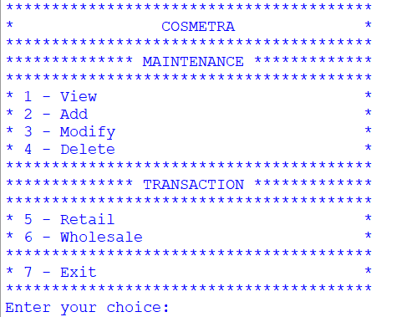

Step 3) If option 1- View is selected

Step 3.1) Enter the item number.

Step 3.2) All details of the item are displayed if the item number is

correct.

Step 3.2.1) If the item number is incorrect, ‘Record Not

Found’ is displayed.

Step 3.3) Menu is redisplayed and ‘Enter your choice’ prompt appea

Step 4) If option 2- Add is selected

Step 4.1) Enter the item number.

Step 4.2) If the item isn’t found in the directory, input details.

Step 4.3) If the item is found in the directory, ‘Record already exists.’

is displayed.

Step 4.4) Menu is redisplayed and ‘Enter your choice’ prompt appears.

Step 5) If option 3- Modify is selected

Step 5.1) Enter item number.

Step 5.2)Question on whether to modify item type appears, with

Yes(y) or No(n) option.

Step 5.2.1) If y, enter the modified item type.

Step 5.2.2) If n, next question appears.

Step 5.3) Question on whether to modify description appears, with

Yes(y) or No(n) option.

Step 5.3.1) If y, enter the modified description.

Step 5.3.2) If n, next question appears.

Step 5.4) Question on whether to modify price appears, with

Yes(y) or No(n) option.

Step 5.4.1) If y, enter the modified price.

Step 5.4.2) If n, next question appears.

Step 5.5) Menu is redisplayed and ‘Enter your choice’ prompt appears.

Step 6) If option 4- Delete is selected

Step 6.1) Enter item number.

Step 6.2)Question on whether to delete record appears, with

Yes(y) or No(n) option.

Step 6.2.1) If y, record will be deleted with a message ‘Record

Deleted Successfully’.

Step 6.2.2) If n, menu redisplayed.

Step 6.3) Menu is redisplayed and ‘Enter your choice’ prompt appears.

Step 7) If option 5- Retail is selected

Step 7.1) Enter item number.

Step 7.1.1) Prompt to enter quantity of items to be bought

displayed.

Step 7.1.1.1) The total price of items is displayed.

Step 7.1.1.1.1) Question on whether

the items are to be bought is

displayed with y and n option.

Step 7.1.1.1.1.1)If y is

selected,

‘Transaction

Successful’

appears.

Step 7.1.1.1.1.2) If n is

selected,

‘Transaction

Unsuccessful’

appears.

Step 7.1.1.2) If the number of items exceeds 10,

‘Choose the Wholesale option.’ is displayed.

Step 7.1.1.3) If the number of items precedes 1,

‘Enter a no. between 1-9.’ is displayed.

Step 8) If option 6- Wholesale is selected

Step 8.1) Enter item number.

Step 8.1.1) Prompt to enter quantity of items to be bought

displayed.

Step 8.1.1.1) The total price of items is displayed.

Step 8.1.1.1.1) Question on whether

the items are to be bought is

displayed with y and n option.

Step 8.1.1.1.1.1)If y is

selected, ‘Transaction

Successful’ appears.

Step 8.1.1.1.1.2) If n is

selected,

‘Transaction Unsuccessful’

appears.

Step 8.1.1.2) If the number of items is between

1-9, ‘Choose the Wholesale option.’ is displayed.

Step 7.1.1.3) If the number of items precedes 1,

‘Enter a no. between 1-9.’ is displayed.

Step 9) If option 7- Exit is selected

Step 9.1) ‘Thank you for visiting COSMETRA. Please come again.’ is

displayed.

Step 9.2) The loop ends.

Step 10) If any other options are selected

Step 10.1) ‘Please enter a correct option.’ is displayed.

Step 10.2) Menu is redisplayed and ‘Enter your choice’ prompt

appears.

PROGRAM LISTING

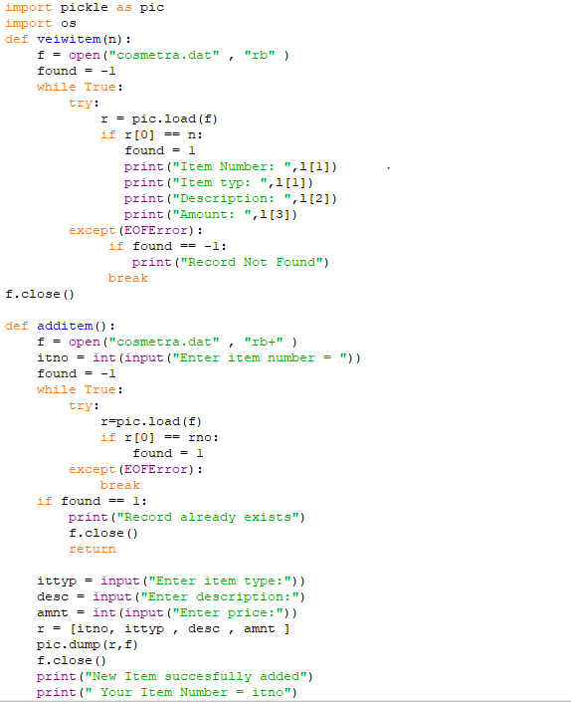

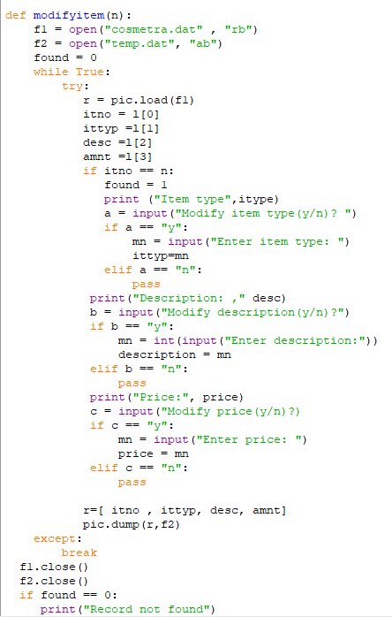

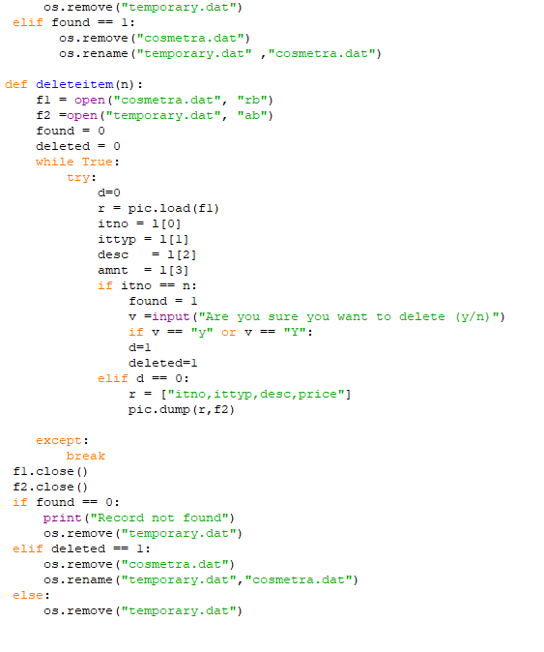

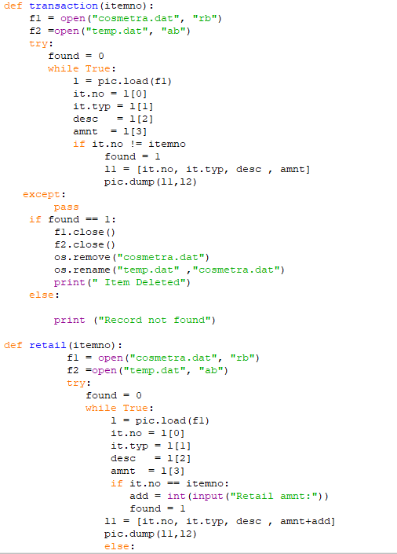

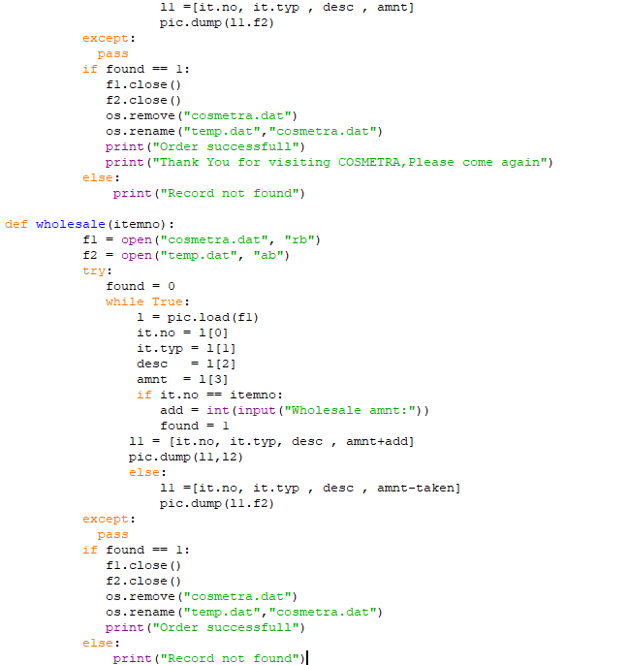

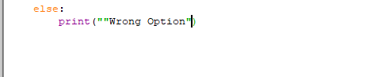

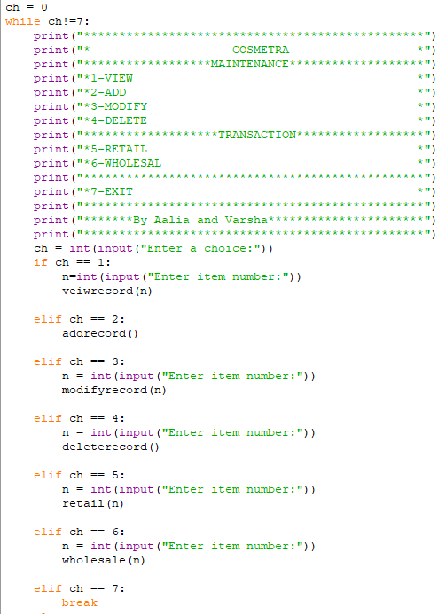

INPUT AND OUTPUT SAMPLES

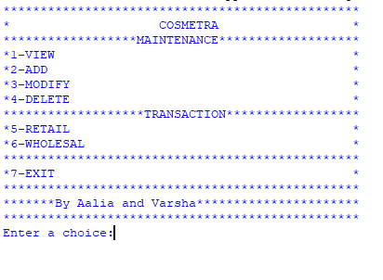

OPTION 1- VIEW

FOUND

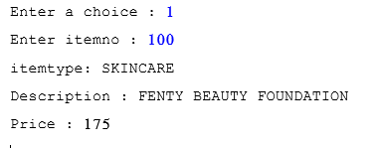

NOT FOUND

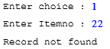

OPTION 2 – ADD

FOUND

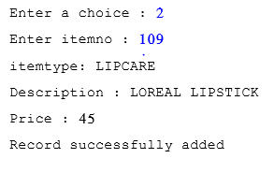

**NOT FOUND**

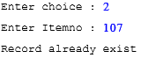

OPTION 3 – MODIFY

FOUND

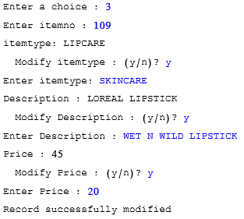

NOT FOUND

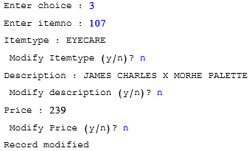

OPTION 4- DELETE

FOUND

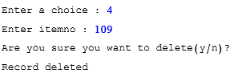

NOT FOUND

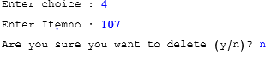

OPTION 5- TRANSACTIONS

-RETAIL

FOUND

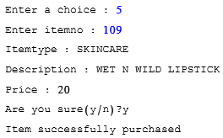

NOT FOUND

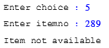

-WHOLESALE

FOUND

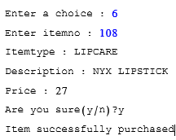

NOT FOUND

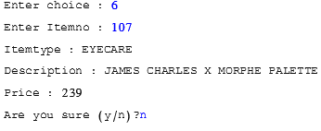

BIBILIOGRAPHY

Programming Language: Python 3.7 (32- bit)

Language Compiler: Python 3.7.2 shell

Project Documentation: Microsoft Word 2013

Coding Reference: Class Notes

Input/ Output Samples: Python, Snipping tool

Image Sources: Google Images