Name:Varsha.M
Reg No:1924260282
Lab Program(1-20)

AIM:
To explore the R and RStudio environment and identify its main features.
ALGORITHM:
1. Open RStudio and identify the console, script editor and environment pane.
2. Execute a simple R command.
3. Check the R version and working directory.
4. Open the help page for mean().
code
# Welcome message
print("Welcome to R Programming")
# R version
print(R.version.string)
# Working directory
print(getwd())
# Calculate mean
print(mean(c(10, 20, 30, 40, 50)))
# RStudio environment features
print("Console - Executes commands")
print("Script Editor - Writes programs")
print("Environment - Stores variables")
print("Files Pane - Displays files")
print("Help System - Provides documentation")
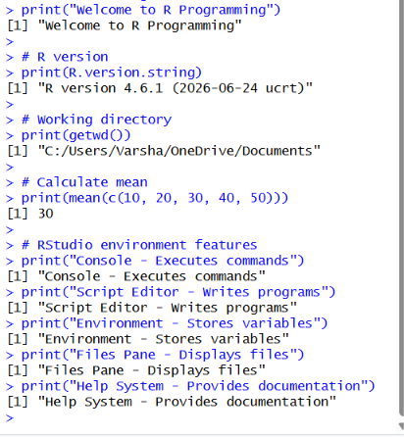
Result:
The RStudio environment was explored successfully. The console, script editor, environment
2. AIM:
To perform arithmetic operations using two numbers.
ALGORITHM:
1. Declare two numeric variables.
2. Perform addition, subtraction and multiplication.
3. Perform division, integer division and modulus.
4. Display all results.
CODE:
a <- 20
b <- 6
print(paste("Addition:", a+b))
print(paste("Subtraction:", a-b))
print(paste("Multiplication:", a*b))
print(paste("Division:", a/b))
print(paste("Integer Division:", a%/%b))
print(paste("Modulus:", a%%b))
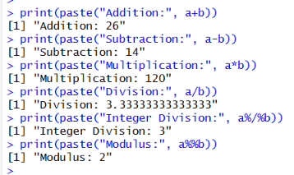

RESULT:
Arithmetic operations were performed successfully.
3. AIM:
To demonstrate different assignment operators in R.
ALGORITHM:
1. Create variables using <-, = and ->.
2. Assign different numeric values.
3. Print all variables.
4. Observe the assigned values.
CODE:
a <- 10
b = 20
30 -> c

print(a)
print(b)
print(c)
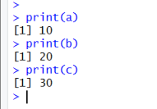

RESULT:
Different assignment operators were demonstrated successfully.
4. AIM:
To identify different data types using class(), typeof() and str().

ALGORITHM:
1. Create numeric, integer, character, logical and complex variables.
2. Apply class() and typeof().
3. Use str() to inspect the variables.
4. Display the results.
CODE:

a <- 10.5
b <- 10L
c <- "Hello"
d <- TRUE
e <- 3+2i

print(class(a))
print(typeof(a))

print(class(b))
print(typeof(b))

print(class(c))
print(typeof(c))

print(class(d))
print(typeof(d))

print(class(e))
print(typeof(e))

str(a)
str(b)
str(c)
str(d)
str(e)
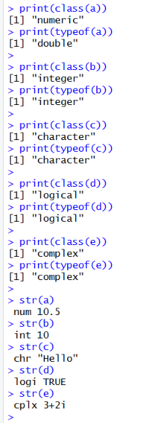

RESULT:
Different data types were created and inspected successfully.
5. AIM:
To demonstrate type conversion using as.numeric(), as.character() and as.logical().
ALGORITHM:
1. Create a character vector.
2. Convert it into numeric values.
3. Identify invalid values and NA.
4. Demonstrate other type conversions.

# CODE:
x <- c("10", "20", "30", "abc")
y <- as.numeric(x)
print(y)
a <- as.character(100)
b <- as.logical(1)
c <- as.numeric("25")
print(a)
print(b)
print(c)
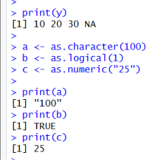
RESULT:
Type conversion was performed successfully.
The invalid string "abc" produced NA and a warning.
6. AIM:
To demonstrate relational and logical operators in R.

ALGORITHM
1. Create a numeric vector.
2. Apply relational operators.
3. Combine conditions using &, | and !.
4. Display the logical results.

# CODE:

x <- c(10, 20, 30, 40, 50)

print(x > 25)
print(x < 30)
print(x == 20)
print(x != 40)

print(x > 20 & x < 50)
print(x < 20 | x > 40)
print(!(x == 30))
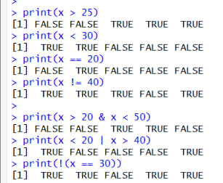
RESULT:
Relational and logical operations were performed successfully.
7. AIM:
To demonstrate built-in mathematical functions in R.

ALGORITHM:
1. Select suitable numeric values.
2. Apply mathematical functions.
3. Display the results.
4. Observe the output of each function.

# CODE:

x <- -16

print(abs(x))
print(sqrt(25))
print(round(12.567, 2))
print(ceiling(12.3))
print(floor(12.8))
print(log(10))
print(exp(2))
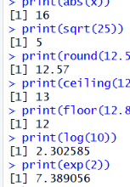
RESULT:
Mathematical functions were executed successfully.
8. AIM:
To demonstrate positive, negative and logical indexing in R.

ALGORITHM:
1. Create a numeric vector.
2. Select elements using positive indexing.
3. Exclude elements using negative indexing.
4. Select values using logical indexing.

# CODE:

x <- c(10, 20, 30, 40, 50)
print(x[c(1, 3)])
print(x[-c(2, 4)])
print(x[x > 25])
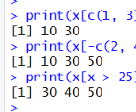
RESULT:
Different vector indexing methods were demonstrated successfully.

9. AIM:
To demonstrate seq() and rep() functions in R.

ALGORITHM:
1. Generate a sequence using seq().
2. Repeat individual values using rep().
3. Repeat a vector.
4. Display all results.

# CODE:

x <- seq(1, 10, by=2)

y <- rep(5, times=3)

z <- rep(c(1, 2, 3), times=2)

print(x)
print(y)
print(z)
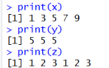
RESULT:
Sequence generation and repetition were performed successfully.
10. AIM:
To perform arithmetic and comparison operations on vectors.

ALGORITHM:
1. Create two numeric vectors.
2. Perform arithmetic operations.
3. Perform comparison operations.
4. Demonstrate vector recycling.
CODE:
a <- c(10, 20, 30)
b <- c(2, 4, 6)
print(a+b)
print(a-b)
print(a*b)
print(a/b)
print(a > b)
print(a == b)
x <- c(10, 20, 30, 40)
y <- c(2, 4)
print(x+y)
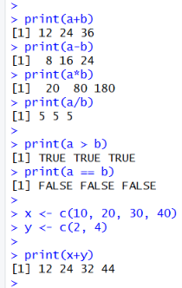
RESULT:
Vector arithmetic, comparisons and recycling were performed successfully.
11. AIM:
To calculate statistical summary values of a numeric vector.

ALGORITHM:
1. Create a numeric vector.
2. Calculate sum and mean.
3. Find median, length, minimum and maximum.
4. Display the range.

# CODE:

x <- c(10, 20, 20, 30, 40, 50)

print(sum(x))
print(mean(x))
print(median(x))
print(length(x))
print(min(x))
print(max(x))
print(range(x))
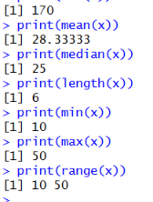
RESULT:
Statistical summary functions were executed successfully.

12. AIM:
To demonstrate sort(), unique(), duplicated() and table() functions.

ALGORITHM:
1. Create an unsorted vector with repeated values.
2. Apply sort() to arrange the values.
3. Use unique() and duplicated().
4. Calculate frequencies using table().

# CODE:
x <- c(30, 10, 20, 10, 40, 20, 30)
print(sort(x))
print(unique(x))
print(duplicated(x))
print(table(x))
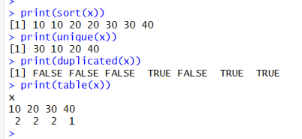
RESULT:
Sorting, unique values, duplicate identification and frequency calculation were performed successfully.
13. AIM:
To create and manipulate lists containing different data types.
ALGORITHM:
1. Create a list with student details.
2. Access elements using position and name.
3. Update an element.
0 4. Display the complete list.

# CODE:

student <- list(
Name = "Arun",
Age = 20,
Marks = c(80, 85, 90),
Pass = TRUE
)

print(student[1])
print(student$Name)
student$Age <- 21
print(student)
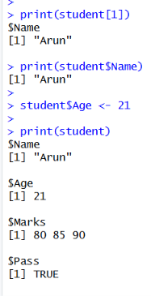
RESULT:
List creation, accessing and updating were performed successfully.

14. AIM:
To create a matrix and access its rows, columns and elements.

ALGORITHM:
1. Create a 3x3 matrix.
2. Display the matrix.
3. Extract a selected row and column.
4. Access an individual element.

CODE:

m <- matrix(1:9, nrow=3, ncol=3)
print(m)
print(m[2, ])
print(m[, 3])
print(m[2, 2])
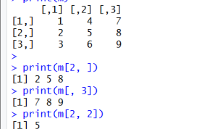
RESULT:
Matrix creation and element extraction were performed successfully.
15. AIM:
To perform arithmetic operations on two matrices.
ALGORITHM:
1. Create two 2x2 matrices.
2. Perform addition and subtraction.
3. Find the transpose.
4. Perform matrix multiplication.

# CODE:

A <- matrix(c(1, 2, 3, 4), nrow=2)
B <- matrix(c(5, 6, 7, 8), nrow=2)

print(A)
print(B)

print(A+B)
print(A-B)
print(t(A))
print(A %*% B)
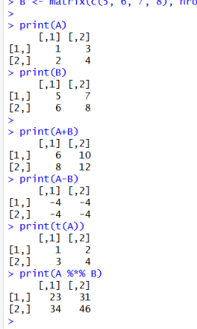
RESULT:
Matrix addition, subtraction, transpose and multiplication were performed successfully.
16. AIM:
To create and manipulate a three-dimensional array in R.
ALGORITHM:
1. Create an array with values from 1 to 24.
2. Specify dimensions as 3x4x2.
3. Display its dimensions.
4. Extract both two-dimensional slices.

CODE:
arr <- array(1:24, dim=c(3, 4, 2))
print(arr)
print(dim(arr))
print(arr[1, 2, 1])
print(arr[, , 1])
print(arr[, , 2])
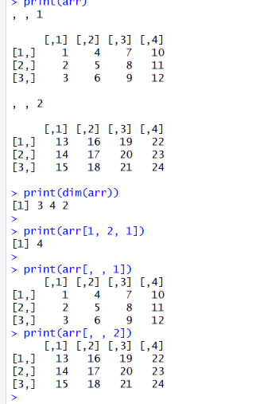
RESULT:
A three-dimensional array was created and its dimensions and slices were displayed successfully.
17. AIM:
To create ordered factors and calculate category frequencies.

ALGORITHM:
1. Create a vector containing categories.
2. Convert it into an ordered factor.
3. Specify the factor levels.
4. Display levels and frequencies.

# CODE:

x <- c("Low", "Medium", "High", "Low",
"High", "Medium", "Low")
f <- factor(x,
levels=c("Low", "Medium", "High"),
ordered=TRUE)
print(f)
print(levels(f))
print(table(f))
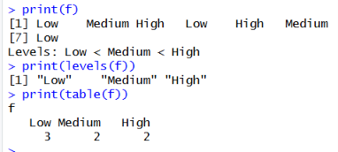
RESULT:
Ordered factors and category frequencies were displayed successfully.
18. AIM:
To demonstrate different string manipulation functions in R.

ALGORITHM:
1. Create character strings.
2.Calculate string length using nchar()
3.Extract substrings using substr()
4. Apply paste(), toupper() and tolower().

# CODE:
x <- "Hello World"
print(nchar(x))
print(substr(x, 1, 5))
print(paste("Welcome", "to", "R"))
print(toupper(x))
print(tolower(x))
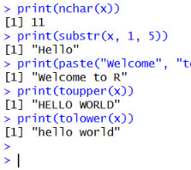
RESULT:
String manipulation functions were executed successfully.
19. AIM:
To create Date objects and perform date arithmetic in R.

ALGORITHM:
1. Create two dates in YYYY-MM-DD format.
2. Display both dates.
3. Calculate the difference in days.
4. Perform date arithmetic.

# CODE:

date1 <- as.Date("2026-01-01")
date2 <- as.Date("2026-01-15")
print(date1)
print(date2)
print(date2-date1)
print(date1+10)
print(date2-5)
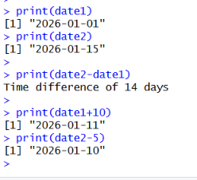

RESULT:
Date creation, date difference and date arithmetic were performed successfully.

20. AIM:
To create a student marks dataset using vectors, matrices and lists.
ALGORITHM:
1. Create student names and marks.
2. Store the marks in a matrix.
3. Calculate total and average marks.
4. Identify the highest mark and create a report list.

CODE:
name <- c("Arun", "Bala", "Chitra")
marks <- matrix(c(80, 90, 85,
70, 75, 80,
90, 95, 85),
nrow=3, byrow=TRUE)

colnames(marks) <- c("Maths", "Science", "English")
rownames(marks) <- name
total <- rowSums(marks)
average <- rowMeans(marks)
highest <- max(marks)
report <- list(
Names = name,
Marks = marks,
Total = total,
Average = average,
Highest_Mark = highest
)

print(marks)
print(total)
print(average)
print(highest)
print(report)
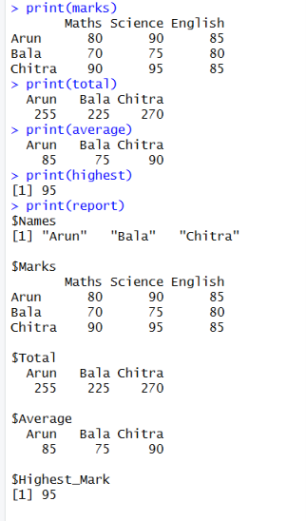
RESULT:
Student marks were analyzed successfully.
Total, average and highest marks were calculated.
A structured student report was created.

