How to run the EmployeeRecord System Django Python
1. Download the zip file
2. Extract the file, copy ers folder, and paste it on the desktop
3. Open MySQL Create a database erspythondb then import the SQL File available in the SQL File Folder (For MySQL we used XAMPP server)
4. Open PyCharm and click on the terminal
5. Navigate the project folder using the cd command
cd project_path
For ex: cd C:\Users\ANUJ\OneDrive\Desktop\ers
6. Now Navigate to the Apartment Visitor System folder
cd employeerecord
7. Run the Project using the following command
python manage.py runserver

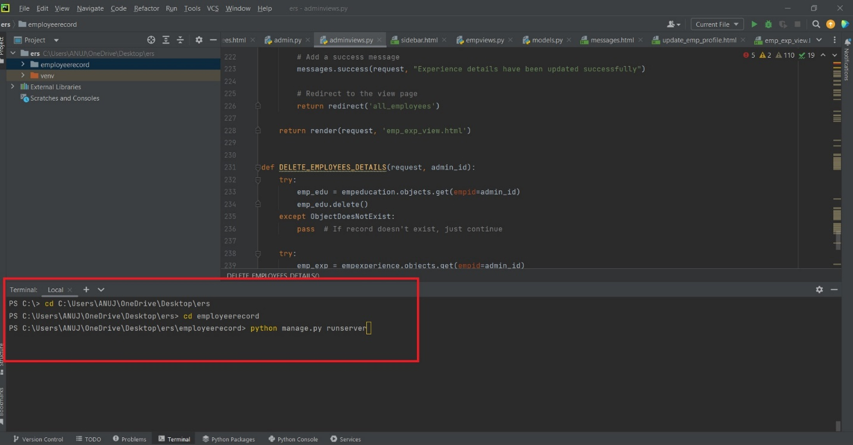

Login Details

*****Admin*****
Username: admin
Password: Test@123

*****Employee*****
Username: rahul12
Password: Test@123

Or Register a New Employee.

