**Week 3 - Entity Framework Core 8.0  
EF Core 8.0 Guided Hands-On Exercises**

**Lab 1: Understanding ORM with a Retail Inventory System**

Scenario: You’re building an inventory management system for a retail store. The store wants to track products, categories, and stock levels in a SQL Server database.

Objective: Understand what ORM is and how EF Core helps bridge the gap between C# objects and relational tables.

**- Created a .NET Console App:**

dotnet new console -n RetailInventory

cd RetailInventory

**- Installed EF Core Packages:**

dotnet add package Microsoft.EntityFrameworkCore.SqlServer

dotnet add package Microsoft.EntityFrameworkCore.Design

**Lab 2: Setting Up the Database Context for a Retail Store**

Scenario: The retail store wants to store product and category data in SQL Server.

Objective: Configure DbContext and connect to SQL Server.  
 **Models.cs**  
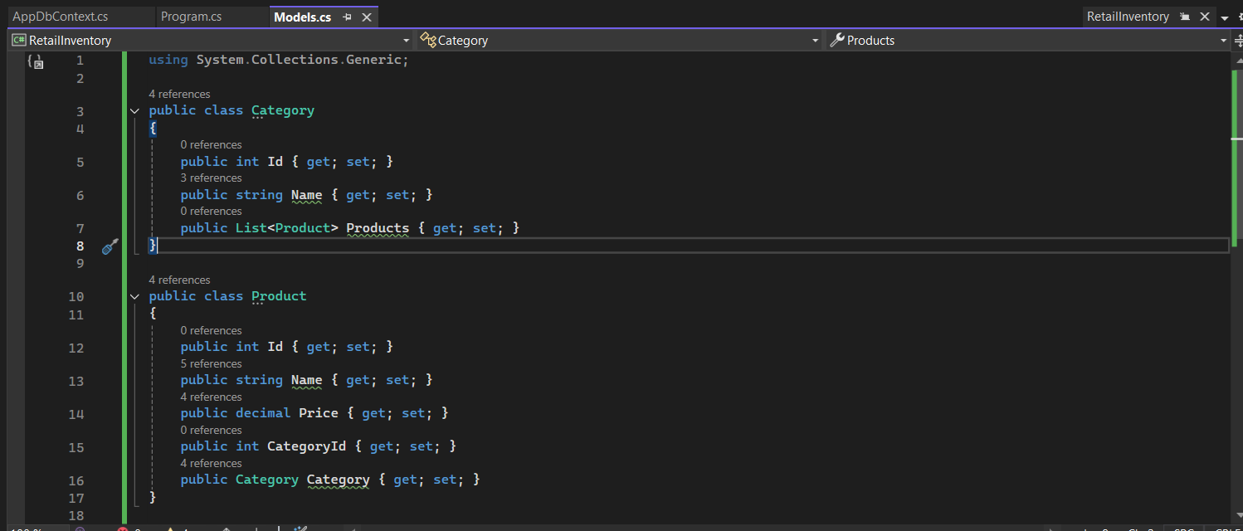

**AppDbContext.cs**  
  
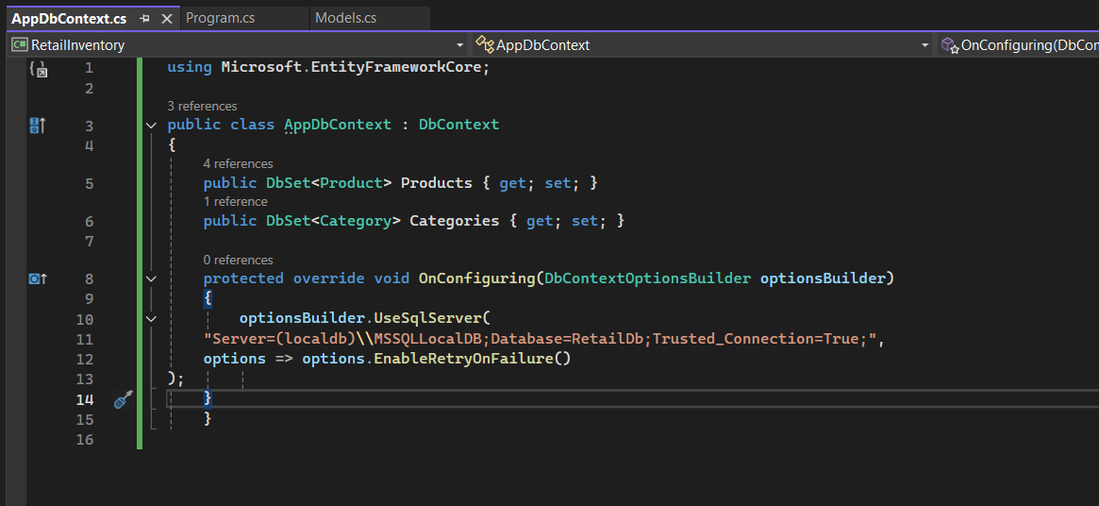

**Lab 3: Using EF Core CLI to Create and Apply Migrations**

Scenario: The retail store's database needs to be created based on the models you've defined. You’ll use EF Core CLI to generate and apply migrations.

Objective: Learn how to use EF Core CLI to manage database schema changes.

Steps:

1. Install EF Core CLI (if not already): dotnet tool install --global dotnet-ef

2. Create Initial Migration: dotnet ef migrations add InitialCreate This generates a Migrations folder with code that represents the schema.

3. Apply Migration to Create Database: dotnet ef database update

4. Verify in SQL Server: Open SQL Server Management Studio (SSMS) or Azure Data Studio and confirm that tables Products and Categories are created.

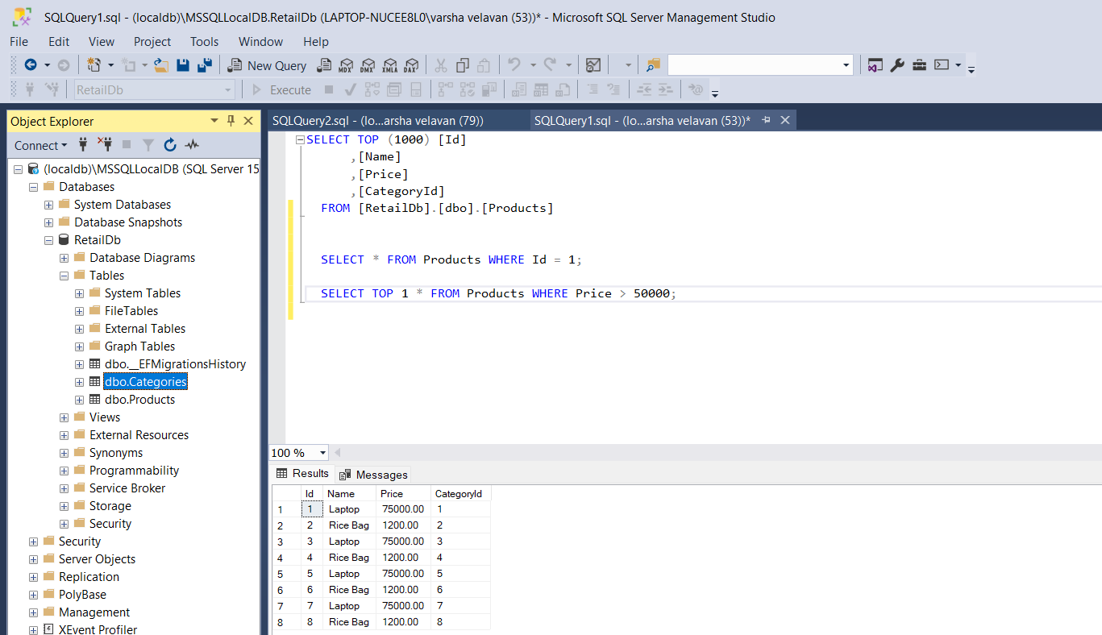

**Lab 4: Inserting Initial Data into the Database**

Scenario: The store manager wants to add initial product categories and products to the system.

Objective: Use EF Core to insert records using AddAsync and SaveChangesAsync.

**Lab 5: Retrieving Data from the Database**

Scenario: The store wants to display product details on the dashboard.

Objective: Use Find, FirstOrDefault, and ToListAsync to retrieve data.

Steps:

1. Retrieve All Products

2. Find by ID

3. FirstOrDefault with Condition

**Program.cs  
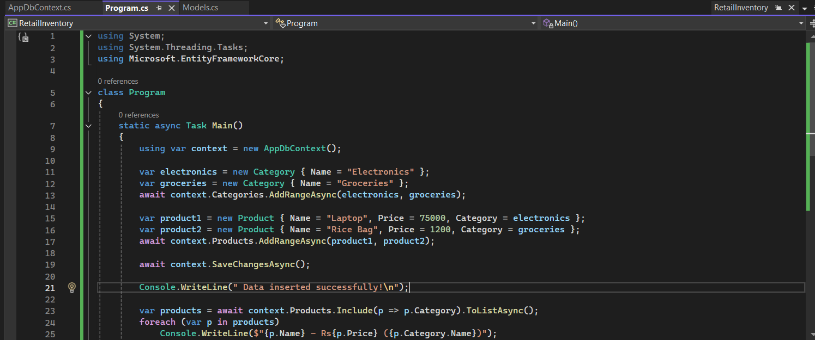**

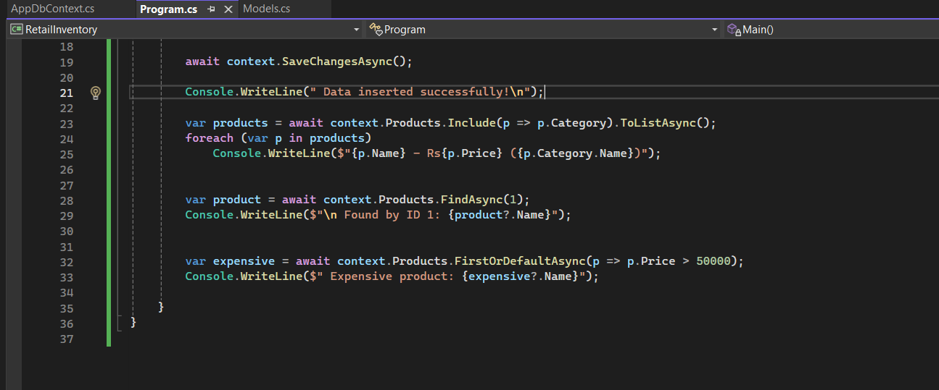

**Output:**  


