Linear Dimensionality Reduction-Survey,
Insights
Stats 517 Literature Review
-Varsha Venugopal

1.Introduction:
Linear dimensionality reduction techniques have been evolved all through statistics, machine learning, and applied fields for over a century, and these strategies have turned out to be imperative devices for examining high dimensional, noisy data. These strategies deliver a low-dimensional linear mapping of the first high-dimensional information that saves some component of interest for the data. Linear dimensionality reduction can be utilized for picturing or investigating structure in information, de-noising or packing information, and removing important component spaces. These strategies, over an assortment of information types and fields, proposes an incredible intricacy to the space of linear dimensionality reduction systems. In that case, there has been little exertion to merge our comprehension. Here we review a large group of strategies and explore when a more broad advancement system can enhance execution and expand the consensus of these methods.
A typical false assumption is that numerous or all linear dimensionality reduction issues can be lessened to eigenvalue or summed up eigenvalue issues. In addition to the fact that this is false basically, it is false for some exceptional algorithms that are regularly thought of as summed up eigenvalue issues. The sub-optimality of utilizing eigenvector bases in these settings is occasionally talked about and is one understanding of this review. Maybe acquired from this eigenvalue false output, a second normal inclination is for specialists to insatiably pick the low-dimensional information: the primary calculation is improved the issue goal, and afterward ensuing measurements are streamlined the goal on a leftover or lessened informational collection. The improvement structure in this demonstrates the confinement of this view.

1.Linear Dimensionality Reduction as a Matrix Optimization Program:

Linear Dimensionality Reduction is defined by: “Given n d-dimensional data points
X = [x1; :::; xn] $∈$ IR d$×$n and a choice of dimensionality r < d, optimize some objective fX(_) to produce a linear transformation P $∈$ IRr$×$d, and call Y = PX 2 IRr_n the low-dimensional transformed data.”

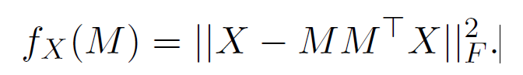

M= Matrix with r Orthonormal columns
Here produces an M such that P=Mt and the expected low dimensional projection is Y=MtX.

Note additionally that both PCA and CCA result in a framework disintegration, and to be sure a typical way to deal with numerous linear dimensionality reduction techniques is to endeavor to cast the issue as an eigenvalue or summed up eigenvalue issue (Burges, 2010). This interest
can be productive however is constrained, frequently bringing about specially appointed or problematic calculations. As a specic model, in numerous settings symmetrical projections of information are required for perception,and other fundamental needs. Would we be able to make an Orthogonal CCA, where we look for symmetrical projections Ya = M> a Xa for a grid Ma with orthonormal sections (and comparable for Yb), to such an extent that the example connecting Ya and Yb is boosted? No known eigenvalue issue can create this projection, so one enticing and regular methodology is to orthonormalize Pa and Pb (the outcomes found by conventional CCA). We will demonstrate that this decision can be significantly imperfect, and in later segments we will make Orthogonal CCA utilizing a nonexclusive advancement program. Along these lines network disintegration approaches recommend a disastrous constraint to
the arrangement of conceivable direct dimensionality decrease issues, and a more extensive structure is required to completely catch Definition 1 and linear dimensionality reduction.

  - Optimization Framework for Linear Dimensionality Reduction:
Given Denition 1, the instinct behind this improvement program ought to be evident: the objective fX(.) explains the element important to be caught in the information, and the lattice complex encodes a few parts of the linear mapping P with the end goal that Y = PX.2
All techniques considered here determine M as one of two grid frames. In the first place, a few strategies are unconstrained enhancements over rank r linear mappings, inferring the trifling complex imperative of Euclidean space, which we indicate as M 2 IRdr. For this situation, streamlining might be clear, and calculations like desire boost (Dempster et al., 1977) or standard first solvers have been very much utilized.
Second, all the time the framework shape will have a symmetry requirement M = fM 2 IRdr : M>M = Ig, relating to symmetrical projections of the information X. For this situation we compose M = Odr. As noted beforehand, the normal and frequently awed methodology is to endeavor to give these issues a role as eigenvalue issues. Rather, saw through the perspective of Equation 1, linear dimensionality reduction is just an improvement program over a network complex, and to be sure there is a very much created streamlining writing for framework manifolds (establishments incorporate Luenberger, 1972; Gabay, 1982; Edelman et al., 1998; an astounding synopsis is Absil et al., 2008).
As a basic role of this work is to review linear dimensionality reduction, we first
detail linear dimensionality reduction methods utilizing this advancement structure. We at that point actualize a conventional solver for projects of the frame Equation 1, where M is the group of symmetrical frameworks O d$×$r.

- Survey of Linear Dimensionality Reduction Methods:
We presently survey linear dimensionality reduction systems utilizing the structure of Section 2, to comprehend the issue specic goal and complex imperative of every strategy.
  - Linear Dimensionality Reduction with Orthogonal Matrix Constraints:
Among all dimensionality reduction strategies, the most generally utilized procedures are symmetrical projections. These strategies owe their ubiquity to a limited extent because of their basic geometric elucidation as a low-dimensional perspective of high-dimensional information. This elucidation is of extraordinary solace to numerous application zones, since these techniques don't articially make or then again overstate numerous sorts of structure in the information, as is conceivable with different models that encode solid earlier presumptions.

    - Principal Component Analysis:
Initially detailed by Pearson (1901) as a minimization of the sum of squared residual errors between projected data points and the original data. PCA reduces reconstruction error of the projected data points with the original data points. It rotates so that the principal axis lie in the direction of maximum covariance.
PCA in formula is defined as,
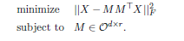
Qr -denotes the columns of Q associated with the largest r eigenvalues.

Few examples for PCA are:

kernel PCA: Which uses PCA on a feature space instead of the inputs themselves.

Probabilistic PCA: This can be run generatively to provide samples from the distribution.

    - Multidimensional scaling:

It is a means of visualizing the level of similarity of individual cases of a dataset. It refers to a set of related ordination techniques used in information visualization, in particular to display the information contained in a distance matrix.
A more general MDS problem statement is to fit the low-dimensional data so as to preserve these pairwise distances as closely as possible in the least squares.
MDS seeks to maximize pairwise distances.
MDS leads to the seemingly novel optimization program (Equation 1) over the scatter
Objective.
which can be expanded as,
X – It has zero mean and hence,

    - Linear Discriminant Analysis:
The purpose of LDA is to project the data in such a way that separation between classes is maximized. A common misconception is that LDA for higher dimensional projections r > 1 can be solved with a greedy selection of the top r eigenvectors. However, this is certainly not the case, as the top r eigenvectors will not be orthogonal in general.
LDA begins by splitting the data covariance into covariance contributed within each of the c classes (W) and covariance contributed between the classes.
For, 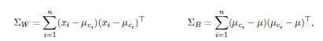
-Global Data Mean
LDA optimizes the program to,
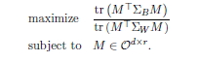
    - Canonical Correlations Analysis
It is a way of inferring information from cross covariance matrices. CCA is a problem of joint dimensionality reduction.
Consider 2 data sets, and find the low dimensional mapping between them given by formula,
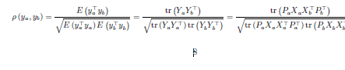
    - Maximum Autocorrelation Factors
It is a kind of method that seek to preserve temporally interesting structure in the projected data. MAF can be seen as a method balancing the desire for cross-covariance () of the data without over counting data that has high power.
MAF is used for yielding the objective given by,
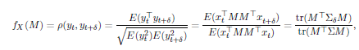
Where sigma – Empirical covariance of the data
- symmetrized empirical cross-covariance of the data evaluated at a one-step time lag

    - Slow Feature Analysis

It is a technique developed to seek invariant representations in object recognition problems.
SFA assumes that measured data, such as pixels in a movie, can have rapidly changing values over time, whereas the identity, pose, or position of the underlying object should move much more slowly. Thus, recovering a slowly moving projection of data may produce a meaningful representation of the true object of interest. It is defined by,

    - Sufficient Dimensionality Reduction
It is to find an orthogonal projection of the data. Such that the reduced-dimension points Y capture all statistical dependency between X and Z. Thus, SDR is a problem of feature selection.
Defined by , 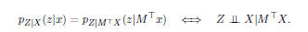
It makes covariates and responses conditionally independent.

    - Locality Preserving Projections

It is a direct linear interpretation of Laplacian Eigenmaps.
LPP begins by defining a graph with each data point as a vertex, connecting with the edge if these points are in the same neighborhood.
The cost of the reconstruction yi = Pxi is then,
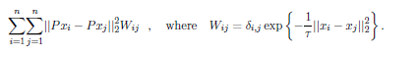
To weight the existing edges a kernel is used.

- Linear Dimensionality Reduction with Unconstrained Objectives
All methods reviewed so far involve orthogonal mappings, but several methods simplify
further to an unconstrained optimization over matrices
3.1.1 Independent Component Analysis:
It is a massively popular class of methods that is often considered alongside PCA and other simple linear transformations.
It describes the data as combination of independent and unknown sources.
Given by, 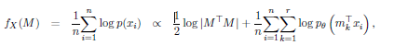
Where is the columns of M.

3.1.2 Factor Analysis:
It is one of the most widely used statistical methods, in particular in psychology and behavioral sciences. Factor Analysis is a more general case of Probabilistic PCA model.
Given by, 
3.1.3 Linear Regression:
Linear regression is one of the most basic and popular tools for statistical modeling. This technique maps d-dimensional data onto an r-dimensional hyperplane defined by the number of independent variables.
It is to 
Using this model a regressed data set is generated.
3.1.4 Distance Metric Learning:
It is an important class of machine learning methods that is typically motivated by the desire to improve a classification method.
It uses Mahalanobis distance dM(xi; xj) instead of Euclidean distance, to measure the distance.
Few of the instances include, k-nearest neighbors and support vector machines which will calculate distances between training points, and the performance of these algorithms can be improved by a careful choice of distance metric between these points.
This optimizes the objective, 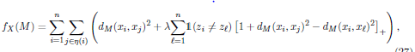
4.Summary:
This paper surveys and consolidates the space of linear dimensionality reduction methods.
It clarifies that linear dimensionality reduction goes well beyond PCA.
The paper tells that it requires much more than simply eigenvalue decompositions.
This consolidated view suggests that, optimization programs over well-understood matrix manifolds address a significant subclass of these methods.

5.Results:
A portion of these works have been in the machine learning network , and some have made the association of geometric advancement techniques to PCA.
All methods considered here have specified as either unconstrained matrices or matrices with orthonormal columns.
In the unconstrained case, numerous standard optimizers can and have been brought to bare to optimize the objective. In the orthogonal case, the very well-understood geometry of the manifold of orthogonal matrices enables optimization over these manifolds.
  - Performance Improvement: We demonstrate the quantitative improvements shown by directly optimizing an objective, rather than resorting to an eigenvector.

Performance comparison:
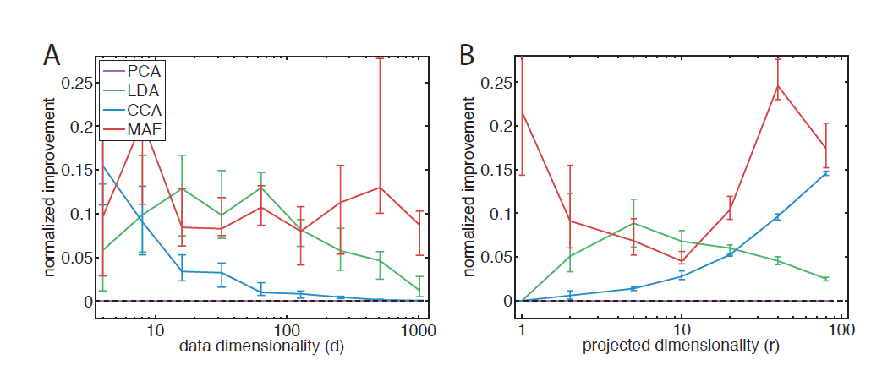
Figure shows the distribution of normalized improvements for PCA is entirely 0 in panel A. Performance comparison between heuristic solvers and direct optimization of linear dimensionality reduction objectives. The vertical axis depicts the normalized improvement of the optimization program over traditional approaches where the vertical bars indicate the error rate.
Cautionary example of differences in objectives for LDA:

Figure shows the suboptimality for LDA . In
Every grid(A and B), the data is simulated with the dimensionality d = 3, with n = 3000 points,
corresponding to 1000 points in each of 3 clusters. In the right figure we have optimized the objective hence known as Orthogonal LDA and the Heuristic LDA is obtained by, orthogonalizing the top two eigenvectors of the matrix .The performance in the right subpanel showed a better performance as it it was obtained by using the optimization framework rather than following the traditional approach as shown in the left subpanel.
  - Computational Cost: Matrix manifold solver does not incur massive computational cost.The only additional computation beyond standard unconstrained first-order optimization of variables is the projection onto or along the manifold to ensure a feasibility, which in any scheme requires a matrix decomposition.
Computational cost of direct optimization:
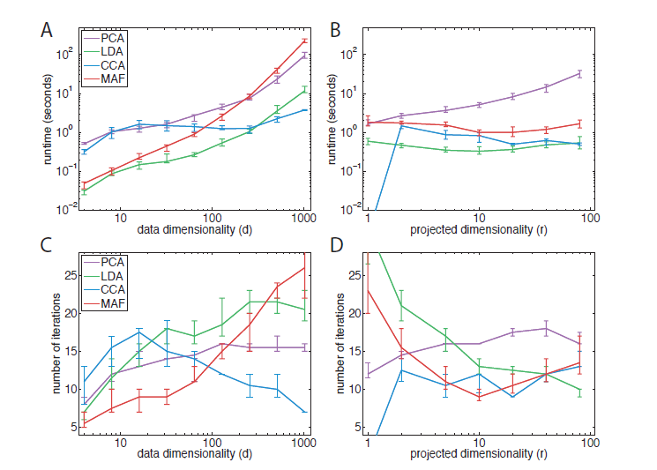
Same Data sets is used which was used for Figure 2. The vertical axis in panels
A and B denotes runtime in seconds. Panels C and D show the same data by the number of solver iterations. This panel demonstrates that runtime increases ~(approx) linearly as expected in d. I.e they vary linearly.

5.Future Scope:
- This survey also suggests that future linear dimensionality reduction algorithms can be derived in a simpler and more principled fashion. Of course, even with such a method one must be careful to design a linear dimensionality reduction sensibly to avoid the many unintuitive pitfalls of high-dimensional data.
- Both that literature and the present work focus on optimizing objective functions on projections to a lower dimensional coordinate space.
- The literature approach leads to (potentially significant) suboptimality of the results and requires costly computation on the space of the high-dimensional data for structure removal.
- References:
Linear Dimensionality Reduction:
Survey, Insights, and Generalizations ,Cunningham and Ghahramani
P. A. Absil, R. Mahony, and R. Sepulchre. Optimization Algorithms on Matrix Manifolds.
Princeton University Press, Princeton, 2008.
M. Borga, T. Landelius, and H. Knutsson. A uni_ed approach to PCA, PLS, MLR, and
CCA. Technical Report, 1997.

