ELECTRIC VEHICLE CHARGE AND RANGE ANALYSIS

**Abstract**

This project aims to provide comprehensive insights into the current state and future potential of electric vehicles (EVs) in India. Utilizing **Tableau Public** as the primary data visualization tool, the project integrates and analyzes four diverse datasets covering aspects such as **charging infrastructure**, **EV range and efficiency**, **plug types**, and **vehicle pricing**.

The data was cleaned, pre-processed, and visualized through a series of **interactive dashboards**, enabling dynamic exploration of EV trends. These visualizations reveal key patterns such as region-wise distribution of charging stations, availability of fast chargers, comparison of EV ranges by brand, and affordability analysis of electric cars. The study highlights the gaps and opportunities in India's EV ecosystem, helping to assess **regional readiness** for EV adoption.

### ****Keywords**:**

Electric Vehicle (EV), EV Charging Stations, EV Range, Plug Types, Data Visualization, Tableau Public, Sustainable Mobility, India EV Market, Charging Infrastructure, Regional Analysis, EV Pricing, Interactive Dashboards, Clean Energy, Electric Mobility Trends, Policy Making.

### ****Introduction****

The global shift towards sustainable transportation has placed **electric vehicles (EVs)** at the forefront of innovation and policy development. With growing concerns over climate change, rising fuel prices, and the need to reduce carbon emissions, many countries—including India—are promoting electric mobility as a cleaner and more efficient alternative to traditional fuel-powered vehicles.

India, being one of the largest automotive markets in the world, is rapidly adapting to this change. However, the successful adoption of EVs depends on several factors such as **vehicle range**, **charging infrastructure**, **cost-effectiveness**, and **public awareness**. Understanding these factors through data-driven insights can accelerate the growth and adoption of EVs in both urban and rural regions.

# Problem Statement

With the rapid growth of electric vehicles, buyers and decision-makers need data-driven insights into range, vehicle types, and charging infrastructure. This project provides a visual dashboard to understand key EV factors using open datasets.

# Objectives

- Analyze EV vehicle types and range

- Compare charging plug types and their capabilities

- Visualize pricing vs range trends

- Identify states with the highest number of charging stations

- Build an interactive dashboard using Tableau

# Pre-requirements

Before starting the project, the following software and skills are required:  
  
1. Basic understanding of data analytics and visualization  
2. Tableau Public installed or access to Tableau Public online  
3. Microsoft Excel for data preprocessing  
4. CSV format data files related to EV specifications and charging stations  
5. A stable internet connection to access Tableau Public and datasets  
  
These requirements ensure a smooth workflow from data cleaning to visualization.

# Datasets Used

1. EVIndia.csv – Indian EV models with range and type

2. ElectricCarData_Clean.csv – Global EV specs including price and charging

3. Cheapestelectriccars-EVDatabase.csv – Affordable EVs data

4. electric_vehicle_charging_station_list.csv – Charging station locations and regions in India

# Tools Used

- Tableau Public (Data Visualization)

- CSV format data

- Preprocessing in Microsoft Excel

# Methodology

1. Collected EV-related datasets

2. Cleaned and prepared using Excel

3. Imported into Tableau Public

4. Created multiple sheets with meaningful charts

5. Combined all visuals into a single interactive dashboard

6. Published to Tableau Public

# Dashboard Explanation

Sheet 1: Vehicle Type Distribution – Count of EV types in India

Sheet 2: Range by Plug Type – Avg. range comparison by plug

Sheet 3: FastCharge vs Plug Type – Fast charging speed per plug

Sheet 4: Price vs Range – Relationship between price and range

Sheet 5: Charging Stations by Region – No. of charging stations in Indian states

# Key Insights

- Plug Type 2 is most common for high-range vehicles

- EVs with fast charging support are gaining popularity

- Maharashtra and Karnataka have more charging stations

- Price and range are closely related, with higher-priced EVs offering better range

# Expanded Project Objectives

This project is intended to help stakeholders in the electric vehicle (EV) sector gain better insight into EV performance, availability, and infrastructure. The key objectives include:  
  
- Visualizing the distribution of different types of EVs available in India.  
- Understanding the relationship between vehicle price and range to assist potential buyers.  
- Comparing the efficiency and range of EVs based on plug types and charging capabilities.  
- Identifying fast-charging capabilities and highlighting which models support them.  
- Mapping the availability of charging stations across Indian states and analyzing regional readiness.  
- Creating an interactive Tableau dashboard that allows filtering and deep-diving into the datasets.

# Benefits of the Project

The EV Charge and Range Analysis dashboard provides the following benefits:  
  
- Helps EV buyers compare range, price, and performance of available electric cars.  
- Aids policymakers in identifying regions lacking sufficient charging infrastructure.  
- Assists researchers and manufacturers in analyzing market trends.  
- Offers interactive and easy-to-understand visuals to present complex datasets.  
- Encourages data-driven decision-making in the automotive and energy sectors.

# Future Scope

This project can be extended further in the following ways:  
  
- Integration of real-time EV performance and location data.  
- Incorporation of battery life, warranty, and environmental impact factors.  
- Predictive analytics to forecast EV adoption growth in different regions.  
- Use of machine learning models to suggest best EVs based on user preferences.  
- Expansion to include international EV data for global comparison.

**Result:**

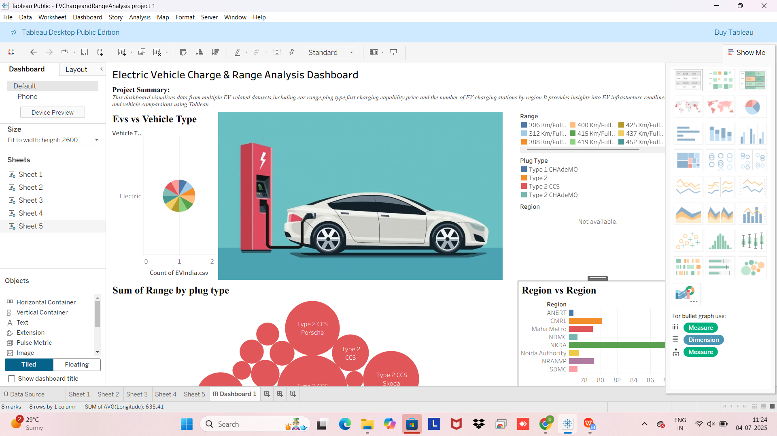

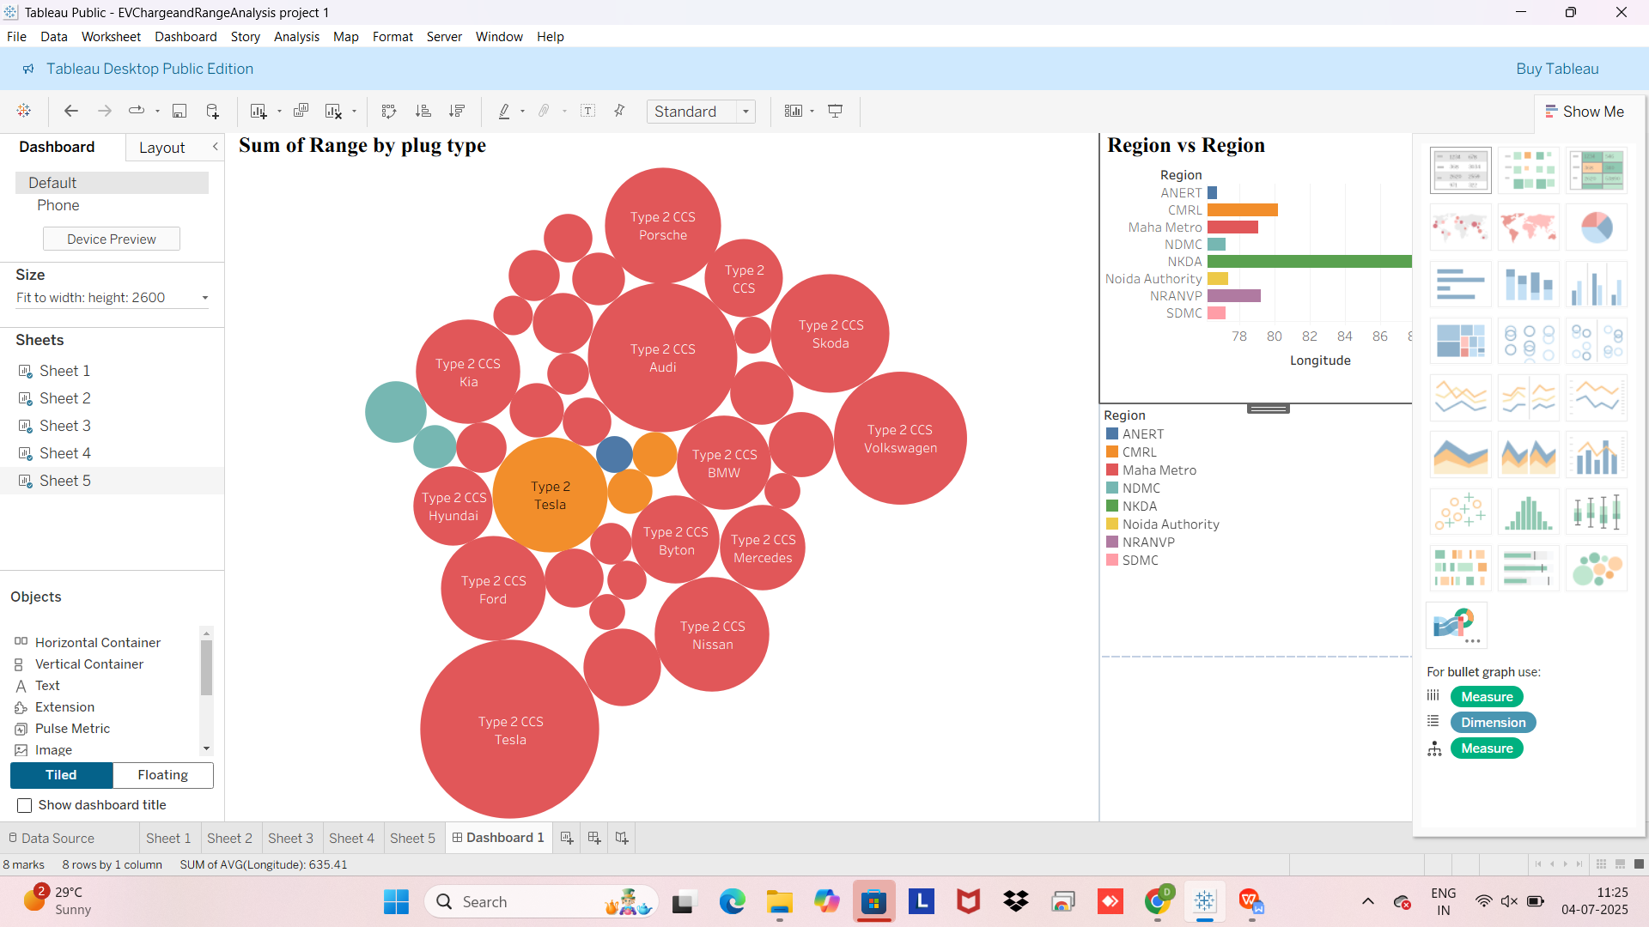

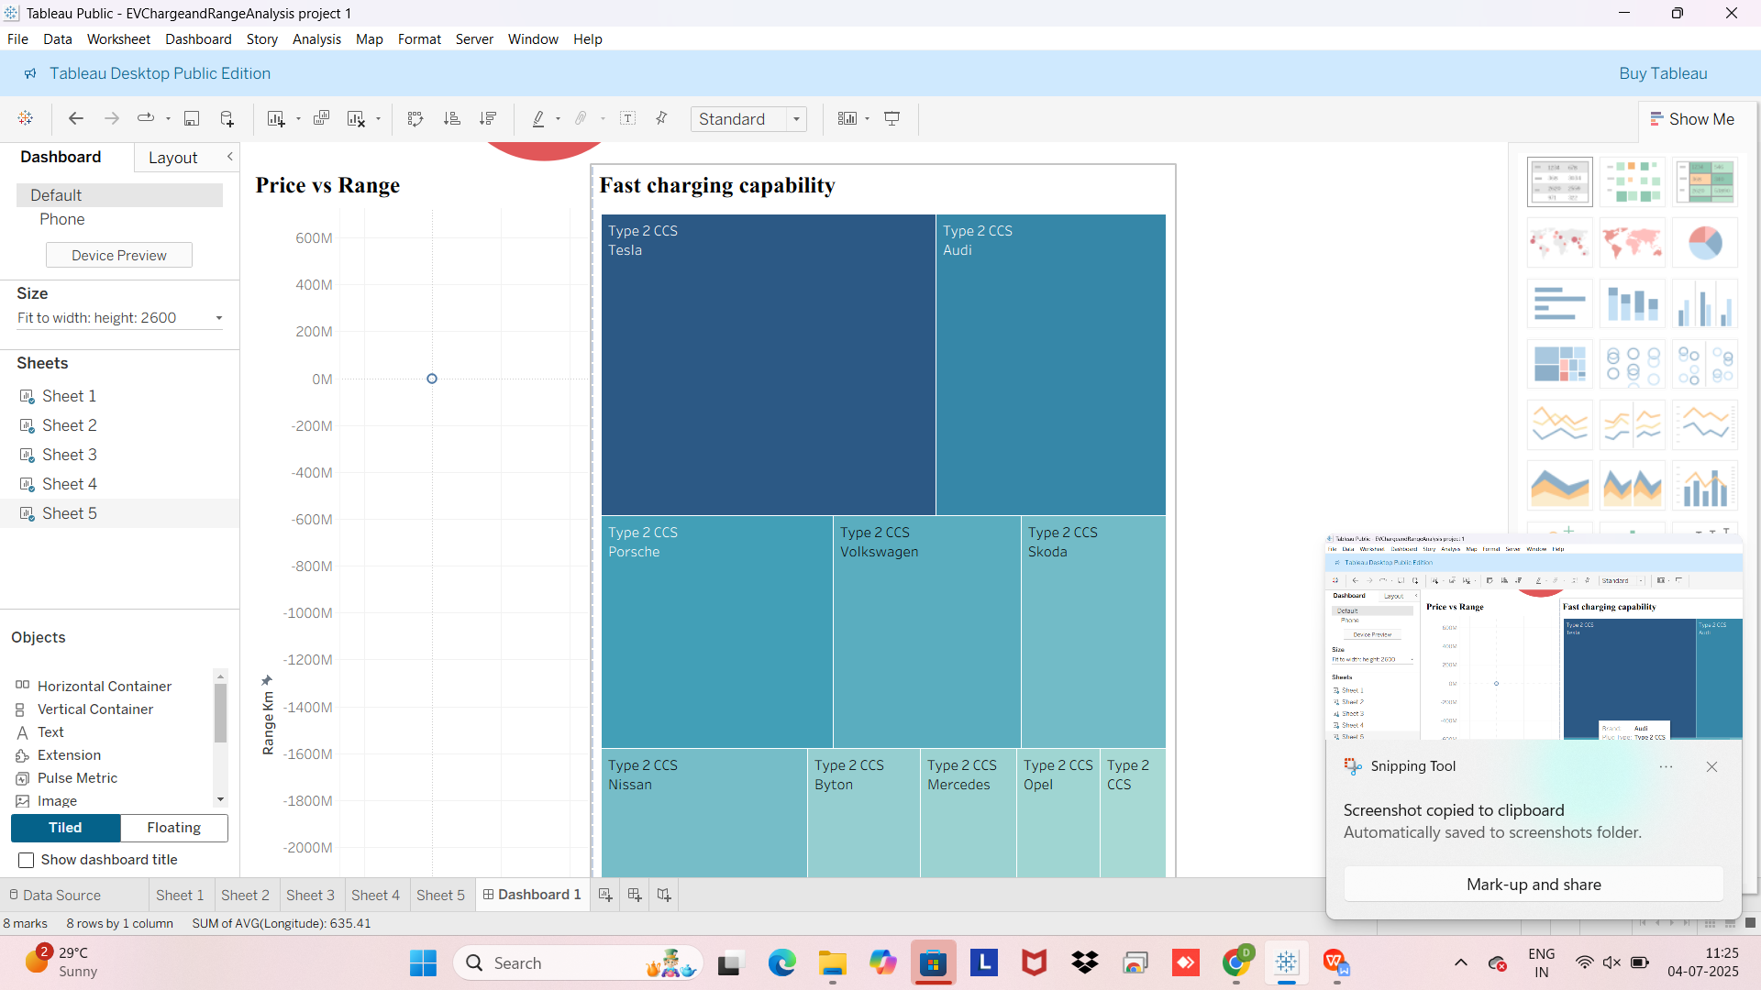

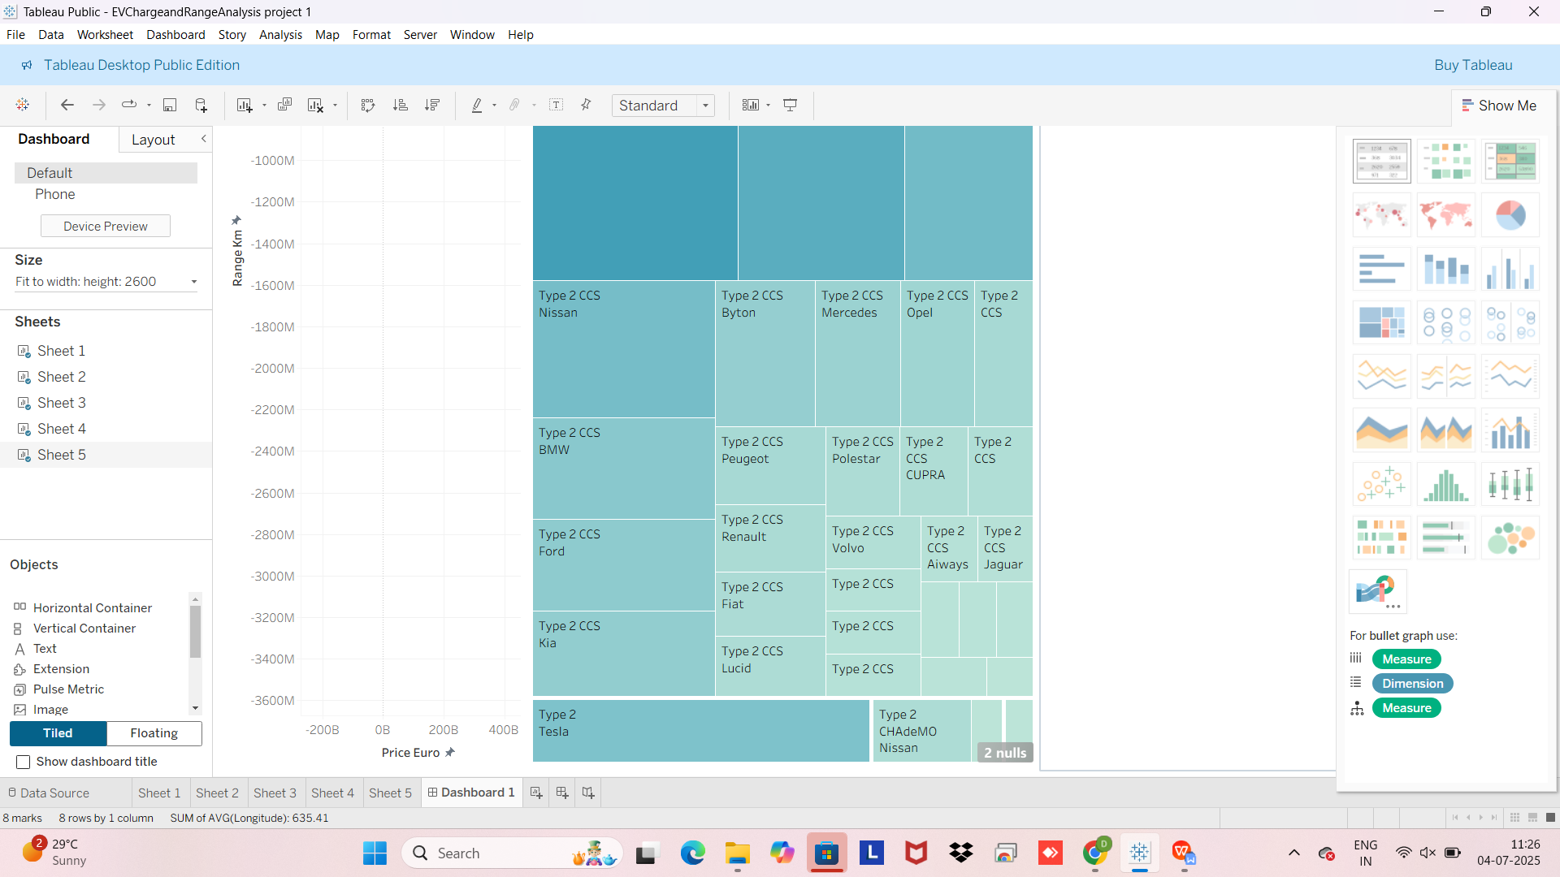

# Tableau Public Link

<https://public.tableau.com/app/profile/devi.varshini.jakkampudi/viz/EVChargeandRangeAnalysis/Dashboard1?publish=yes>