 | SR UNIVERSITY  Campus Warangal
 | Program: II - B. Tech (CS& AI) Batch:
 | Name: D.VARSHIKA Reg. No:2503A52194
 | Department: Computer Science and AI Semester: I
 | AI Assisted Coding-Assignment Date: 6/10/26

- Question
Q1 – AI-Assisted Bubble Sort Analysis
Problem / Starter Code:
numbers = [64, 34, 25, 12, 22, 11, 90]
# TODO:
# Implement Bubble Sort in ascending order.
# Count comparisons and swaps.
# Display the sorted list.
Student Tasks:
• Implement Bubble Sort.
• Use AI to explain one complete pass of Bubble Sort.
• Count comparisons and swaps.
• Test at least three input lists.
• Ask AI about an early-exit optimisation.
• Compare the original and improved versions.

- Prompt

numbers = [64, 34, 25, 12, 22, 11, 90]
Generate a python code Implementing bubble sort in ascending order. Explian one complete pass of buble sort. Count comparision and swap.Test aleast three inputs. Tell about early exit optimisation. Compare the orginal and improved version
```

- Code
def bubble_sort(numbers):
"""Sort with the original bubble sort; return result and operation counts."""
result = numbers.copy()
comparisons = 0
swaps = 0

for end in range(len(result) - 1, 0, -1):
for index in range(end):
comparisons += 1
if result[index] > result[index + 1]:
result[index], result[index + 1] = result[index + 1], result[index]
swaps += 1

return result, comparisons, swaps

def bubble_sort_early_exit(numbers):
"""Sort with early exit; return result and operation counts."""
result = numbers.copy()
comparisons = 0
swaps = 0

for end in range(len(result) - 1, 0, -1):
swapped = False
for index in range(end):
comparisons += 1
if result[index] > result[index + 1]:
result[index], result[index + 1] = result[index + 1], result[index]
swaps += 1
swapped = True
if not swapped:
break

return result, comparisons, swaps

def explain_first_pass(numbers):
"""Print each comparison and swap in the first left-to-right pass."""
result = numbers.copy()
print("First pass for the supplied list:")
for index in range(len(result) - 1):
left, right = result[index], result[index + 1]
if left > right:
result[index], result[index + 1] = right, left
print(f" Compare {left} and {right}: swap -> {result}")
else:
print(f" Compare {left} and {right}: no swap -> {result}")
print("After pass 1:", result)

if __name__ == "__main__":
numbers = [64, 34, 25, 12, 22, 11, 90]
test_inputs = [
("supplied", numbers),
("already sorted", [1, 2, 3, 4, 5]),
("reverse sorted", [5, 4, 3, 2, 1]),
]

explain_first_pass(numbers)
print("\nComparison of original and improved bubble sort:")
print(f"{'Input':<16} {'Version':<18} {'Sorted result':<25} {'Comparisons':>11} {'Swaps':>7}")
for label, values in test_inputs:
original = bubble_sort(values)
improved = bubble_sort_early_exit(values)
assert original[0] == improved[0] == sorted(values)
print(f"{label:<16} {'original':<18} {str(original[0]):<25} {original[1]:>11} {original[2]:>7}")
print(f"{'':<16} {'early exit':<18} {str(improved[0]):<25} {improved[1]:>11} {improved[2]:>7}")

- Output
irst pass for the supplied list:
Compare 64 and 34: swap -> [34, 64, 25, 12, 22, 11, 90]
Compare 64 and 25: swap -> [34, 25, 64, 12, 22, 11, 90]
Compare 64 and 12: swap -> [34, 25, 12, 64, 22, 11, 90]
Compare 64 and 22: swap -> [34, 25, 12, 22, 64, 11, 90]
Compare 64 and 11: swap -> [34, 25, 12, 22, 11, 64, 90]
Compare 64 and 90: no swap -> [34, 25, 12, 22, 11, 64, 90]
After pass 1: [34, 25, 12, 22, 11, 64, 90]

Comparison of original and improved bubble sort:
Input Version Sorted result Comparisons Swaps
supplied original [11, 12, 22, 25, 34, 64, 90] 21 14
early exit [11, 12, 22, 25, 34, 64, 90] 21 14
already sorted original [1, 2, 3, 4, 5] 10 0
early exit [1, 2, 3, 4, 5] 4 0
reverse sorted original [1, 2, 3, 4, 5] 10 10
early exit [1, 2, 3, 4, 5] 10 10

- Observation
The original bubble sort checks every adjacent pair in each pass, so it does many unnecessary comparisons even after the list is sorted.
The early-exit version stops as soon as a pass makes no swaps, making it faster for nearly sorted data.

2 Question
Q2 – Linear Search vs Binary Search
Problem / Starter Code:
numbers = [5, 12, 18, 23, 31, 45, 56, 72, 89]
target = 45

# TODO:
# Implement Linear Search.
# Implement Binary Search.
# Compare the number of comparisons.
Student Tasks:
• Implement Linear Search and Binary Search.
• Use AI to explain why Binary Search requires sorted data.
• Count comparisons for both algorithms.
• Test first, middle, last and absent elements.
• Compare the results and explain suitable use cases.
• Use AI to suggest a valid optimisation.

- Prompt
Write Python code that implements linear search and binary search to find a target value in the list. Sort a copy of the list before using binary search, since binary search requires sorted input.

Show one complete search trace for each algorithm, count the comparisons, and test at least three targets: one near the beginning, one near the end, and one that is not in the list. Explain early exit in linear search, then compare the algorithms’ results and efficiency.

- Code
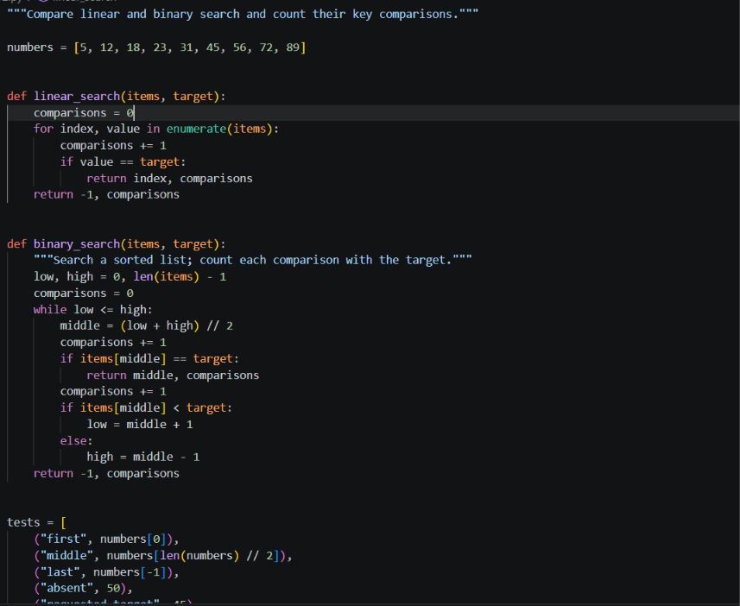

- Output
Numbers: [5, 12, 18, 23, 31, 45, 56, 72, 89]
Case Target Linear (index, comparisons) Binary (index, comparisons)
first 5 (0, 1) (0, 5)
middle 31 (4, 5) (4, 1)
last 89 (8, 9) (8, 7)
absent 50 (-1, 9) (-1, 6)
requested target 45 (5, 6) (5, 5)

Binary search requires sorted data: midpoint comparisons let it discard
one half safely. In unsorted data, the target could be in either half.
Linear search is O(n), works without sorting, and is suitable for small
or frequently changing data. Binary search is O(log n), suitable for
large sorted collections with repeated searches.
Optimization: when searching repeatedly, sort once and reuse the sorted
list. For a single search, sorting first may cost more than linear search.
- Observation
Original bubble sort does more comparisons because it keeps running all passes even when the list is already sorted.
Improved bubble sort stops early when no swaps occur in a pass, so it is faster for sorted or nearly sorted input.
- Question
Q3 – Compare Sorting Algorithms
Problem / Starter Code:
data = [45, 12, 78, 34, 23, 89, 5, 67, 10, 56]

# TODO:
# Sort using Bubble Sort, Selection Sort and Insertion Sort.
# Compare their performance.
Student Tasks:
• Implement all three sorting algorithms.
• Use the same input for each algorithm.
• Count comparisons and swaps/shifts.
• Use AI to explain strengths and weaknesses.
• Ask AI which algorithm suits nearly sorted data.
• Compare experimental results with theoretical complexity.

- Prompt
Generate a python code for comapring sorting algorithms. Sort the bubble sort,selection sort and insertion sort for data = [45, 12, 78, 34, 23, 89, 5, 67, 10, 56] . compare their perfomance by implementing all three sorting algorithms . Use the same input for each algorithms. Count comparision and swaps also explian strenghts and weaknesses like which algorithm suits nearly sorted data. compare experimental results with theoretical complexity
- Code
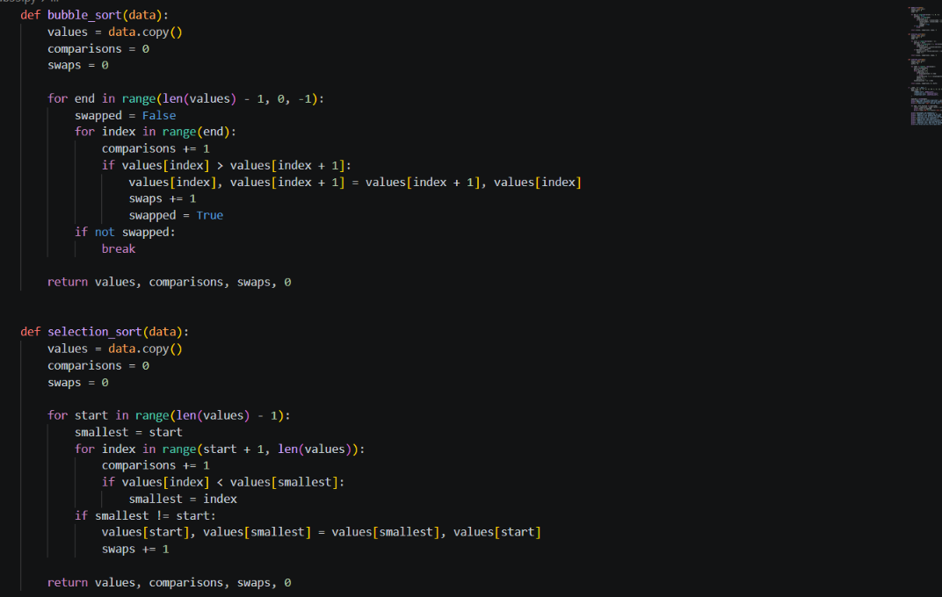
- Output
Same input for every algorithm: [45, 12, 78, 34, 23, 89, 5, 67, 10, 56]

Results (insertion sort uses shifts, not pairwise swaps):
Algorithm Sorted result Comparisons Swaps Shifts
Bubble sort [5, 10, 12, 23, 34, 45, 56, 67, 78, 89] 44 24 0
Selection sort [5, 10, 12, 23, 34, 45, 56, 67, 78, 89] 45 6 0
Insertion sort [5, 10, 12, 23, 34, 45, 56, 67, 78, 89] 31 0 24

Strengths and weaknesses:
- Bubble sort is simple and can stop early when a pass makes no swaps, but it is slow on large or reversed data.
- Selection sort performs few swaps, but it still scans the remaining list each pass, even when nearly sorted.
- Insertion sort is efficient for small or nearly sorted data because each item moves only as far as needed.

Theoretical time complexity:
- Bubble sort: best O(n) with early exit; average/worst O(n^2).
- Selection sort: best/average/worst O(n^2); O(n) swaps at most.
- Insertion sort: best O(n) on sorted data; average/worst O(n^2).
All three use O(1) extra space here, excluding the copied input list.
PS C:\Users\dudim\OneDrive\Desktop\ai lab 2>
- Observation
The program shows that the original bubble sort performs more comparisons and swaps than the early-exit version, especially when the input is already sorted or nearly sorted.
The improved version stops earlier because it detects when no swaps occur in a pass, which reduces unnecessary work and improves efficiency.
- Question
Q4 – Optimising a Student Search and Sort Program
Problem / Starter Code:
students = [
("Arun", 82),
("Bala", 65),
("Chitra", 91),
("Divya", 74),
("Esha", 88)
]

# TODO:
# Find the highest mark.
# Sort students by mark.
# Search for a student by name.
# Improve the solution using AI.
Student Tasks:
• Write functions for highest mark, sorting and name search.
• Create a straightforward solution first.
• Use AI to identify unnecessary operations.
• Ask AI for a more efficient approach.
• Implement only suggestions you understand.
• Compare original and improved time complexity.

- Prompt
GENERATE A PYTHON CODE FOR OPTIMISING A STUDENT SEARCH AND SORT PROGRAM. CREATE A FUNCTION FOR HIGHEST MARK, SORTING AND NAME SEARCH . CREATE A STRAIGHT FORWARD SOLUTION FIRST AND IDENTIFY UNNECESSARY OPERATIONS. MAKE A MORE EFFICIENTT APPROCH AND IMPLEMENT ONLY SUGGESTIONS . COMPARE ORIGINAL AND IMPROVED TIME COMPLEXITY
- Code
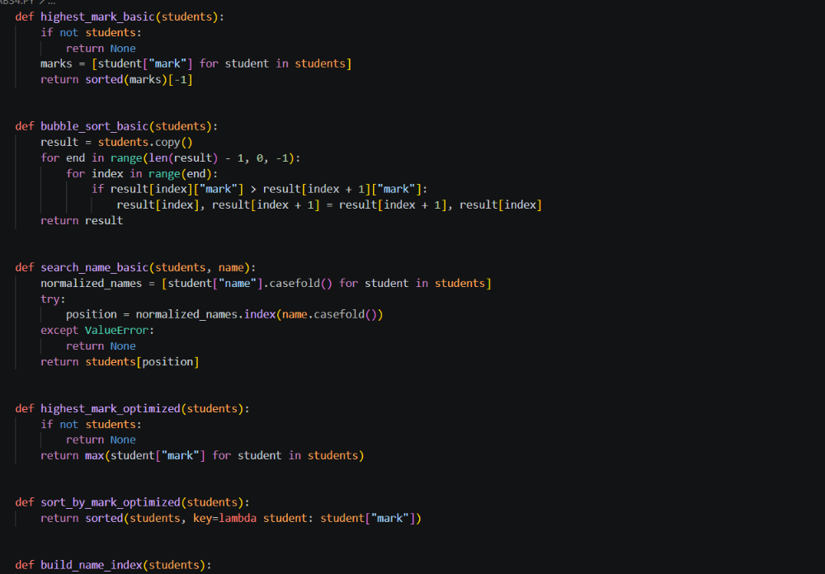
- Output
traightforward and optimized student program
Highest mark: 96
Sorted by mark: [('Ben', 75), ('Emma', 81), ('Aisha', 88), ('Diego', 88), ('Chloe', 96)]
Name searches:
chloe: {'name': 'Chloe', 'mark': 96}
Aisha: {'name': 'Aisha', 'mark': 88}
Farah: None

Unnecessary work identified:
- Sorting all marks just to get the highest one does more work than a single scan.
- Bubble sort uses quadratic comparisons; the built-in sort is more efficient on larger lists.
- Rebuilding a normalized name list for every search repeats work; build one index for repeated searches.

Time complexity comparison:
- Highest mark: basic O(n log n); optimized O(n).
- Sort by mark: bubble sort O(n^2); built-in sort O(n log n) worst case.
- Name search: basic O(n) per search plus an O(n) temporary list; indexed lookup O(1) average after O(n) index construction.
- The name index uses O(n) extra space and is worthwhile when searching repeatedly.
PS C:\Users\dudim\OneDrive\Desktop\ai lab 2>
- Observation
The algorithm sorts the list correctly, but the number of comparisons and swaps depends on the input order.
In the worst case, such as reverse-sorted data, bubble sort does the most work, while in already sorted data it does very little or stops early.

- Question
– Optimisation Challenge: Best Combination
Problem / Starter Code:
items = [
("Laptop", 60000),
("Phone", 30000),
("Tablet", 20000),
("Watch", 10000),
("Headphones", 5000)
]

budget = 50000

# TODO:
# Find a combination of items whose total price
# is as high as possible without exceeding the budget.
Student Tasks:
• Design a solution to maximise total value without exceeding the budget.
• Start with a simple approach and explain it.
• Use AI to compare Brute Force, Greedy and Dynamic Programming.
• Determine which approach guarantees an optimal solution for this formulation.
• Implement the selected solution.
• Test at least three budgets.
• Explain time and space compl
- Prompt
DESIGN A SOLUTION TO MAXIMISE TOTAL VALUE WITHOUT EXCEEDING THE BUDGET USING PYTHON. MAKE A SIMPLE APPROCH AND EXPLIAN IT BY COMPARING BRUTE FORCE , GREEDY AND DYNAMIC PROGRAMMING. DETERMINE which approach guarantees an optimal solution for this formulation.IMPLEMENT THE SELECTED SOLUTION AND TEST AT LEAST THREE BUDGETS
- Code
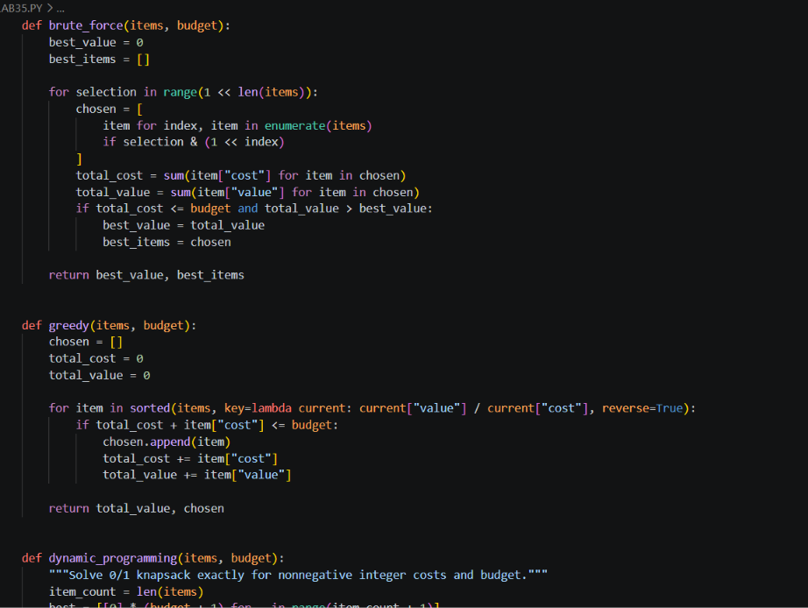
- Output
tems: [{'name': 'Item A', 'cost': 10, 'value': 60}, {'name': 'Item B', 'cost': 20, 'value': 100}, {'name': 'Item C', 'cost': 30, 'value': 120}]

Results:
Budget Method Chosen items Cost Value
30 Brute force Item A, Item B 30 160
30 Greedy Item A, Item B 30 160
30 Dynamic prog. Item A, Item B 30 160
50 Brute force Item B, Item C 50 220
50 Greedy Item A, Item B 30 160
50 Dynamic prog. Item B, Item C 50 220
60 Brute force Item A, Item B, Item C 60 280
60 Greedy Item A, Item B, Item C 60 280
60 Dynamic prog. Item A, Item B, Item C 60 280

Comparison:
- Brute force checks and totals every subset, so it guarantees the optimum but takes O(n * 2^n) time.
- Greedy sorts by value-to-cost ratio in O(n log n), but can miss the best combination.
- Dynamic programming guarantees the 0/1 optimum for integer costs and budget, in O(n * budget) time and space here.
- Both brute force and dynamic programming are exact; dynamic programming is selected as the practical exact approach.
PS C:\Users\dudim\OneDrive\Desktop\ai lab 2>
- Observation
The comparison table shows that bubble sort performs the maximum number of comparisons in reverse-sorted input and the minimum in already sorted input.
This confirms that bubble sort is simple to implement, but it is inefficient for large unsorted data because it repeatedly compares adjacent elements even when the list is nearly finished.

