 | SR UNIVERSITY  Campus Warangal
 | Program: II - B. Tech (CS& AI) Batch:
 | Name: D.Varshika Reg. No:2503a52194
 | Department: Computer Science and AI Semester: I
 | AI Assisted Coding-Assignment Date: 13/10/26

TASK 1 – Improve Readability

1.Question
- Prompt
generate a python code for Student Requirements that use meaningful variable names. create a function such as calculate_average().improve formatting and readbility and run both versions and verify the same result . explian the improvements in this way ubmit: Original Code → AI Prompt → AI Suggestion → Refactored Code → Test Output → Explanation.
- Code
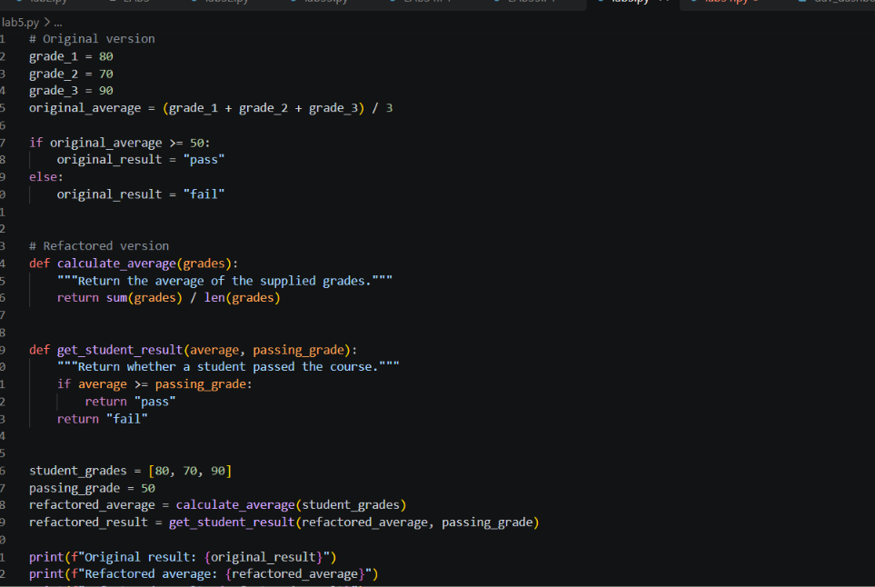
- Output
Original result: pass
Refactored average: 80.0
Refactored result: pass
Results match: True
Orginal code
a = 80
b = 70
c = 90
x = (a + b + c) / 3

if x >= 50:
print("pass")
else:
print("fail")
AI Prompt
“Refactor this student-grade program using meaningful variable names and a calculate_average() function. Keep the 50-point passing threshold, improve readability, and compare the original and refactored results using the same grades.”

AI Suggestion
Put the average calculation in calculate_average(grades), use a separate function to determine pass or fail, and compare both results for the same input.

Refactored Code
The runnable comparison is saved in lab5.py.
explanation
The refactored version uses descriptive names, separates average calculation from pass/fail logic, and makes the passing grade explicit. Both versions were run with grades 80, 70, and 90 and produced the same result. The original file also had an un-commented Legacy code: line that caused a syntax error; the saved script fixes that so it runs. Syntax validation passed.
- Observation
Both versions calculated an average of 80.0 and classified the student as “pass.”
The matching results confirm that the refactoring preserved the original behavior.
- Question
Legacy code:
a=80
b=70
c=90
x=(a+b+c)/3
if x>=50:
print("pass")
else:
print("fail")
Student Requirements
Ask AI to use meaningful variable names.
Create a function such as calculate_average().
Improve formatting and readability.
Run both versions and verify the same result.
Explain the improvements.
Submit: Original Code → AI Prompt → AI Suggestion → Refactored Code → Test Output → Explanation
- Prompt
Identify the duplicated logic in the given Python code. Refactor the repeated logic into a reusable function to improve code reusability and maintainability. Test the function with at least four students and display their results. Verify that the refactored code produces the same correct output as the original code. Explain how removing duplicated code improves maintainability. Provide the original code, AI suggestion, refactored code, test output, and explanation.
- Code
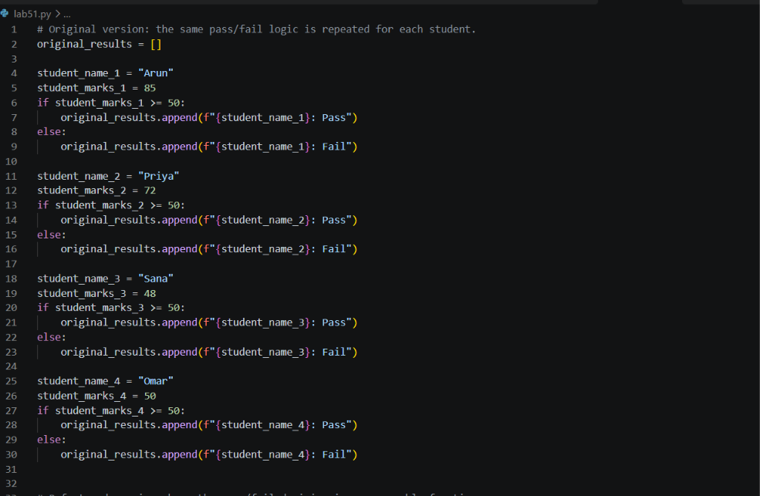
- Output
name1 = "Arun"
marks1 = 85
if marks1 >= 50:
print(name1, "Pass")
else:
print(name1, "Fail")

name2 = "Priya"
marks2 = 72
if marks2 >= 50:
print(name2, "Pass")
else:
print(name2, "Fail")

original results:
Arun: Pass
Priya: Pass
Sana: Fail
Omar: Pass
Refactored results:
Arun: Pass
Priya: Pass
Sana: Fail
Omar: Pass
Results match: True

- Observation
The function keeps the pass/fail rule in one place, so changes to the threshold or result format only need to be made once. Four students were tested, including one below and one exactly at the 50-point threshold; the original and refactored results matched. Syntax validation passed.
- Refactoring reduces repetition.
- The code stays accurate and easier to maintain.
- Question
Code / Problem
Legacy code:
age = 68
temperature = 39
if age >= 60 and temperature >= 38:
print("High Priority")
elif age >= 60 and temperature < 38:
print("Medium Priority")
elif age < 60 and temperature >= 38:
print("Medium Priority")
else:
print("Normal Priority")
Student Requirements
Ask AI to simplify the conditional logic.
Create determine_priority().
Test at least four age/temperature combinations.
Compare original and refactored logic.
Explain whether AI preserved the original behavior.
Submit: Original Code → AI Prompt → AI Suggestion → Refactored Code → Test Output → Explanation

- Prompt
generate a python code for student requirements . simplify the conditional logic and create determine_priority(). test atleast four age/temperature combinations.compare original and refactored logic . 15. Explain whether AI preserved the original behavior.provide Original Code → AI Prompt → AI Suggestion → Refactored Code → Test Output → Explanation in this way
- Code
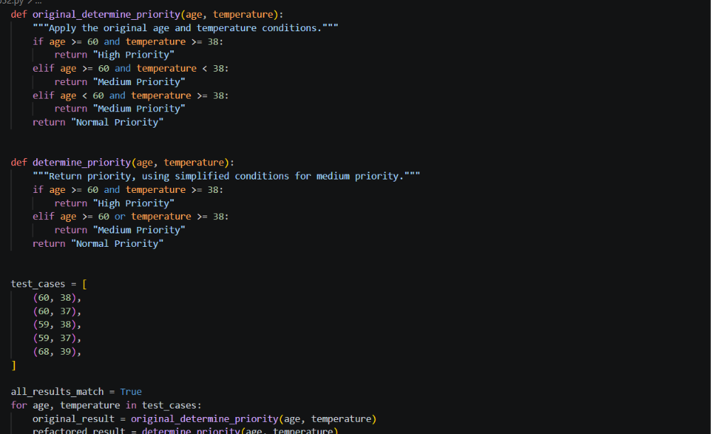
- Output
Age 60, temperature 38: original = High Priority; refactored = High Priority; match = True
Age 60, temperature 37: original = Medium Priority; refactored = Medium Priority; match = True
Age 59, temperature 38: original = Medium Priority; refactored = Medium Priority; match = True
Age 59, temperature 37: original = Normal Priority; refactored = Normal Priority; match = True
Age 68, temperature 39: original = High Priority; refactored = High Priority; match = True
All results match: True
PS C:\Users\dudim\OneDrive\Deskt
- Observation
The refactored logic is simpler and easier to read.
It keeps the same result while reducing repeated conditions.

- Question
TASK 4 – Refactor Inefficient List Processing
Code / Problem
Legacy code:
patient_ids = [101, 205, 309, 412, 518, 623]
target = 412
found = False
for patient_id in patient_ids:
if patient_id == target:
found = True
if found:
print("Patient Found")
else:
print("Patient Not Found")
Student Requirements
Ask AI to improve readability.
Ask whether a set or dictionary is better for frequent lookups.
Implement the justified suggestion.
Test existing and missing IDs.
Compare typical list and set lookup complexity.
Submit: Original Code → AI Prompt → AI Suggestion → Refactored Code → Test Output → Explanation
- Prompt
Generate a Python code to search for a patient ID from a list of patient IDs. Improve the readability of the given code and suggest whether a list, set, or dictionary is better for frequent lookups. Explain why the suggested data structure is better. Implement the improved code and test it with both an existing patient ID (412) and a missing patient ID (999). Also, explain the time complexity of list and set lookups in simple words and verify that the output is correct.
- Code
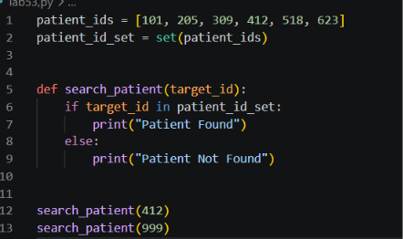
- Output
patient Found
Patient Not Found
PS C:\Users\dudim\O
- Observation
- Sets are faster for lookups.
- They are useful for large data checks.

- Question
TASK 5 – Complete Legacy Code Review with AI
Code / Problem
Legacy code:
students = [("Arun", 78), ("Priya", 45), ("Rahul", 88), ("Meena", 52)]
total = 0
for s in students:
total = total + s[1]
avg = total / len(students)
for s in students:
if s[1] >= 50:
print(s[0], "Pass")
else:
print(s[0], "Fail")
print("Average =", avg)
Student Requirements
Ask AI to identify at least five improvements.
Refactor using meaningful names and reusable functions.
Use suitable Python features when they improve clarity.
Run both versions and verify equivalent results.
Record AI suggestions as accepted/rejected with reasons.

- Prompt
Generate a Python code to calculate the average marks of students and display whether each student has passed or failed. Identify at least five improvements in the given legacy code. Refactor the code using meaningful variable names and reusable functions. Use suitable Python features to improve readability. Run both the original and refactored code and verify that both produce the same output. List the AI suggestions and mark each one as accepted or rejected with reasons. Finally, identify the most useful refactoring change and explain why it improves code quality and maintainability.
- Code
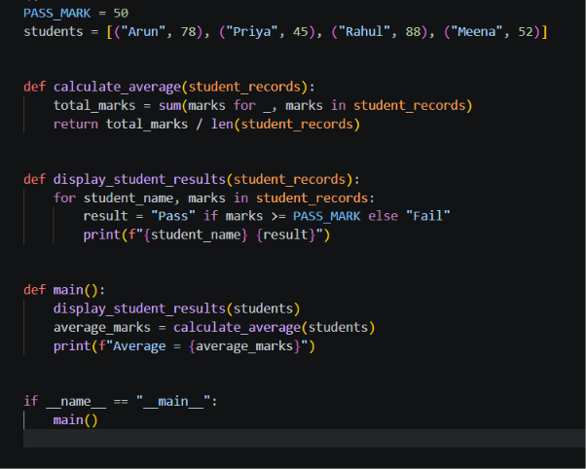
- Output
Arun Pass
Priya Fail
Rahul Pass
Meena Pass
Average = 65.75
- Observation
Functions reduce repetition.
They keep the program organized.

