**Name**: Varshil Shah

**UID**: 2022301013

**Batch**: D

**Aim**:

Design Interactive Dashboards and Storytelling using using Power BI / Power BI / R / Python / D3.js on the dataset - Animal / Wildlife / Marine

* Basic - Bar chart, Pie chart, Histogram, Timeline chart, Scatter plot, Bubble plot, Advanced -

Word chart, Box and whisker plot, Violin plot, Regression plot (linear and nonlinear), 3D chart, Jitter.

* Write observations from each chart.

# Theory:

#### Dataset:

<https://www.kaggle.com/datasets/varshilshah09/characteristics-of-various-animals-in-a-zoo>

#### Dataset Description:

This dataset consists of 101 animals from a zoo. There are 16 variables with various traits to describe the animals. The 7 Class Types are: Mammal, Bird, Reptile, Fish, Amphibian, Bug and Invertebrate

The purpose for this dataset is to be able to predict the classification of the animals, based upon the variables. It is the perfect dataset for those who are new to learning Machine Learning.

#### Columns Description:

1. **animal_name** - Name of the animal (unique identifier).
2. **hair** - Binary; indicates if the animal has hair (1) or not (0).
3. **feathers** - Binary; indicates if the animal has feathers (1) or not (0).
4. **eggs** - Binary; indicates if the animal lays eggs (1) or not (0).
5. **milk** - Binary; indicates if the animal produces milk (1) or not (0).
6. **airborne** - Binary; indicates if the animal can fly (1) or not (0).
7. **aquatic** - Binary; indicates if the animal lives in water (1) or not (0).
8. **predator** - Binary; indicates if the animal is a predator (1) or not (0).
9. **toothed** - Binary; indicates if the animal has teeth (1) or not (0).
10. **backbone** - Binary; indicates if the animal has a backbone (1) or not (0).
11. **breathes** - Binary; indicates if the animal breathes air (1) or not (0).
12. **venomous** - Binary; indicates if the animal is venomous (1) or not (0).
13. **fins** - Binary; indicates if the animal has fins (1) or not (0).
14. **legs** - Numeric; represents the number of legs the animal has (0, 2, 4, 5, 6, 8).
15. **tail** - Binary; indicates if the animal has a tail (1) or not (0).
16. **domestic** - Binary; indicates if the animal is domesticated (1) or not (0).
17. **catsize** - Binary; indicates if the animal is roughly cat-sized (1) or not (0).
18. **type** - Numeric; classifies the animal into one of seven classes (1 to 7).

# Charts:

#### Sum of Animal Count by Aquatic Status and Airborne Status:

* 1. **DAX Code:**

EVALUATE SUMMARIZE(

Zoo, Zoo[aquatic], Zoo[airborne],

"Aquatic Status", IF(Zoo[aquatic] = 1, "Aquatic", "Non-Aquatic"), "Airborne Status", IF(Zoo[airborne] = 1, "Airborne", "Non-Airborne"), "Animal Count", COUNT(Zoo[animal_name])

)

#### Chart:

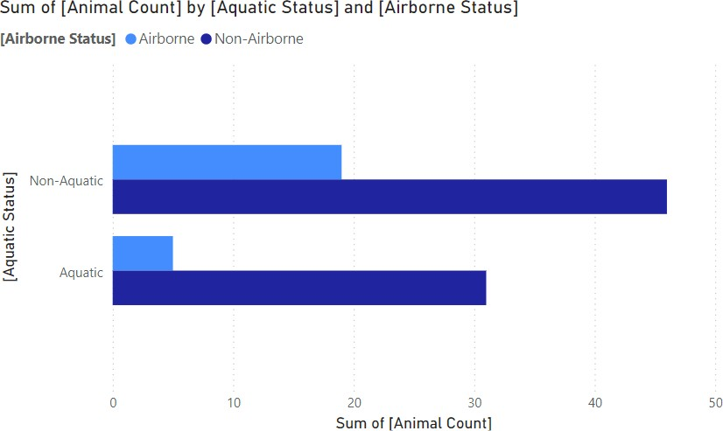

* + - **Non-Aquatic Animals Dominate**: The majority of animals in the dataset are not aquatic. This is evident from the longer bar representing the "non-aquatic" category compared to the "Aquatic" category.
    - **Airborne Animals are Fewer**: Within both the aquatic and non- aquatic categories, there are fewer airborne animals. The blue bars, representing airborne animals, are shorter than the dark blue bars representing non-airborne animals.
    - **Non-Aquatic Non-Airborne Animals are Most Numerous**: The largest number of animals falls into the category of being neither aquatic nor airborne. This is indicated by the longest dark blue bar.

In summary, this chart suggests that the zoo primarily houses terrestrial animals, with a smaller proportion of aquatic and airborne species.

1. **Sum of Animal Count by Predator Status and Domesticated Status:**
   1. **DAX Code:**

EVALUATE SUMMARIZE(

Zoo, Zoo[predator], Zoo[domestic],

"Predator Status", IF(Zoo[predator] = 1, "Predator", "Not Predator"), "Domesticated Status", IF(Zoo[domestic] = 1, "Domesticated", "Wild"), "Animal Count", COUNT(Zoo[animal_name])

)

## Chart:

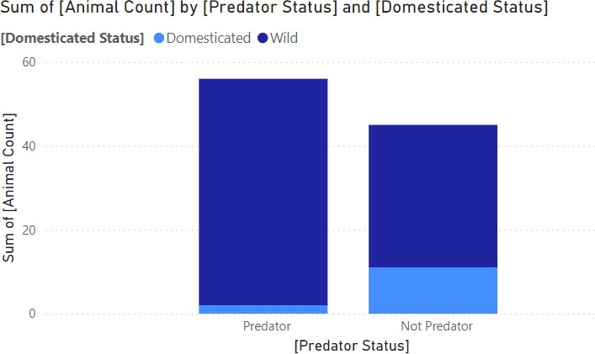

### **Predators are Primarily Wild:** The majority of predators in the zoo are wild animals, as indicated by the taller dark blue bar in the "Predator" category.

* + - **Non-Predators are More Diverse:** The "Not Predator" category shows a more balanced distribution between domesticated and wild animals. While the wild animals still outnumber the domesticated ones, the difference is less pronounced.
    - **Domesticated Animals are Mostly Non-Predators:** The majority of domesticated animals in the zoo are not predators, as evidenced by the larger light blue bar in the "Not Predator" category.

In summary, this chart suggests that the zoo has a higher proportion of wild predators compared to wild non-predators. Additionally, domesticated animals in the zoo are predominantly peaceful species.

## Sum of Animal Count by Animal Category:

* 1. **DAX Code:**

EVALUATE SUMMARIZE(

zoo, zoo[class_type], "Animal Category", SWITCH(

zoo[class_type], 1, "Mammal",

2, "Bird",

3, "Reptile",

4, "Fish",

5, "Amphibian",

6, "Insect",

7, "Other"

),

"Animal Count", COUNT(zoo[animal_name])

)

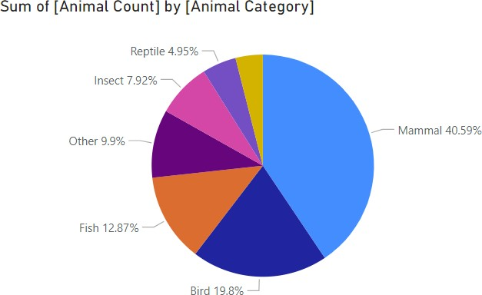

## Observations:

### **Mammals Dominate:** The largest proportion of animals in the zoo are mammals, making up nearly 41% of the total count.

* + **Birds and Fish are Significant:** Birds and fish constitute a substantial portion of the zoo's population, with 19.8% and 12.87%, respectively.
  + **Other Categories are Smaller:** Reptiles, insects, and other categories each account for less than 10% of the total animal count.

### In summary, this chart highlights the zoo's focus on mammals while also showcasing a diverse representation of various animal groups.

1. **Comparison of Airborne and Non-Airborne:**

## DAX Code:

EVALUATE SUMMARIZE(

Zoo, Zoo[airborne],

"Airborne Count", CALCULATE(COUNT(Zoo[animal_name]), Zoo[airborne] = 1), "Non-Airborne Count", CALCULATE(COUNT(Zoo[animal_name]), Zoo[airborne] =

0)

)

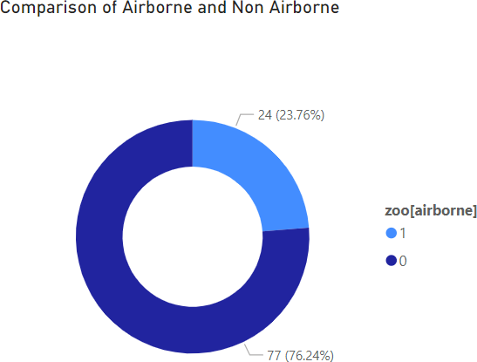

## Observations:

* + **Overwhelmingly Non-Airborne:** A significant majority of the animals in the zoo are not airborne, constituting 76.24% of the total population.
  + **Small Proportion of Airborne Animals:** Only 23.76% of the animals in the zoo are capable of flight.

### In summary, this chart highlights the predominance of non-airborne species in the zoo's collection.

1. **Sum of Predator Count by Animal Category:**

## DAX Code:

EVALUATE SUMMARIZE(

Zoo, Zoo[class_type],

"Predator Count", CALCULATE(COUNT(Zoo[animal_name]), Zoo[predator] = 1)

)

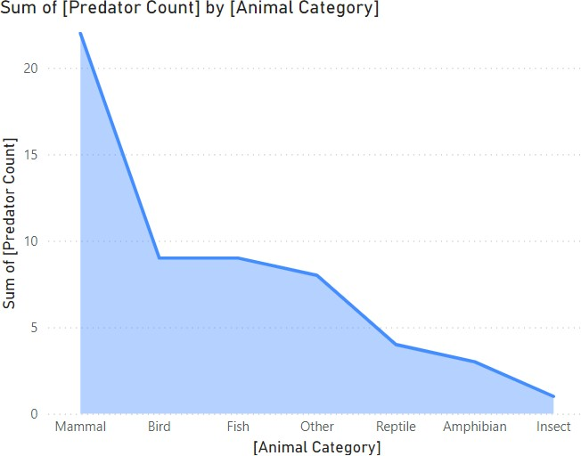

## Observations:

* + **Mammals Have the Highest Predator Count:** Mammals exhibit the largest number of predators, with a count significantly higher than other categories.
  + **Birds and Fish Have Moderate Predator Counts:** Both birds and fish have a moderate number of predators, with their counts being relatively similar.
  + **Reptiles, Amphibians, and Insects Have Low Predator Counts:** These categories show significantly lower predator counts compared to mammals, birds, and fish.

### In summary, this chart suggests that mammals are the dominant predators in the zoo, while reptiles, amphibians, and insects have a much lower representation of predator species.

#### Dashboard:

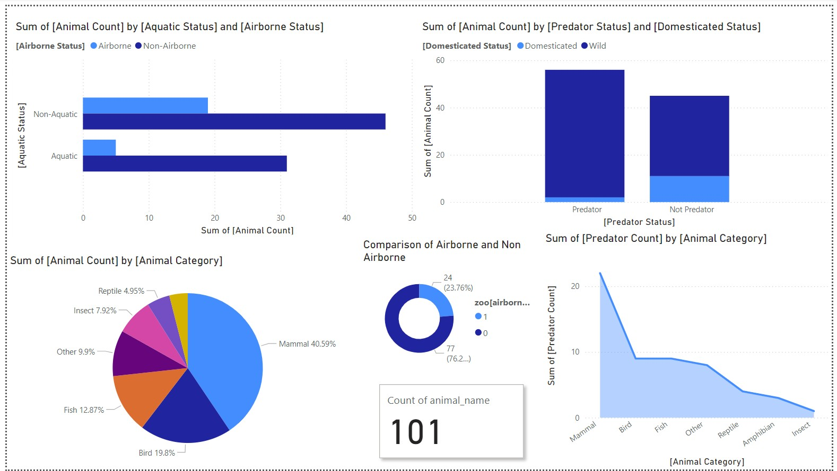

**Questions:**

#### Which animal category has the highest number of individuals in the zoo?

Answer: Mammals have the highest number of individuals in the zoo.

#### What is the relationship between predator status and domesticated status among zoo animals?

Answer: Most predators in the zoo are wild animals, while a majority of domesticated animals are non-predators.

#### How do the proportions of airborne and non-airborne animals compare?

Answer: The zoo has a significantly higher proportion of non-airborne animals compared to airborne animals.

#### Which animal categories have the highest and lowest predator counts?

Answer: Mammals have the highest predator count, while insects have the lowest.

#### What is the distribution of animal counts based on aquatic and airborne status?

Answer: The majority of animals in the zoo are non-aquatic, and within both aquatic and non- aquatic categories, there are fewer airborne animals.

#### Conclusion:

Through the analysis of the zoo dataset using Power BI, we gained valuable insights into the zoo's animal population. Key findings include the dominance of mammals, the predominance of wild

predators, and the relatively small proportion of airborne and aquatic animals. The zoo's diverse range of animal categories demonstrates its commitment to showcasing various species. This analysis provides a foundation for future studies and helps inform decisions regarding the zoo's management

and expansion.