**FIRE ALARM DEVICES**

**(FIRE DOORS)**

5/31/2019

**Importing Records:**

Fire Alarm devices are inspected on a yearly basis. All the records from last year will get duplicated by the system to be inspected for the current year. At any given time, data of two years is kept in the system. Users will be prompted to export last year’s inspections to local files. Also, 2 year old inspections would be deleted permanently from the database.

**Choose Building:**

Selecting the building from the drop down menu, retrieves all records in the building for the current year.

**Search button:** Enters find mode to search for devices for the current year.

**Follow Up devices:** Retrieves all records with “Follow Up” field value set to “YES”.

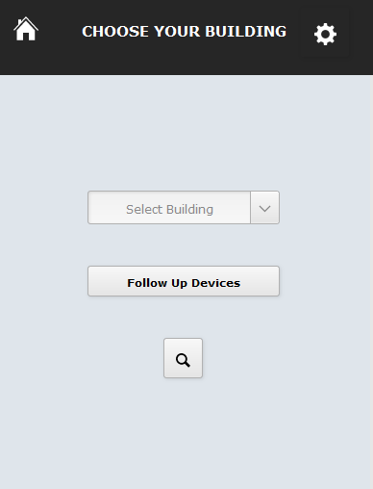

**To add a new building:**

Click the “gear” button (top-right) to be directed to the form below.

Click the “+” button to add the new building.

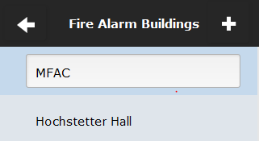

**Fire Alarm Inspections Form:**

On selecting the building from the drop down menu, all devices from that building for the current year will be retrieved by default. The retrieved records can further be filtered by floor.

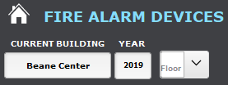

**Show All in Current Building:**



This button resets any filters and finds all the devices from the current building for the present year.

**Current Building & Year Search:**



This button enters find mode to accept field values from the user and performs the search in the current building for the present year.

**Add Record:**

The “Add Record” button on the top- right creates a new record and sets the current building name and year automatically. The user can choose to change it if required. Make sure to delete the newly created record manually, if it is no longer required.

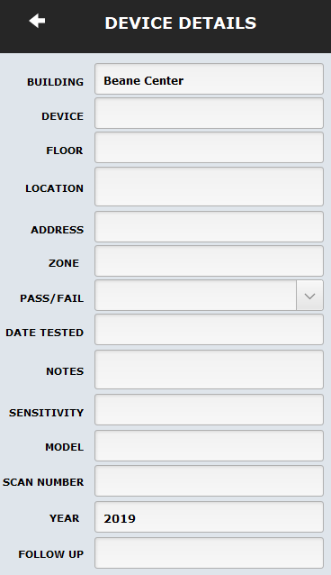

**Print Layout:**

Formats the records in the Found set convenient for printing and emailing as PDF files.

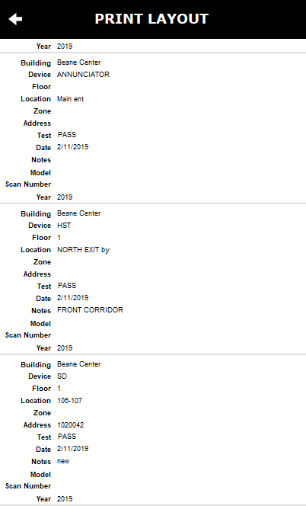

**Export Excel:**

Allows to export the Found Set of records in an excel format.