**TRAINING**

**Importing Records:**

1. Export Records from Formstack to Excel and save it locally on the machine.
2. Login to Filemaker using an account which has full privileges.
3. Click the ‘Import Excel’ button.
4. Open the saved file in Step 1.
5. At the top-right, ensure that the Target is ‘Current Table (“TraineesPersonalDetails”).
6. Click and drag the fields (Name (First), Name (Last), Department, Job Title, Email) so that they match correspondingly. They should also have an arrow between them. At the bottom-left, check across ‘Don’t import first record (contains field names)’. Click OK.

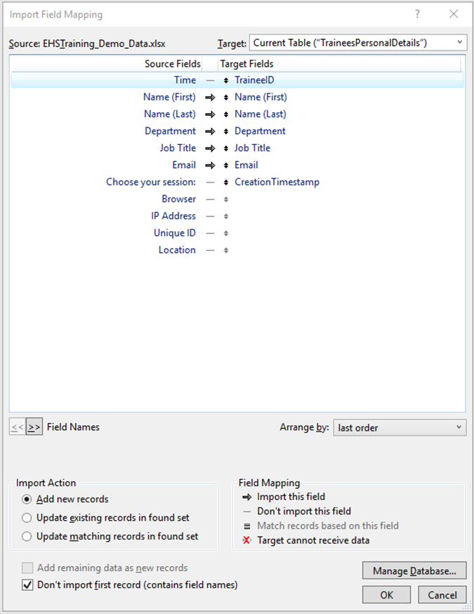

1. Again, open the same saved file in Step 1.
2. At the top-right, ensure that the Target is ‘TrainingSessionDetails’.
3. Click and drag the fields (Time, Email, Choose your session) so that they match correspondingly. They should also have an arrow between them. At the bottom-left, check across ‘Don’t import first record (contains field names)’. Click OK.

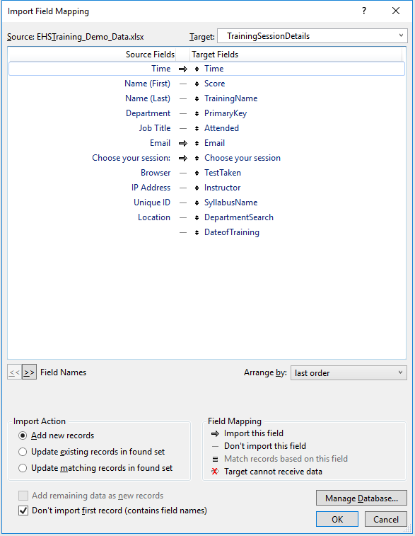

**Check In Trainees Process:**

Click the ‘Check In Trainees’ button on the home page.

* Find the list of trainees registered for the session, by typing the session date (Ex: 2/18/19 for Feb 18, 2019) in the red text box.
* The instructor should enter Training Name, Instructor Name and Syllabus for the first record and click the corresponding three buttons above the fields to auto-enter the same values for all the trainees in the session.

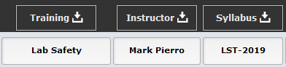

**When the trainees arrive:**

The trainees who show up should be marked present by checking the box on the left of the Email.

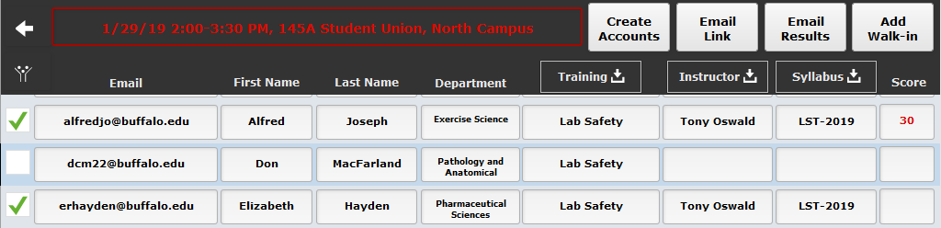

Walk – ins can be added by clicking the ‘Add walk-in’ button. Enter the personal details and click ‘Create’. This would automatically navigate to the previous page where the Email ID should be entered again. The First and Last names will auto-populate. Ensure that the values for Training Name, Instructor, and Syllabus are entered either manually or by clicking the corresponding buttons.

The instructor would then ‘Create Accounts’ by clicking the button on the top-right. This would create accounts for all the trainees who are attending the current session.

The Credentials will be as follows:

Account Name: Email ID used to register for the current session.

Password: safety

The instructor can email the steps to login to all the trainees attending the session by clicking the ‘Email Link’ button.

**Taking the Test:**

Once the trainees login to their accounts, they will be able to see the list of all the trainings they have taken using Filemaker till date.

Trainees shall navigate to the test by clicking ‘Registered Sessions’ followed by ‘Take Test’.

The same 10 questions for a particular test will be displayed in a random order for each trainee.

Once the Test is submitted, the trainee will be able to view his/her score, the correct answers for the questions and will not be able to re-take the test for the same session.

The trainee would simply ‘Logout’ once the test is completed.

**Instructor sends Pass/Fail Emails to the Trainees:**

On the ‘Check In Trainees’ screen, the instructor can view everyone’s scores in the current session. Once all the trainees submit the test and their scores are reflected on the screen, click the ‘Email Results’ button.

Also, records of trainees who did not attend the session (who were not marked present) would be deleted automatically.

**Search by Department:**

Allows users with Full Access to view the list of trainees filtered by Department of interest.

**Search by Name:**

Allows users with Full Access to search for trainees according to the values specified in the fields.

**Reset Password:**

1. Sign in as Guest.
2. Click ‘Reset Password’.
3. Enter the Account Name whose password needs to be reset.
4. Click ‘Reset’
5. The password will be reset to ‘safety’.