**ACTIVITY 12**

**NAME : M.VARSHINI COURSE : Mobile Computing**

**Reg No : 192421293 COURSE CODE: ITA0302 12. Use Figma to create an interactive diagram illustrating the evolution from 1G to 5G.**

**Aim: -**

Design an interactive diagram illustrating the evolution from 1G to 5G using Figma.

**Procedure: -**

1. open Figma

2. Create a new file

3. Select the Frames

4. Fill in the content that is required for presentation

5. Design Visual Elements

6. Make it Interactive

7. Add Annotations and Explanations

8. Incorporate Multimedia

9. Storyboard Animation

11. Review and edit the Prototype

12. Save and Share

**Design: -**

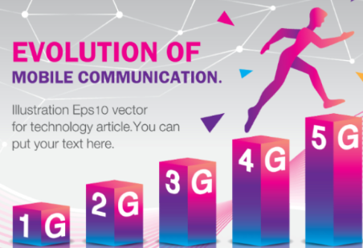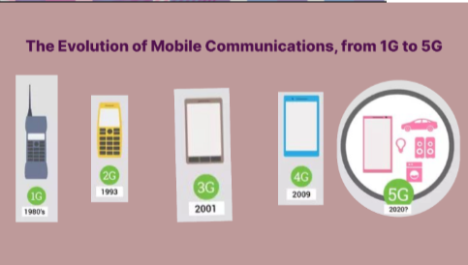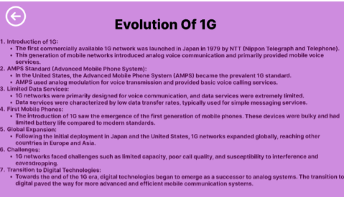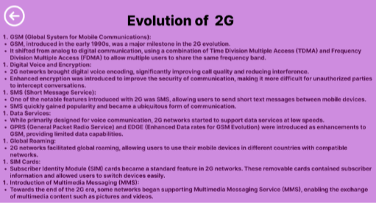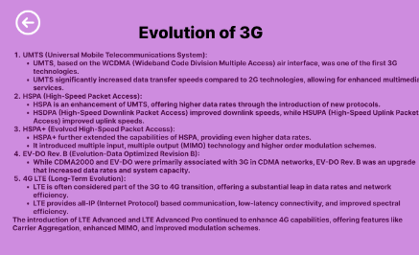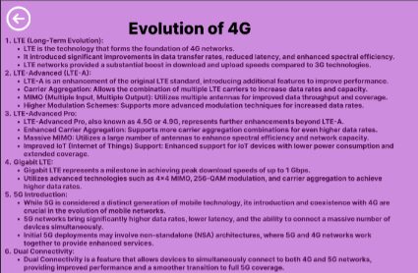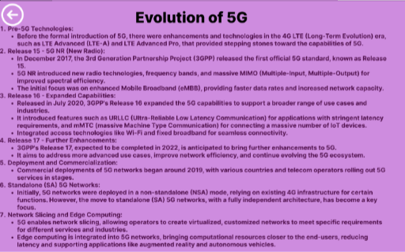

**Prototype: -**

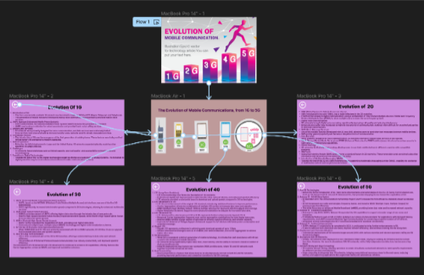

**Result: -**

Hence an interactive diagram illustrating the evolution from 1G to 5G in Figma is created and

executed successfully