**DBMS PROJECT REPORT**

# **Student-Job Matching System**

|  |  |
| --- | --- |
| **Name: Shreya Srinivasan** | **Name: Varshini M** |
| **SRN : PES2UG22CS536** | **SRN : PES1UG22CS678** |

**Abstract**

The Student-Job Matching System is designed to facilitate the recruitment process by connecting students with potential employers based on their skills, academic backgrounds. The system will provide a platform where students can manage their resumes and apply for job opportunities, while employers can filter through candidates and track applications effectively.

**List of Softwares/Tools/Programming languages used**

### *Programming Languages****:***

Python

### *Web Framework:*

Streamlit – Framework for building the interactive dashboard and front-end for the project.

### *Database:*

MySQL

### *Database Connectivity:*

mysql-connector-python – Python library to connect and MySQL database

*Other Tools:* Github

**ER Diagram**

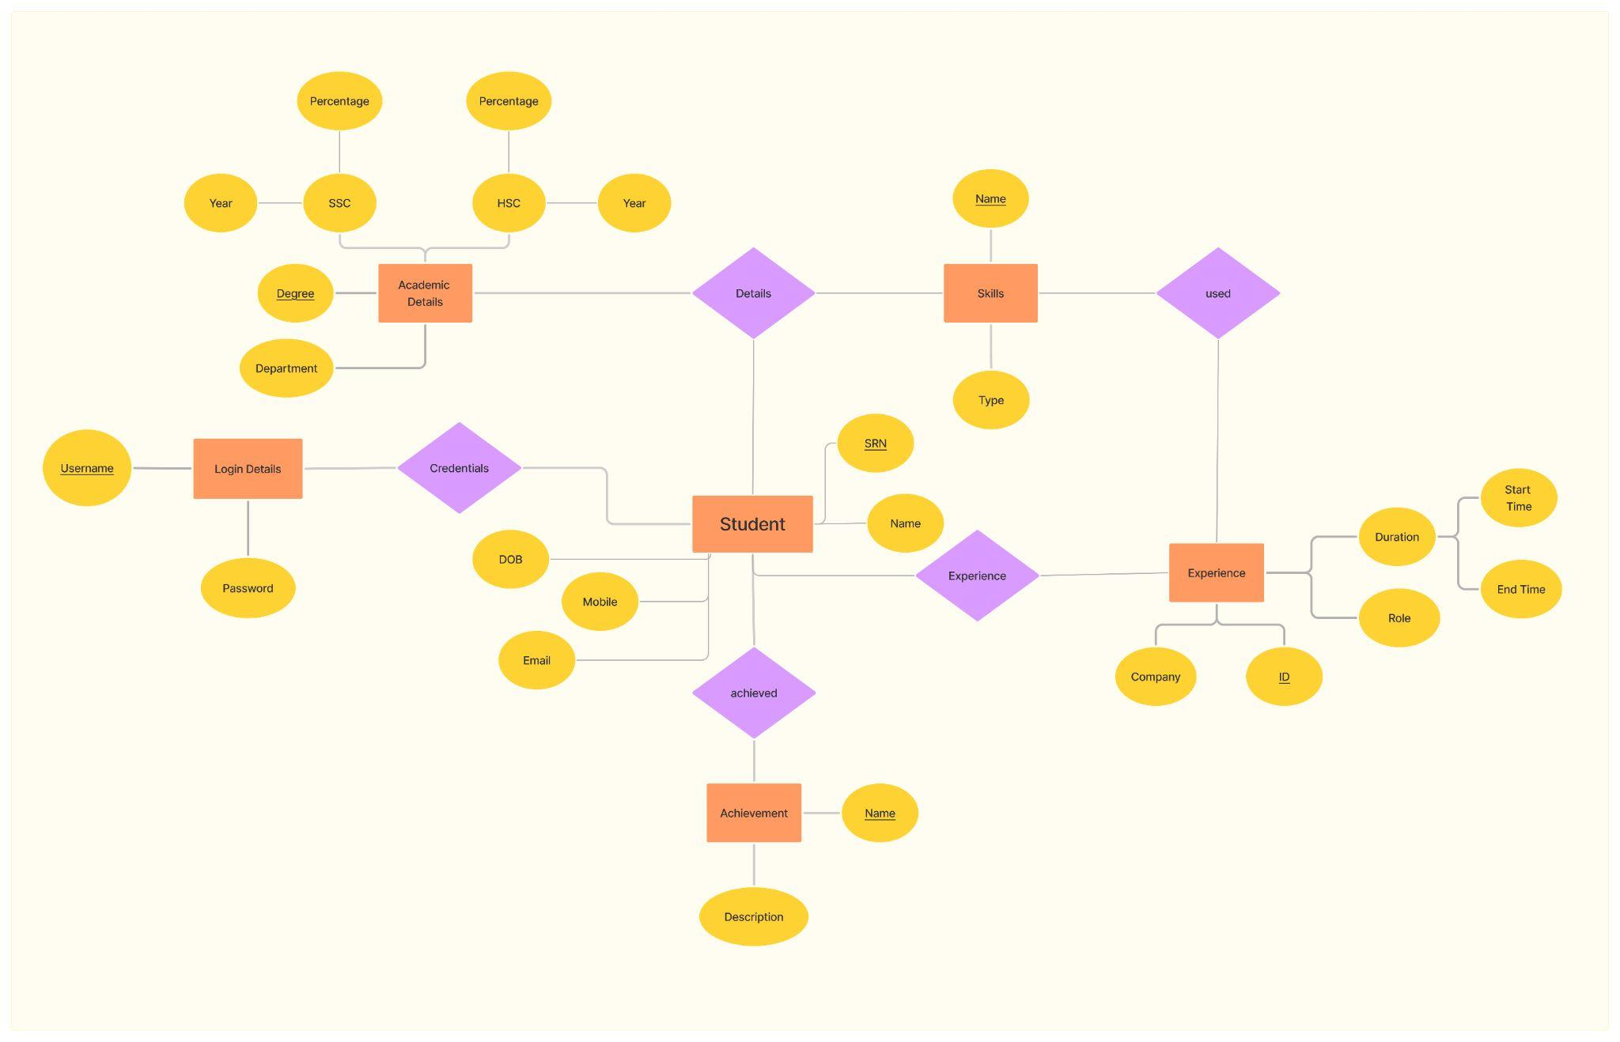

**Relational Schema**

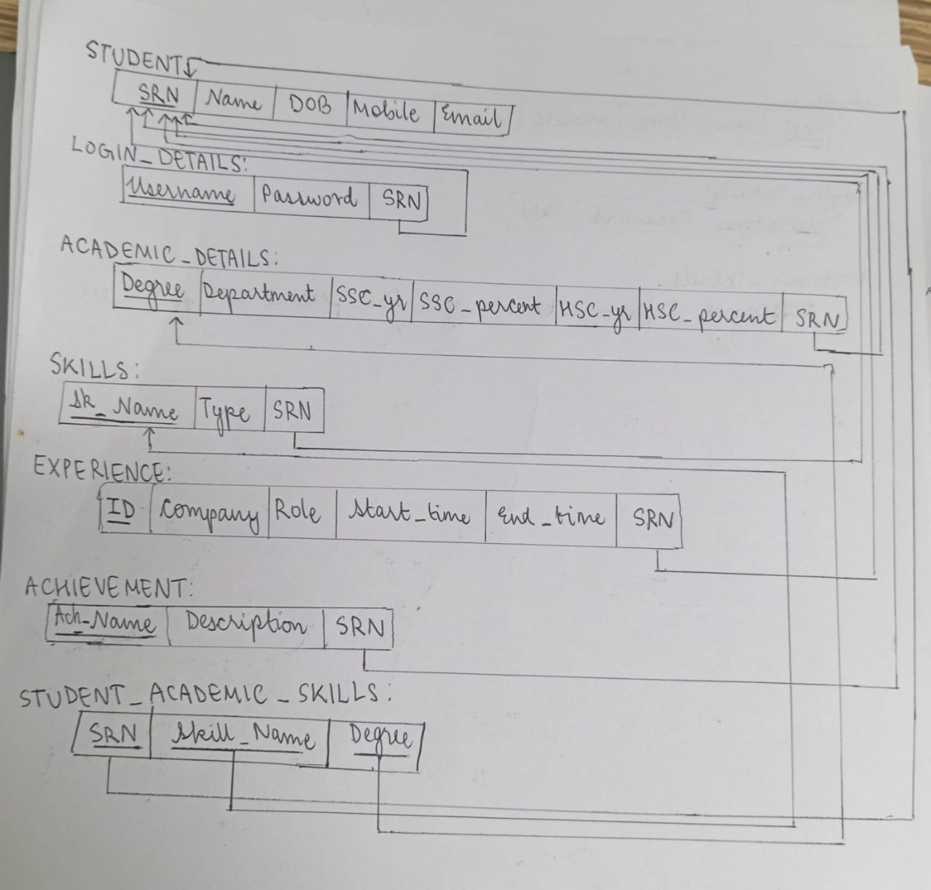

**CRUD operation Screenshots**

**Tables**

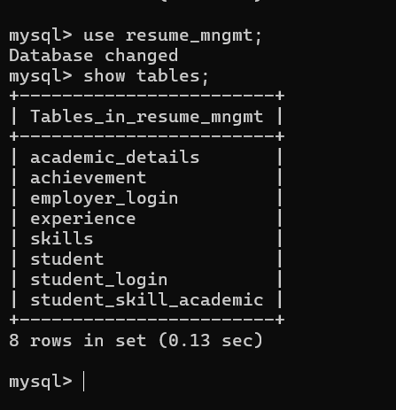

**A) Create Tables**

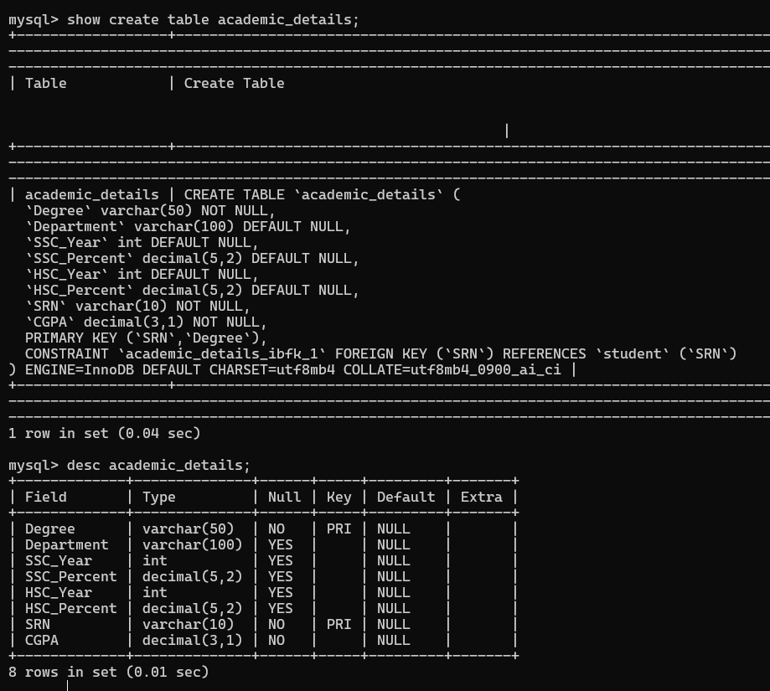

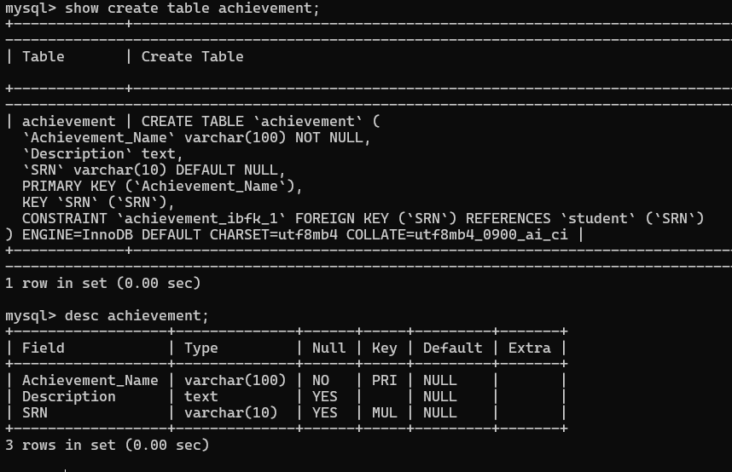

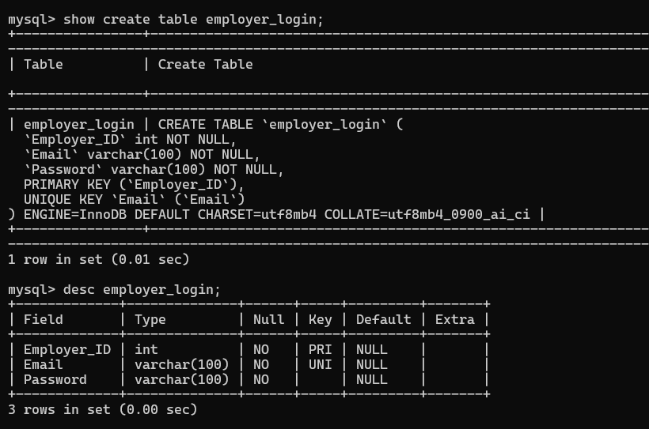

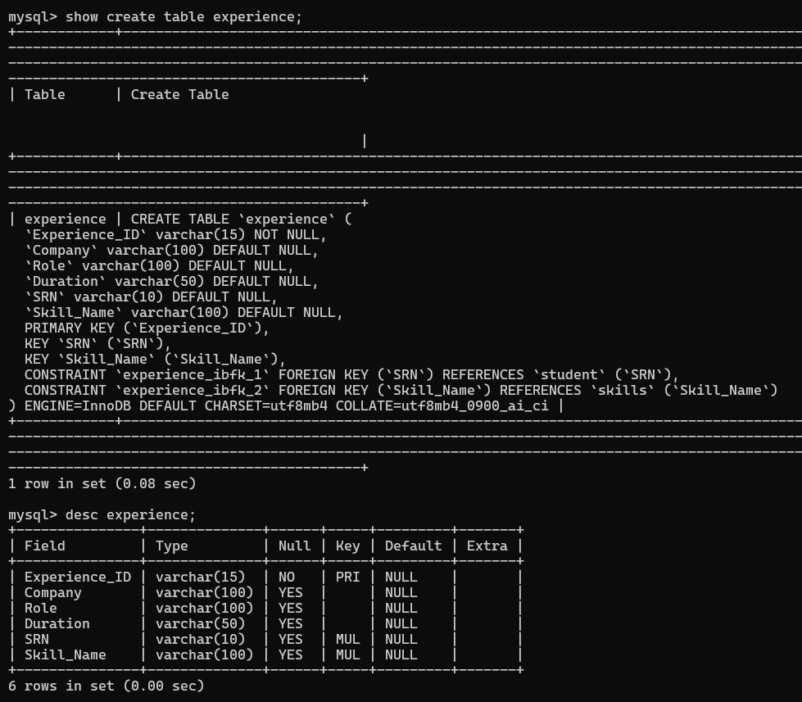

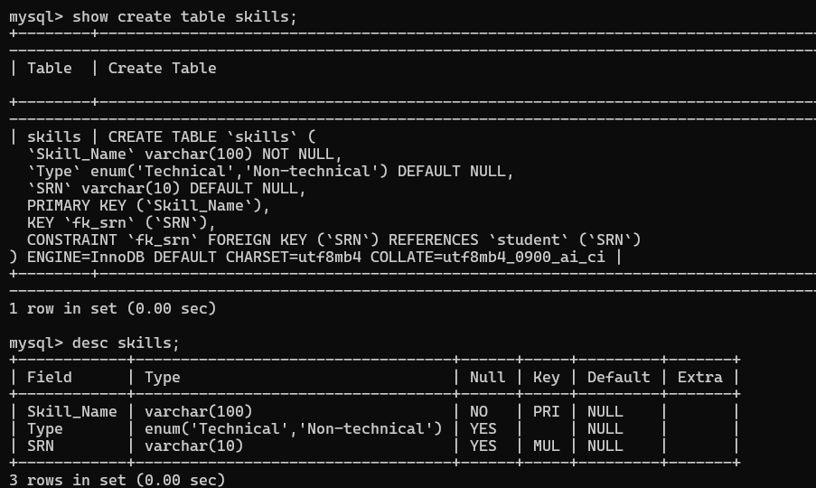

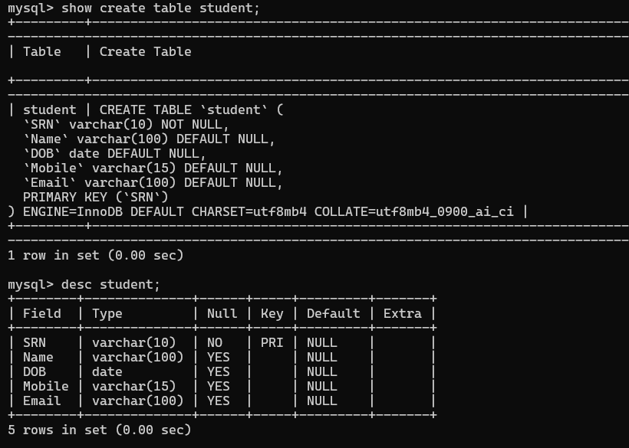

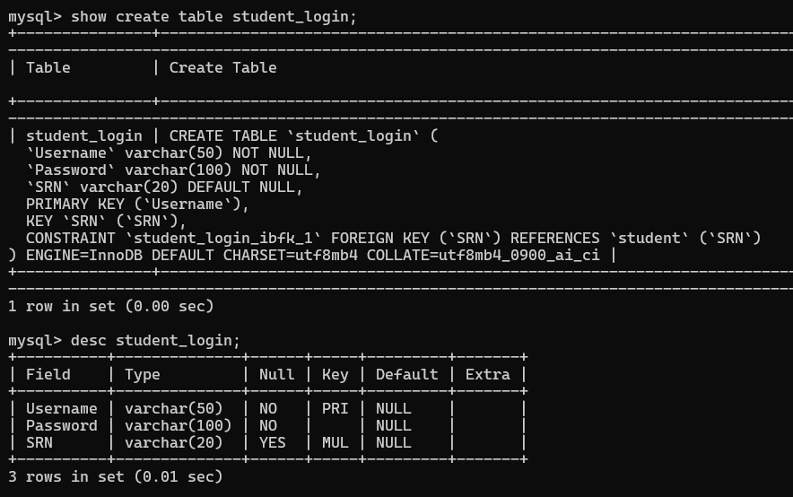

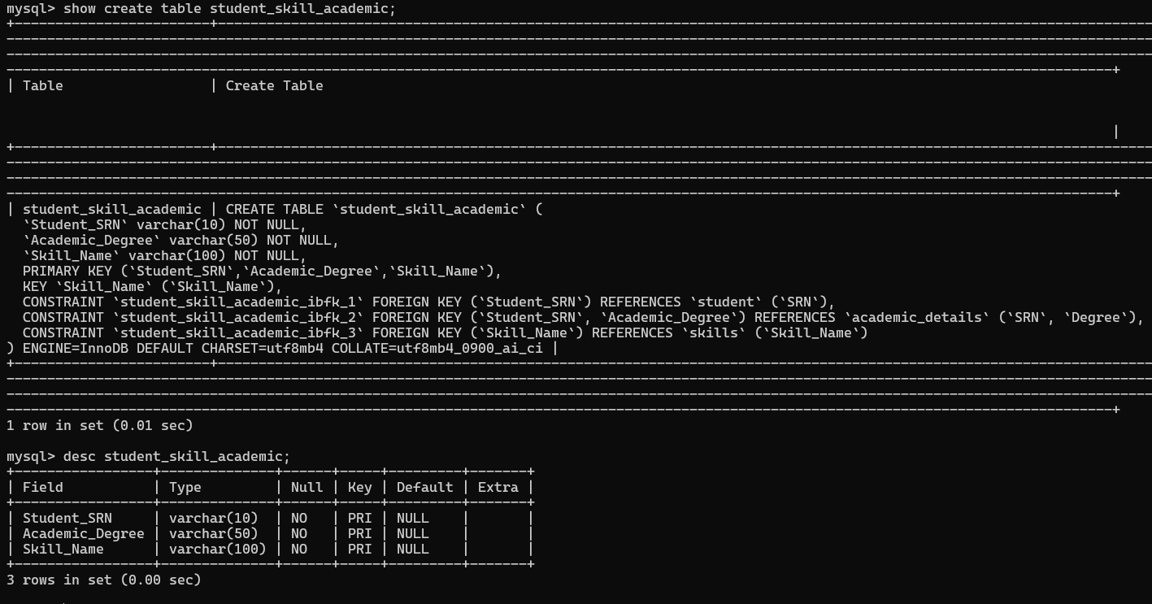

**B) Read**

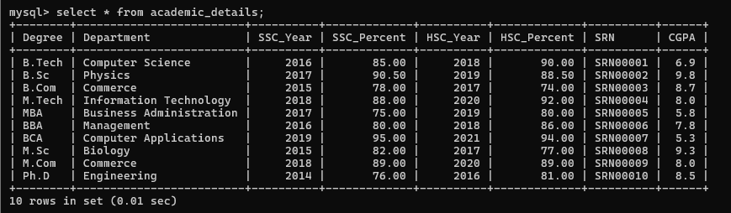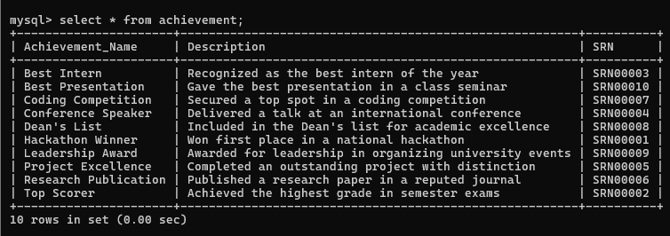

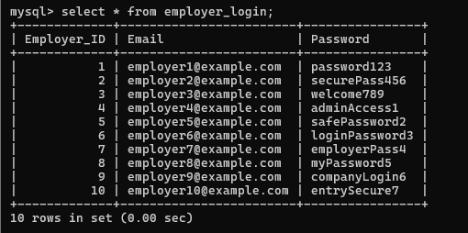

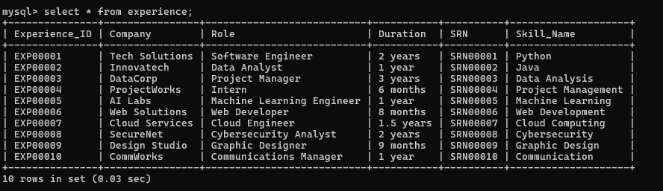

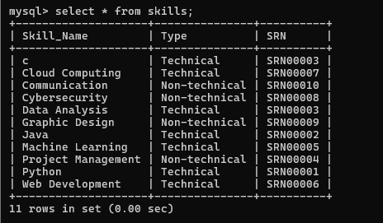

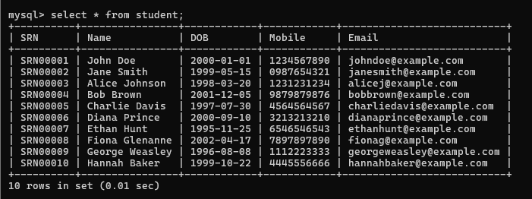

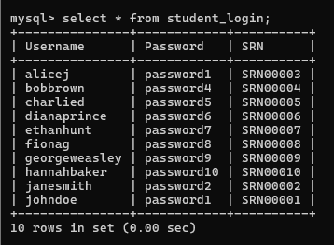

**C) Update**



**Before:**

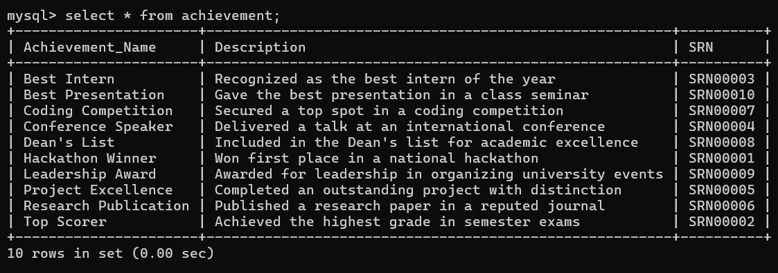

**After:**

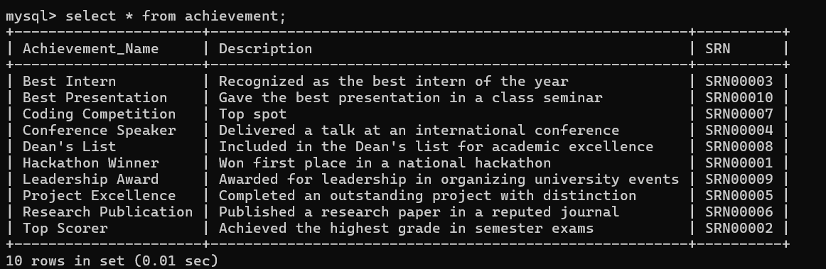

**D) Delete**

1. **Delete Achievement**

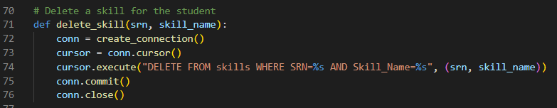

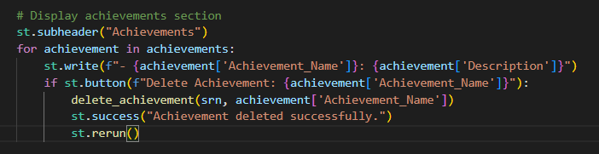

**Before:**

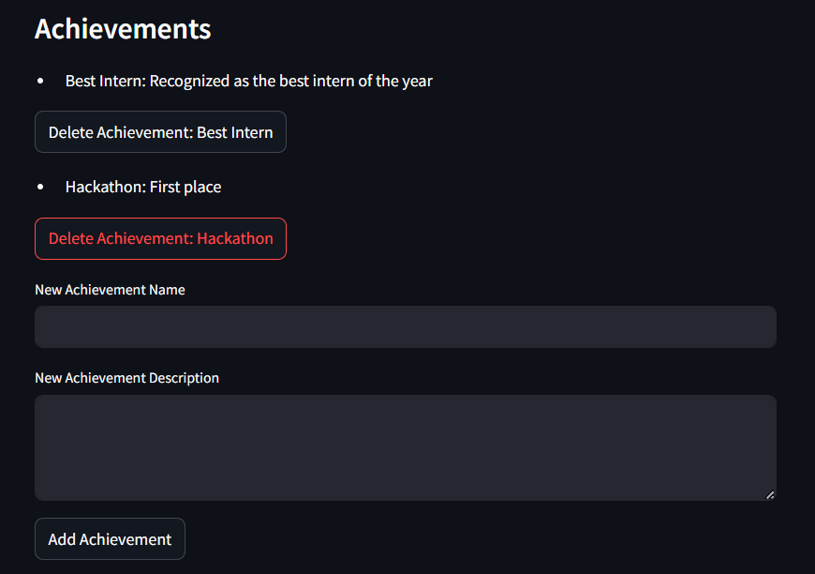

**After:**

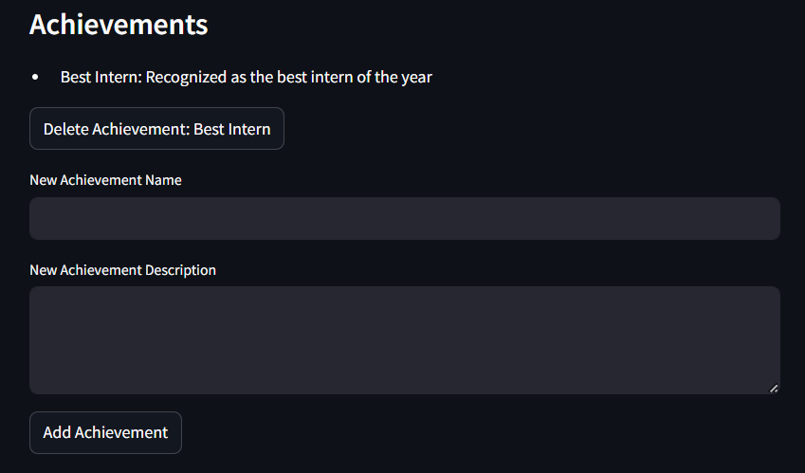

1. **Delete Skill**

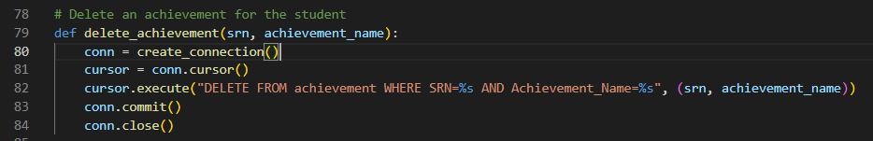

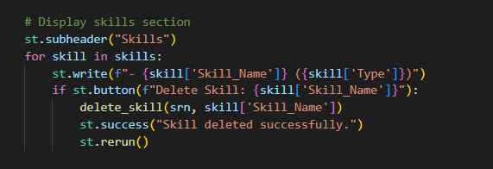

**Before:**

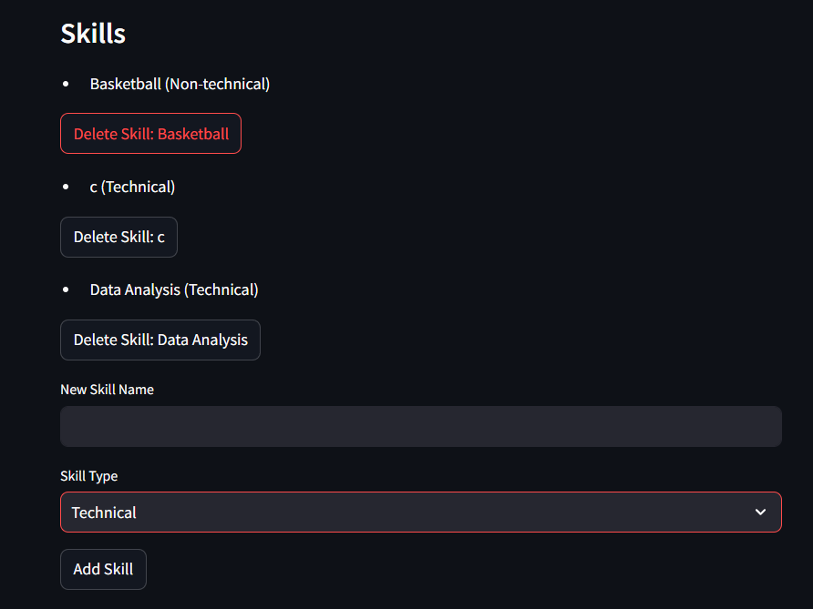

**After:**

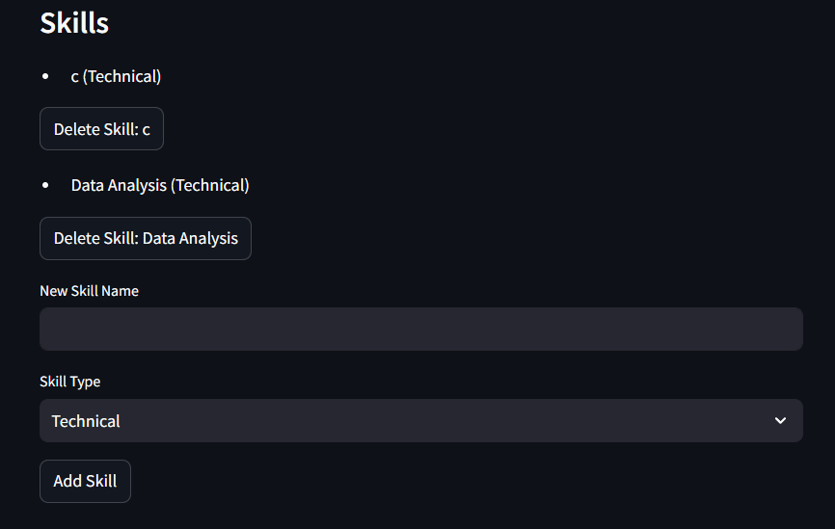

**DDL Command Screenshots**

**Add Feature:**

1. **Adding Achievement**

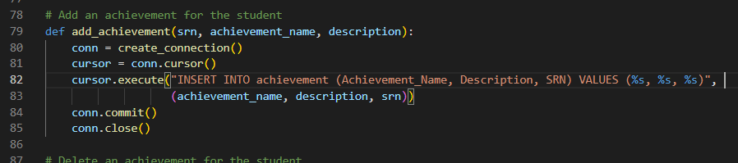

**Before:**

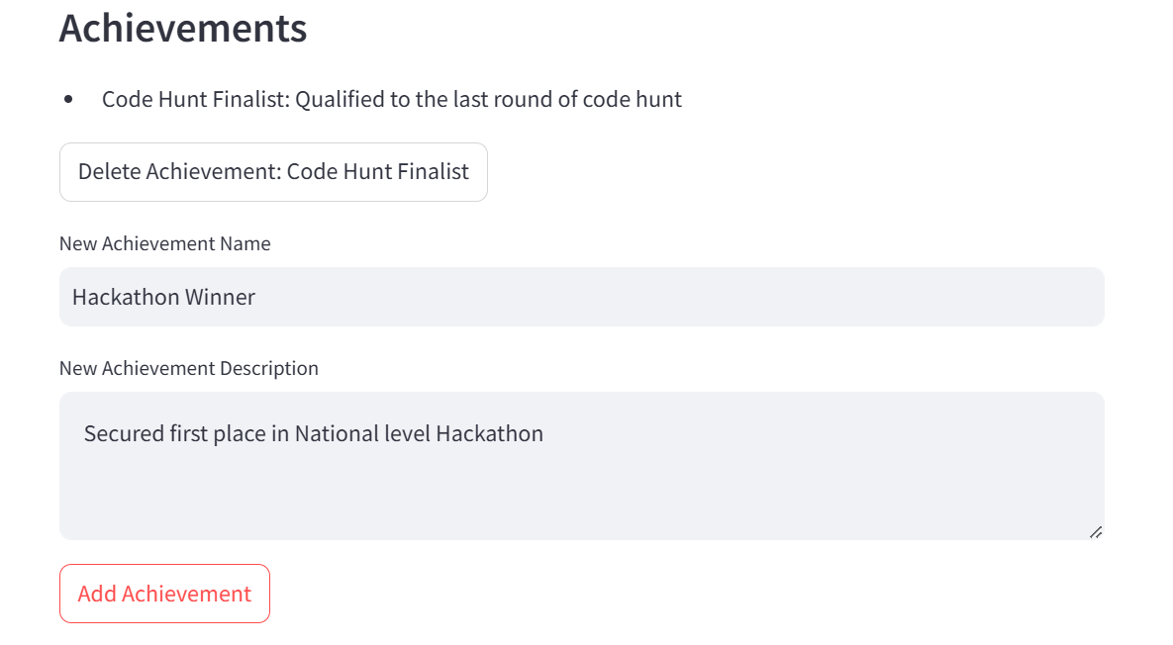

**After:**

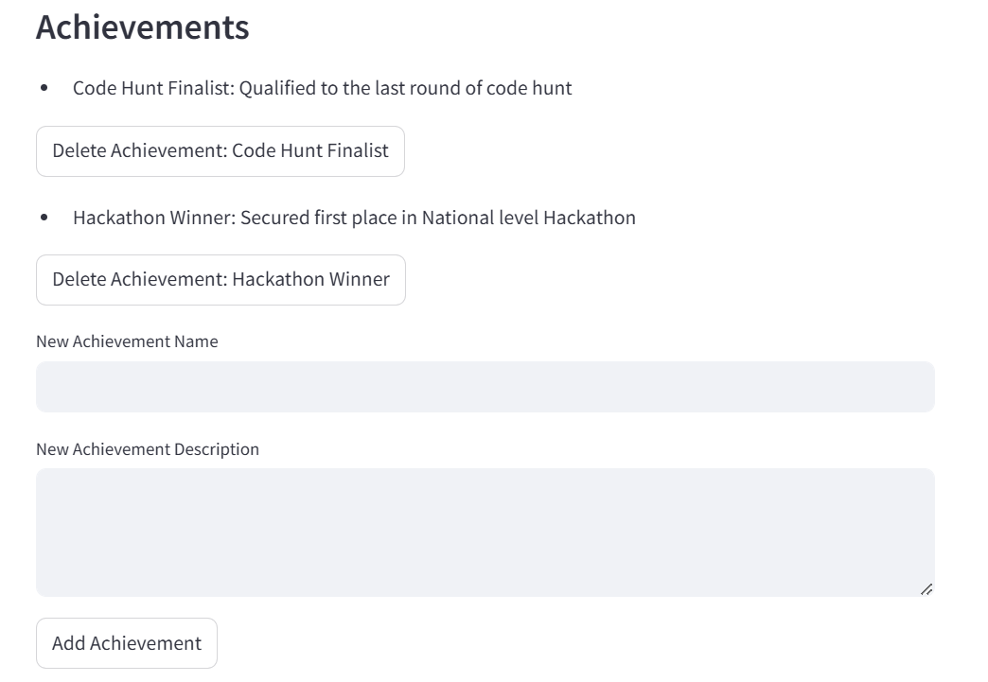

1. **Adding Skill**

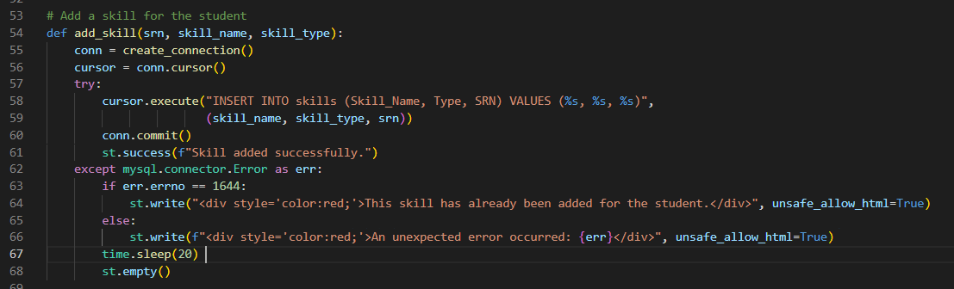

**Before:**

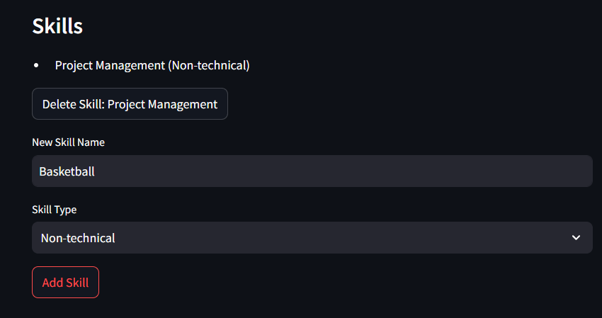

**After:**

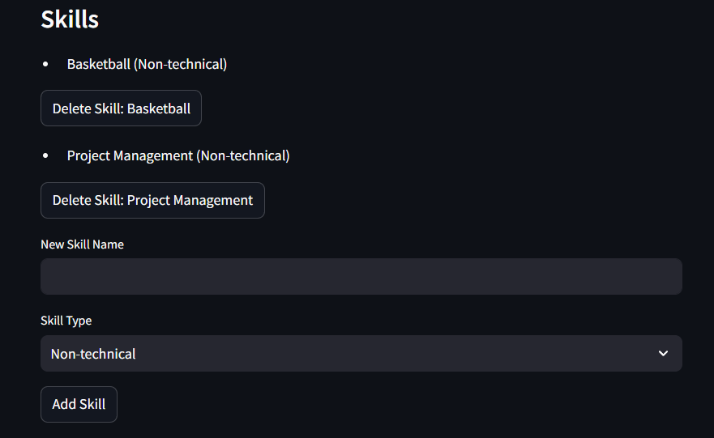

**TRIGGERS**

1. **Trigger for duplicate Skill:**

Checks if a skill for the same student (SRN and Skill_Name pair) already exists in the table.

If a duplicate is detected, it prevents the insertion by raising an error with a specific message, thus helps maintain data integrity.

**Code:**

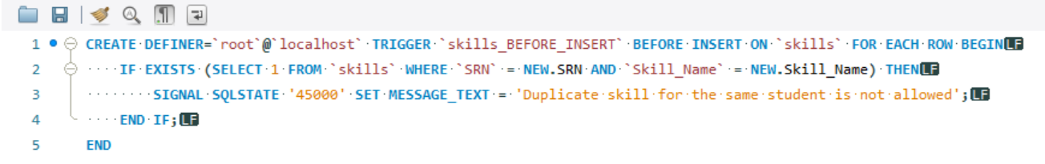

**Before Trigger:**

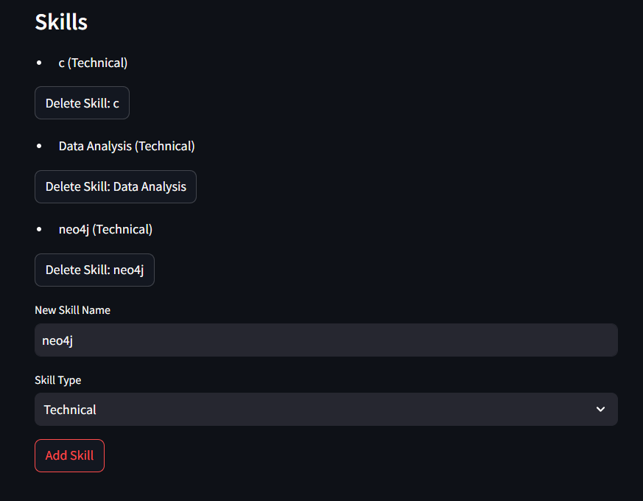

**After Trigger:**

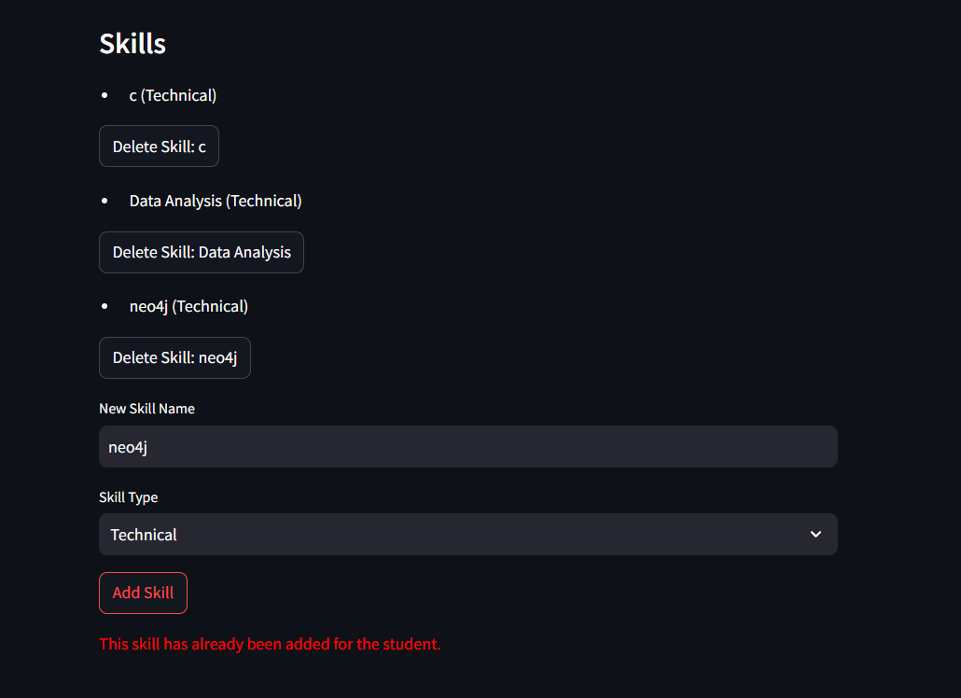

**2)Trigger for duplicate Achievement**

Checks if an achievement for the same student (SRN and Achievement_Name pair) already exists.

If a duplicate is detected, it prevents the insertion by raising an error with a specific message, thus helps maintain data integrity.

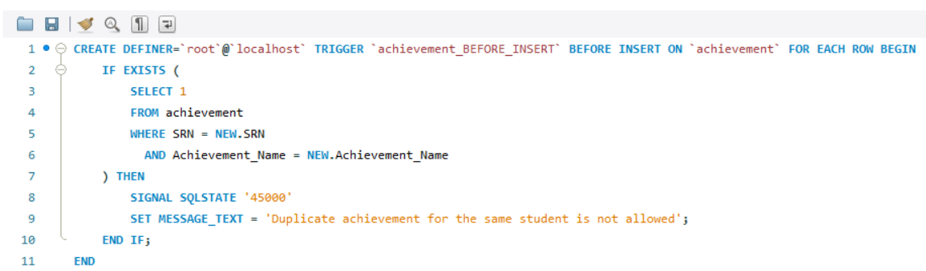

**Before:**

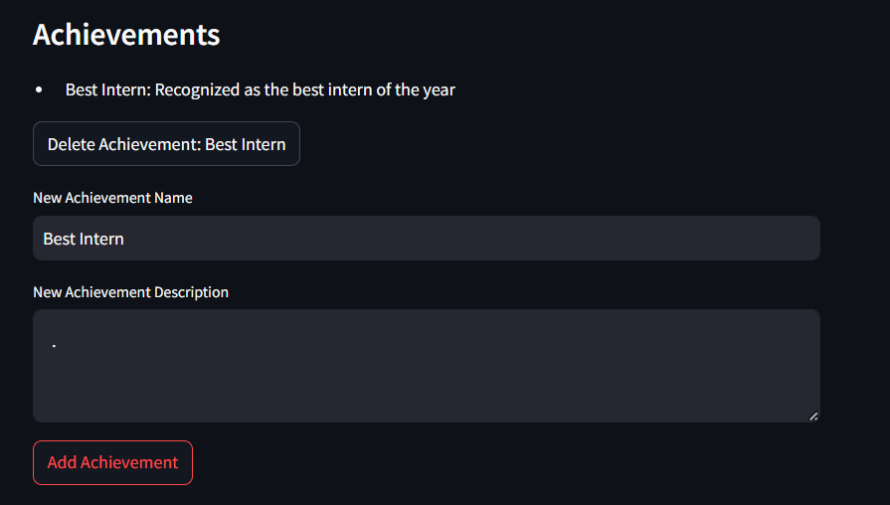

**After:**

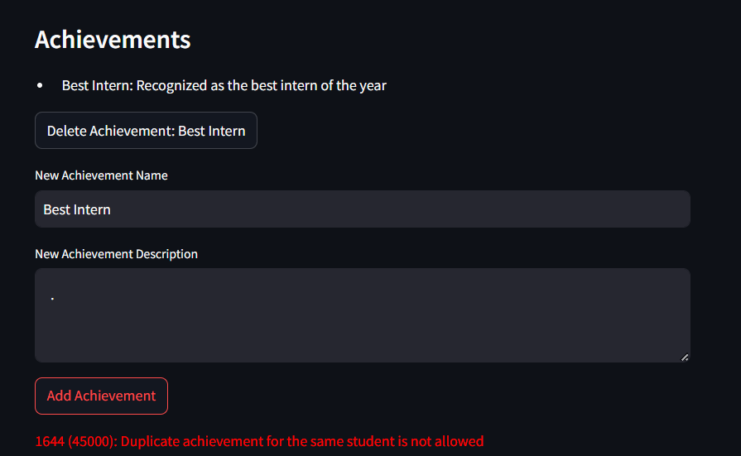

**PROCEDURES / FUNCTIONS**

1. filter_students_by_cgpa_and_skills

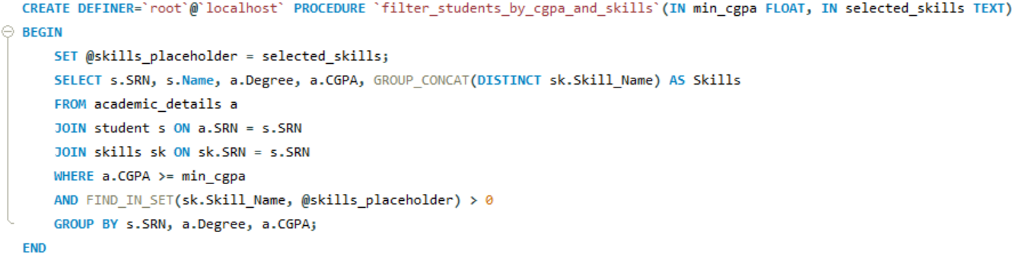

filter_students_by_cgpa_and_skills() is a stored procedure designed to retrieve students who meet specific CGPA and skill requirements

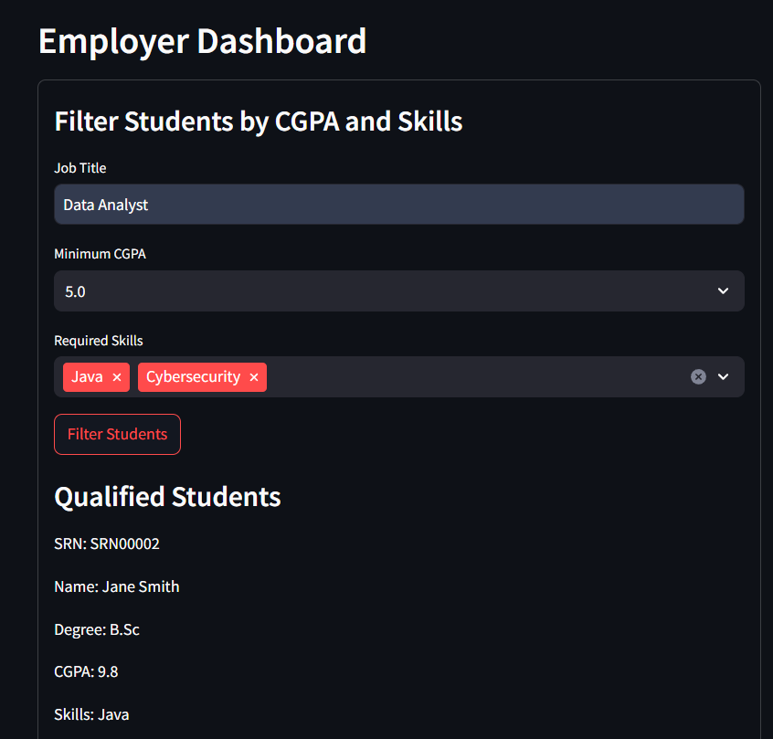

1. get_all_skills

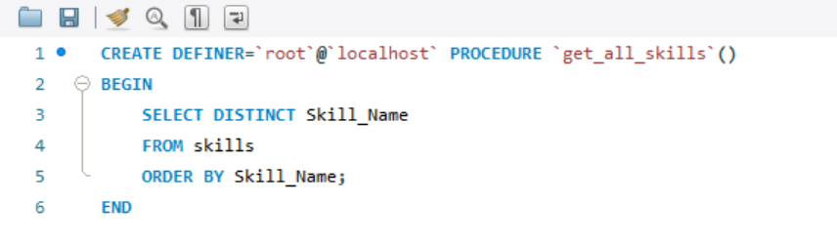

get_all_skills() procedure retrieves all distinct skills from the skills table and orders them alphabetically.

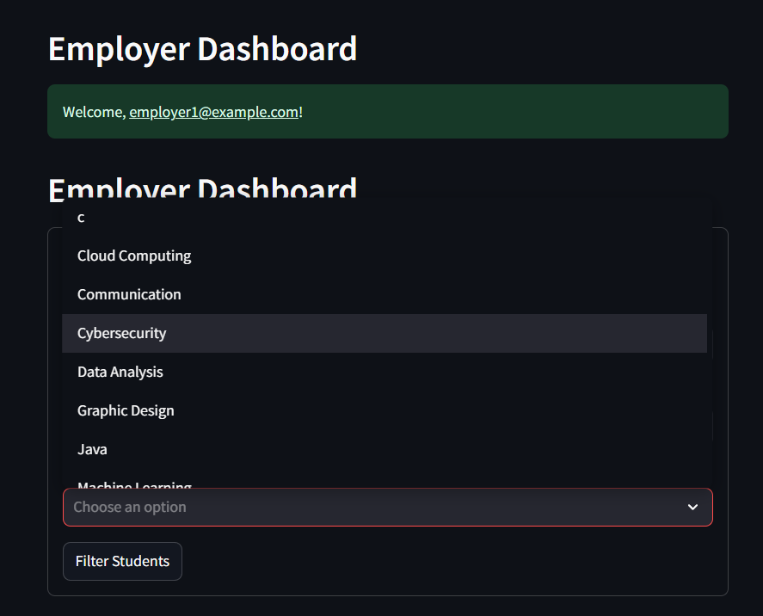

**Join Command:**

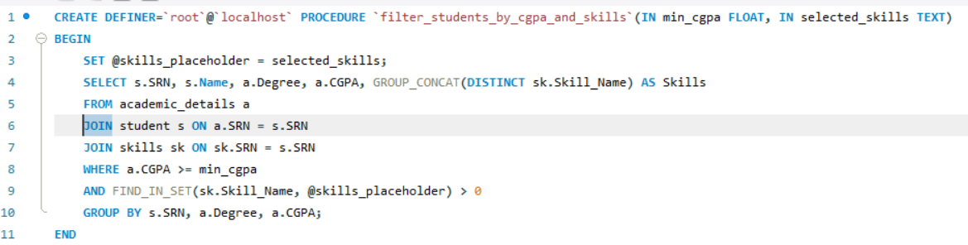

The query joins three tables:

* academic_details (aliased as a)
* student (aliased as s)
* skills (aliased as sk)



**Nested query**

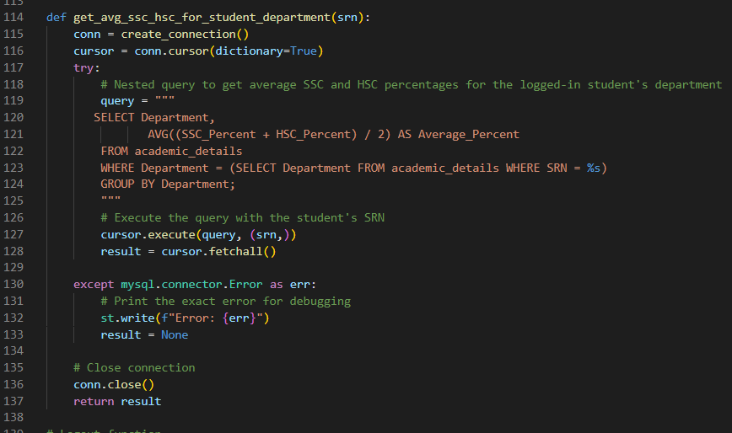

* The subquery (SELECT Department FROM academic_details WHERE SRN = %s) retrieves the Department for the given student SRN.
* The outer query then uses this department to filter results, allowing it to compute average scores (SSC and HSC percentages) for all students in the same department as the specified student.

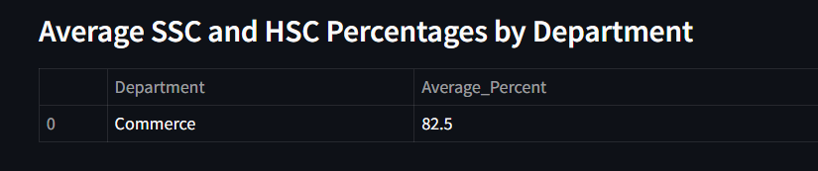

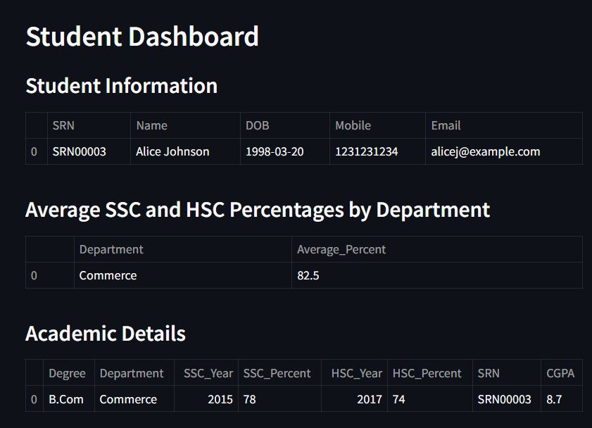

**Aggregate Query:**

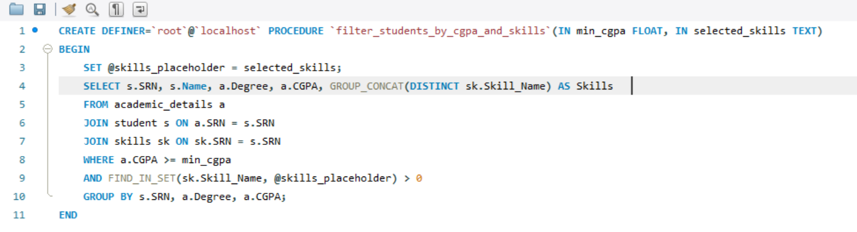

Groups data by student and lists all skills for each student in a single row using GROUP_CONCAT and GROUP BY

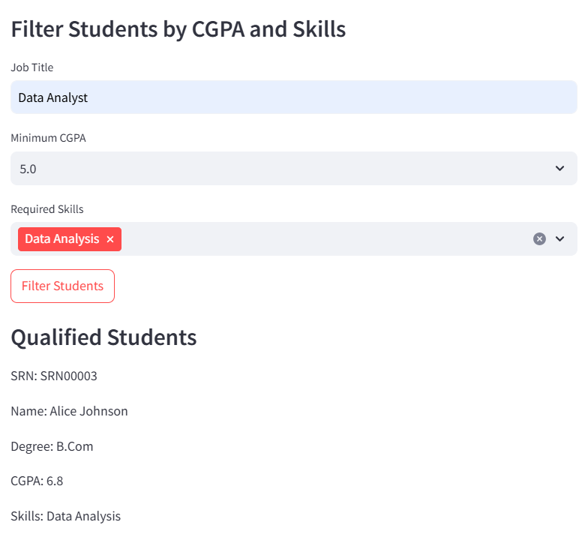

**Other Functionalities:**

1. Login

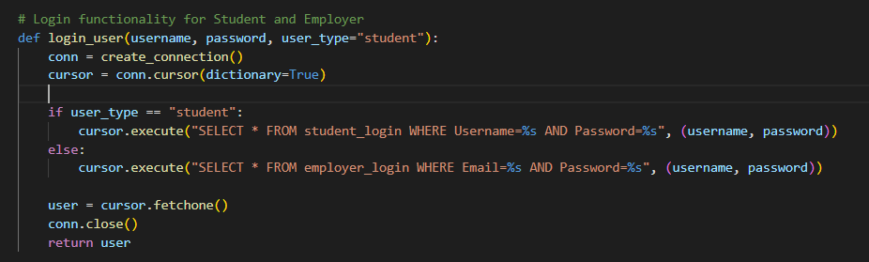

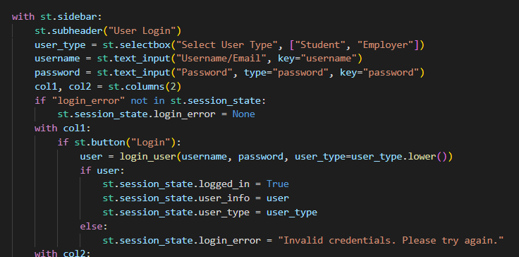

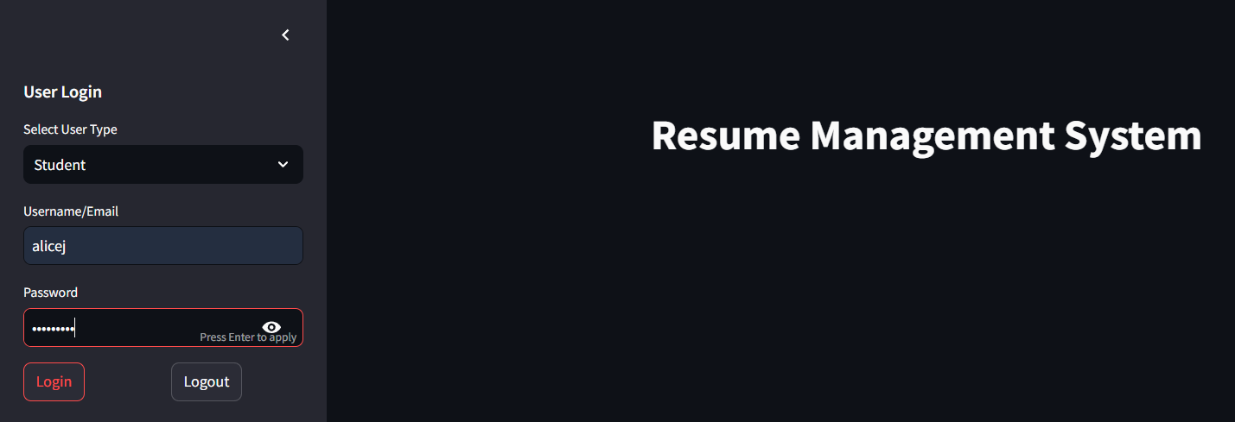

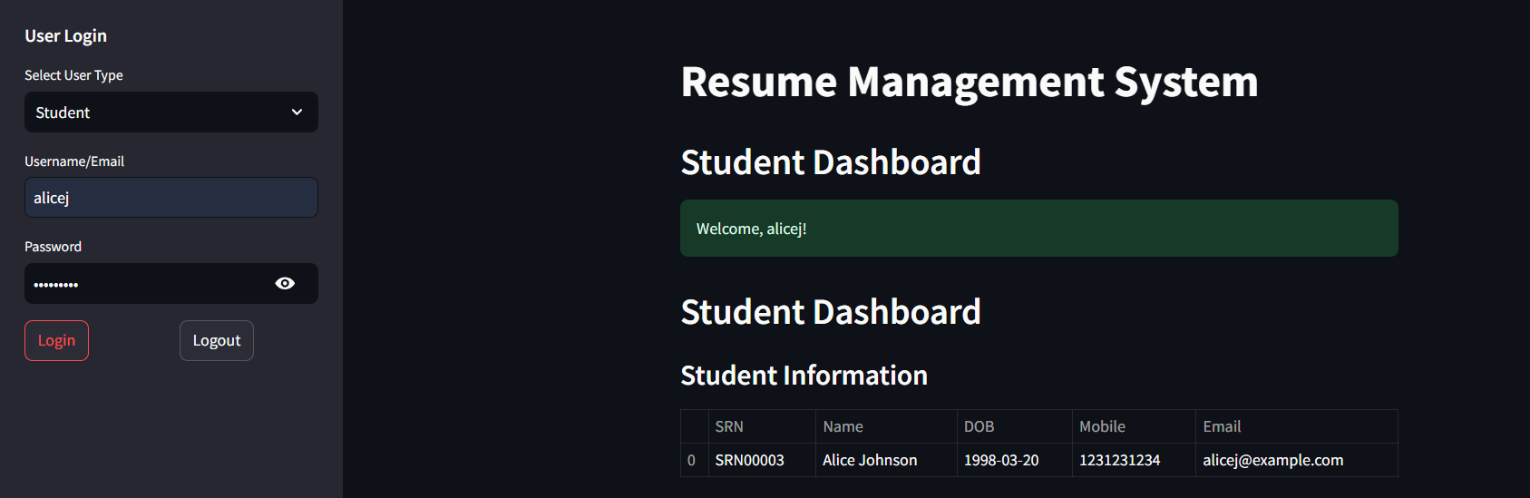

1. Logout

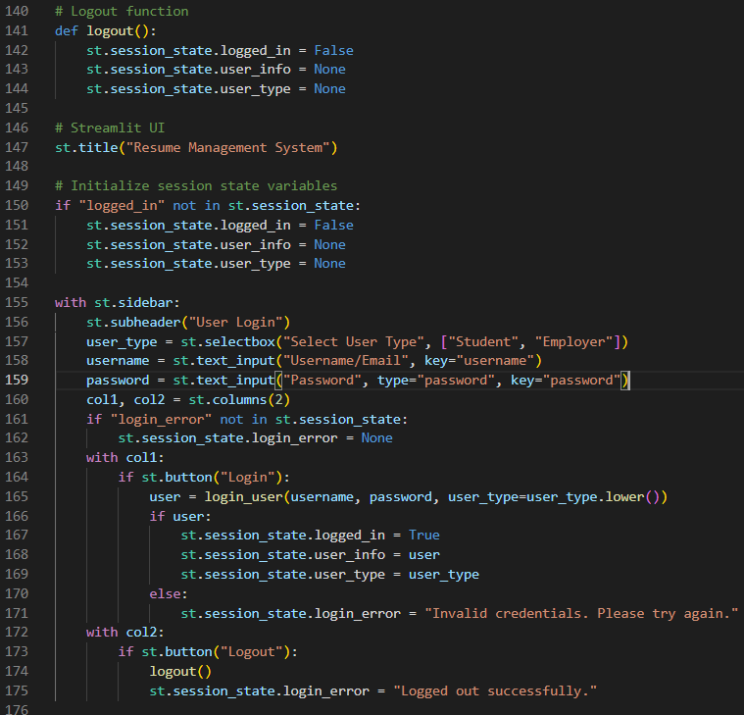

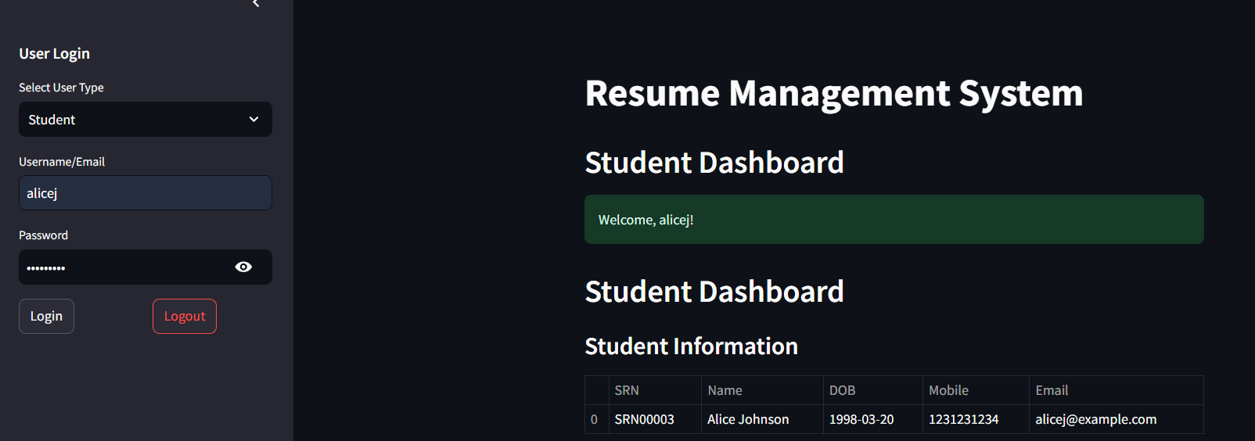

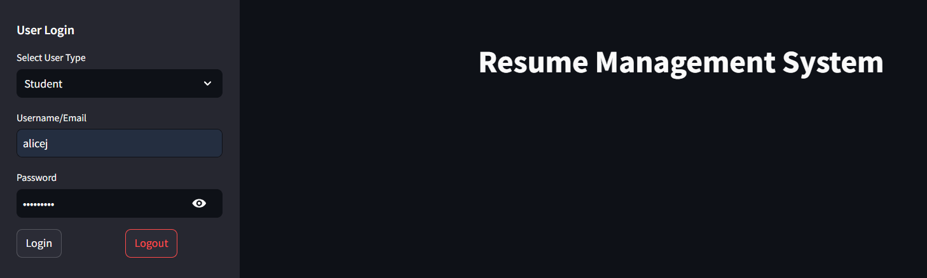

**Github repo link:**

[Github Repository](https://github.com/varshini-m0510/Student-Job-Profile-Matching-System)