CAPSTONE PROJECT
FINAL REPORT

- Summary of problem statement, data, and findings.
- In this project we have worked on Computer vision concept. Computer vision can be used to automate supervision and generate action appropriate action trigger if the event is predicted from the image of interest.
- We have a Cars dataset which contains 16,185 images of 196 classes of cars. The data is split into 8,144 training images and 8,041 testing images, where each class has been split roughly in a 50-50 split. Classes are typically at the level of Make, Model, Year, e.g. 2012 Tesla Model S or 2012 BMW M3 coupe.
- Dataset: https://drive.google.com/drive/folders/1y6JWx2CpsOuka00uePe72jNgr7F9sK45?usp=sharing
- Objective: - Design a DL based car identification model

Data description: ‣
- Train Images: Consists of real images of cars as per the make and year of the car.
- Test Images: Consists of real images of cars as per the make and year of the car.
- Train Annotation: Consists of bounding box region for training images.
- Test Annotation: Consists of bounding box region for testing images. Dataset has been attached along with this project. Please use the same for this capstone project.

- Summary of the Approach to EDA and Pre-processing.
- We used “gdown” to directly load our dataset from the google drive.
- The dataset is loaded as an archive file. As per the dataset description the archive files contains Test and train images with respective annotations file and a class file containing the names of the 196 files.
- The images are of different sizes. We need to resize them to a standard image size to feed them to models.
- To read the images from their folders we used CV2 libraries. Initially we have resized the images to 400*400 size, but finally we settled with the image size of 320*320.
- To resize the images, we also had to augment the bounding boxes of the images to fit the resized images.
- To do the augmentation we used “imgaug” as well as “albumentation” library which provided us with an easy way to augment both image and the bounding boxes. For the final model we have user albumentation in YOLO v5 model.
- With initial settings for the scaling and transformations we faced a problem with the bounding boxes being out of bound of the image and not being plotted in the image at all.
- So with some changes in the parameters for augmentation we could achieve the desired result which we could test with some of the sample images
- When we compared the data we found that the data has a small bias with few classes containing more number of images than other classes.
- To reduce the data we could utilize our image augmentation techniques to increase few of the classes which are less in data.

- Deciding Models and Model Building.
- Firstly, we tried with VGG model using imagenet weights.
- And then we tried with MobileNet V2 model. Compared to VGG model mobileNet v2 is fast and gave pretty good accuracy.
- We also tried CNN which was overfitting on the training data.
- So, we tried RCNN just to see if this model gives us the best result. But with R-CNN taking more time for the training we abandoned it for the YOLO model.
- There were a lot of pre trained YOLO weights available. We used one of the pretrained weights to train our model. YOLO gave lower precision and recall
- While working with the models previously set image sizes started crashing due to CV2 libraries resize mechanism. We had to reduce the image sizes to 128*128 after trying few more image sizes for optimal usage of the resources in hand.
- With all the models we have tried, each one was good with classification/regression. But not with both the aspects of our problem set.
- Of all the models we tried Mobilenet V2 was working good comparatively till we started exploring the new version of YOLO which is v5.
- With YOLO v5 we were able to train our model with larger image sizes 0f 320*320, which dramatically increase the performance and accuracy. The results shown were promising.
- So, we started pursuing our YOLO v5 as our main model to train the data.
- Model Evaluation
- We mapped all the bounding boxes, labels, and classes to their images in both the test and train data.
- The model takes two parameters as an input, one is image file, and the other parameter is the text file containing the bounding boxes and the labels. The process of building the input for the model itself was cumbersome.
- With YOLO v5 the augmentation of the bounding boxes were handled better than the models we have tried.
- There are certain parameters like the image size and the weights from the pretrained models which found to be the key in the accuracy of the model training.
- YOLO v5 s weights gave us the best result and it has reduced the training time considerably.
- The IOU is 80% and this is the best we could achieve in both classification and regression in a single run. Other models couldn’t achieve for both the parameters. Resnet classification the best score achieved only in the classification was 80%.

Sample Predictions:

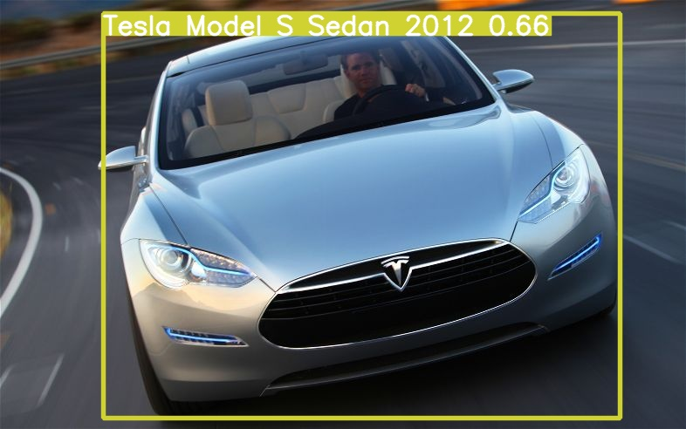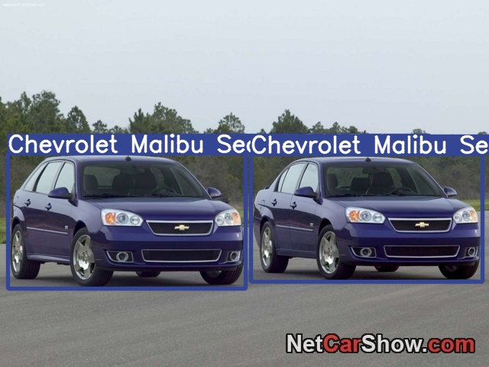
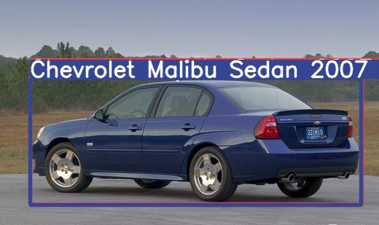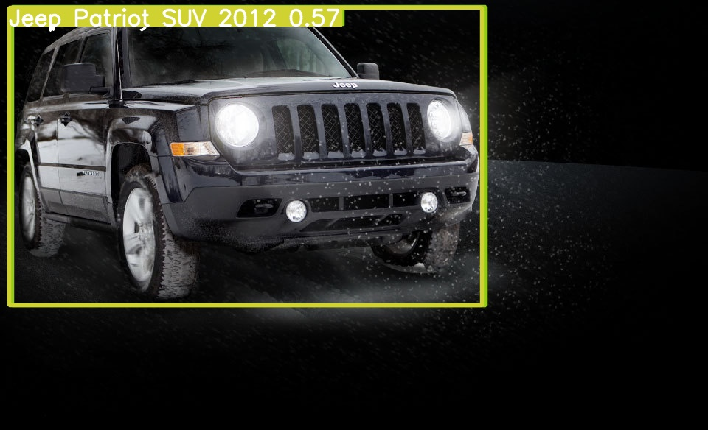

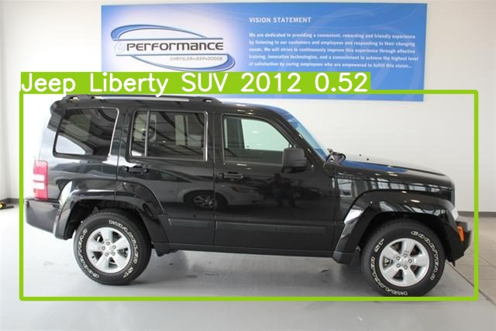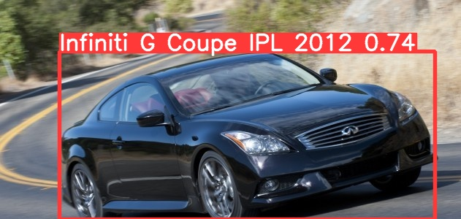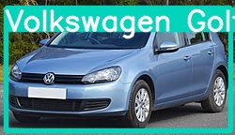

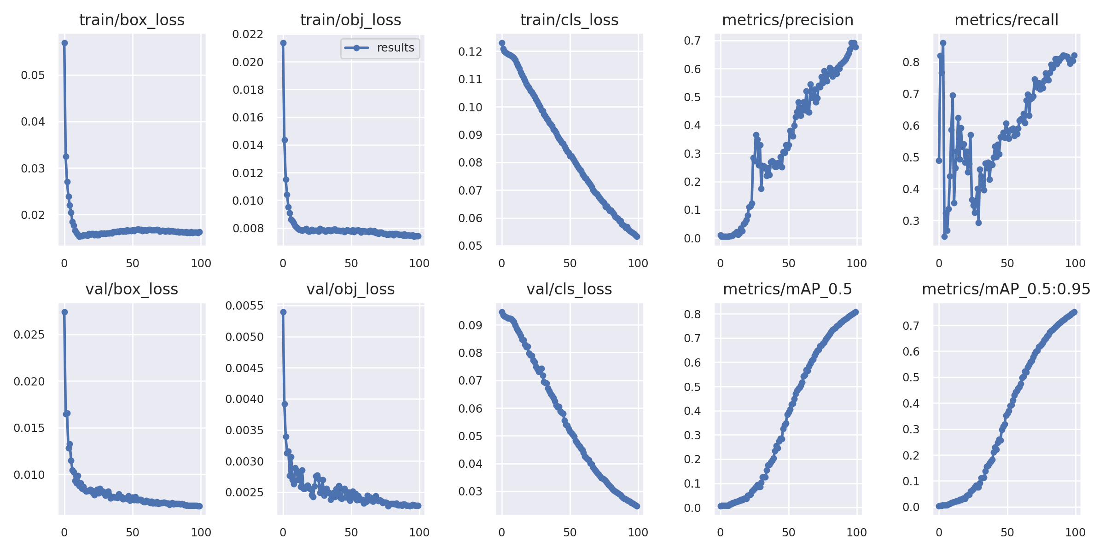
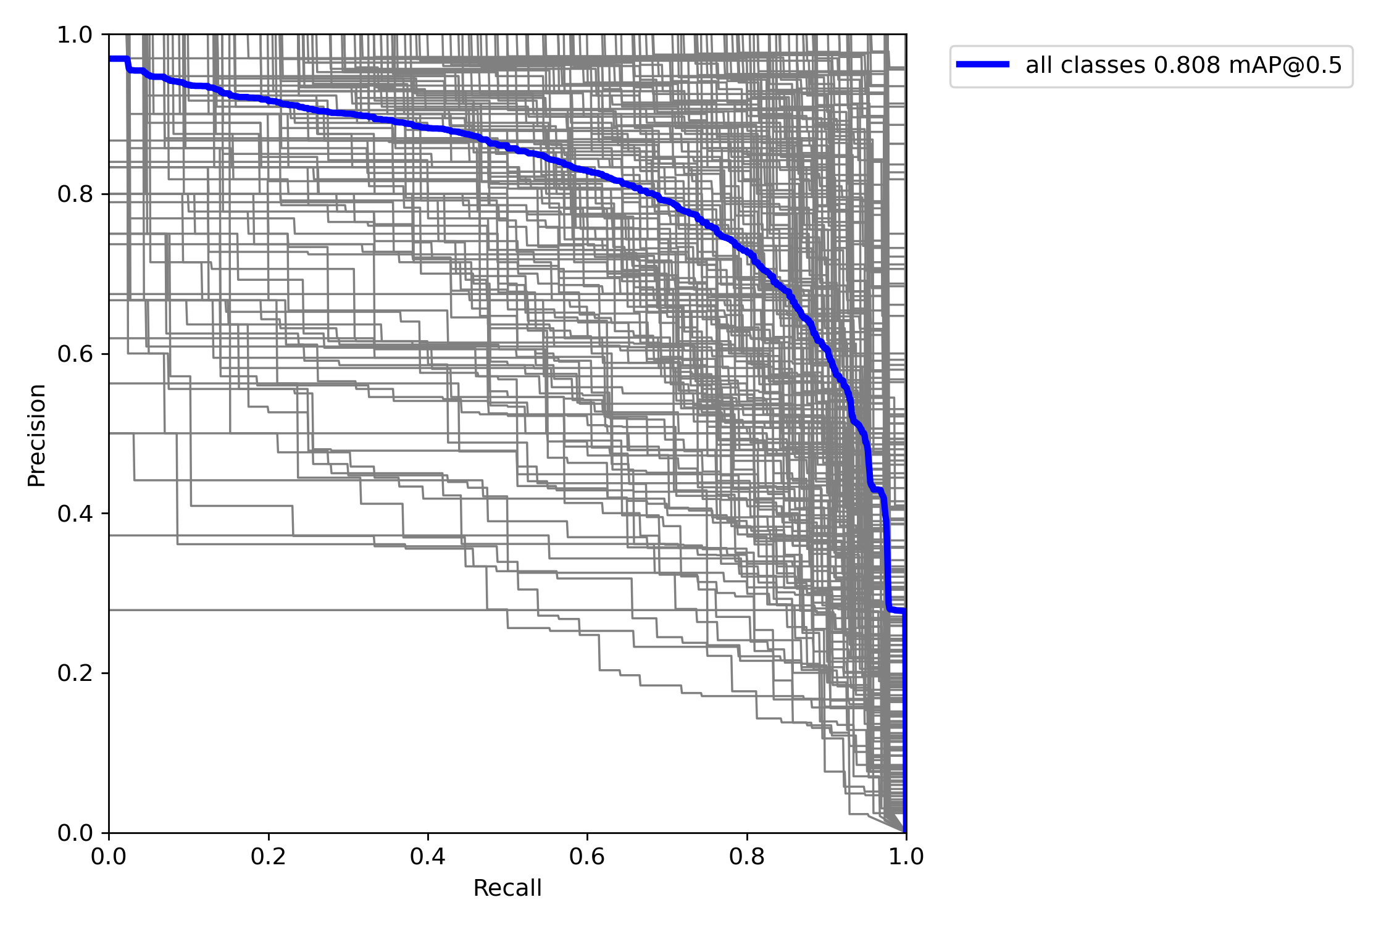

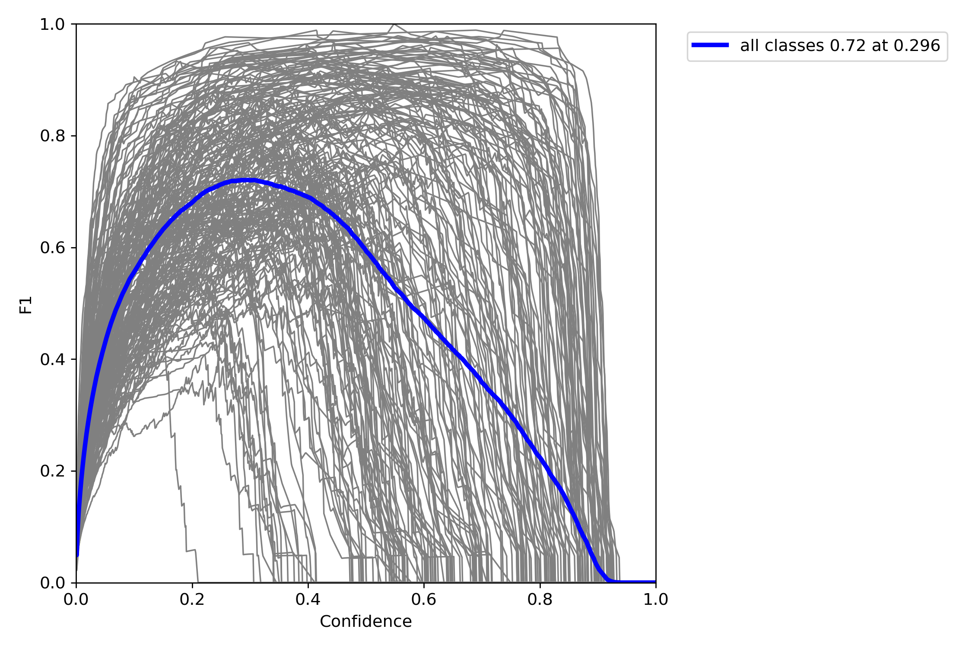

LIMITATIONS
To train the model it takes a lot of computational resources, which makes it harder for a larger dataset. The solution which we have achieved is on a limited data which will not be able work on a larger scale.
With more computational resources we can expand the training data.
Although it was a limited resource, we could learn a lot about the performance of different models and the limitations attached to them. Next time we would like to try all this with more resources and time and other new and old models to see which suites best

