Automatic Light Intensity Controller by External Light Sensing

Nowadays highways are lightened by using High Intensity Lamps. The disadvantage of this High Intensity Lamps is that it consumes a lot of energy and another disadvantage of this is that the intensity cannot be varied according to the requirement. To overcome this limitation, this system “Automatic Light Intensity Controller by External Light Sensing Project” is developed. To overcome the limitations specified above, it makes use of LED’s (Light Emitting Diodes) as light source and simultaneously its intensity can be varied and controlled as per the need. The programmable instructions to control the intensity by producing pulse width modulated signals which drives a MOSFET to switch LEDs to achieve required results are fed into the 8051 family microcontroller. Due to this the intensity increases during the peak hours and slowly starts to diminish after the midnight. At 6 a.m. the intensity completely goes off and resumes again at 6 p.m.

Block Diagram
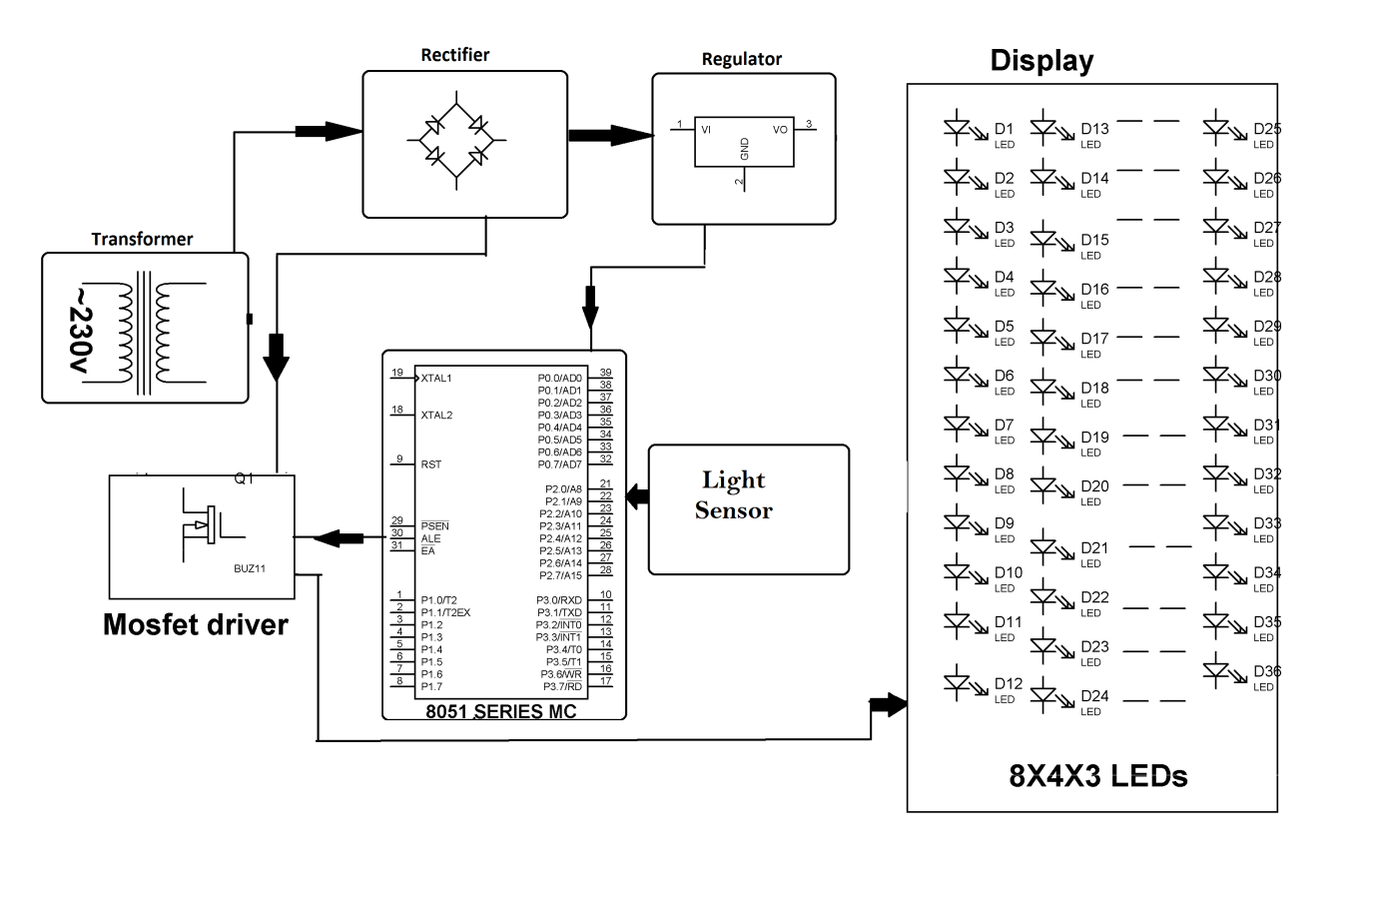

Hardware Specifications
- Transformer
- Diodes
- White LEDs
- Crystal
- 8051 series Microcontroller
- Light Sensor
- MOSFET
- LEDs

Software Specifications
- Keil µVision IDE
- MC Programming Language: Embedded C

Reference
- http://ieeexplore.ieee.org/xpl/articleDetails.jsp?arnumber=4541770&queryText=light%20intensity%20pwm&newsearch=true

- http://ieeexplore.ieee.org/xpl/articleDetails.jsp?arnumber=5675331&queryText=light%20intensity%20pwm&newsearch=true

