Advanced Footstep Power Generation System using RFID for Charging

Day by day, the population of the country is increasing and the requirement of the power is also increasing. At the same time the wastage of energy is also increasing in many ways. So, reforming this energy back to usable form is the major solution. In this footstep power generation project, we are generating power with the help of human’s footsteps; this power is then used to charge battery. The power is stored in a battery that can be used to charge a mobile phone using RFID card. This system is powered by Atmega 328 microcontroller, it consists of Arduino IDE, RFID sensor, USB cable and LCD. When we power on the system, the system enters into registration mode. We can register three users. Once all the user is entered in the system then the system asks to swipe the card and connect the charger. Initially all the user is given 5 minutes of charging time as default. When we swipe the card and if the user is authorised, the system turns on for charging and will charge the Mobile phone. If the user is un-authorised then the system will display as unauthorised user, just in case if the user wants to stop the charging in midway the user needs to swipe the card again. As soon as the card is swiped again, the remaining time balance is displayed and the charging stops. In order to recharge a card, we need to press recharge button which is on the system, and then system will ask to swipe the card, once the user swipes the card, it adds more 5 minutes to the particular card of the user.

Block Diagram :
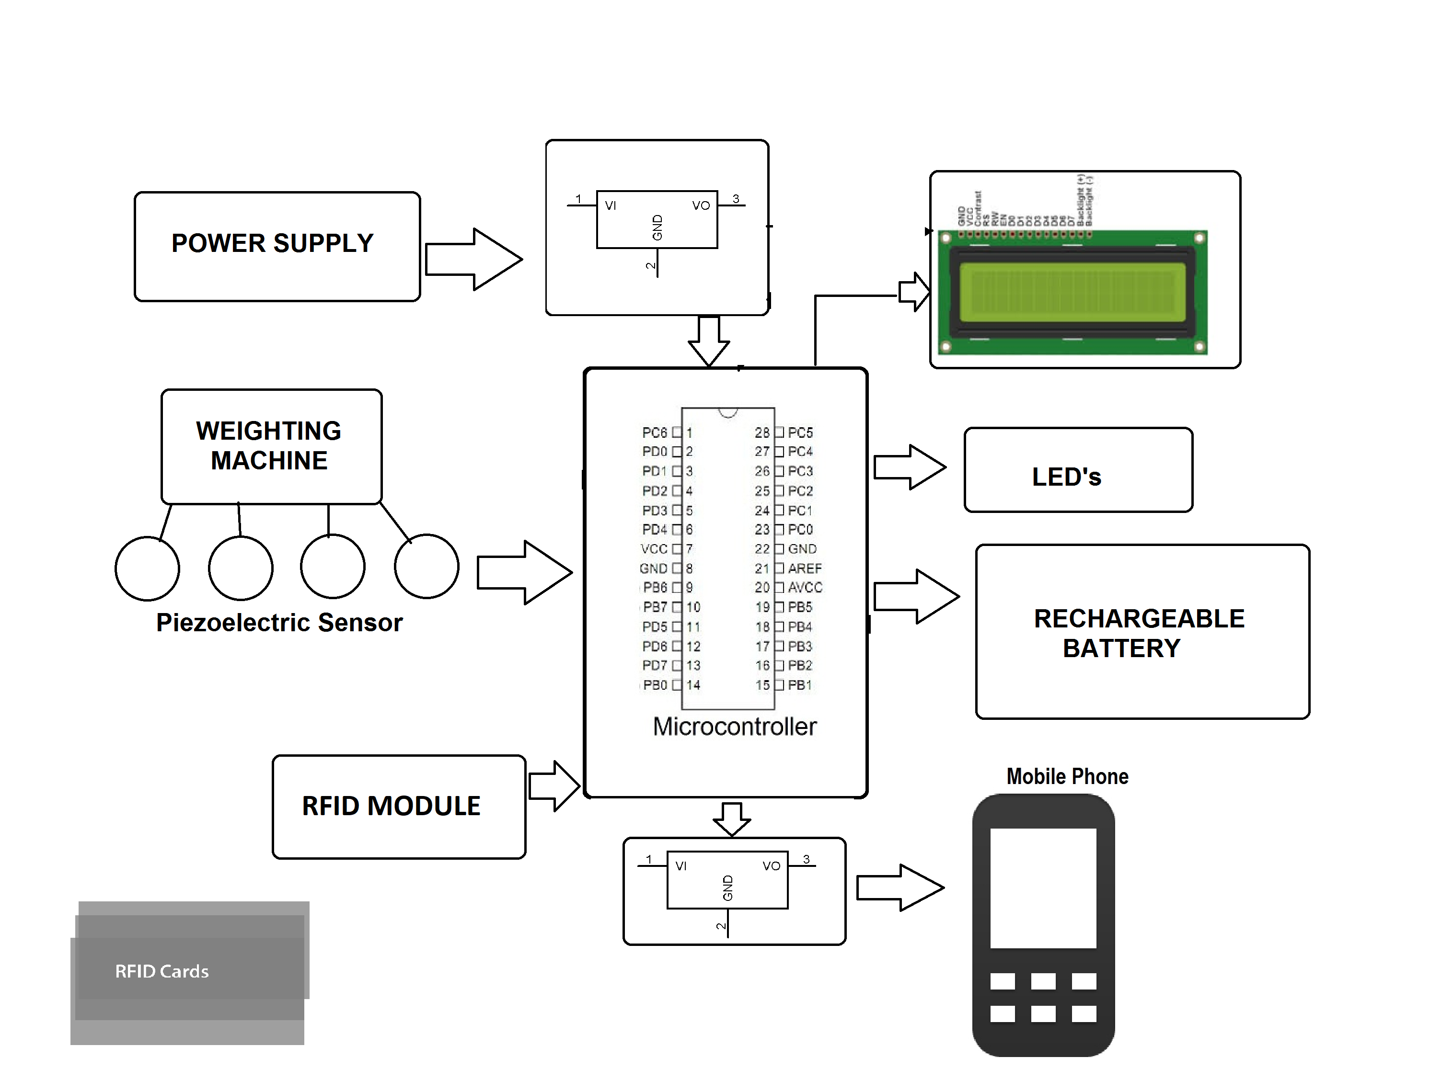

Hardware Specifications
- Power supply
- LED’s
- Weightning Machine
- Mobile
- Atmega microcontroller
- RFID sensor & cards
- USB cable
- LCD 16*2
- Adapter
- Voltage regulator
- Resistor
- Capacitor

Software Specifications

- Arduino Compiler
- Programming Language: C

