Optimizing Direct Marketing Profitability Through Predictive Donor Modeling
ADTA 5230 - Data Analytics II Section 002
Jingjing Tong
Varshini Boyapally , Archana Kannan, Jayasree Rathod
University of North Texas
12-03-2025

Table of Contents
- Introduction, Business Understanding & Analytics Questions
1.1 Project Overview…………………………….
1.2 Business Problem……………………………
1.3 Analytics Questions……………………
- Data Understanding & Exploratory Data Analysis (EDA)
2.1 Data Overview……………………………..
2.3 Visual Explorations………………………………..
- Data Preparation
3.1 Handling Missing Values………………………………….
3.2 Filtering and Variable Selection…………………………….
3.3 Encoding & Scaling………………………………….
- Modeling
4.1 Classification Modeling (DONR)………………………………….
4.2 Regression Modeling (DAMT)……………………………..
- Evaluation
5.1 Classification & Regression Evaluation…………………….
- Deployment & Profit Analysis
- Conclusion
- References

1. INTRODUCTION, BUSINESS UNDERSTANDING & ANALYTICS QUESTIONS
1.1 Project Overview
Non-profit organizations rely heavily on direct mail campaigns to reconnect with past donors and generate fundraising revenue. However, with low response rates and fixed mailing costs, mass-mailing campaigns often result in financial loss. This project aims to use predictive analytics to discover which individuals are most likely to donate and what amount they may contribute, enabling a shift from a high-cost mass-mailing strategy to a profitable targeted-mailing strategy.
The dataset provided by a recent fundraising campaign includes demographic characteristics, donor behavior history, and past giving amounts, enabling the development of models that predict donation probability (DONR) and expected donation amount (DAMT). Using these predictions, the project evaluates mailing scenarios to determine profitability.
1.2 Business Problem
Historical data indicates:
- Only ~10% of mailed individuals donate.
- The average donation is $14.50.
- The cost per mailing is $2.00.
This results in a negative expected profit from mailing everyone.
Therefore, the organization requires a data-driven solution to:
- Identify individuals most likely to donate.
- Estimate expected donation amounts.
- Determine which individuals should be mailed to maximize profit.
1.3 Analytics Questions
Based on business needs, the project focuses on three primary analytical questions:
- Which individuals are most likely to donate?
- For expected donors, how much are they likely to donate?
- What is the total profit achieved using a targeted mailing strategy compared to mailing all individuals?
2. DATA UNDERSTANDING & EXPLORATORY DATA ANALYSIS (EDA)
2.1 Data Overview - The dataset contains:
- Demographic variables – age, wealth indicators, region.
- Behavioral variables – historical donations, frequency, recency.
- Target variables:
- DONR (binary: donor or non-donor)
- DAMT (monetary donation amount for donors only)
The dataset includes a mixture of continuous, categorical, and behavioral attributes.
2.2 Descriptive Statistics
Using train describe (), we examined ranges, central tendencies, and missing values.
Key observations:
- Behavioral variables (gift count, frequency, monetary history) exhibit strong right-skewness.
- DAMT is right-skewed due to a small group of high-value donors.
- Most demographic variables show moderate spread but some skewness.
2.3 Visual Explorations
2.3.1 Numerical Distributions (Histograms)
Histograms show:
- Recency: majority donate infrequently.
- Gift history: large, long-tail; few high-engagement donors.
- Wealth scores: uneven distribution suggesting income variability.

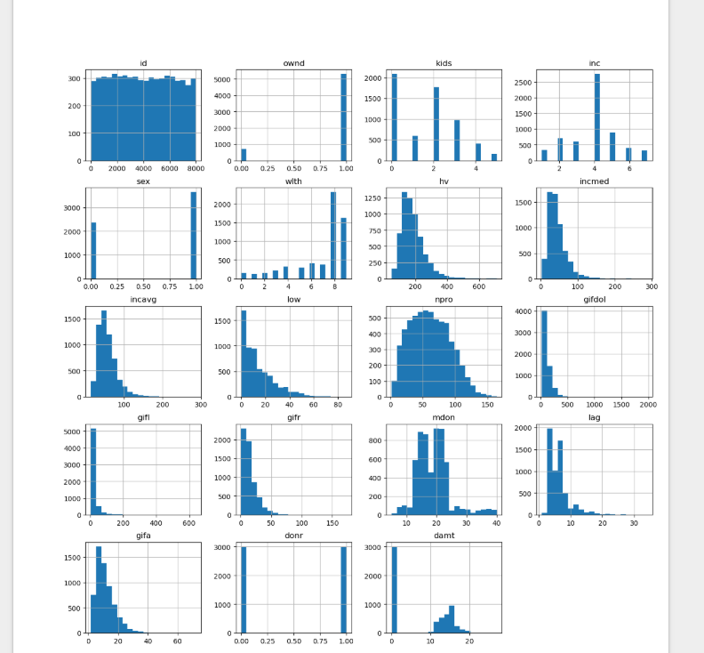
2.3.2 Correlation Heatmap (Figure Placeholder)
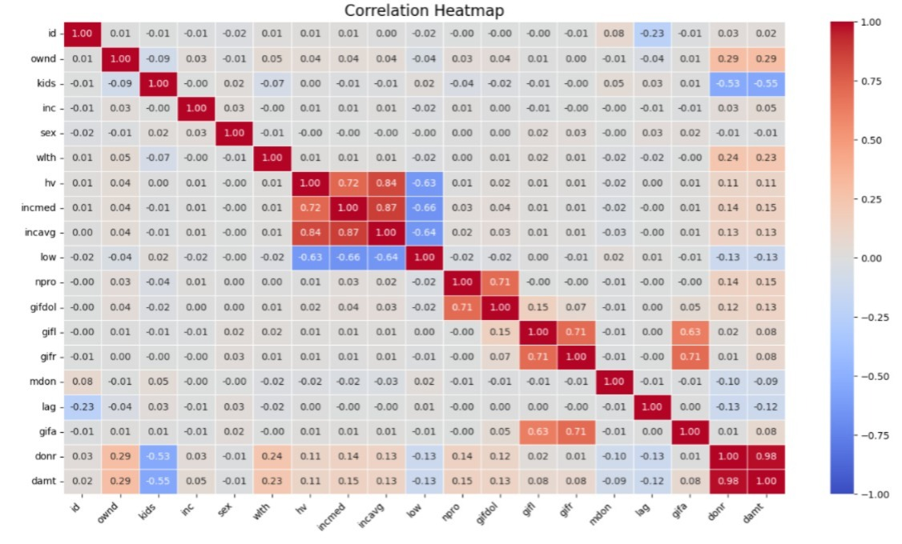
Moderate correlations exist among behavioral variables (e.g., frequency vs. past donation count), but no severe multicollinearity.
This allowed flexible model selection without dimensionality reduction constraints.
2.3.4 DONR vs Non-DONR Comparison
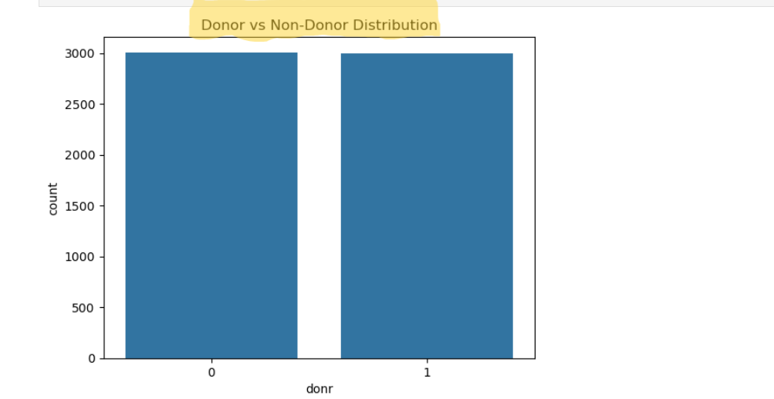
The direct comparison of donor status revealed that the data was not balanced, as most of it was represented by the non-donors. This observation influenced subsequent modeling decisions like the measures of evaluation and the need to make sure that classification is robust.
Other visualizations showed the distribution of donor donations in terms of their values, which served to demonstrate the bias of DAMT and the diversity of donors.
2.3.5 Categorical Variables
There are some categorical predictors which were examined by comparing the donation rates. Some of these categories had higher rates of conversion and this suggests that they can be predictive of the classification task.
3.DATA PREPARATION
3.1 Handling Missing Values
Missing values occurred mainly in wealth and behavioral variables.
Continuous variables: Median imputation.
Categorical variables: Mode imputation.
Dropped fields:
ID (for both DONR and DAMT models)
DAMT (excluded from classification)
DONR (excluded from regression)
Ensured consistent sample sizes and reduced potential bias.
3.2 Filtering and Variable Selection
ID removed from all modeling tasks.
DAMT removed from classification models.
DONR removed from regression models.
All other variables retained unless they showed low variance or no analytical value.
3.3 Encoding and Scaling
Categorical variables - One-Hot Encoding.
Continuous variables - Standard Scaling (especially for KNN and Neural Networks).
Skewed variables evaluated but not transformed to maintain compatibility with tree-based models.
4. MODELING 1 - Data Split: 75% training and 25% validation
4.1 Classification Modeling (DONR)
The main task of the classification exercise was to know whether a person would donate. A reasonable predictor set was chosen, and it was not inclusive of ID or DAMT. There were at least three algorithms that were developed, tuned and tested.
4.1.1 K-Nearest Neighbors
KNN was chosen as a non-parametric classifier, which serves as a baseline. It has the power behind its simplicity and the natural distance-driven decision-making. It is however sensitive to feature scaling, and it may not cope with high dimensional data. Various sets of k were tested to determine optimal bias- variance tradeoff.
4.1.2 Neural Network Classifier
It was developed into a feed forward neural network that was able to model complex non-linear relationships in the donor data. Neural networks come in handy where relationships between predictors are complex as is the case with socio-economic and behavioral characteristics. The tuning of architecture was done through changes in the sizes of hidden-layers and activation functions. Neural networks though powerful need fine-tuning and are not as interpretable as other approaches.
4.1.3 Random Forest Classifier
Random Forest was also added as one of the strong ensemble algorithms that can process noise as well as high-dimensional data. It has advantages such as, it is not prone to overfitting, and it accommodates automatically the interaction of variables. The essential hyperparameters (the number of trees, maximum depth) were optimized. Random Forest also has a feature of measuring variable importance, which is not interpretable in neural networks.
Classification Model Performance Comparison (DONR)
Model | Accuracy | AUC | Expected Profit | Selected?
K-Nearest Neighbors (KNN) | 0.762 | 0.922 | 8585.50 | No
Neural Network Classifier (MLP) | 0.865 | 0.941 | 8465.00 | No
Random Forest Classifier | 0.879 | 0.970 | 8832.50 | No
Gradient Boost | 0.876 | 0.976 (Highest) | $8,927.50 (Highest) | Yes

4.2 MODELING 2
4.2.1 Regression Modeling (DAMT)
In addition to determining which prior donors are most likely to reply, the client intends to estimate the anticipated donation amount (DAMT) for those who actually donate. This appears as a supervised regression problem with a continuous target variable.
Since non-donors make no substantial donations, the DAMT models were only trained on records with DONR = 1. The variables ID and DONR have been dropped from the predictor set as required. The remaining social, historical giving, and demographic factors were also taken into consideration as potential predictors.
We used the same preprocessing workflow that was previously used to guarantee consistency among models:
For numerical variables, median imputation is used for missing values, followed by normalization.
Categorical variables: The most prevalent imputation, then one-hot encoding
Integration in a scikit-learn pipeline using a ColumnTransformer.
This pipeline allows the modeling process to be scalable and consistent while making sure all models using regression receive characteristics that are treated identically.
Next, by using several algorithm families, we developed few candidate models:
Linear Regression: It is a supervised machine learning algorithm, which makes the assumption that the predictors and donation amount have a linear relationship, which means that when the input changes the output also changes at a constant rate. The straight line represents this relationship (geeksforgeeks, 2025).
Pros: It is simple, efficient and interpretable, it has predictive ability and is widely used and very helpful for analysis.
Cons: unable to capture nonlinear correlations or intricate relationships among various variables that are most probably associated with donor behavior.
Random Forest:
A collection of decision trees built via bagging, or bootstrap aggregation.
Pros: automatically detects nonlinear patterns and interaction effects, resistant to noise and outliers; often exceeds linear models on tabular data.
Cons: performance is dependent on the selection of hyperparameters (number of trees, depth, etc.) less interpretable than a single tree.
Gradient Boosting Regressor:
A boosting ensemble that generates trees in sequence, with each one focusing on minimizing the previous model's residuals (Bryan Clark).
Pros: Highly adaptable and effective for structured data. It is useful for modeling complex associations among donor characteristics and donation amounts.
Cons: training may take longer than with simpler models and it is more sensitive to hyperparameters (learning rate, number of estimators, tree depth).
To find the best DAMT prediction model, each model was trained on the donor subset of the training data and then evaluated on a held-out validation set.
All regression and classification models were trained with the same 75% training and 25% validation split to guarantee uniformity and fair comparison across approaches.
5. Evaluation of Classification Models:
Multiple techniques were applied to predict DONR using the same preprocessing pipeline, such as logistic regression, K-nearest neighbors, support vector machine, naïve Bayes, random forest, and a neural network classifier (MLP). Using the validation data, the model's performance was evaluated using:
Misclassification rate / accuracy refers to how frequently the model properly predicts donor vs. non-donor.
The AUC (Area Under the ROC Curve) indicates how effectively the model classifies donors over non-donors.
Expected profit is calculated using the business rule for a grid of probability thresholds.
Expected profit per person = p^​ (donate) × 14.50 − 2.00
We calculated the expected profit on the validation set for each candidate classifier across a range of cutoff probabilities and determined the profit-maximizing threshold. The final DONR model was chosen based on its largest validation profit (and strong AUC). In our situation, the selected classifier offered a solid balance of prediction performance and business value, and the cutoff was then used in deployment to classify "likely donors."

Evaluation of Regression Models (DAMT)
The DAMT regression models were evaluated using a 25% validation split after being trained on 75% of the donor data. For every model, three important metrics were computed (GeeksforGeeks, 2025):
ASE (Average Squared Error)
This is equivalent to mean squared error (MSE). Larger errors are strongly penalized by ASE.
n
ASE= 1/n ∑ (yi - yi)2
i=1
Lower ASE means the model’s predicted donation amounts are closer to the actual amounts.
RMSE (Root Mean Squared Error)
RMSE = $\sqrt{ASE}$
RMSE is easy to understand as an average prediction error and is measured in the same units as DAMT (dollars).
R² (Coefficient of Determination)
R² = 1 − ∑(yi−y^i)2 / ∑(yi−yˉ)
The proportion of variance in donation amount explained by the model and is measured as R², higher R² - better the model.

Regression Model Comparison (Validation Set):
Regression Model | RMSE | ASE | R2 | Selected
Linear Regression | 1.30 | 1.70 | 0.555 | No
Random Forest Regressor | 1.26 | 1.58 | 0.584 | No
Gradient Boosting | 1.14 | 1.30 | 0.659 | Yes
KNN Regressor | 1.42 | 2.01 | 0.473 | No

Linear regression performed effectively as a baseline but failed to capture nonlinearities in donor-amount behavior. Both tree-based models improved performance, but Gradient Boosting Regressor showed the strongest results, with the lowest RMSE/ASE and highest R², suggesting that it accurately represents models complex interactions across demographic and historical giving factors. According to evaluation metrics, the Gradient Boosting Regressor was selected as the final DAMT prediction model and applied during deployment.
6. Deployment and Profit Analysis
The best classification and regression models were chosen, and then the business impact was measured by applying them to the unlabeled score dataset (nonprofit_score.xlsx) (GeeksforGeeks, 2025). The purpose of deployment is to decide which individuals ought to get a solicitation letter so as to optimize the predicted profit from the fundraising effort.

6.1 Two-Stage Prediction Framework:
Each person in the score dataset had two predictions made for them:
1. Probability of Donating (DONR Prediction)
The selected categorization model generates a probability value. for each individual, showing their likelihood of responding with a donation. These probabilities were determined using:
p^​i​ = P(donori​=1)
2. Expected Donation Amount (DAMT Prediction)
Using the best regression model (Gradient Boosting Regressor), we estimated the expected donation amount for each participant, assuming they donate.
3. Expected Revenue and Expected Profit
The expected monetary return from mailing to individual i is:
Expected Revenuei​= p^​i​ × a^i​
Every mailing cost $2.00, so the expected profit per person is:
Expected Profit i​= p^​i​×a^i​ − 2.00
This profit formula directly aligns the model with business goals by taking into account both the probability of a donation and the donation amount.
6.2 Mailing Strategies Compared
We used the calculated expected profit values to determine the two potential mailing techniques.
Strategy A: Bulk Mailing (Send to Every Prospect)
In this method, irrespective of anticipated profitability, the organization mails a letter to each of the 2,007 people in the score file.
Results:
Expected total profit: -$1,490.11
Average anticipated profit per individual: -$0.74
The mass mailing method results in a net financial loss because the predicted donation revenue is insufficient to pay for the mailing costs for the majority of individuals.
This validates the organizations initially expressed issue that it's not affordable to mail everyone.
Strategy B: Model-Based Targeted Mailing.
This method only sends letters to people who have a positive predicted profit:
These are high-value prospects who are expected to contribute enough to cover mailing costs and generate net revenue.
Results:
People mailed: 334.
Expected total profit: $1,402.51
$4.20 is the average anticipated profit per individual sent.
This technique sends emails to only 17% of the score dataset, who are most likely to be lucrative.
Despite sending to fewer persons, this method provides a significant positive profit.

7. CONCLUSION
This project demonstrates how predictive analytics can significantly improve fundraising efficiency for non-profit organizations. Key findings include:
- Behavioral variables and donor history strongly predict donation likelihood.
- Random Forest and Gradient Boosting models provided superior performance for classification and regression.
- Mass mailing results in financial loss, confirming the organization’s initial concern.
- Targeted mailing using predictive models produced a profit of ~$1,400, validating the value of data-driven decisions.
7.1 Limitations
- Imbalanced donor data may limit classification effectiveness.
- Behavioral data may not capture recent donor sentiment changes.
- DAMT predictions can be influenced by extreme gift outliers.
7.2 Future Enhancements
- Incorporate uplift modeling to better estimate individual-level incremental impact.
- Explore SMOTE or other techniques for classification imbalance.
- Add socioeconomic external datasets for improved prediction signals.

8.References
(Bryan Clark). What is Gradient Boosting?
https://www.ibm.com/think/topics/gradient-boosting
(Dr. Tong, 2025). Module 4.1 - Decision Trees
https://unt.instructure.com/courses/131897/pages/module-4-dot-1-materials-decision-trees?module_item_id=8307388
(Dr. Tong, 2025). Module 3.1 - K-Nearest neighbors (KNN)
https://unt.instructure.com/courses/131897/pages/module-3-dot-1-materials-k-nearest-neighbors-knn?module_item_id=8201649
(GeeksforGeeks, 2025). Linear Regression in Machine learning.
/https://www.geeksforgeeks.org/machine-learning/ml-linear-regression/
(GeeksforGeeks, 2025). Random Forest Algorithm in Machine learning.
https://www.geeksforgeeks.org/machine-learning/random-forest-algorithm-in-machine-learning/
(GeeksforGeeks, 2025). Regression Metrics
https://www.geeksforgeeks.org/machine-learning/regression-metrics/
(GeeksforGeeks, 2025). K-Nearest Neighbors (KNN) Algorithm
https://www.geeksforgeeks.org/machine-learning/k-nearest-neighbours/
(GeeksforGeeks, 2025). Machine learning deployment
​​https://www.geeksforgeeks.org/machine-learning/machine-learning-deployment/
Appendix:
Archana handled all data cleaning, preparation, and EDA and drafted those sections.
Varshini developed and documented Modeling-2, model evaluation, and deployment including profit analysis.
Jayasree wrote the introduction, conclusion, and created the PPT.
Joint Contributions:
- All team members contributed to reviewing, revising, and integrating the full written report to maintain consistency in tone, formatting, and analytical accuracy.
- Group discussions were held throughout the project to validate modeling choices, interpretation of results, and final business recommendations.

