Part -1:

My chosen operating system is MacOS and it was installed in my MacBook Pro. I’m aware of its components such as files, drives, folders and directories and to access with both administrative rights and also as a normal user.
- I can find file or other media contents in my computing device by using the spotlight search (command + space) button to locate the file then go with Show in finder to see the real storage location of the file.
- To get the real, physical path of a file - click on Finder - right click on the file you want - select get info, under ‘where” you can see the exact location and we see check the same with Terminal too.
- On macOS the physical media contents or documents can be accessed by Finder - by going through their actual storage locations like - downloads, photos or documents folders.
I can create a folder and put files in it and if needed I can edit files as required and I can download applications and save them in folders and install them when needed like I did for Anaconda Navigator. Likewise I can work in Terminal and know the basic command lines and can create folders. I can look and resolve the basic OS issues and if not - I know how to take technical help from vendors or Apple’s official support team. So overall, I can effectively manage all such things in my computing device for my assignments.

Part - 2:

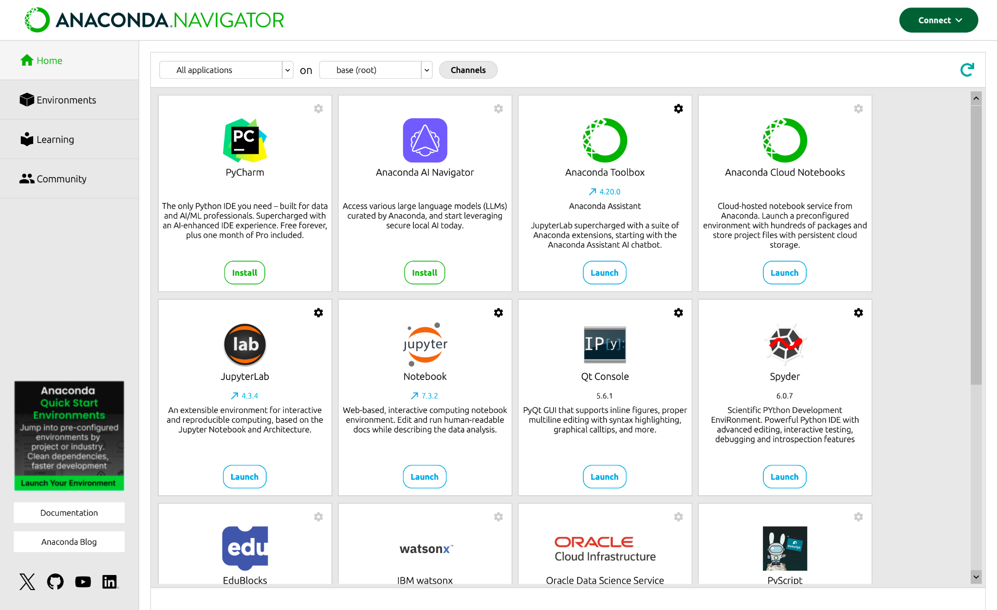

Part - 3:

