Write a C program on the following
1. Double Ended Queue

#include <stdio.h>
#define size 5

int q[size];
int f = -1;
int r = -1;

int isFull()
{
if ((r + 1) % size == f)
return 1;
else
return 0;
}

int isEmpty()
{
if (f == -1 && r == -1)
return 1;
else
return 0;
}

void EnqueueR(int x)
{
if (isFull())
{
printf("queue is full\n");
}
else if (isEmpty())
{
f = 0;
r = 0;
q[r] = x;
}
else
{
r = (r + 1) % size;
q[r] = x;
}
}

void EnqueueF(int x)
{
if (isFull())
{
printf("queue is full\n");
}
else if (isEmpty())
{
f = 0;
r = 0;
q[f] = x;
}
else
{
// Wrap around to the end of array if f is 0
f = (f - 1 + size) % size;
q[f] = x;
}
}

void DequeueF()
{
if (isEmpty())
{
printf("Queue is Empty\n");
}
else if (f == r)
{
f = -1;
r = -1;
}
else
{
f = (f + 1) % size;
}
}

void DequeueR()
{
if (isEmpty())
{
printf("Queue is Empty\n");
}
else if (f == r)
{
f = -1;
r = -1;
}
else
{
// Wrap around to the end of array if r is 0
r = (r - 1 + size) % size;
}
}

void display()
{
if (isEmpty())
{
printf("Queue is Empty\n");
return;
}

printf("queue elements are: ");
int i = f;
while (1)
{
printf("%d ", q[i]);
if (i == r)
break;
i = (i + 1) % size;
}
printf("\n");
}

int main()
{
int choice, x;
while (1)
{
printf("1.EnqueueR\n 2.EnqueueF\n 3.DequeueF\n 4.DequeueR\n 5.display\n 6.Exit\n");
printf("Enter choice: ");
scanf("%d", &choice);

switch (choice)
{
case 1:
printf("Enter the element: ");
scanf("%d", &x);
EnqueueR(x);
break;

case 2:
printf("Enter the element: ");
scanf("%d", &x);
EnqueueF(x);
break;

case 3:
DequeueF();
break;

case 4:
DequeueR();
break;

case 5:
display();
break;

case 6:
return 0;

default:
printf("Invalid choice\n");
}
}
return 0;
}

Output
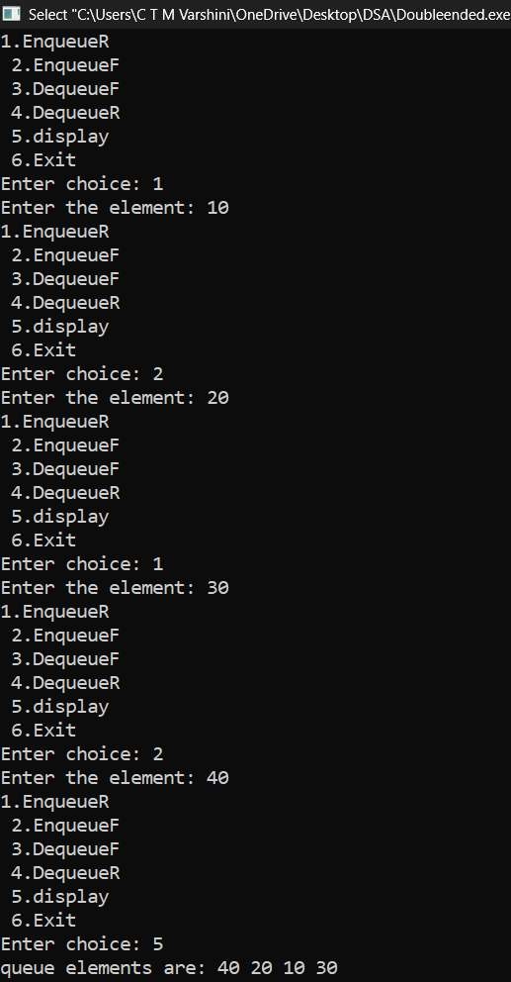
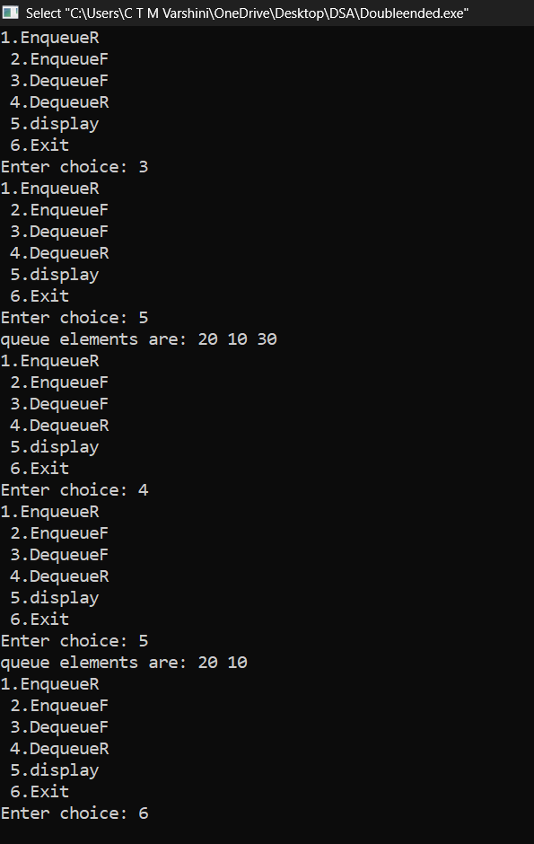

1(a) Input Restricted

#include <stdio.h>
#define size 5

int q[size];
int f = -1;
int r = -1;

int isFull()
{
if ((r + 1) % size == f)
return 1;
else
return 0;
}

int isEmpty()
{
if (f == -1 && r == -1)
return 1;
else
return 0;
}

// Allowed: Insertion only at the Rear
void EnqueueR(int x)
{
if (isFull())
{
printf("queue is full\n");
}
else if (isEmpty())
{
f = 0;
r = 0;
q[r] = x;
}
else
{
r = (r + 1) % size;
q[r] = x;
}
}

// Allowed: Deletion from the Front
void DequeueF()
{
if (isEmpty())
{
printf("Queue is Empty\n");
}
else if (f == r)
{
f = -1;
r = -1;
}
else
{
f = (f + 1) % size;
}
}

// Allowed: Deletion from the Rear
void DequeueR()
{
if (isEmpty())
{
printf("Queue is Empty\n");
}
else if (f == r)
{
f = -1;
r = -1;
}
else
{
// Safe circular decrement to prevent negative array indexing
r = (r - 1 + size) % size;
}
}

void display()
{
if (isEmpty())
{
printf("Queue is Empty\n");
return;
}

printf("queue elements are: ");
int i = f;
while (1)
{
printf("%d ", q[i]);
if (i == r)
break;
i = (i + 1) % size;
}
printf("\n");
}

int main()
{
int choice, x;
while (1)
{

printf("\n--- Input Restricted Deque ---\n");
printf("1.Enqueue (Rear)\n");
printf("2.Dequeue (Front)\n");
printf("3.Dequeue (Rear)\n");
printf("4.Display\n");
printf("5.Exit\n");
printf("Enter your choice: ");
scanf("%d", &choice);

switch (choice)
{

case 1:
printf("Enter the element: ");
scanf("%d", &x);
EnqueueR(x);
break;

case 2:
DequeueF();
break;

case 3:
DequeueR();
break;

case 4:
display();
break;

case 5:
return 0;

default:
printf("Invalid choice\n");
}
}
return 0;
}

Output
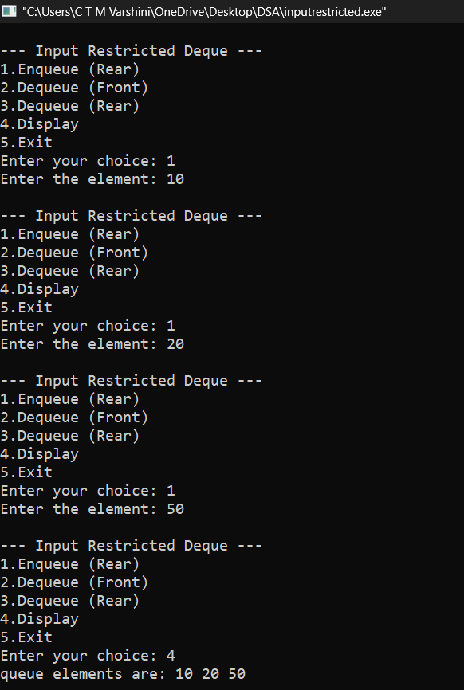

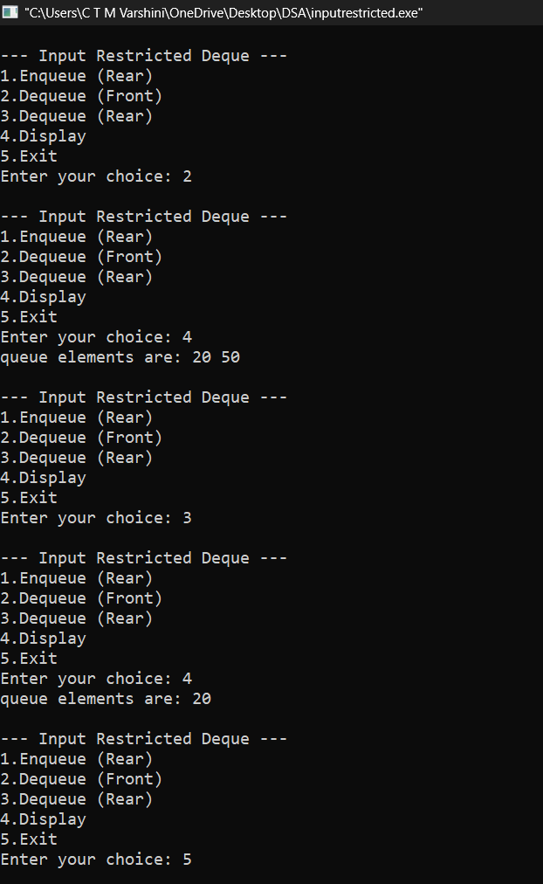

1(b) Output Restricted

#include <stdio.h>
#define size 5

int q[size];
int f = -1;
int r = -1;

int isFull()
{
if ((r + 1) % size == f)
return 1;
else
return 0;
}

int isEmpty()
{
if (f == -1 && r == -1)
return 1;
else
return 0;
}

void EnqueueR(int x)
{
if (isFull())
{
printf("queue is full\n");
}
else if (isEmpty())
{
f = 0;
r = 0;
q[r] = x;
}
else
{
r = (r + 1) % size;
q[r] = x;
}
}

void EnqueueF(int x)
{
if (isFull())
{
printf("queue is full\n");
}
else if (isEmpty())
{
f = 0;
r = 0;
q[f] = x;
}
else
{
f = (f - 1 + size) % size;
q[f] = x;
}
}

void DequeueF()
{
if (isEmpty())
{
printf("Queue is Empty\n");
}
else if (f == r)
{
f = -1;
r = -1;
}
else
{
f = (f + 1) % size;
}
}

void display()
{
if (isEmpty())
{
printf("Queue is Empty\n");
return;
}

printf("queue elements are: ");
int i = f;
while (1)
{
printf("%d ", q[i]);
if (i == r)
break;
i = (i + 1) % size;
}
printf("\n");
}

int main()
{
int choice, x;
while (1)
{

printf("\n--- Output-Restricted Deque Menu ---\n");
printf("1.EnqueueR \n2.EnqueueF \n3.DequeueF \n4.Display\n5.Exit\n");
printf("Enter choice: ");
scanf("%d", &choice);
switch (choice)
{

case 1:
printf("Enter the element: ");
scanf("%d", &x);
EnqueueR(x);
break;

case 2:
printf("Enter the element: ");
scanf("%d", &x);
EnqueueF(x);
break;

case 3:
DequeueF();
break;

case 4:
display();
break;

case 5:
return 0;

default:
printf("Invalid choice\n");
}
}
return 0;
}

Output
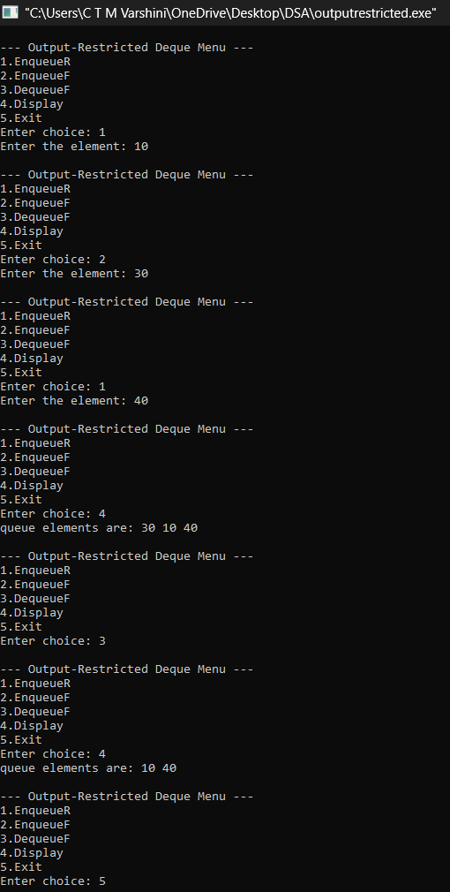

2. Priority Queue
#include <stdio.h>
#include <stdlib.h>

#define MAX 5

int pri_que[MAX];
int front = -1, rear = -1;

void create();
void insert_by_priority(int data);
void check(int data);
void delete_by_priority();
void display_pqueue();

int main()
{
int ch, n;

create();

while (1)
{
printf("\n\n--- PRIORITY QUEUE ---");
printf("\n1. Insert an element");
printf("\n2. Delete highest priority element");
printf("\n3. Display queue");
printf("\n4. Exit");
printf("\nEnter your choice: ");
scanf("%d", &ch);

switch (ch)
{
case 1:
printf("Enter value to insert: ");
scanf("%d", &n);
insert_by_priority(n);
break;

case 2:
delete_by_priority();
break;

case 3:
display_pqueue();
break;

case 4:
exit(0);

default:
printf("Invalid choice!");
}
}

return 0;
}

void create()
{
front = rear = -1;
}

void insert_by_priority(int data)
{
if (rear == MAX - 1)
{
printf("Queue Overflow!");
return;
}

if (rear == -1)
{
front = rear = 0;
pri_que[rear] = data;
}
else
{
check(data);
rear++;
}
}

void check(int data)
{
int i, j;

for (i = 0; i <= rear; i++)
{
if (data > pri_que[i])
{
for (j = rear; j >= i; j--)
pri_que[j + 1] = pri_que[j];

pri_que[i] = data;
return;
}
}

pri_que[rear + 1] = data;
}

void delete_by_priority()
{
int i;

if (rear == -1)
{
printf("Queue Underflow! Queue is empty.");
return;
}

printf("Deleted highest priority element: %d",
pri_que[front]);

for (i = front; i < rear; i++)
pri_que[i] = pri_que[i + 1];

rear--;

if (rear == -1)
front = -1;
}

void display_pqueue()
{
int i;

if (rear == -1)
{
printf("Queue is empty!");
return;
}

printf("Priority Queue: ");

for (i = front; i <= rear; i++)
printf("%d ", pri_que[i]);

printf("\n");
}

Output
