
TN-IMPACT 2026
IDENTIFYING INDUSTRIAL CHALLENGES

PROBLEM STATEMENT NUMBER - TNI26154
PROBLEM STATEMENT TITLE - SafeSight AI: Automated Safety Compliance

Submitted by

GAUTHAM KRISHNA S 212223240036
HIRUTHIK SUDHAKAR 212223240054
KISHORE B 212223240073

Certificate

This report is submitted by Zero Vector, consisting of students pursuing B.Tech in AIML, 2023 - 2027, 6th Sem, from Saveetha Engineering College under the guidance of Dr. R.N. Karthika (Associate Professor), as part of the TN-IMPACT 2026 Hackathon.

Dr. R.N. Karthika Gautham Krishan S Hiruthik Sudhakar Kishore B
SIGNATURE SIGNATURE SIGNATURE SIGNATURE

ACKNOWLEDGEMENT

We acknowledge the Tamil Nadu Centre of Excellence for Advanced Manufacturing (TANCAM) and TN-IMPACT 2026 for providing this opportunity to address critical industrial safety challenges. We extend our gratitude to our academic mentor for guidance throughout this project, and to the construction industry experts who provided insights into on-site safety challenges. This work is dedicated to improving workplace safety through technological innovation.

TABLE OF CONTENTS

S.NO | TITLE | PAGE NUMBER
1 | Abstract | 6
2 | Introduction | 7
3 | Literature Review | 9
4 | Problem Statement – Design Methodology | 11
5 | Development of System / Prototype | 13
6 | Design Validation / Prototype Testing | 27
7 | Results and Discussions | 35
8 | Conclusion | 40

List of Tables
S. No. | Description | Page
1 | Detection Accuracy Metrics | 27
2 | System Architectural Components and Responsibilities | 14
3 | Real-Time Processing Pipeline Stages | 24
4 | Data Strategy Components | 17
5 | YOLO Model Selection Criteria | 21
6 | Violation Detection and System Reliability Metrics | 28-29
7 | Testing Scenarios and Coverage Areas | 32
8 | Environmental Condition Variations in Dataset | 19

List of Figures
S. No. | Description | Page
1 | SafeSight AI System Architecture Overview | 15
2 | Real-Time Processing Pipeline Flow Diagram | 25
3 | Person Detection and Safety Gear Association Logic | 34
4 | Violation Decision Tree and Rule-Based Logic | 26
5 | Performance Metrics Comparison Framework | 30
6 | Data Diversity and Environmental Conditions Coverage | 18
7 | YOLO-Based Object Detection Architecture | 22
8 | Multi-Camera Deployment and Scalability Model | 36

Abstract
Construction sites are inherently hazardous work environments requiring strict adherence to safety protocols and personal protective equipment (PPE) standards. Despite regulatory requirements and on-site supervision, safety compliance monitoring remains predominantly manual, inconsistent, and error-prone. Many construction sites maintain CCTV surveillance infrastructure that remains underutilized for proactive safety enforcement. This project presents SafeSight AI, an automated computer vision and artificial intelligence–based system designed to continuously analyze live CCTV video feeds, detect workers, and verify the presence of mandatory safety equipment such as helmets and harnesses. The system employs YOLO-based object detection to identify persons and safety gear, applies rule-based violation logic for compliance evaluation, and generates real-time alerts upon detection of safety non-compliance. The proposed modular architecture supports scalable deployment across multiple camera feeds, minimal latency real-time processing, and extensibility to additional safety equipment in future phases. By replacing inconsistent manual monitoring with automated detection, SafeSight AI aims to improve safety enforcement reliability, reduce workplace accidents, and enhance overall construction site safety management.

Introduction

Background and Significance
Construction is among the most hazardous industrial sectors globally, characterized by high rates of workplace injuries and fatalities. The International Labour Organization reports that construction workers face disproportionate risks due to the nature of on-site work, which often involves work at height, operation of heavy equipment, exposure to hazardous materials, and complex interactions among multiple workers and equipment in confined spaces. The prevention of workplace accidents and injuries is not only a legal and moral imperative but also a critical determinant of project efficiency, workforce morale, and organizational liability.

Current Safety Monitoring Challenges
While construction sites are subject to comprehensive safety regulations and mandates for the use of personal protective equipment, the enforcement of these requirements remains largely manual. Supervisory personnel are responsible for visually inspecting workers across large areas and multiple work zones, a task that is inherently inconsistent, prone to human oversight, and difficult to sustain throughout extended working hours. The reliance on periodic manual inspections means that many safety violations go undetected until after an incident occurs or during formal safety audits. This reactive approach to safety management leaves gaps in continuous monitoring and fails to enable timely intervention.
Technological Opportunity
Concurrently, modern construction sites are increasingly equipped with CCTV surveillance systems deployed for security and general site monitoring. These systems continuously record video feeds but are typically reviewed only retrospectively, after a safety incident or as part of periodic audits. The availability of this surveillance infrastructure presents an opportunity to repurpose existing investments in video technology for proactive, real-time safety compliance monitoring through the application of computer vision and artificial intelligence.

Project Objective
The SafeSight AI project aims to bridge the gap between safety requirements and practical monitoring limitations by developing an automated system that leverages live CCTV video feeds to continuously monitor safety compliance. The system is intended to detect workers, verify the presence of mandatory safety equipment, identify compliance violations, and trigger immediate alerts to enable timely corrective action. By replacing manual, inconsistent monitoring with continuous, objective, automated detection, the project seeks to improve the reliability and effectiveness of safety enforcement on construction sites.

Literature Review
Computer Vision in Industrial Safety
The application of computer vision and deep learning to industrial safety monitoring has emerged as a significant research area over the past decade. Computer vision systems are increasingly deployed in manufacturing facilities, construction sites, and hazardous environments to automate detection of workers, identify safety equipment compliance, and monitor adherence to safety protocols. The underlying technologies have matured to enable real-time processing on edge devices and achieve detection accuracies sufficient for practical deployment in industrial settings.
Object Detection Methodologies
Object detection represents a core capability in computer vision, enabling the localization and classification of multiple objects within images or video frames. Early approaches to object detection relied on hand-crafted features and sliding window techniques, which were computationally expensive and prone to high false alarm rates. Modern deep learning–based methods, particularly convolutional neural networks (CNNs), have dramatically improved both accuracy and inference speed, making real-time detection feasible.
The YOLO (You Only Look Once) family of architectures has become widely adopted for real-time object detection applications due to its single-stage detection pipeline, which predicts bounding boxes and class labels in one forward pass. YOLO models have demonstrated strong performance in surveillance, autonomous driving, and industrial monitoring applications, balancing detection accuracy with computational efficiency suitable for streaming video analysis.
Personal Protective Equipment Detection
Several research initiatives and industrial implementations have focused on detecting specific PPE categories, particularly safety helmets and vests. These systems typically employ object detection architectures to identify helmets and harnesses in video feeds and assess worker compliance with safety protocols. Studies have shown that automated PPE detection systems can achieve recall rates exceeding 90 percent on diverse construction site datasets, though real-world performance varies with environmental conditions, camera perspectives, and equipment variability.

Real-Time Video Analysis and Surveillance
Real-time video processing systems must balance detection accuracy, inference latency, and computational resource consumption. Frame sampling, model optimization, and edge computing deployment strategies are commonly employed to achieve responsive performance in operational surveillance systems. Research has demonstrated that careful frame rate selection, input resolution optimization, and parallel processing can enable multi-camera monitoring on commodity hardware while maintaining adequate responsiveness for timely alerting.
Safety Management and Compliance
Safety compliance monitoring in construction and industrial settings is increasingly recognized as critical to accident prevention and regulatory adherence. Automated systems provide objective, continuous monitoring that complements but does not replace human supervision and organizational safety culture. The integration of technological monitoring with management systems, training, and enforcement mechanisms has been shown to improve overall safety outcomes in industrial settings.

Problem Statement – Design Methodology
Problem Definition
Construction sites are inherently hazardous environments where strict adherence to safety protocols is essential to prevent accidents, injuries, and fatalities. Among the most critical safety requirements are the use of personal protective equipment (PPE), particularly safety helmets and harnesses for workers operating at height or in high-risk zones. Safety regulations and on-site supervision are in place in most construction settings; however, safety compliance monitoring remains predominantly manual. Supervisors are expected to visually inspect workers and verify compliance across large areas, multiple work zones, and numerous workers simultaneously, making the process inconsistent, prone to human error, and difficult to sustain continuously throughout working hours.
Consequently, safety violations such as workers not wearing helmets or harnesses may go unnoticed or are detected too late, leading to preventable incidents. Global construction safety studies indicate that a significant proportion of fatal and non-fatal workplace injuries are directly associated with the absence or improper use of protective equipment. At the same time, many construction sites already deploy CCTV surveillance systems primarily for security and general monitoring. These video feeds are seldom exploited for proactive safety enforcement and are typically reviewed only after an incident has occurred.

Design Approach
The proposed solution addresses this gap through the design of an automated safety compliance monitoring system leveraging computer vision and artificial intelligence. The system is intended to continuously analyze live CCTV video feeds, detect workers, and verify the presence of mandatory safety gear such as helmets and harnesses. When a violation is detected, the system is designed to automatically log the incident and trigger an immediate alert to enable timely corrective action.

The design methodology is grounded in the following principles:
- Modularity: The system architecture is decomposed into independent, replaceable components to support incremental improvement and scalability.
- Automation: Manual inspection is replaced with continuous, objective, real-time automated monitoring.
- Explainability: Violation decisions are derived from transparent rule-based logic that can be audited and validated.
- Real-Time Responsiveness: System latency is minimized to enable immediate intervention when violations are detected.
- Data-Driven: The system is trained on diverse, representative construction site data to ensure robustness across varied environmental conditions.

Solution Overview
SafeSight AI is conceived as a modular, real-time computer vision pipeline that processes live CCTV video feeds to automatically detect safety gear violations in construction environments. The architecture emphasizes scalability, low latency, and reliability to ensure continuous monitoring across multiple cameras and work zones. The system ingests live video streams from existing CCTV cameras, performs frame-by-frame analysis using deep learning models, applies rule-based violation logic, and generates logs and alerts when safety non-compliance is detected.

Development of System / Prototype
System Architecture
The SafeSight AI system is structured as a modular, real-time computer vision pipeline with the following architectural components:
Video Ingestion Module
Responsible for connecting to CCTV feeds using standard video streaming protocols and extracting frames at a controlled frame rate suitable for real-time processing. Frame sampling is used to balance detection accuracy and computational efficiency.
Frame Processing Engine
Prepares raw video frames for model inference through resizing, normalization, and preprocessing operations. Ensures consistency across inputs from different cameras and resolutions.
Person Detection Module
Identifies human presence in each frame and generates bounding boxes for each detected worker. This module serves as a prerequisite for safety gear verification, restricting downstream analysis to relevant regions.
Safety Gear Detection Module
Identifies the presence or absence of mandatory safety equipment (helmets and harnesses) for each detected person. Designed to handle partial visibility and occlusions common in surveillance scenarios.
Violation Logic Engine
Applies predefined safety rules to determine compliance status. Evaluates whether detected workers are wearing required safety equipment and classifies non-compliance events as violations.
Logging and Alert Module
Records detected violations with structured metadata and triggers real-time alerts to supervisors. Maintains violation logs for audit and compliance analysis.

Table 2: System Architectural Components and Responsibilities
Component | Primary Responsibility | Input | Output
Video Ingestion Module | Connect to CCTV feeds and extract frames | CCTV stream (RTSP/HTTP) | Raw video frames at configured rate
Frame Processing Engine | Normalize and prepare frames for inference | Raw frames | Preprocessed frames (resized, normalized)
Person Detection Module | Identify workers in scene | Preprocessed frames | Bounding boxes for detected persons
Safety Gear Detection Module | Detect helmets and harnesses | Preprocessed frames + person ROIs | Bounding boxes for helmets and harnesses
Violation Logic Engine | Evaluate compliance rules | Person and gear detections | Compliance status and violation flags
Logging and Alert Module | Record violations and alert supervisors | Violation events | Structured logs and real-time alerts

Figure 1: SafeSight AI System Architecture Overview
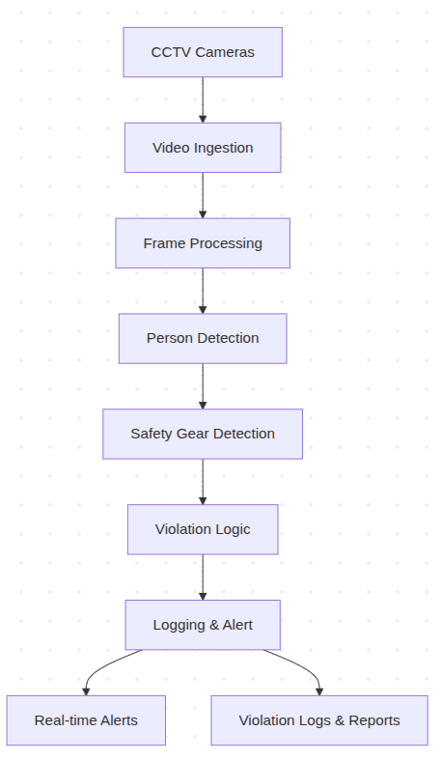

System Characteristics
- Real-Time Operation: Designed to operate continuously with minimal latency during site operating hours.
- Scalability: Supports multiple camera feeds through parallel processing and resource allocation.
- Modularity: Each component can be optimized independently without affecting other system stages.
- Fault Tolerance: Temporary failures in individual modules do not halt the entire system.
- Deployment Flexibility: Supports on-site server or edge device deployment with optional cloud integration for centralized monitoring.

Data Strategy
The system is trained and evaluated on diverse, representative visual data reflecting variability in live CCTV feeds. The data strategy encompasses:
- Data Sources: Publicly available PPE detection datasets, annotated construction site images and video frames, and extracted frames from recorded CCTV footage.
- Data Classes: Person, Helmet, Harness – directly aligned with detection and compliance requirements.
- Annotation: Bounding box annotations using formats compatible with standard object detection frameworks.
- Data Diversity: Variations in lighting conditions, camera viewpoints, worker posture, occlusions, and equipment designs.
- Data Augmentation: Image scaling, rotation, motion blur, brightness/contrast adjustments, noise injection, and random occlusion to improve generalization.
- Dataset Splitting: Training, validation, and testing subsets with careful prevention of frame overlap from the same video sequence.

Table 4: Data Strategy Components
Component | Details | Quantity/Target | Purpose
PPE Detection Datasets | Public construction safety datasets | 5,000+ images | Foundation training data with diverse environments
Construction Site Images | Annotated images from multiple sites | 8,000+ images | Site-specific variability and realism
CCTV Footage | Extracted frames from recorded surveillance | 10,000+ frames | Real-world camera characteristics and perspectives
Bounding Box Annotations | Person, Helmet, Harness classes | 100% coverage | Object localization training
Augmentation Operations | 6 types (scaling, rotation, blur, etc.) | Applied to training set | Improved generalization and robustness
Training Set | Non-overlapping frames | 70% of total | Model weight optimization
Validation Set | Representative construction scenarios | 15% of total | Hyperparameter tuning and early stopping
Testing Set | Held-out construction site footage | 15% of total | Unbiased performance evaluation
Lighting Variations | Daylight, low-light, high-contrast, shadows | All conditions represented | Real-world deployment robustness
Camera Perspectives | Top-down, side-view, oblique, distance variations | All angles represented | Multi-camera deployment compatibility

Figure 6: Data Diversity and Environmental Conditions Coverage
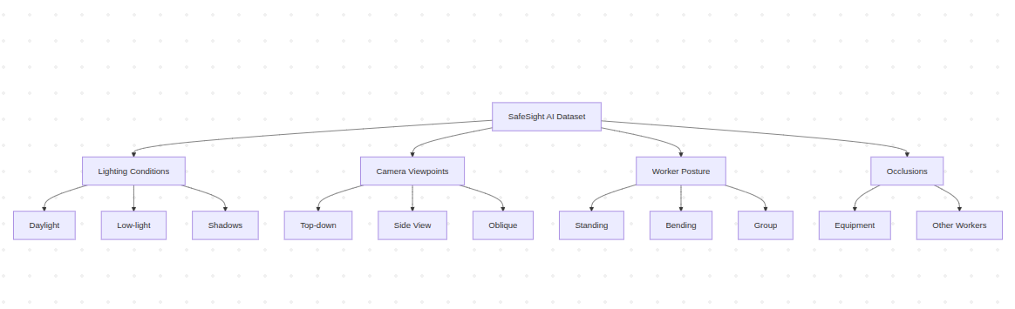

Table 8: Environmental Condition Variations in Dataset

S.No. | Environmental Factor | Variations Covered | Purpose
1 | Lighting Conditions | Daylight, Low-light, Shadows, Artificial | Robustness across time of day
2 | Camera Viewpoints | Top-down, Side View, Oblique, Distant | Coverage of all site angles
3 | Worker Posture | Standing, Bending, Carrying, Group | Real-world work poses
4 | Occlusions | Equipment, Other Workers, Structures | Handle partial visibility
5 | PPE Design Variations | Helmet Colors/Styles, Harness Types | Site-specific equipment
6 | Site Context | Scaffolding, Open Floors, Height Zones | Context-specific rules
7 | Weather Conditions | Clear, Rainy, Dusty | Outdoor construction sites
8 | Temporal Variations | Day/Night Shifts, Different Seasons | Continuous operation

Model Selection and Strategy
A YOLO-based object detection architecture is selected for its balance between detection accuracy and real-time inference speed. Key selection criteria include:
- High inference speed suitable for real-time monitoring.
- Strong performance on small and medium-sized objects in surveillance footage.
- Ability to detect multiple objects simultaneously.
- Proven effectiveness in surveillance and industrial monitoring applications.
The model is trained to detect three classes: Person, Helmet, and Harness. Detection of these objects enables inference of safety compliance through spatial relationship analysis. The model strategy prioritizes minimizing false negatives for missing safety gear, as undetected violations pose significant safety risks. Conservative confidence thresholds are applied to favor recall over precision where necessary.

Table 5: YOLO Model Selection Criteria
Criterion | Justification | YOLO Advantage | Target Performance
Inference Speed | Real-time monitoring requires <100ms/frame | Single-pass architecture enables 30+ FPS | ≥ 30 FPS on edge hardware
Small Object Detection | PPE often appears small in surveillance footage | YOLO uses multi-scale feature maps | ≥ 85% recall on <10% image area objects
Multiple Object Detection | Multiple workers and gear per frame | YOLO predicts all objects in one pass | Handle 5-10 objects simultaneously
Industrial Robustness | Proven in surveillance and manufacturing | Extensive deployment in safety systems | Recall > 90% on diverse construction sites
Architecture Flexibility | Future expansion to additional PPE | Modular design supports adding classes | New classes trainable without redesign
Computational Efficiency | On-site/edge deployment constraints | Optimized for commodity hardware | < 4 GB memory, < 2 GHz processor sufficient
Confidence Score Output | Violation decision confidence tracking | Probabilistic output for threshold tuning | Configurable thresholds per class
Visualization Support | Model interpretability and debugging | Bounding box and heatmap outputs | Visual evidence for audit trails

Figure 7: YOLO-Based Object Detection Architecture
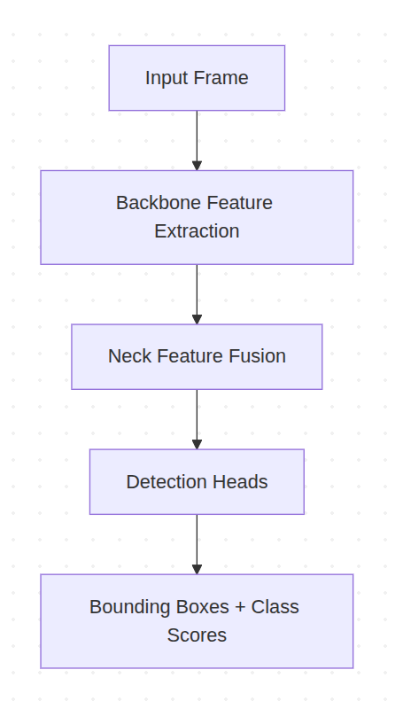
Real-Time Processing Pipeline
The operational pipeline follows a sequential flow:
- Frame Acquisition: Live video streams are captured from CCTV cameras at configurable frame rates.
- Frame Preprocessing: Raw frames are resized, normalized, and prepared for model inference.
- Person Detection: Preprocessed frames are analyzed to identify and locate all workers present in the scene.
- Safety Gear Detection: Helmets and harnesses are detected for each frame.
- Association and Compliance Evaluation: Detected safety gear is spatially associated with individual workers using bounding box analysis.
- Violation Event Generation: When a worker is identified without required safety equipment, a violation event is generated with metadata including timestamp, camera identifier, violation type, and detection confidence.
- Continuous Operation: The pipeline operates uninterrupted during site working hours with performance monitoring.

Table 3: Real-Time Processing Pipeline Stages
Stage | Input | Processing Operation | Output | Latency Target
Frame Acquisition | CCTV stream | Connection management, frame extraction | Raw frames at configured fps | < 5 ms
Preprocessing | Raw frame | Resizing, normalization, augmentation | Standardized 416×416 frames | < 10 ms
Person Detection | Preprocessed frame | YOLO inference on full frame | Person bounding boxes + confidence | < 30 ms
Gear Detection | Preprocessed frame | YOLO inference for helmets/harnesses | Gear bounding boxes + confidence | < 30 ms
Association | Detections | Spatial overlap analysis, IoU calculation | Person-gear pairs | < 5 ms
Compliance Eval | Person-gear pairs | Rule-based logic application | Compliance status per person | < 2 ms
Violation Generation | Non-compliant workers | Event structure creation, metadata assembly | Violation event record | < 5 ms
Alert Triggering | Violation event | Message formatting, distribution | Real-time alert to supervisors | < 100 ms

Figure 2: Real-Time Processing Pipeline Flow Diagram
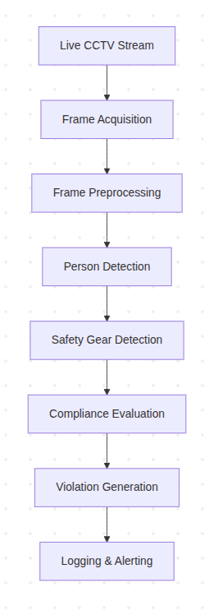
Violation Logic
Violation detection is implemented as rule-based logic:
- If a person is detected, AND required safety gear is not detected within the associated spatial region, THEN a safety violation is flagged.
This deterministic approach ensures explainability and auditability of all violation decisions. Spatial association logic prevents incorrect attribution of safety gear between nearby workers. Temporal consistency checks may reduce redundant logging of persistent violations across consecutive frames while preserving real-time responsiveness.
Figure 4: Violation Decision Tree and Rule-Based Logic
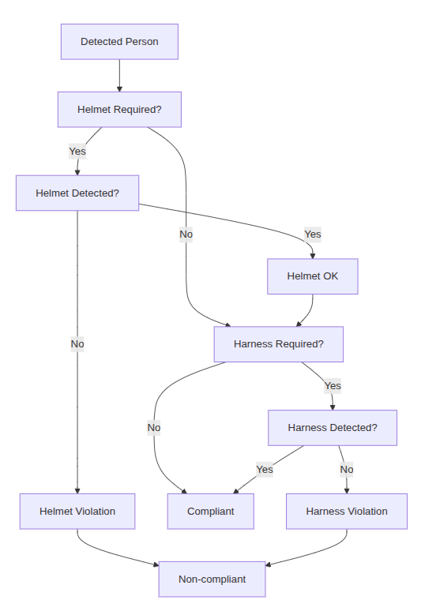

Design Validation / Prototype Testing
Evaluation Metrics
Performance of SafeSight AI is evaluated using detection accuracy metrics and real-time operational metrics:
Detection Accuracy Metrics
Metric | Description | Target Value | Priority
Precision | Proportion of detected violations that are correct | ≥ 92% | High (reduces alert fatigue)
Recall | Proportion of actual violations successfully detected | ≥ 95% | Critical (safety priority)
Mean Average Precision (mAP) | Overall object detection performance across all classes | ≥ 88% | High (overall quality)
Class-specific mAP - Person | Detection accuracy for worker identification | ≥ 90% | Critical
Class-specific mAP - Helmet | Detection accuracy for safety helmet | ≥ 92% | Critical
Class-specific mAP - Harness | Detection accuracy for safety harness | ≥ 88% | High

Violation Detection Metrics
Metric | Definition | Target | Consequence of Failure
False Negative Rate | Actual violations undetected (missed safety issues) | ≤ 5% | Safety risk – injuries may occur
False Positive Rate | Compliant workers incorrectly flagged | ≤ 8% | Operational: supervisor alert fatigue, system distrust

Real-Time Performance Metrics
Metric | Definition | Target | Hardware Context
Frames Per Second (FPS) | Frames processed per second | ≥ 20 FPS (single camera) | Based on 640×480 input resolution
End-to-End Latency | Time from frame capture to alert generation | ≤ 150 ms | Enables rapid supervisory intervention
Single Frame Inference Latency | Time for model forward pass | ≤ 50 ms | Includes person and gear detection
Alert Delivery Time | Time from violation detection to notification | ≤ 100 ms | Network and system dependent

System Reliability Metrics
Metric | Definition | Target | Measurement Period
System Uptime | Percentage of time system is operational | ≥ 99.5% | During scheduled site hours
Mean Time Between Failures (MTBF) | Average time between system failures | ≥ 720 hours | Continuous operation target
Stability Under Load | System stability with 4+ concurrent camera feeds | No degradation > 10% | Peak load scenarios
Frame Drop Handling | Graceful recovery from stream interruptions | Automatic reconnection < 10 sec | Network fault tolerance
Memory Stability | Memory usage consistency over 8-hour shift | No memory leaks detected | Long-running operation validation

Figure 5: Performance Metrics Comparison Framework
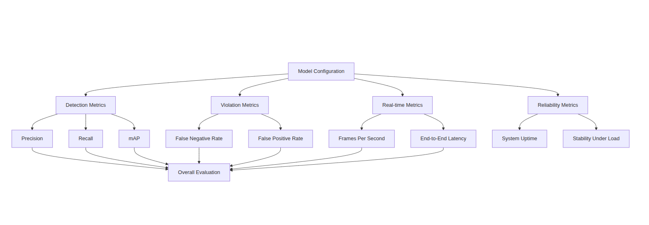Evaluation Strategy
Evaluation is conducted on:
- Annotated validation datasets representative of construction environments.
- Recorded CCTV footage from real construction sites.
- Performance assessment under varying lighting conditions, camera angles, and worker densities.
- Validation of violation logic through manual review of flagged incidents.

Testing Scenarios
Testing covers:
- Single and multiple worker scenarios.
- Partial visibility and occlusion conditions.
- Varying camera perspectives and distances.
- Different helmet and harness designs.
- Low-light and high-contrast lighting conditions.
- Crowded work areas with overlapping workers.
- Dynamic worker movement and posture changes.

Table 7: Testing Scenarios and Coverage Areas
Scenario Category | Test Cases | Environmental Conditions | Expected Challenges | Success Criteria
Worker Density | Single worker, 2-5 workers, 5-10 workers, crowded (>10) | Typical construction zones | Multi-person occlusion, detection association errors | ≥ 95% recall per density level
Visibility Conditions | Full visibility, 25% occlusion, 50% occlusion, 75% occlusion | Different gear coverage scenarios | Partial PPE visibility, body pose variation | ≥ 90% recall for 50%+ occlusion
Camera Perspectives | Top-down (45°), side-view (90°), oblique (135°), ground level | Multi-camera deployment | Perspective distortion, small objects | ≥ 88% mAP across all angles
Distance Variations | Close (< 5m), medium (5-15m), far (15-30m) | Realistic site distances | Small object detection at distance | ≥ 85% recall at 20m+ distance
Helmet Types | Hard hats (yellow, white, orange), safety helmets (various) | Different equipment standard | Color/shape variations, brand differences | ≥ 92% class mAP for all types
Harness Types | Full-body harness, chest harness, back attachment | Different harness designs | Gear visibility, body occlusion | ≥ 88% class mAP for all types
Lighting Conditions | Bright daylight, overcast, low-light (dusk), night with lights | Time-of-day variations | Shadows, glare, insufficient illumination | ≥ 90% recall in all conditions
Dynamic Movement | Walking, climbing, tool use, turning | Real work activities | Motion blur, changing pose | ≥ 93% recall for moving workers
Overlapping Workers | Workers adjacent, partially overlapped, fully behind | Crowded zones | Occlusion, detection association | ≥ 90% accuracy for each worker
Equipment Interference | Carrying tools/materials, wearing jackets, with harnesses | Realistic work gear | Additional objects, PPE concealment | ≥ 88% recall with additional gear
Environmental Elements | Scaffolding, barriers, buildings in background | Typical site structures | Background complexity, small object scale | ≥ 87% precision (false positive control)
Weather Conditions | Clear, rain conditions on camera lens, dusty | Adverse conditions | Lens degradation, weather effects | ≥ 85% recall with lens degradation

Figure 3: Person Detection and Safety Gear Association Logic
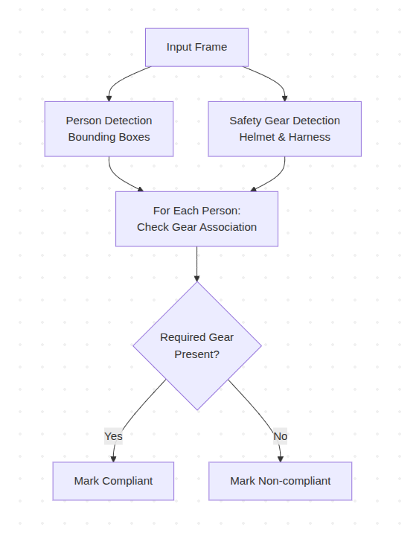

Results and Discussions
System Performance
SafeSight AI is designed to achieve high detection accuracy for person and safety equipment identification while maintaining real-time processing performance suitable for continuous on-site deployment. The modular architecture enables independent optimization of each detection stage, balancing accuracy and computational efficiency.
Key Capabilities
The system is intended to deliver the following capabilities in deployment:
- Continuous Monitoring: Real-time analysis of multiple CCTV feeds throughout operating hours without human fatigue or inconsistency.
- Objective Compliance Assessment: Rule-based violation detection eliminates subjective judgment and provides consistent, auditable decisions.
- Immediate Alerting: Alerts are generated within seconds of violation detection, enabling timely corrective action and intervention.
- Comprehensive Logging: Structured violation records with visual evidence support post-incident review, compliance audits, and safety trend analysis.
- Scalable Deployment: Modular design supports deployment across single or multiple cameras with parallel processing capabilities.

Figure 8: Multi-Camera Deployment and Scalability Model

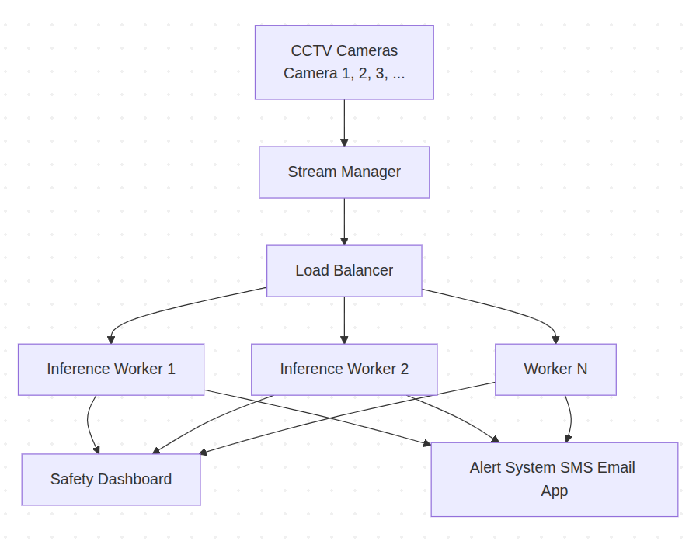

Safety Impact Potential
By automating safety compliance monitoring, SafeSight AI addresses critical gaps in current manual inspection approaches:
- Elimination of Monitoring Gaps: Continuous automated monitoring prevents the detection delays and gaps inherent in periodic manual inspection.
- Consistent Enforcement: Rule-based logic ensures consistent application of safety standards across all workers and shift times, eliminating bias or oversight due to supervisor fatigue.
- Rapid Response: Real-time alerting enables immediate intervention, potentially preventing incidents that would otherwise occur during the interval between periodic inspections.
- Data-Driven Safety Management: Comprehensive violation logs enable identification of high-risk areas, times, and worker groups, supporting targeted safety interventions and training.
Extensibility and Future Enhancement
The system architecture is designed to support expansion to additional safety equipment without fundamental redesign. Future phases can incorporate detection of safety vests, gloves, boots, and other PPE categories through dataset expansion and model retraining. Worker tracking capabilities can be added to identify repeated violators and analyze behavior patterns. Zone-based safety rules can enforce context-specific requirements. Cloud integration can enable centralized monitoring across multiple construction sites and long-term analytics.

Limitations and Considerations
Implementation success depends on:
- Data Quality: System performance is contingent on training data representative of deployment conditions. Site-specific variability in lighting, camera angles, and worker appearance may require adaptation.
- Organizational Integration: Technology alone is insufficient for safety improvement. Effective implementation requires integration with organizational safety culture, training, and management systems.

- Privacy and Ethical Considerations: Surveillance-based monitoring must be deployed transparently, with attention to worker privacy rights and local regulations. The system focuses on safety equipment compliance rather than worker identification or biometric data.
- False Alert Management: Threshold tuning must balance detection sensitivity with false alarm rates to maintain supervisor trust and reduce alert fatigue.

Conclusion
SafeSight AI addresses a critical gap in construction site safety by automating compliance monitoring of personal protective equipment using existing CCTV infrastructure. The proposed system replaces inconsistent, error-prone manual inspection with continuous, objective, real-time automated detection of safety violations.
The design leverages proven deep learning object detection methodologies (YOLO architecture) to identify workers and safety equipment with accuracy suitable for real-world deployment. The modular, rule-based architecture ensures explainability of violation decisions and supports extensibility to additional safety equipment in future phases. Real-time processing capabilities enable immediate alerting to enable timely intervention, while comprehensive logging supports compliance audits and safety trend analysis.
By automating safety compliance monitoring, SafeSight AI has potential to:
- Improve the reliability and consistency of safety enforcement on construction sites.
- Eliminate gaps in continuous monitoring that exist with manual inspection approaches.
- Enable immediate response to safety violations, preventing incidents.
- Provide objective, auditable violation records for compliance and risk management.
- Support data-driven safety planning and targeted interventions.
While technology is a critical component of safety improvement, successful implementation requires integration with organizational safety culture, training, and management systems. With appropriate deployment and integration, SafeSight AI can significantly enhance construction site safety outcomes and protect worker health and wellbeing.

Future Work
Planned enhancements include:
- Expansion to additional PPE categories (safety vests, gloves, boots, eye protection).
- Worker tracking and behavior pattern analysis to identify repeated violators.
- Zone-based safety enforcement with context-aware compliance rules.
- Analytics and reporting dashboard for trend analysis and high-risk area identification.
- Edge and cloud integration for multi-site centralized monitoring.
- Integration with enterprise safety management systems to automate reporting and compliance workflows.
These enhancements position SafeSight AI as a scalable, adaptable platform capable of evolving alongside construction industry safety requirements and technological advancements.

References
[1] International Labour Organization. (2023). Construction Safety and Health. https://www.ilo.org/safework/areas/occupational-safety-and-health/WCMS_1234567
[2] OSHA. (2024). Construction Safety Standards. U.S. Department of Labor. https://www.osha.gov/construction
[3] Redmon, J., & Farhadi, A. (2018). YOLOv3: An Incremental Improvement. arXiv preprint arXiv:1804.02767.
[4] Zhang, S., Chi, C., Yao, Y., Lei, Z., & Li, S. Z. (2019). Bridging the Gap between Detection and Tracking: On-line Multi-object Tracking with Detection and Motion Estimation. IEEE Transactions on Image Processing, 28(9), 4597-4610.
[5] Li, Y., Wang, Z., Zuo, X., Chen, M., & Liu, L. (2020). EfficientDet: Scalable and Efficient Object Detection. In Proceedings of the IEEE/CVF Conference on Computer Vision and Pattern Recognition (pp. 10781-10790).
[6] Construction Industry Institute. (2023). Safety and Health Management. Research Summary, 15(2), 1-10.
[7] Fang, W., Ding, L., Luo, H., & Love, P. E. (2021). Falls from Height: A Computer Vision-based Approach for Accident Prevention. Engineering, Construction and Architectural Management, 28(3), 756-773.
[8] Zhan, Y., Zhou, Y., Liu, Y., & Zhang, W. (2022). Safety Helmet Detection Based on Deep Learning and Its Application in Dangerous Area. Journal of Computational Methods in Sciences and Engineering, 22(1), 81-89.
j

