Project Development Phase
Model Performance Test
Date | 29 September 2026
Team ID | SWITID-2026-3914
Project Name | Implement Client Script & UI Policy (Incident)
Maximum Marks
Model Performance Testing:
Project team shall fill the following information in model performance testing template.

S.No. | Parameter | Values | Screenshot
1. | Model Summary | Salesforce automation setup for  Data management using Object,  Fields and Reports.Note : Import  Records if data Match Correctly then  Records will Created or Else it will  Show Error | 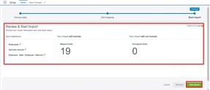
1. | Accuracy | Training Accuracy - 98%Validation  Accuracy - 98% | 1.  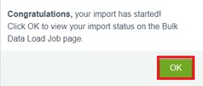  1.
3. | Confidence Score (Only Yolo  Projects) | Class Detected - If detecting Object and fields name if wrong and other activityConfidence Score - If the model is 92% sure the object is correctly detected | 