SECURECORP
Cybersecurity Assessment Capstone
Final Submission Report
Junior Cybersecurity Consultant • Controlled Training Laboratory

1. Executive Summary
This engagement assessed a controlled SecureCorp training environment from offensive and defensive perspectives. The completed evidence establishes the lab, DVWA availability, Nmap discovery, and Wazuh Cloud monitoring with an active Ubuntu WSL agent. The target exposes a broad legacy service surface. Unsupported attack successes are not claimed.

2. Scope and Rules of Engagement
Only the controlled lab was considered. Password testing was limited to self-created lab accounts. Evidence was required for findings. The assessment followed Build → Discover → Attack → Log → Detect → Investigate → Assess → Remediate → Report.

3. Lab Architecture
WSL Ubuntu 26.04 acted as attacker/analyst; Metasploitable2 hosted DVWA as target; Wazuh Cloud provided monitoring. The successfully enrolled Wazuh agent was on WSL Ubuntu, not on Metasploitable2.

4. Asset Inventory
Metasploitable2, DVWA, WSL Ubuntu, Wazuh Cloud, lab network and security evidence were assessed as relevant assets.

5. CIA Analysis
High confidentiality/integrity were assigned to the target, DVWA, monitoring and evidence assets; availability was rated high or medium depending on the asset.

6. Network Discovery
Nmap identified a broad exposed surface including FTP 21, SSH 22, Telnet 23, SMTP 25, DNS 53, HTTP 80, Samba 139/445, NFS 2049, ProFTPD 2121, MySQL 3306, PostgreSQL 5432, VNC 5900 and X11 6000, plus other legacy services.

7. Application Security Assessment
DVWA access was verified. Brute force, SQL injection, XSS and command injection were required by the handbook but were not captured with sufficient evidence to claim successful exploitation. FTP and SSH credential attacks were also not verified.

8. Wazuh Monitoring
Wazuh Cloud was created and the SecureCorp-WSL agent was shown Active. Local agent state reported connected. Target-side Wazuh monitoring was not established in the captured evidence.

9. Risk Assessment
Highest priorities are command injection risk in vulnerable web applications, legacy exposed services, exposed databases, remote administration services, and insufficient target-side monitoring.

10. Recommendations
Restrict inbound services; remove/isolate Telnet, VNC, X11, unused FTP/RPC/NFS; patch obsolete software; enforce strong authentication/MFA; secure web inputs; install target-side Wazuh/log collection; improve detection rules; maintain tested backups; train users.

11. Incident / Investigation Conclusion
No confirmed compromise is asserted. The next investigation cycle should establish target-side telemetry and replay each Week 2 activity with timestamps, source/target IPs, evidence and Wazuh rule references.

12. Final Submission Status
The report and presentation are submission-ready as an evidence-based capstone package. Items without sufficient practical evidence are explicitly marked Not Verified rather than fabricated.

Evidence Gallery
Wazuh environment
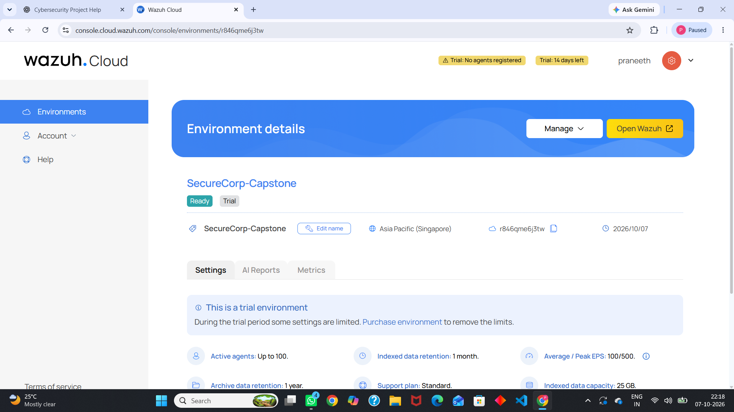
Agent deployment
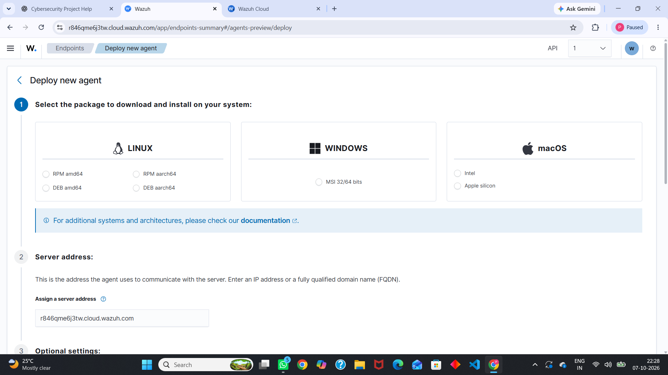
Agent installation
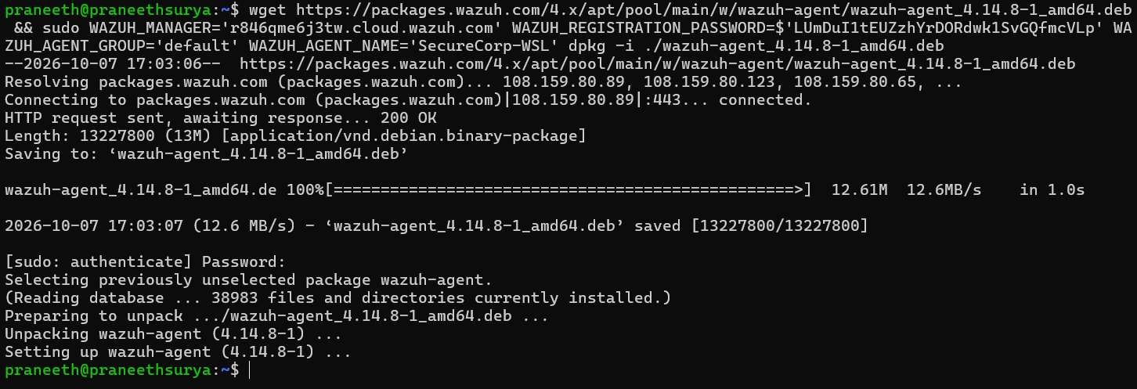
Active agent
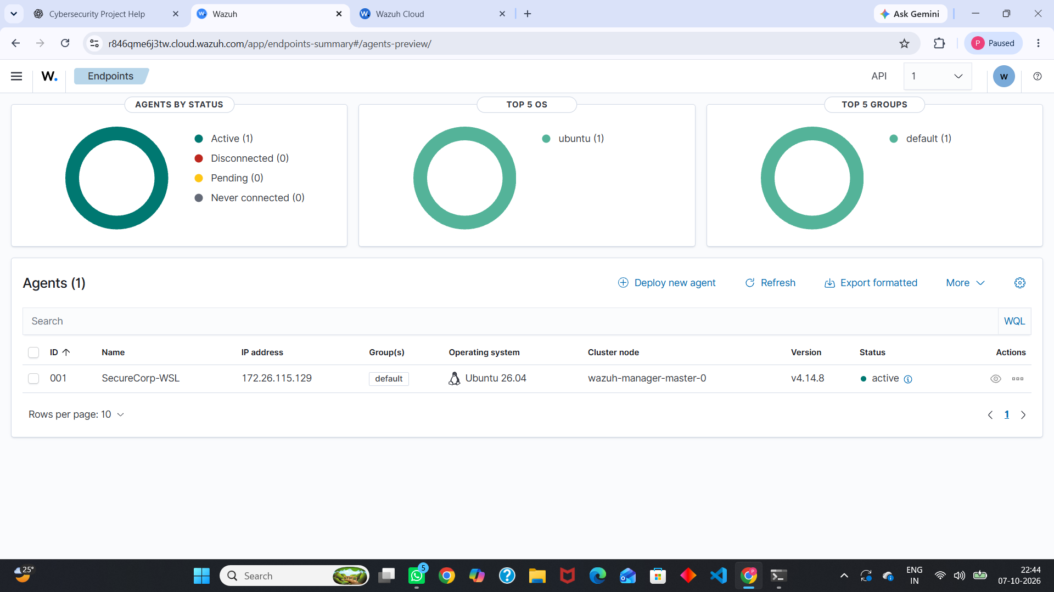
Wazuh overview
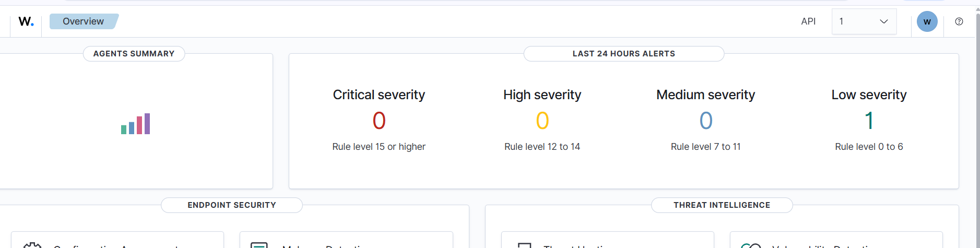
Target network evidence
