LOG ANALYSIS SYSTEM
Automated Server Log Error Detection and Monitoring
Project Report submitted for the partial fulfilment of grade for the course

Data Structures and Algorithms -3 (25CS2103E)
in

A.Y. 2026-2027

Submitted by
G. Varshini (2520030017)
M. Avishya (2520030482)
K. Pragnya (2520030430)

Team Number: 2
Section: 1

Under the guidance of
Dr. CH. Anuradha
CSE

Hyderabad-500090, Telangana, India.

K L (Deemed to be) University
DEPARTMENT OF COMPUTER SCIENCE ENGINEERING / COMPUTER SCIENCE AND INFORMATION TECHNOLOGY/ARTIFICIAL INTELLIGENCE & DATA SCIENCE



DECLARATION

The Mini Project Report entitled “Log Analysis System” is a record of bona fide work carried out by G. Varshini – 2520030017, M. Avishya – 2520030482, and K. Pragnya – 2520030430, submitted in partial fulfilment of the requirements for the award of the B.Tech degree at K L (Deemed to be) University. The report is based on the project presentation prepared by the team.

G. Varshini – 2520030017
M. Avishya – 2520030482
K. Pragnya – 2520030430

K L (Deemed to be) University
DEPARTMENT OF COMPUTER SCIENCE ENGINEERING / COMPUTER SCIENCE AND INFORMATION TECHNOLOGY
CERTIFICATE

This is to certify that the mini project report entitled “Log Analysis System” is a bona fide work submitted by G. Varshini – 2520030017, M. Avishya – 2520030482, and K. Pragnya – 2520030430, in partial fulfilment of the requirements for the award of the Bachelor of Technology degree at K L (Deemed to be) University during the academic year 2026–2027.

Signature of the Supervisor

Signature of the HOD Signature of the External Examiner

ACKNOWLEDGEMENT

We express our sincere gratitude to our project guide, Dr. CH. Anuradha, for her guidance and support during the preparation of this project report. We also thank the faculty and staff of K L (Deemed to be) University for providing the academic environment and resources required to complete this work.

We are grateful to our department and all those who provided suggestions and encouragement. Finally, we thank our parents, friends, and classmates for their support and cooperation.

We express our gratitude to Dr. P.Venkateshwar Rao (CSE)/Dr. Khaja Shareef (CSIT)/ Dr. Sreenath Itikela (AI&DS), Head of the Department for Computer Science Engineering/ Department for Computer Science and Information Technology/Department of Artificial Intelligence and Data Science for providing us with adequate facilities, ways and means by which we are able to complete this project-based Lab.

We thank all the members of teaching and non-teaching staff members, and also who have assisted me directly or indirectly for successful completion of this project. Finally, I sincerely thank my parents, friends and classmates for their kind help and cooperation during my work.

G. Varshini – 2520030017
M. Avishya – 2520030482
K. Pragnya – 2520030430

TABLE OF CONTENTS

S.No. | Contents | Page no.
1. | Abstract
2. | Introduction
3. | Literature survey
4. | Problem Statement and Objectives
5. | Hardware and Software requirements
6. | Implementation
7. | Results & Discussion
8. | Conclusion & Future Scope
9. | References

1.ABSTRACT

The Log Analysis System is designed to identify recurring error patterns in large server log files efficiently. Servers generate log entries containing system activities, user requests, warnings, and errors; manually inspecting these records can be slow and error-prone. The proposed system accepts log files and predefined error patterns as input and searches for matching entries using string-matching techniques. It identifies errors such as database connection failures, authentication failures, connection timeouts, and out-of-memory errors. Each matched entry can be associated with a timestamp, source, error signature, frequency, and severity level. Severity can be represented as Low, Medium, High, or Critical, while log categories may include INFO, WARNING, ERROR, and CRITICAL. The system consolidates repeated errors and produces summary reports so administrators can prioritize faults and investigate recurring problems. The presentation also identifies requirements for handling millions of log entries, including efficient searching, limited memory use, scalability, accurate matching, and continuous monitoring. The project aims to reduce manual effort and processing time, support faster fault diagnosis, and improve server reliability. Future enhancements may include alert notifications, cloud log support, AI-assisted anomaly detection, and prediction of possible failures.
Team Name: Log Analysis System Team

Team Logo:

Team Members:
- G. Varshini, 2520030017
- M. Avishya, 2520030482
- K. Pragnya, 2520030430

- INTRODUCTION

Modern computing environments produce large volumes of server logs that record timestamps, user activities, requests, warnings, and errors. As the number of entries grows, manual inspection becomes time-consuming and can cause important faults to be overlooked. A Log Analysis System automates this task by scanning log entries for known error patterns or signatures.
The system takes log files and predefined patterns as input, identifies matching entries through string-matching techniques, counts repeated errors, and organizes findings by frequency and severity. It can display matched logs and prepare summary reports containing the error message, timestamp, source, and severity. Continuous monitoring can help detect newly generated errors promptly. This report describes the problem, objectives, requirements, implementation approach, expected outputs, and future enhancements of the Log Analysis System.

- LITERATURE SURVEY
1. Log File Analysis
Log file analysis involves examining server logs that contain timestamps, IP addresses, user activities, warnings, and error messages. It helps administrators understand system behavior and identify recurring problems. The proposed project uses log files as input to detect predefined error patterns.
2. ELK Stack (Elasticsearch, Logstash, Kibana)
The ELK Stack is used to collect, process, search, and visualize log data. Elasticsearch supports searching large volumes of information, while Logstash processes logs and Kibana presents results through dashboards. These features are relevant to developing scalable log analysis solutions.
3. Splunk Log Analysis
Splunk provides tools for collecting, searching, and analyzing machine-generated data. It helps administrators investigate errors and monitor system performance. Its searching and reporting capabilities are related to the objectives of the proposed Log Analysis System.
4. Graylog
Graylog is a centralized log management platform that collects and analyzes logs from different sources. It supports searching, filtering, and monitoring log events. These capabilities help administrators identify errors and investigate system issues.
5. Apache Flume
Apache Flume is designed to collect and transfer large amounts of log and event data. It supports the movement of log information from multiple sources to centralized storage. Its data collection approach is relevant when designing systems that process large log volumes.
6. Fluentd
Fluentd collects and processes logs from different applications and systems. It supports structured log handling and routing data to different destinations. Its approach demonstrates the importance of organizing log data before analysis.
7. Regular Expressions for Error Detection
Regular expressions are commonly used to identify predefined patterns in textual data. They can detect messages such as authentication failures, database connection errors, and connection timeouts. The proposed project similarly searches log entries for known error signatures.
8. String-Matching Algorithms
String-matching algorithms search for a particular pattern within a text. Efficient algorithms can reduce the time required to find errors in large log files. The proposed system uses the concept of pattern matching to identify relevant log entries.
9. Real-Time Log Monitoring
Real-time log monitoring examines newly generated log entries as they appear. It helps administrators identify errors without repeatedly checking files manually. The proposed project includes continuous monitoring as a feature for detecting new errors.
10. Log Severity Classification and Reporting
Log management systems commonly classify events according to levels such as INFO, WARNING, ERROR, and CRITICAL. Grouping errors by severity and frequency helps administrators prioritize problems. The proposed system uses severity classification and summary reports to highlight recurring and important errors.

- Problem Statement and Objectives

Problem Statement: A clear and specific articulation of the problem, outlining its importance.
Manual analysis of very large server log files is slow and error-prone, making recurring and critical errors difficult to identify quickly.

Problem Description: A concise explanation of the issue or challenge that needs to be solved.
The system searches log entries for predefined error signatures, counts repeated matches, and classifies them by severity while aiming to control processing time and memory use.
Objectives:
• Automate searching of server logs for predefined error patterns.
• Detect and display matched log entries with timestamps and source information.
• Calculate the frequency of recurring errors.
• Categorize findings by severity (Low, Medium, High, Critical) and log level (INFO, WARNING, ERROR, CRITICAL).
• Generate concise summary reports to support fault diagnosis.
• Design the processing approach to accommodate large log files and newly generated entries.

- HARDWARE AND SOFTWARE REQUIREMENTS
Hardware Requirements:
• Processor: Intel Core i3 or above
• RAM: Minimum 4 GB; 8 GB recommended
• Storage: At least 10 GB free space
• Device: Laptop or desktop computer
• Internet connection for downloading packages and datasets
Software Requirements:
• Operating system: Windows, Linux, or Ubuntu
• Python 3.x
• VS Code or PyCharm
• Flask
• Pandas
• Matplotlib
• SQLite or MySQL (optional)
• Git/GitHub
• Web browser

- IMPLEMENTATION

Module 1 — Log file reader and pattern matching (illustrative Python)
import re
def read_log_file(path):
"""Yield log lines one at a time to limit memory use."""
with open(path, "r", encoding="utf-8", errors="ignore") as file:
for line in file:
yield line.rstrip("\\n")
def find_matches(lines, patterns):
matches = []
for line in lines:
for pattern, severity in patterns.items():
if re.search(pattern, line, re.IGNORECASE):
matches.append({
"log": line,
"pattern": pattern,
"severity": severity
})
break
return matches
Module 2 — Error frequency and severity summary
from collections import Counter
def summarize_errors(matches):
frequency = Counter(item["pattern"] for item in matches)
severity_count = Counter(item["severity"] for item in matches)
return frequency, severity_count
Module 3 — Analysis controller
DEFAULT_PATTERNS = {
r"database connection failed": "HIGH",
r"authentication failed": "MEDIUM",
r"connection timeout": "HIGH",
r"out of memory": "CRITICAL",
r"file not found": "LOW",
r"connection refused": "HIGH"
}
def analyze_log(path):
lines = read_log_file(path)
matches = find_matches(lines, DEFAULT_PATTERNS)
frequencies, severities = summarize_errors(matches)
return matches, frequencies, severities
Module 4 — Text summary report
def print_report(matches, frequencies, severities):
print("LOG ANALYSIS SUMMARY")
print("Total matched entries:", len(matches))
print("\\nErrors by pattern:")
for pattern, count in frequencies.most_common():
print(f"- {pattern}: {count}")
print("\\nErrors by severity:")
for level, count in severities.most_common():
print(f"- {level}: {count}")
print("\\nMatched log entries:")
for item in matches:
print(f"[{item['severity']}] {item['pattern']} | {item['log']}")
# Example use:
# matches, frequencies, severities = analyze_log("server.log")
# print_report(matches, frequencies, severities)
Note: The supplied PPT describes the system and lists Python, Flask, Pandas, Matplotlib,
and SQLite/MySQL as requirements, but does not include source code. The snippets above
are illustrative Python modules derived from the described workflow; they are not claimed
to be the exact code used in the team's implementation.

- RESULTS & DISCUSSION
The project presentation describes these expected results:
• Matched log entries for known errors such as database connection failures, authentication failures, connection timeouts, and out-of-memory errors.
• Frequency counts for recurring error patterns.
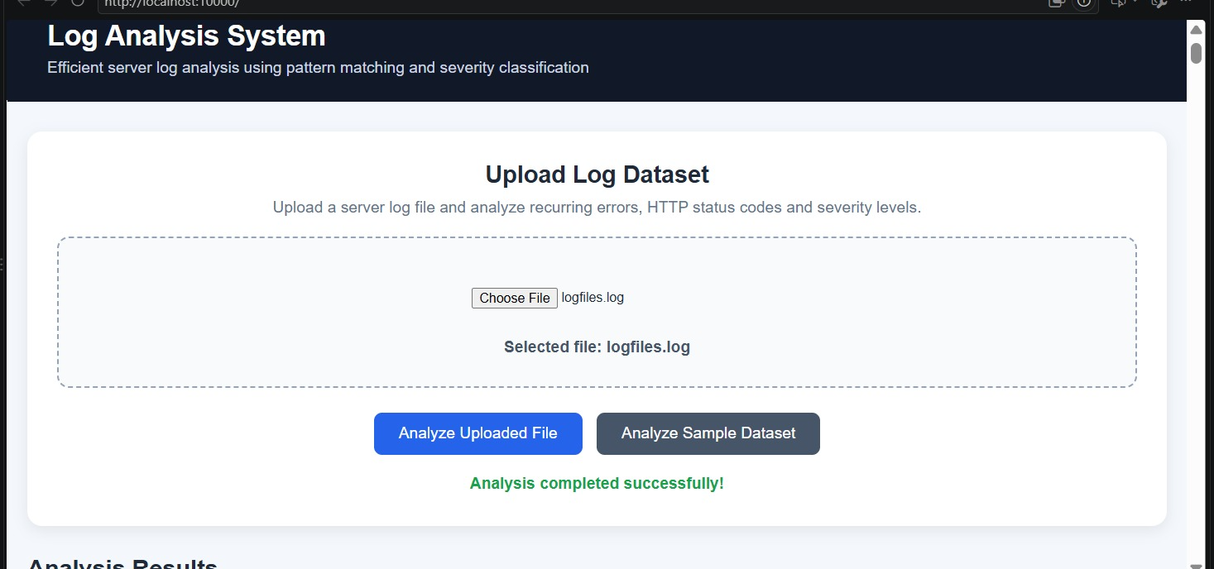
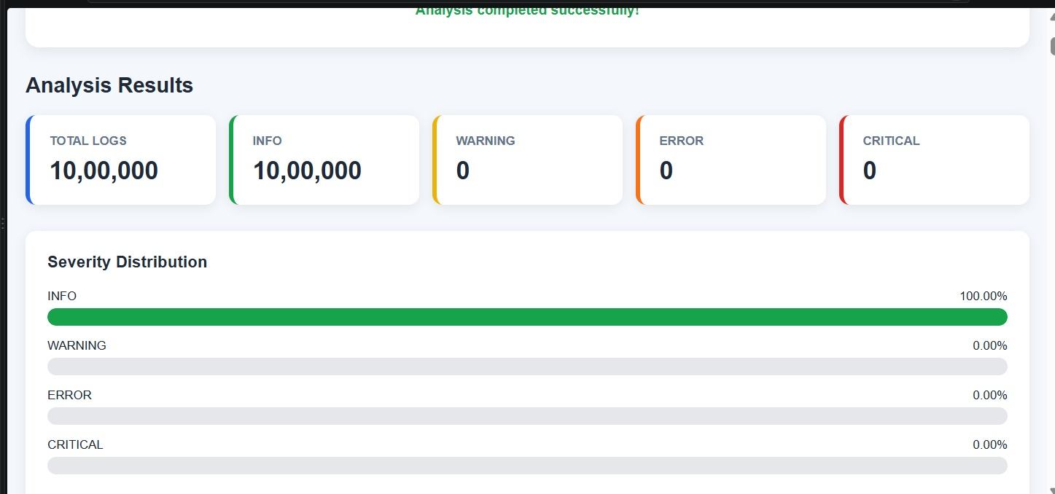

- CONCLUSION & FUTURE SCOPE
The Log Analysis System addresses the challenge of manually examining large server log files. Based on the project design described in the presentation, it searches for predefined error patterns, identifies matching entries, counts recurring errors, classifies their severity, and organizes the findings into summary reports. These functions can reduce manual effort and help administrators locate important faults faster. Processing logs incrementally and avoiding repeated scans are important considerations for handling millions of entries. The supplied presentation describes the intended functionality but does not provide benchmark measurements or application screenshots, so quantitative performance improvements cannot be claimed from the provided material.
The Log Analysis System can be enhanced in the following ways to improve its performance, accuracy, and usability.
1. Real-Time Monitoring: The system can continuously monitor log files and detect newly generated errors immediately.
2. AI Integration: Artificial Intelligence and Machine Learning techniques can be incorporated to identify unusual log patterns and automatically detect potential errors.
3. Error Alerts: Automatic notifications can be generated when high-severity or critical errors occur, helping administrators respond quickly.
4. Improved Reports: Graphs, charts, and detailed reports can be added to display error frequency, severity levels, and recurring issues.
5. Cloud Support: The system can be extended to analyze log files stored on cloud platforms and servers.

- REFERENCES

1. https://docs.python.org/3/library/logging.html
2. https://docs.python.org/3/library/re.html
3. https://httpd.apache.org/docs/2.4/logs.html
4. https://nginx.org/en/docs/
5. https://docs.python.org/3/tutorial/inputoutput.html
6. https://flask.palletsprojects.com/
7. https://pandas.pydata.org/docs/
8. https://matplotlib.org/stable/
9. https://www.sqlite.org/docs.html
10. https://docs.github.com/

