A CASE-STUDY BASED REPORT
ON
Multi-Class Disease Diagnosis Using Multinomial Logistic Regression
submitted in partial fulfilment of the requirements for the Course
MACHINE LEARNING
BACHELOR OF TECHNOLOGY
in
A.Y.: 2026-27
by
Name: G.Varshini roll no:2520030017
Name: M.Geethika Chowdary roll no:2520030056
Under the Esteemed guidance of
Mr. Shaik Asif
Asst.Professor, Dept. of CSE




INDEX
Abstract
Introduction
Background
Motivation for the Project
Overview of the Work Carried Out
Scope and Responsible-Use Statement
Problem Statement
Case-Study Scenario
Central Case-Study Question
Formal Problem Definition
Objectives that Guide the Study
Assumptions and Limitations
Dataset and Exploratory Data Analysis
About the Dataset
Purpose of EDA
Preparation Steps Actually Performed
EDA Exploration - Implementation
Summary of EDA Findings
Algorithm Selection and Implementation

Conclusion

1.Abstract
This project presents a machine learning approach for multi-class disease diagnosis using Multinomial Logistic Regression. The study uses the Disease Symptoms and Patient Profile Dataset, which contains patient symptoms and basic profile information such as age, gender, blood pressure, and cholesterol level. The symptoms considered include fever, cough, fatigue, and difficulty breathing. The dataset is explored and pre-processed to understand the features and prepare them for machine learning. Categorical features are encoded into numerical representations before model training. A Multinomial Logistic Regression model is then applied to classify patients into different disease categories. The project demonstrates the application of exploratory data analysis, data preprocessing, feature encoding, multi-class classification, and model evaluation in a healthcare-related case study. The developed system is intended for academic purposes and should not be considered a replacement for professional medical diagnosis.

2. Introduction

2.1 Background
Machine learning is a field of artificial intelligence that enables computers to learn patterns from data and make predictions. In healthcare, machine learning can be applied to analyze patient information and assist in disease classification. In this project, patient symptoms and basic profile information are used as input features to classify patients into different disease categories using a multi-class classification approach.
2.2 Motivation for the Project
The motivation for this project is to understand how machine learning can be used to identify patterns in patient symptoms and profile information. Since different diseases may be associated with different combinations of symptoms, a machine learning model can learn these patterns from the available d ataset and classify new patient records into suitable disease categories.
2.3 Overview of the Work Carried Out
The project follows these main steps:
Dataset → Data Preprocessing → Feature Encoding → Exploratory Data Analysis → Model Training → Prediction → Evaluation
The Disease Symptoms and Patient Profile Dataset is analyzed using symptoms and patient profile features. The categorical features are converted into numerical form, after which Multinomial Logistic Regression is trained for multi-class disease classification.
2.4 Scope and Responsible-Use Statement
The project focuses on demonstrating the use of machine learning for multi-class disease classification based on the features available in the dataset. The system is developed for academic purposes and demonstrates the complete process from data preparation to model evaluation. The predictions generated by the model should not be considered a substitute for professional medical diagnosis or treatment.

3. Problem Statement

3.1 Case-Study Scenario
Consider a patient who visits a healthcare facility with symptoms such as fever, cough, fatigue, and difficulty in breathing. Along with these symptoms, basic patient information such as age, gender, blood pressure, and cholesterol level is available. Since different diseases may have different combinations of these characteristics, the available information can be provided to a machine learning model to classify the patient into one of the disease categories present in the dataset.
3.2 Central Case-Study Question
How can patient symptoms and basic profile information be used to classify a patient into one of multiple disease categories using machine learning?
3.3 Formal Problem Definition
The problem is formulated as a multi-class classification problem. The input consists of patient symptoms and profile features, including fever, cough, fatigue, difficulty breathing, age, gender, blood pressure, and cholesterol level. The objective is to train a Multinomial Logistic Regression model that learns patterns from the available data and predicts the corresponding disease category for a given patient record.
3.4 Objectives that Guide the Study
- To understand and analyze the patient symptoms and profile features in the dataset.
- To perform appropriate data preprocessing and feature encoding.
- To conduct exploratory data analysis to identify important patterns in the dataset.
- To implement Multinomial Logistic Regression for multi-class disease classification.
- To evaluate the performance of the developed classification model.
3.5 Assumptions and Limitations
Assumptions:
- The patient information in the dataset is available in the required format.
- The recorded features are suitable for training the classification model.
- The model can learn useful patterns from the available training data.

Limitations:
- The model is dependent on the quality and characteristics of the given dataset.
- The available features may not represent all factors required for real-world disease diagnosis.
- The model is developed for academic purposes and cannot replace professional medical diagnosis.
- The prediction is limited to the disease categories represented in the dataset.

4. Dataset and Exploratory Data Analysis

4.1 About the Dataset
The project uses the Disease Symptoms and Patient Profile Dataset for multi-class disease classification.
The dataset contains patient-related symptoms and profile information that are used as input features for predicting the disease category.
Input Features:
- Fever
- Cough
- Fatigue
- Difficulty Breathing
- Age
- Gender
- Blood Pressure
- Cholesterol Level
Target Variable:
- Disease
The input features contain both numerical and categorical data. Therefore, preprocessing and encoding are performed before applying the machine learning algorithm.

4.2 Purpose of EDA
The purpose of Exploratory Data Analysis (EDA) is to understand the dataset before applying the machine learning model.
EDA is performed to:
- Understand the structure and characteristics of the dataset.
- Examine the available patient features.
- Analyze the distribution of disease categories.
- Identify patterns in symptoms and patient profile information.
- Understand the numerical and categorical variables.
- Prepare the data appropriately for model implementation.

4.3 Preparation Steps Actually Performed
The dataset was first loaded and examined to understand its structure, features, and target variable. The input features and the disease outcome were identified. The dataset contains both numerical and categorical features. Categorical features were converted into numerical form using encoding so that they could be used by the machine learning algorithm. The processed features were then organized as input variables, while the Disease column was considered the target variable for multi-class classification. The prepared data was then used for exploratory data analysis and model implementation.

4.4 EDA Exploration – Implementation
Exploratory Data Analysis was performed to understand the structure, distribution, and characteristics of the dataset. Different statistical checks and visualizations were used to examine the disease classes and patient-related features before applying the machine learning model.

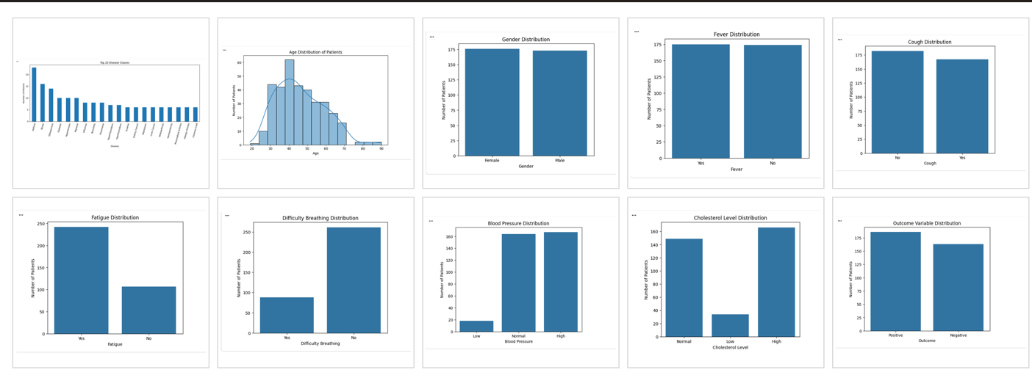

4.5 Summary of EDA Findings

The exploratory data analysis provided an overall understanding of the patient and disease-related features in the dataset. The analysis showed the distribution of disease classes and the variation in patient age, gender, symptoms, blood pressure, and cholesterol level. The categorical features showed different distributions across the patient records, while the disease distribution indicated that some disease categories had more observations than others. These observations helped in understanding the characteristics of the dataset and preparing the data for multi-class classification using Multinomial Logistic Regression.

5.Algorithm Selection and Implementation
Multinomial Logistic Regression was selected for this project because the problem involves predicting one disease category from multiple possible disease classes. The prepared patient features were used as input to train the classification model. The model learns the relationship between patient symptoms and profile information and the corresponding disease category. After training, the model was used to predict disease classes for the test data. The performance of the model was evaluated using classification metrics and a confusion matrix.

5.1 Algorithm Used – Multinomial Logistic Regression
Multinomial Logistic Regression was selected as the classification algorithm for this project because the target variable contains multiple disease categories. It is an extension of log
istic regression that is suitable for multi-class classification problems. The algorithm uses the patient symptoms and profile features as input and estimates the probability of each possible disease class. The disease class with the highest predicted probability is selected as the final prediction. In this project, Multinomial Logistic Regression is used to classify patients into the disease categories present in the dataset.

5.2 Model Training and Prediction
The preprocessed dataset was divided into training and testing sets. The training data was used to train the Multinomial Logistic Regression model, while the testing data was used to evaluate its performance. The model learned the relationship between the input features and the corresponding disease categories during training. After training, the model was applied to the test data to predict the disease category for each patient record. These predictions were then compared with the actual disease labels to evaluate the performance of the classification model.

5.3 Model Evaluation
The performance of the Multinomial Logistic Regression model was evaluated using standard classification metrics. Accuracy measures the proportion of correctly classified patient records. Precision indicates how accurately the model identifies a particular disease class. Recall measures the ability of the model to correctly identify the actual instances of a disease class. F1-score provides a combined measure of precision and recall. These evaluation measures help in understanding the classification performance of the developed model.

5.4 Confusion Matrix
The confusion matrix was used to evaluate the classification performance of the Multinomial Logistic Regression model. It compares the actual disease classes with the disease classes predicted by the model. The diagonal elements of the matrix represent correctly classified instances, while the off-diagonal elements represent misclassifications. The confusion matrix provides a visual representation of how well the model distinguishes between the different disease categories.
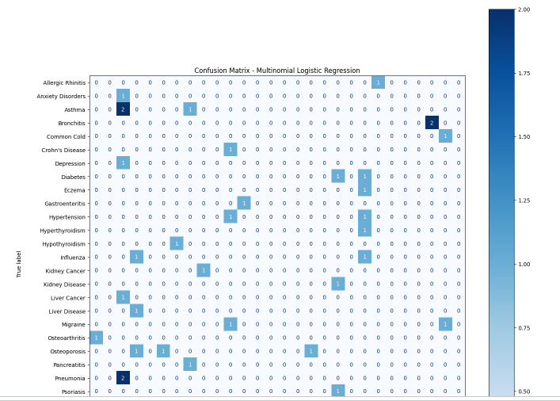

- Conclusion
The project successfully demonstrated the application of machine learning for multi-class disease classification using patient symptoms and basic profile information. Exploratory Data Analysis helped in understanding the structure, distribution, and characteristics of the dataset. The data was prepared and encoded appropriately for machine learning, and Multinomial Logistic Regression was implemented to classify patients into different disease categories. The model predictions were evaluated using classification metrics and a confusion matrix. Overall, the project demonstrates how machine learning can be applied to analyze patient-related data and perform disease classification. However, the developed model is intended for academic purposes and should not be used as a replacement for professional medical diagnosis.

Signature of the Team members

