Software Architecture and Design Specification (SAD)
Pocket Packet Sniffer — System Architecture, Component Models, and Detailed Design
Document ID: PPS-SAD-V1.0 | Course: Software Engineering (UE24CS341A) — PES University
Team Members: Ritu Ravish (PES1UG24CS928), Vishal Prasath (PES1UG24CS536), Tejaswini R Pujar (PES1UG24CS500), Varshini A (PES1UG24CS517)
Date: October 2026 | Status: Final Submission Baseline

1. Introduction
1.1 Purpose
This document specifies the software architecture and detailed design for the Pocket Packet Sniffer (PPS v1.0). It defines subsystem decomposition, inter-module communication protocols, architectural patterns, UML component diagrams, sequence flows, API contracts, database schema, and security controls.
1.2 Scope
The architecture encompasses four collaborating functional subsystems: Multi-Interface Packet Capture (F1), Protocol Parsing & Zeek Integration (F2), Threat & Anomaly Detection (F3), and Live Monitoring, Device Inventory & Reporting (F4).
1.3 Audience
This specification is intended for the development team, QA engineers, security leads, course evaluators, and system maintainers implementing the Raspberry Pi appliance.
1.4 Definitions and Acronyms
- PPS: Pocket Packet Sniffer edge intrusion detection appliance.
- IPC: Inter-Process Communication via Python asyncio queues and shared database.
- OUI: Organizationally Unique Identifier for MAC vendor resolution.
- SAST: Static Application Security Testing (Bandit / SonarQube).
2. Document Overview
This document provides architectural and design models adhering to IEEE standard specifications for Software Architecture and Design Description (SADD). It traces directly to requirements defined in PPS-SRS-V1.0 and verification specifications in PPS-STP-V1.0.
3. Architecture
3.1 Goals and Constraints
- Near Real-Time Analytics: End-to-end packet processing and alert generation within <= 2.0 seconds.
- Bounded Resource Footprint: Safe execution on a 4GB Raspberry Pi 4 Model B with <= 5,000 packets/sec throughput without unbounded memory growth.
- Extensibility (Open/Closed Principle): Pluggable BaseDetector interface permitting independent threat rules without modifying engine core.
- Platform Constraints: Requires Linux CAP_NET_RAW / CAP_NET_ADMIN capabilities for promiscuous Ethernet and 802.11 monitor mode.
3.2 Stakeholders and Concerns
- Security Analyst: Comprehensive threat visibility, accurate alert timestamps, evidence forensics, and PCAP export.
- DevOps Engineer: Reproducible containerized deployment on ARM64 Linux, CI/CD pipeline stability.
- QA / Test Lead: Modular decoupled interfaces with verifiable entry/exit contracts enabling >85% branch coverage.
3.3 UML Component Diagram
Figure 3.1 illustrates the structural decomposition of the Pocket Packet Sniffer into cooperating components, data repositories, and external physical network boundaries.
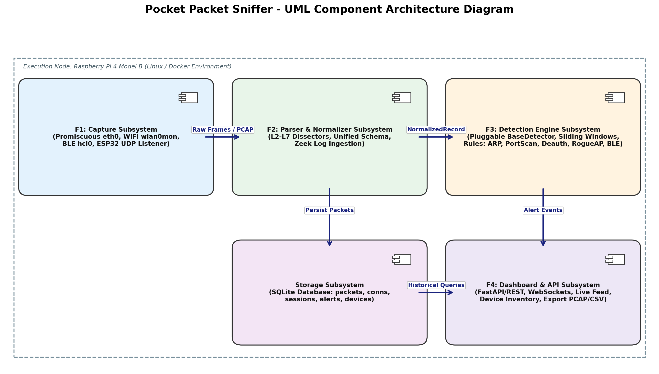
Figure 3.1: Pocket Packet Sniffer UML Component Architecture Diagram
3.4 Component Descriptions
- F1 Capture Component (`src/capture`): Interacts with OS network adapters (eth0, wlan0mon, hci0) and opens a UDP socket (port 5555) for ESP32 frames. Manages PCAP file rotation upon reaching size/time limits.
- F2 Parser Component (`src/parser`): Decodes L2-L7 protocols into strongly-typed NormalizedRecord data classes. Ingests Zeek connection logs and persists normalized records into SQLite tables.
- F3 Detection Engine (`src/detection`): Central coordinator executing pluggable BaseDetector rules over the streaming records. Maintains in-memory sliding windows to detect ARP spoofing, port sweeps, WiFi deauth floods, and BLE flooding.
- F4 Dashboard Component (`src/dashboard`): FastAPI web server exposing REST endpoints for querying packets and alerts, alongside a WebSocket hub broadcasting live stats and alerts to mobile/desktop browsers.
- Database Component: SQLite relational store configured with Write-Ahead Logging (WAL) mode for concurrent read/write transactions.
3.5 Chosen Architecture Pattern and Rationale
The system adopts a hybrid **Pipes-and-Filters** and **Microkernel (Pluggable)** architecture pattern:
- Pipes-and-Filters: Packet data naturally moves as a linear pipeline: Physical Frame -> Raw Capture Filter -> Dissection & Normalization Filter -> Threat Inspection Filter -> Storage & WebSocket Dispatch.
- Microkernel Pattern: The Detection Engine core serves as a microkernel, while threat detectors (ArpSpoofDetector, PortScanDetector, WifiDeauthDetector) act as isolated plugins inheriting from BaseDetector. This prevents single-detector failures from crashing the engine.
3.6 Technology Stack and Data Stores
Layer / Subsystem | Technology / Framework | Purpose / Rationale
Edge Hardware | Raspberry Pi 4 Model B + ESP32 | Low-cost, portable multi-interface capture platform
Language & Core | Python 3.11+, Scapy 2.5 | High-level networking libraries and asynchronous event loops
Network Telemetry | Zeek Network Monitor 5.0+ | Stateful connection tracking and protocol log generation
Embedded Storage | SQLite 3 (WAL Mode) | Zero-configuration serverless ACID database on flash storage
API & Web Server | FastAPI, Uvicorn, WebSockets | High-performance asynchronous REST and real-time push

3.7 Requirements Traceability
Table 3.2 maps each architectural subsystem to the functional requirements defined in the SRS:
Architectural Subsystem | SRS Requirements Covered | Key Design Deliverable
Capture Subsystem (F1) | REQ-F1-01 to REQ-F1-05, NFR-PERF-01 | Raw socket workers, monitor hopping, PCAP rotator
Parser Subsystem (F2) | REQ-F2-01 to REQ-F2-05, NFR-PERF-02 | Dissector registry, NormalizedRecord, SQLite WAL writer
Detection Engine (F3) | REQ-F3-01 to REQ-F3-10, SEC-01 to 04 | DetectionEngine, BaseDetector, sliding window queues
Dashboard & API (F4) | REQ-F4-01 to REQ-F4-05, NFR-USE-01 | FastAPI endpoints, WebSocket broadcaster, HTML5 UI

3.8 Security Architecture
- Principle of Least Privilege: Root privileges are dropped immediately after raw sockets are opened by capture workers.
- Defensive Exception Boundaries: Every detector rule wraps execution in try/except blocks to guarantee that malformed or fuzzed packets cannot destabilize the pipeline.
- Static Code Hardening: Automated CI/CD integration with Bandit and SonarQube enforcing zero high/critical SAST findings.
- Alert Immutability: Alert records inserted into SQLite are read-only and timestamped using UTC epoch floats for forensic integrity.
4. Detailed Design
4.1 Design Overview
The detailed design specifies message interactions between subsystems, REST API endpoint definitions, SQLite relational table schemas, and error recovery policies.
4.2 UML Sequence Diagrams
4.2.1 Sequence Diagram 1: Real-Time Threat Detection & Alert Dispatch
Figure 4.1 details the asynchronous execution path from raw frame receipt to live WebSocket notification on the client browser:
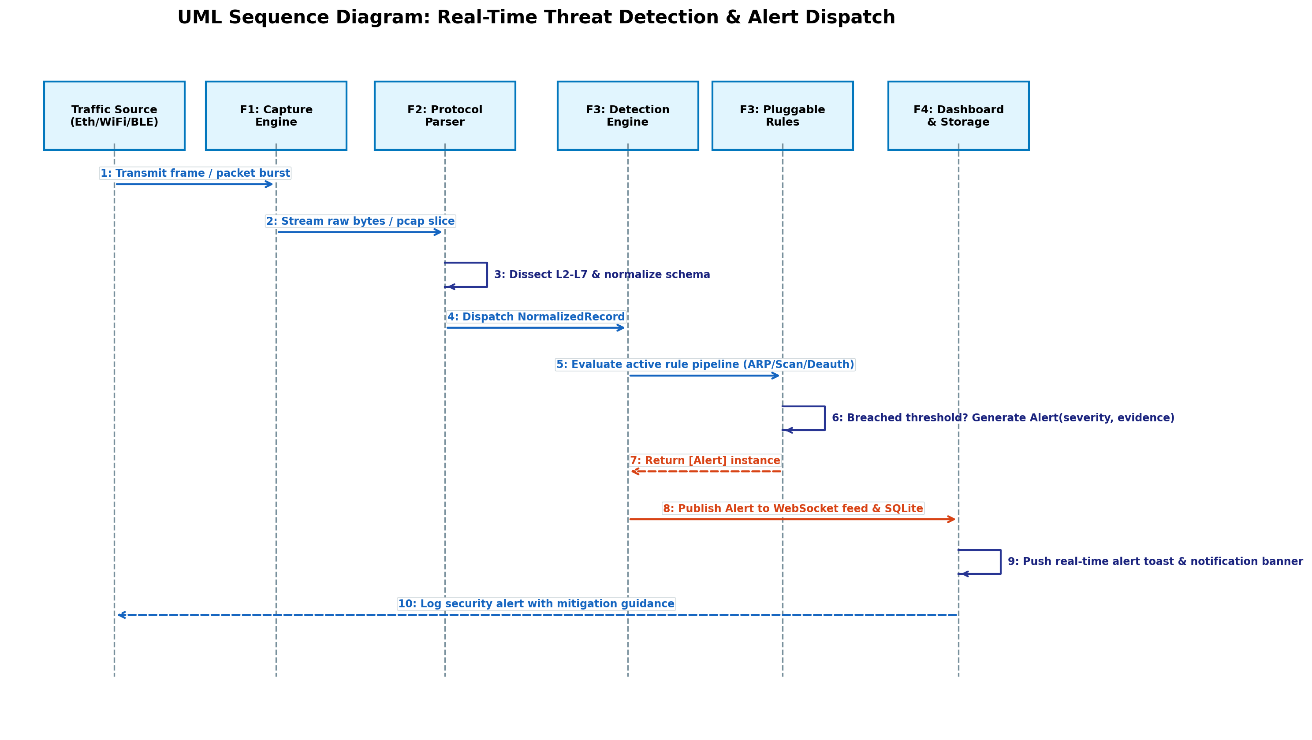
Figure 4.1: Real-Time Threat Detection & Alert Dispatch Sequence Diagram
4.2.2 Sequence Diagram 2: Historical Search, Filtering & Session Export
Figure 4.2 details the workflow for parameterized search and PCAP/CSV/JSON session export from the web dashboard:
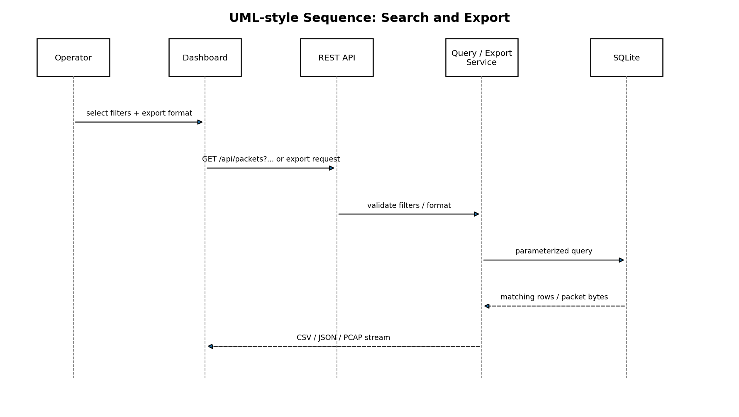
Figure 4.2: Search, Filtering & Session Export Sequence Diagram
4.3 API Design
The dashboard backend exposes standard REST endpoints and a real-time WebSocket connection:
Method | Endpoint | Parameters / Body | Description / Response
GET | /api/health | None | Returns 200 OK with CPU, memory, and interface status
GET | /api/packets | limit, offset, interface, protocol | Paginated list of normalized packet records from SQLite
GET | /api/alerts | severity, threat_type, limit | Returns recent alert objects with evidence dictionaries
GET | /api/devices | limit, offset | Returns active device inventory with MAC OUI vendor info
GET | /api/export | format (pcap/csv/json), filter query | Streams downloadable file containing matching traffic

4.4 Error Handling and Fault Tolerance
- Packet Ingestion Faults: Malformed or truncated frames are discarded with an error log counter; parsing never throws unhandled exceptions.
- Database Lock Contention: SQLite WAL mode with a 5000ms busy timeout ensures concurrent web reads never block ingestion writes.
- Sliding Window Memory Caps: In-memory deque structures automatically evict entries older than window expiration thresholds to prevent memory leakage.
4.5 Database Design (SQLite Schema)
The relational persistence model comprises four primary tables: `packets`, `connections`, `devices`, and `alerts`:
Table Name | Key Columns | Indexes
`packets` | id (PK), timestamp, interface, src_mac, dst_mac, src_ip, dst_ip, protocol, length | INDEX(timestamp), INDEX(src_ip, dst_ip)
`connections` | uid (PK), start_time, proto, orig_h, orig_p, resp_h, resp_p, duration, state | INDEX(orig_h), INDEX(resp_h)
`devices` | mac (PK), vendor, hostname, link_type, first_seen, last_seen, packet_count | INDEX(mac), INDEX(last_seen)
`alerts` | alert_id (PK), timestamp, threat_type, severity, title, evidence_json, mitigation | INDEX(timestamp), INDEX(severity)

5. Appendices
5.1 References
1. IEEE Std 1016-2009: Standard for Information Technology — Systems Design — Software Design Descriptions.
2. Gamma et al.: Design Patterns: Elements of Reusable Object-Oriented Software (Strategy Pattern).
3. Martin, Robert C.: Clean Architecture: A Craftsman's Guide to Software Structure and Design.

