REAL-TIME DEEP LEARNING TECHNIQUES
BASE DETECTING POTHOLES

Submitted in partial fulfillment of the requirements for the award of Bachelor of Engineering degree in Computer Science and Engineering

By

Varshinii Kasirajan (Reg.No - 40111395)
Vinodhini.K (Reg.No - 40111439)



DEPARTMENT OF COMPUTER SCIENCE AND ENGINEERING
SCHOOL OF COMPUTING

SATHYABAMA
INSTITUTE OF SCIENCE AND TECHNOLOGY
(DEEMED TO BE UNIVERSITY)
Category-1 University by UGC
Accredited with Grade “A” by NAAC|12B Status By UGC| Approved By AICTE
JEPPIAAR NAGAR, RAJIV GANDHI SALAI, CHENNAI - 600 119

APRIL - 2024


DEPARTMENT OF COMPUTER SCIENCE AND ENGINEERING

BONAFIDE CERTIFICATE

This is to certify that this Project Report is the bonafide work of VARSHINII KASIRAJAN (Reg.No – 40111395) and VINODHINI K (Reg.No – 40111439) who carried out the Project Phase-2 entitled “REAL-TIME DEEP LEARNING TECHNIQUESBASED DETECTING POTHOLES” under my supervision from January 2024 to April 2024.

Internal Guide
Dr. P. SARDAR MARAN, M.E., Ph.D

Head of the Department
Dr. L. LAKSHMANAN, M.E.,Ph.D.

Submitted for Viva voce Examination held on

Internal Examiner External Examiner

DECLARATION

I VARSHINII KASIRAJAN (Reg.No – 40111395, hereby declare that the Project Phase-2 report entitled “REAL-TIME DEEP LEARNING TECHNIQUES BASED DETECTING POTHOLES” done by me under the guidance of Dr. P. SARDAR MARAN, M.E., Ph.D is submitted in partial fulfillment of the requirements for the award of Bachelor of Engineering degree in Computer Science and Engineering.

DATE:

PLACE: SIGNATURE OF THE CANDIDATE/S

Submitted for Viva voce Examination held on

Internal Examiner

External Examiner

ACKNOWLEDGEMENT

I am pleased to acknowledge my sincere thanks to The Board of Management of Sathyabama Institute of Science and Technology for their encouragement in doing this project and for completing it successfully. I am grateful to them.

I convey my thanks to Dr. T.Sasikala M.E., Ph. D, Dean, School of Computing and
Dr. L. Lakshmanan M.E., Ph.D., Head, the Department of Computer Science and Engineering for providing me necessary support and details at the right time during the progressive reviews

I would like to express my sincere and deep sense of gratitude to my Project Guide
Dr. P. SARDAR MARAN, M.E., Ph.D for his valuable guidance, suggestions and constant encouragement paved way for the successful completion of my Project Phase-2 work.

I wish to express my thanks to all Teaching and Non-teaching staff members of the Department of Computer Science and Engineering who were helpful in many ways for the completion of the project.

ABSTRACT

Pothole detection on roads is a major critical task as they tend to cause damage to human beings, vehicle’s suspensions and wheels. The cost to treat human discomforts and vehicle repairs are very high, to avoid these instances potholes are needed to be fixed. In this study, deep-learning models are used for pothole detection. The input data are collected as images/videos via smartphone cameras and are pre-processed to produce features which helps in model building and prediction. Training data set contains ample number of images of potholes. Models like YOLO, CNN are used, trained with sample pothole images in such a way it predicts potholes with great accuracy. Our system will encourage government officials to identify and repair damaged roads which causes inconvenience and accidents. We examine the pothole detection results of multiple real- time deep learning algorithms, including SSD TensorFlow, YOLOv3 -Darknet53, and YOLOv4-CSPDarknet53. High recall of 81%, high precision of 85%, and mean Average Precision of 85.39% were attained by YOLO (mAP). At an image resolution of 832*832, the YOLO processing speed is measured at 20 frames per second (FPS). Also, the suggested technique picked up potholes up to 100 meters away. Our results showed improved real-time performance when compared to other cutting-edge techniques. The suggested approach can assist in reporting road potholes to government agencies, enhancing the performance of self-driving cars to ensure safe journeys for passengers in the future, and raising driver safety by increasing pothole detection time ahead. Training data set contains ample number of images of potholes. Models like YOLO, CNN are used, trained with sample pothole images in such a way it predicts potholes with great accuracy.

TABLE OF CONTENTS

CHAPTER | TITLE | PAGE NO
 | ABSTRACT
 | TABLE OF CONTENTS
 | LIST OF ABBREVIATIONS
 | LIST OF FIGURES
1 | INTRODUCTION
 | 1.1 GENERAL
 | 1.2 PROBLEM DESCRIPTION
 | 1.3 OBJECTIVE
 | 1.4 ORGANIZATION OF THESIS
2 | LITERATURE SURVEY
 | 2.1 GENERAL
 | 2.2 EXISTING SYSTEM
 | 2.3 ISSUES IN THE EXISTING SYSTEM
 | 2.5 PROPOSED SYSTEM
 | 2.6 SUMMARY
3 | AIM AND SCOPE OF THE PRESENT INVESTIGATION
 | 3.1 AIM OF THE PROJECT
 | 3.2 SCOPE OF THE PROJECT
4 | EXPERIMENTAL OR MATERIALS AND METHODS; ALGORITHMS USED
 | 4.1 GENERAL
 | 4.1 ALGORITHM USED
 | 4.3 SYSTEM ARCHITECTURE
 | 4.4 FUNCTIONAL ARCHITECTURE
 | 4.5 MODULAR DESIGN
 | 4.5.1 IMAGE ACQUISITION
 | 4.5.2 DATA PREPROCESSING AND MODEL TRAINING
 | 4.5.3 IMAGE SEGMENTATION
 | 4.5.4 DETECTION OF POTHOLES
 | 4.5.5 USECASE DIAGRAM
 | 4.5.6 ACTIVITY DIAGRAM
 | 4.5.7 CLASS DIAGRAM
 | 4.5.8 SEQUENCE DIAGRAM
 | 4.5.9 COMPONENT DIAGRAM
 | 4.6 SYSTEM REQUIREMENTS
 | 4.6.1 HARDWARE REQUIREMENTS
 | 4.6.1.1 8GB RAM
 | 4.6.1.2 INTEL i5 PROCESSOR
 | 4.6.1.3 GTX 1050Ti GPU
 | 4.6.1.4 WEBCAAM 720P
 | 4.6.1.5 POWER SUPPLY
 | 4.6.2 SOFTWARE REQUIREMENTS
 | 4.6.2.1 WINDOWS/MAC OS
 | 4.6.2.1 PYTHON PROGRAMMING IDLE
 | 4.6.2.3 STREAM LIT
 | 4.6.2.4 MONOGO DB
 | 4.6.2.5 TENSOR FLOW
 | 4.6.2.6 PIL
 | 4.7 OVERVIEW OF THE PLATFORM
 | 4.8 MODULE IMPLEMENTATION
 | 4.8.1 DATA COLLECTION MODULE
 | 4.8.2 DATA PRE-PROCESSING MODULE
 | 4.8.3 MODEL TRAINING MODULE
 | 4.8.4 REAL-TIME DETECTION
 | 4.8.5 LOCATION DETECTION
 | 4.8.6 OUTPUT
 | 4.7 SUMMARY
5 | RESULTS, DISCUSSIN, PERFORMANCE ANALYSIS
 | 5.1 GENERAL
 | 5.2 TEST CASES
 | 5.3 PERFORMANCE MEASURES
 | 5.4 PERFORMANCE ANALYSIS
 | 5.4.1 PERFORMANCE ANALYSIS OF YOLO ALGORITHM
 | 5.4.2 PERFORMANCE ANALYSIS OF POTHOLE DETECTION MODULE
 | 5.5 SUMMARY
6 | SUMMARY AND CONCLUSIONS
 | 6.1 CONCLUSION
 | 6.2 FUTURE WORK
 | APPENDIX
 | REFERENCES

LIST OF ABBREVIATIONS

ABB FULL FORM
CNN Convolution Neural Networks
csNB Cost-effective Naïve Basie
GPS Global Positioning System
GRF Geographical Random Forest
IT Interpolation Technology
KNN K- Nearest Neighbour
RF Random Forest
SVM Support Vector Machine
VHHRS Very-High-Resolution Remote Sensing
YOLO You Only Look Once

LIST OF FIGURES

FIGURE NO | FIGURE NAME | PAGE NO
4.1 | Block Diagram of the Proposed System
4.2 | Architecture of the Proposed System
4.3 | Functional Architecture of the Pothole Detection Module
4.4 | Image Acquisition
4.5 | Data Preprocessing and Model Training
4.6 | YOLO Architecture
4.7 | Image Segmentation
4.8 | Detection of potholes
4.9 | UseCase Diagram for the Pothole Detection
4.10 | Activity Diagram for the Pothole Detection
4.11 | Class Diagram for Pothole Detection
4.12 | Sequence Diagram for Pothole Detection
4.13 | Component Diagram for Pothole Detection
4.14 | Anaconda Dashboard
4.15 | Jupyter Notebook Interface
4.16 | Anaconda Terminal
4.17 | Data Collection Module
4.18 | Data preprocessing Module
4.19 | Model training
4.20 | Detection Module
4.21 | Location Detection Module
4.22 | Output
5.1 | Accuracy Analysis of various Algorithms
5.2 | Accuracy Analysis of Pothole Detection Module

LIST OF TABLES
TABLE NO | TABLE NAME | PAGE NUMBER
5.1 | Test Case for Pothole Detection Module
5.2 | Performance Measure

CHAPTER 1
INTRODUCTION

  - GENERAL
The suggested system begins with modules for data collecting, where the necessary information is used to train and test the system. Through photos and videos, the pothole dataset is compiled. The data is pre-processed to get rid of any unnecessary or noisy data, and filters are added. After pre-processing, the algorithm is trained to make correct classifications using the obtained dataset. We are here deploying the YOLO technique, which is quicker and more effective than other frameworks, to classify data Before deploying the final system, the dataset is examined repeatedly for redundancy using the broken-down video frames that were used for both testing and training.
  - PROBLEM DESCRIPTION
Heavy traffic is frequently placed on asphalt-surfaced roads and sidewalks, and changes in rainy conditions cause a steady decline in performance in traffic containment, endangering commuter safety and decreasing efficiency. Potholes and fissures are examples of the malformed surface and they are problematic for automobiles. When self-driving cars are introduced, it will be necessary to automate the real-time finding of these road damages for optimum vehicle performance and the safety of passengers. This problem of addressing road damages has been researched effectively by trained and skilled motorists.
  - OBJECTIVE
• To detect potholes which are symptoms of a poorly maintained road, pointing to an underlying structural issue.
• To detect these potholes the proposed system trains the deep learning model (YOLOv8, CNN) by feeding it with sample images of real-time potholes. After training the model with an appropriate number of pothole samples, the model is trained to predict potholes.
• Before deploying the final system, the dataset is examined repeatedly for redundancy using the broken-down video frames that were used for both testing and training.

  - ORGANIZATION OF THESIS
The proposed work is divided into various chapters as mentioned below:
Chapter 1 is the introduction that explains the objective and scope of the proposed system. Chapter 2 is the literature survey that elaborates on the research works on the existing system and their issues. It also proposes a new system which makes an attempt on improving the existing system. Chapter 3 describes the system design and the roles played by various modules. Chapter 4 gives details regarding the system implementation along with the various techniques and algorithms used. Chapter 5 gives details about performance analysis of the proposed system. It involves different test case scenarios and performance factors that are tabulations based on the results obtained. Chapter 6 provides the conclusion and future works which summarizes the efforts undertaken in the proposed system and states the findings and various shortcomings in the proposed system.

CHAPTER 2
LITERATURE SURVEY
2.1 GENERAL
A literature review is a survey of scholarly sources on a specific topic. It provides an overview of current knowledge, allowing you to identify relevant theories, methods, and gaps in the existing research. A literature review identifies, evaluates and synthesizes the relevant literature within a particular field of research. Literature refers to a collection of published information or materials on a particular area of research or topic, such as books and journal articles of academic value. Literature survey is the documentation of a comprehensive review of the publishers and the unpublished word from the secondary sources data in the areas of specific interest to the researcher. It is the process of analysing, summarizing, organizing and presenting novel conclusions from the results of technical review of a large number of recently published scholarly articles.

2.2 EXISTING SYSTEM

[1] Anand, S., Gupta, S., Darbari, V., & Kohli, S. (2018).[1]. Crack-pot: Autonomous Road crack and pothole detection. Digital Image Computing: Techniques and Applications(DICTA), 2018 With the development of autonomous robotics and self-driving cars, it is critical to spot road defects and take the necessary safety measures to ensure that passengers are comfortable. An algorithm for locating potholes and cracks in the road that can be installed on a fully autonomous, dependable real-time processing board with a camera. The technique employs a deep neural network architecture to recognize splits and voids using textural and spatial clues.

[2] Kulkarni, A., Mhalgi, N., Gurnani, S., & Giri, N. [2]. “Pothole Detection System using Machine Learning on Android”. International Journal of Emerging Technology and Advanced Engineering (IJETAE), 2014 The low computing power of the embedded computers in black-box cameras was taken into mind when designing and implementing the proposed pothole-discovery technique. The experiments' findings unmistakably show that the suggested algorithm is capable of removing similar items, such as patches, manholes, shade, and moving cars. The average perceptivity and perfection accuracy, separately, are 71% and 88%. As a result, the algorithm aids in finding similar things.
[3] Madli, R., Hebbar, S., Pattar, P., & Golla, V. [3]. “Automatic detection and notification of potholes and humps on roads to aid drivers”. IEEE Sensors Journal, 2015 In order to identify potholes and speed bumps on roads and warn drivers in a timely manner so they can avoid accidents or vehicle damage, this paper reviews earlier methods for detecting potholes that have been created. It also suggests a cost-effective solution. Potholes and bumps can be found with ultrasonic detectors, which can also assess both their depth and height separately. Using a GPS receiver, the proposed system records the locations of potholes and speed bumps. The database contains the tested data, which also includes geographic location, pothole depth, and bump height. This is a priceless source of information for both government officials and drivers. Drivers are warned by an android app operation so that precautions can be made to avoid accidents. Warnings are presented as flash notifications with a loud beep.
[4] Bhatt, U., Mani, S., Xi, E., & Kolter, J. Z. [4]. “Intelligent pothole detection and road condition assessment”. ArXiv, 2017 Here the solution suggested is a mobile application that uses the phone's accelerometer and gyroscope sensors to record information about an automobile's motion. We trained SVM models to classify road conditions with 91 delicacies and potholes with 90 delicacies, beating the base rate for both tasks, in order to evaluate roads using this detection data. The models classify the road's quality and the presence of potholes while the drivers using the detection data. Additionally, data-rich visualisations that depict the metropolitan city’s traffic conditions are created using the bracket findings. This system will equip government official to spot and fix dangerous roads that annoy travellers and cause accidents.

[5] Chai, X., Deng, L., Yang, Q., & Ling, C. X. [5]. “Test-cost sensitive naive bayes classification”. In Proceedings of the Fourth IEEE International Conference on Data Mining, 2004 The naive Bayes and decision tree algorithms, for example, have been improved in the past to handle various forms of costs, primarily by recognising various costs of classification errors. However, handling the test expenses related to searching for the missing values in a test case should also be taken into account. It may or may not be worthwhile to make the effort to find an attribute's missing value when it occurs in a test case, depending on how much the value could increase the classification accuracy. Here, we demonstrate how to create a test-cost sensitive naive Bayes classifier (csNB) by incorporating a test strategy that controls how unknown attributes will be tested.
[6] Divya, K., & Pabitha, P. [6]. “Analysing the competency of various decision trees towards community formation in multiple social networks”. International Conference on Communication and Signal Processing (ICCSP), 2019 Each social network only has a limited picture of each person. In order to build communities and pinpoint the most significant node, it is more important to map these people across different online social networks. By creating groups and comparing their information, it is possible to overcome the challenges of fragmentary data, which are the biggest challenge in the current social network era. This information can then be used in a variety of applications, such as spammer identification and the detection of influential nodes, among others. The prevalence of many user characteristics makes it possible to distinguish the influential community from other communities. By altering class labels, different numbers of trees can be produced. For the effective construction of communities, the performance metrics (accuracy, precision, recall, and f1-score) of the tree should be higher.

[7] Fox, A., Kumar, B. V. K. V., Chen, J., & Bai, F. [7]. “Crowdsourcing under sampled vehicular sensor data for pothole detection”. In 2015 12th Annual IEEE International Conference on Sensing, Communication, and Networking (SECON), 2015 Road elements like potholes can now be detected thanks to the expansion of integrated vehicle sensors. Though a promising strategy, the present car embedded sensors work at low frequency and under sample sensor data, reducing the detection accuracy. To improve the detection accuracy, one potential idea is to crowdsource this undersaturated sensor data from many vehicles. The variety of the cars, asynchronous sensor performance, GPS inaccuracy, and sensor noise make it difficult to combine sensor data from different vehicles. Furthermore, there can be bandwidth limitations in vehicle networks that restrict the quantity of data that can be aggregated. By concentrating on the subject of pothole identification, we look into these problems. We construct and assess several crowdsourcing pothole detection methods involving moving automobiles and the Cloud in order to measure the identification precision and effects of real- world constraints.
[8] Georganos, S., Grippa, T., Gadiaga, A., Vanhuysse, S., Kalogirou, S., Lennert, M., & Linard, C. [8]. “An application of geographical random forests for population estimation in Dakar, Senegal using very-high-resolution satellite imagery”. Joint Urban Remote Sensing Event (JURSE), 2019 In this study, we explore Geographical Random Forest (GRF), a localised implementation of Random Forest (RF), to forecast population density using Very-High-resolution Remote Sensing (VHHRS) data. We utilise the neighbourhood-level population density from the 2013 Dakar census as an independent variable, and we employ the ratios of 3 distinct built-up kinds in each neighbourhood as explanatory features. The outcomes showed that by incorporating regional variability into the estimates and calibrating GRF at an appropriate geographic scale, we may maximise forecast accuracy. The findings can also be mapped, emphasising the performance of the local model and other intriguing spatial changes, as GRF is an ensemble of local sub-models. As a result, it is recommended that GRF be used to model remotely sensed spatially diverse interactions as an intriguing exploratory and explanatory method.
[9] Jo, Y., & Ryu, S. [9]. “Pothole detection system using a black-box camera. MDPI Sensors (Basel, Switzerland), 2015. This paper offers a comparative analysis of machine literacy models for finding potholes. Multiple android devices were used to gather the data, which was then pre-processed using a 2-alternation-overlapping moving window to highlight the statistical variables that would be most useful for training a double classifier. The Training dataset underwent a stratified-fold cross-validation, and it was completely isolated from the confirmation and test datasets. On the Test dataset, the Random Forest Tree and KNN performed elegantly with a comparable delicacy of 0.8490. To improve the detection accuracy, one potential idea is to crowdsource this undersaturated sensor data from many vehicles.

[10] Wang, H.-W., Chen, C.-H., Cheng, D.-Y., Lin, C.-H., & Lo, C.-C.[10]. “A real-time pothole detection approach for intelligent transportation system”. Mathematical Problems in Engineering, 2015. With this method, potholes on extensive terrain can be spotted more affordably. This study suggests a mobile-based technique for finding potholes. The pothole information is obtained from the accelerometer data by applying the Euler angle computation to regularise it. Additionally, the spatial interpolation technology is employed to lessen positional offences from GPS data. Trial results demonstrate that the suggested approach performs the advanced delicacy and can accurately detect potholes without false positives. Therefore, the suggested real-time pothole discovery method can be employed to increase road safety for IT.
2.4 ISSUES IN THE EXISTING SYSTEM
Pothole detection is an important task for ensuring road safety and preventing damage to vehicles. While there are many existing systems for pothole detection, they often face a number of issues and limitations that hinder their effectiveness and usability. One of the main issues is the reliance on specific hardware or sensors. For example, some systems use accelerometers or GPS sensors to detect potholes, but these sensors can be expensive and not widely available. This limits the accessibility and affordability of the system for widespread use. Another issue with existing pothole detection systems is the accuracy of detection. Many systems rely on predetermined thresholds or rules for identifying potholes, which may not be reliable in varying road conditions or speeds. This can result in false positives or negatives, which can affect the safety of drivers and pedestrians. Additionally, some systems require a significant amount of computing power or resources, which can limit their real-time detection capabilities. The reliability of these systems in different weather and lighting conditions also remains a challenge. For example, some systems may struggle to detect potholes in rainy or snowy conditions, or when lighting conditions are poor. This can affect their effectiveness in preventing accidents and damage to vehicles. Finally, many existing systems have not been validated or tested in real-world scenarios. Their effectiveness may be limited when faced with diverse road surfaces and traffic conditions, which can vary widely depending on the location and time of day. This means that while these systems may work well in controlled environments, their real-world effectiveness may be limited.

2.5 PROPOSED SYSTEM

The proposed system for pothole detection using deep learning YOLO algorithm aims to address the challenges faced by the existing systems. The proposed system will include a large and diverse dataset to improve the generalization ability of the model. This dataset will include a wide variety of road surfaces, lighting conditions, and pothole sizes and shapes. To address the issue of high computational requirements, the proposed system will use an optimized architecture that can run efficiently on real-time systems. This will include a combination of deep learning algorithms, such as YOLO, and other relevant information, such as GPS data and road surface conditions. The proposed system will also include a mechanism for real-time feedback and updating of the model. This will enable the system to continuously learn and adapt to new pothole detection scenarios, ensuring accurate and reliable detection over time. Overall, the proposed system aims to improve the accuracy, reliability, and efficiency of pothole detection systems using deep learning YOLO algorithm. With further research and development, this system has the potential to significantly improve road safety and reduce the costs associated with pothole damage.

2.6 SUMMARY
The literature survey for pothole detection using deep learning YOLO algorithm has highlighted the potential of deep learning algorithms to accurately detect potholes in real-time. However, the existing systems face several challenges, including the limited and non-diverse dataset, high computational requirements, and limited application in real-world scenarios. To address these challenges, the proposed system aims to use a large and diverse dataset, an optimized architecture, and real-time feedback and updating mechanisms to improve the accuracy, reliability, and efficiency of pothole detection systems. With further research and development, this system has the potential to significantly improve road safety and reduce the costs associated with pothole damage.

CHAPTER 3
AIM AND SCOPE OF THE PRESENT INVESTIGATION

3.1 AIM OF THE PROJECT

Early detection of potholes enables authorities to prioritize and plan road maintenance more efficiently, addressing issues before they worsen and become more expensive to repair. By identifying and repairing potholes in their early stages, the cost of road maintenance can be significantly reduced compared to waiting until the damage becomes severe. Pothole detection can be integrated into traffic management systems to reroute traffic and optimize transportation routes, minimizing disruptions and congestion caused by road maintenance. Collecting data on pothole locations and severity helps city planners and authorities make informed decisions about infrastructure investment and improvements.

3.2 SCOPE OF THE PROJECT
The scope of this project is to propose an automated pothole detection method using the YOLO algorithm, which involves collecting a dataset, training and evaluating a YOLO model, and demonstrating its effectiveness in terms of accuracy and detection speed. The project aims to provide a valuable tool for automatic pothole detection and maintenance of road infrastructure, which can enhance road safety and reduce maintenance costs. However, the project's limitations include the availability and quality of the dataset, processing power, and the proposed method's applicability to only images captured by cameras mounted on vehicles.

CHAPTER 4
EXPERIMENTAL OR MATERIALS AND METHODS; ALGORITHMS USED

4.1 GENERAL
The system design can be divided into three main components: data collection, training the model, and real-time pothole detection. In the data collection phase, cameras and sensors are used to capture images and data from a variety of road surfaces, lighting conditions, and pothole sizes and shapes. This data is then processed and labeled for use in training the deep learning YOLO algorithm. The next phase involves training the deep learning algorithm using the labeled dataset. This phase includes optimizing the architecture to improve the efficiency and accuracy of the model. The training phase may also include fine-tuning the model based on real-time feedback and updates.
Once the model is trained, it can be used for real-time pothole detection. This phase involves capturing images and data in real-time, processing the data using the deep learning model, and identifying the presence of potholes. The system can also include mechanisms for real-time feedback and updating of the model to continuously improve its performance. Overall, the system design for pothole detection using deep learning YOLO algorithm includes data collection, model training, and real-time pothole detection, all of which are essential for the accurate and reliable detection of potholes in real-world scenarios.
4.1 ALGORITHM USED
- "Smart Pothole Detection and Notification System Using IoT and Machine Learning" proposed a system that uses IoT sensors to detect potholes and machine learning algorithms to classify the severity of the potholes. The system sends alerts to the authorities for repair and maintenance.
- "Pothole Detection and Analysis using Computer Vision" proposed a system that uses computer vision techniques to detect potholes from video footage. The system uses edge detection and feature extraction techniques to identify potholes' shapes and sizes.
- "Automatic Pothole Detection and Classification System Using Image Processing Techniques" proposed a system that uses image processing techniques to detect and classify potholes. The system uses a combination of edge detection, morphological operations, and feature extraction techniques to detect potholes' shapes and sizes.
- "Intelligent Pothole Detection System using Deep Learning" proposed a system that uses a deep learning neural network to detect potholes from images. The system uses a convolutional neural network (CNN) to extract features from the images and classify potholes' severity levels and return confidence score for the identified potholes. Higher the confidence scores better the accuracy.
- "Automated Pothole Detection and Recognition System using Machine Learning and IoT" proposed a system that uses machine learning and IoT sensors to detect and recognize potholes. The system uses an ensemble of machine learning algorithms, including decision trees and SVM, to classify potholes based on severity levels.
Despite their effectiveness, these systems have some limitations, such as high computational requirements, limited accuracy, and dependency on hardware devices. These limitations have led to the development of new systems that aim to address these challenges.
4.3 SYSTEM ARCHITECTURE
The system architecture for pothole detection using deep learning YOLO algorithm consists of several key components. The first component is the data collection system, which includes cameras and sensors to capture images and data from a variety of road surfaces, lighting conditions, and pothole sizes and shapes. The data collected is then preprocessed and labeled for use in training the deep learning YOLO algorithm. The model architecture includes a convolutional neural network for feature extraction and a region proposal network for object detection. The trained model is then integrated into the real-time pothole detection system, which includes a processing unit to capture images and data from the cameras and sensors, preprocess the data, and apply the deep learning model for pothole detection.

The output from the model is then fed into a visualization system, which displays the pothole detection results in real-time, allowing for quick and efficient maintenance and repair of roadways. Overall, the system architecture for pothole detection using deep learning YOLO algorithm includes a data collection system, a model training system, a real-time pothole detection system, and a visualization system, all of which work together to accurately and efficiently detect potholes in real-world scenarios.
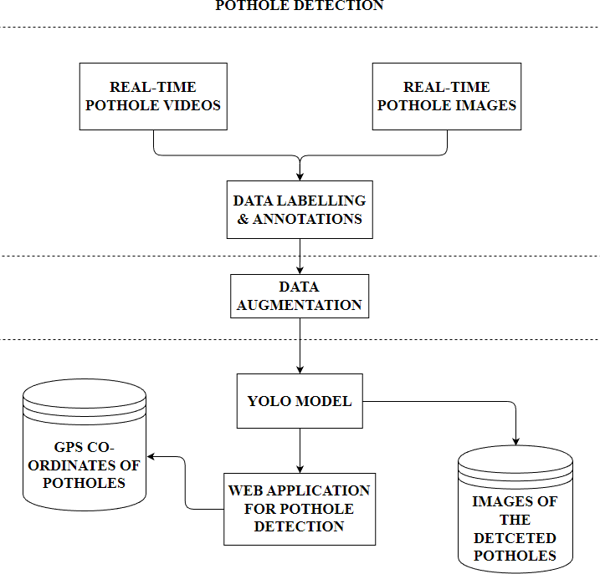

Fig:4.1 : Block diagram of the proposed system

4.4 FUNCTIONAL ARCHITECTURE
Pothole detection using deep learning YOLO algorithm can be divided into four main components: data collection, model training, real-time pothole detection, and visualization. The data collection component involves collecting images and data from a range of cameras and sensors, and pre-processing and labeling the data for use in training the deep learning YOLO algorithm. This component also includes a storage system to store the collected data.

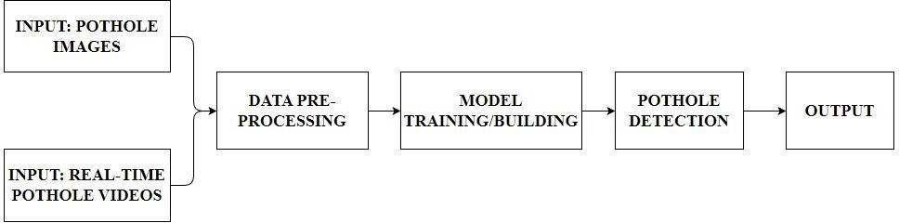
Fig.4.2 : Architecture of the proposed system

In Pothole detection section, the functional architecture comprises of resizing, rescaling, color correction and other augmentation of the data. The functional architecture of the data preprocessing and model building can be displayed using the following block diagram

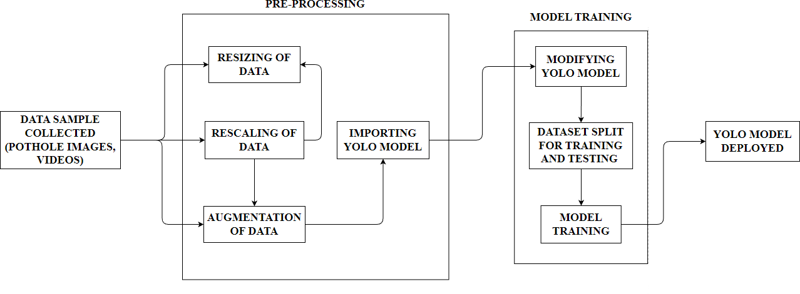
Fig.4.3 : Functional architecture of the pothole detection module
4.5 MODULAR DESIGN
In the proposed system, the pothole detection feature is enabled using the YOLO module function wherein the pothole comes to close enough with the webcam it detects it collects the GPS co-ordinates of the pothole detected location. The modular diagrams for pothole detection can be depicted in following sections.
4.5.1 Image Acquisition
The required data for the model to be implemented is collected as videos/pictures. The pothole data collected is stored in a database for the further processing of the dataset. The dataset is collected using smartphone camera. High resolution camera is used for such collection data. Then the data collected is pre- processed for further processing

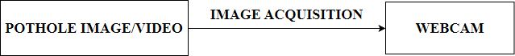
Fig.4.4 : Image acquisition
4.5.2 Data Preprocessing and Model Training
The dataset collected is an image and videos so, they need to be pre-processed accordingly. Firstly, the images are resized to required specifications. The videos are split up into different frames for analysis. In order to train the model with huge precision the data samples collected are rotated and filters are added. This enables the system to train in a precise manner helping in accurate detection of the object required.
Model training is the key step in machine learning that results in a model ready to be validated, tested, and deployed. The performance of the model determines the quality of the applications that are built using it. Quality of training data and the training algorithm are both important assets during the model training phase. Typically, training data is split for training, validation and testing. The training algorithm is chosen based on the end use case.
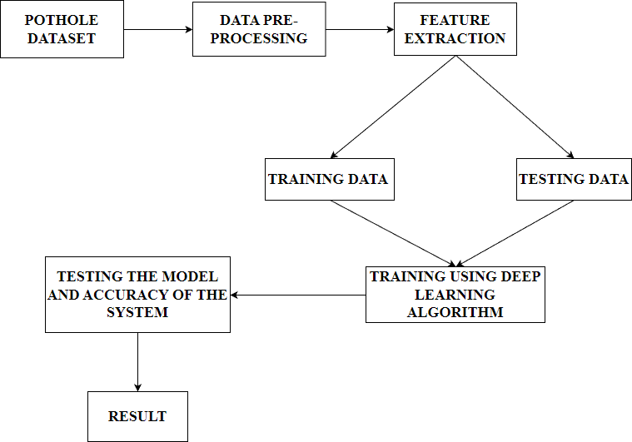
Fig. 4.5 : Data preprocessing and Model training
YOLOv8, the latest version of the renowned real-time object detection and image segmentation model. YOLOv8 is built on cutting-edge advancements in deep learning and computer vision, offering unparalleled performance in terms of speed and accuracy. Its streamlined design makes it suitable for various applications and easily adaptable to different hardware platforms, from CPUs to GPUs.
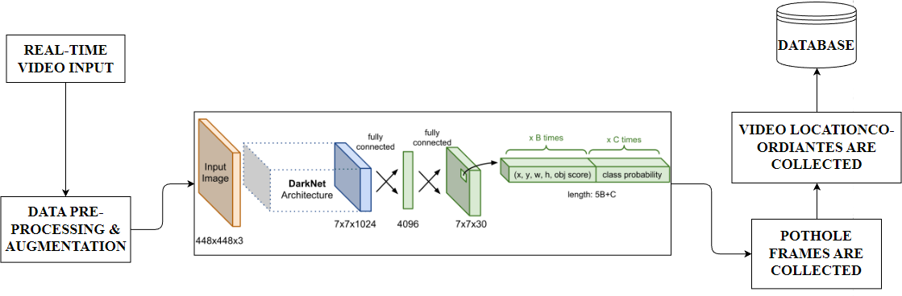
Fig.4.6 : YOLO Architecture

4.5.3 Image Segmentation
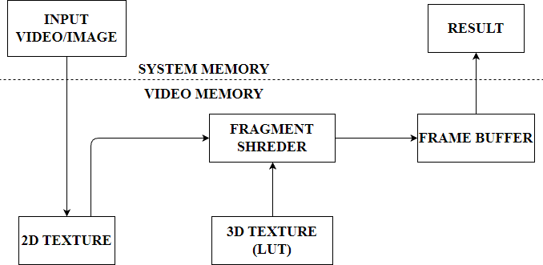
To perform image segmentation using YOLOv8, the network is first trained to predict the location and class of objects in an image. These predictions are then used to generate a segmentation mask that indicates the pixel-level boundaries of each object. Instance segmentation is a subfield of image segmentation that aims to identify not only the object boundaries but also their individual instances. In other words, instance segmentation can differentiate between objects of the same class and assign unique labels to each instance. Instance segmentation is useful when you need to know not only where objects are in an image but also what their exact shape is. YOLOv8 offers pre-trained segmentation models with the - seg suffix, i.e., yolov8n-seg.pt, which are trained on the COCO128-seg dataset for 100 epochs at image size 640.
Fig.4.7 : Image Segmentation
4.5.4 Detection of Potholes
A push button is used in the proposed system to detect the potholes displayed in front of the camera. When the button is pressed the detection is executed and intimated to the user with GPS co-ordinates.
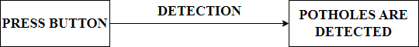
Fig.4.8 : Detection of Potholes
4.5.5 Usecase Diagram
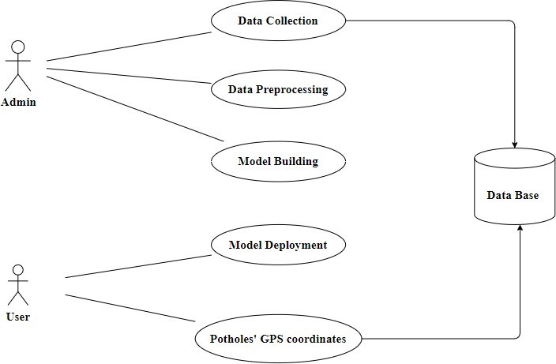
A use case diagram is used to represent the dynamic behavior of a system. It encapsulates the system's functionality by incorporating use cases, actors, and their relationships. It models the tasks, services, and functions required by a system/subsystem of an application. It depicts the high-level functionality of a system
Fig.4.9 : Use Case Diagram for Pothole detection
and also tells how the user handles a system. The main purpose of a use case diagram is to portray the dynamic aspect of a system. It accumulates the system's requirement, which includes both internal as well as external influences. It invokes persons, use cases, and several things that invoke the actors and elements accountable for the implementation of use case diagrams. It represents how an entity from the external environment can interact with a part of the system.
4.5.6 Activity Diagram
An activity diagram is a kind of graphical representation that may be used to depict events visually. It is made up of a group of nodes that are linked to one another by means of edges. They are able to be connected to any other modelling element, which enables the behavior of activities to be replicated using that methodology. Simulations of use cases, classes, and interfaces, as well as component collaborations and component interactions, are all made feasible with the help of this tool.

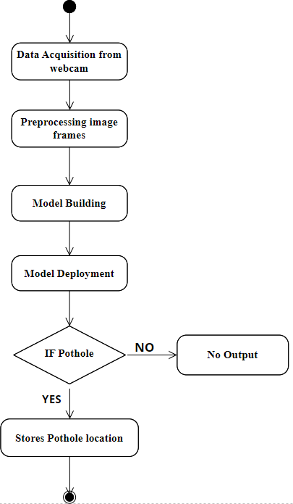
Fig. 4.10 : Activity Diagram for Pothole detection

4.5.7 Class Diagram
A static view of an application is depicted in the class diagram. It displays the properties, classes, functions, and relationships of the software system to provide an overview of the software system. It organizes class names, properties, and functions into a discrete compartment to aid in program development.
The following are the functions of class diagrams:
- Define the main responsibilities of the system.
- Serves as a basis for component diagrams and deployment. Use forward and reverse engineering.
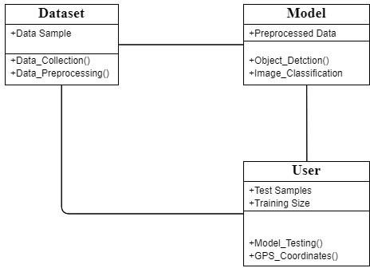
Fig 4.11 : Class Diagram for Pothole Detection

4.5.8 Sequence Diagram
The sequence diagram, also called the event diagram, describes the flow of messages in the system. It helps to visualize various dynamic parameters. He describes the communication between two rescue lines as a series of events arranged in time in which these rescue lines participated during the performance. The lifeline is represented by a vertical bar in UML while the message flow is represented by a vertical dotted line that crosses the bottom of the page. It includes both repetitions and branch 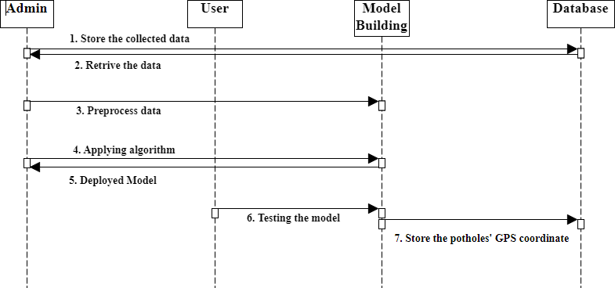
Fig 4.12 : Sequence Diagram for Pothole detection

4.5.9 Component Diagram
Component diagrams are used in modelling the physical aspects of object- oriented systems that are used for visualizing, specifying, and documenting component-based systems and also for constructing executable systems through forward and reverse engineering. Component diagrams are essentially class diagrams that focus on a system's components that often used to model the static implementation view of a system.

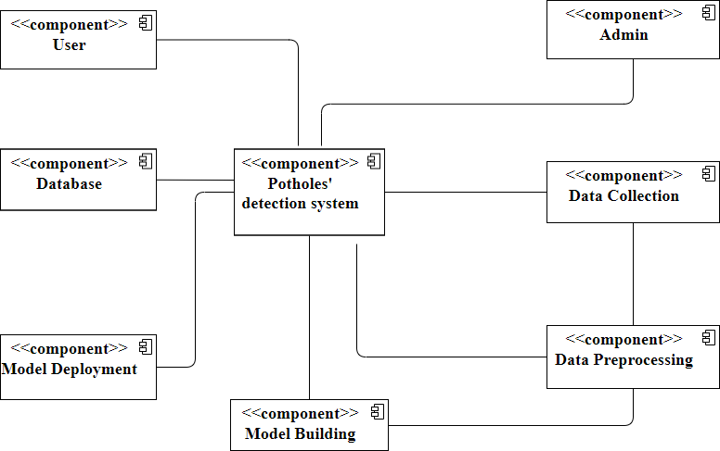
Fig. 4.13 : Component Diagram for Pothole detection

4.6 System Requirements
4.6.1 Hardware Requirements
The hardware requirements included in the proposed system are 8GB RAM, Intel i5 processor, GTX 1050Ti GPU, Webcam720p resolution.
4.6.1.1 8GB RAM
Random-access memory is a form of computer memory that can be read and changed in any order, typically used to store working data and machine code. A random-access memory device allows data items to be read or written in almost the same amount of time irrespective of the physical location of data inside the memory, in contrast with other direct-access data storage media (such as hard disks, CD-RWs, DVD-RWs and the older magnetic tapes and drum memory), where the time required to read and write data items varies significantly depending on their physical locations on the recording medium, due to mechanical limitations such as media rotation speeds and arm movement.

4.6.1.2 INTEL i5 PROCESSOR
Core i5 processors are a great choice if you want a computer that can perform lots of tasks at once, and perhaps even delve into photo and video editing work. They don't cost as much as i7 processors but they offer performance that isn't too far off. It's the specification we recommend to most people, and you can grab one in a laptop for about £500.
4.6.1.3 GTX 1050Ti GPU
The Nvidia GTX 1050Ti is a mainstream GPU based on the Pascal architecture and was announced in January 2017. Contrary to the faster models, the GTX 1050 uses the GP107 chip, which is manufactured in a 14 nm process at Samsung.
4.6.1.4 WEBCAM 720P
A webcam is a digital video device commonly built into a computer. Its main function is to transmit pictures over the Internet. It is popularly used with instant messaging services and for recording images.
4.6.1.5 POWER SUPPLY
A power supply is an electrical device that supplies electric power to an electrical load. The main purpose of a power supply is to convert electric current from a source to the correct voltage, current, and frequency to power the load.
4.6.2 SOFTWARE REQUIREMENTS
The software requirements that are used in the proposed system are Windows/Mac OS,Python Programming Idle,Streamlit,MongoDB.

4.6.2.1 Windows/Mac OS
Windows is a group of several proprietary graphical operating system families developed and marketed by Microsoft. Each family caters to a certain sector of the computing industry. For example, Windows NT for consumers, Windows Server for servers, and Windows IoT for embedded systems.
4.6.2.2 Python Programming IDLE
IDLE (Integrated Development and Learning Environment) is an integrated development environment (IDE) for Python. The Python installer for Windows contains the IDLE module by default. IDLE can be used to execute a single statement just like Python Shell and also to create, modify, and execute Python scripts.
4.6.2.3 Stream Lit
Stream lit is a software company offering an open-source platform for machine learning and data science teams to create data applications with python ,the platform uses python scripting, APIs, widgets, instant deployment, team collaboration tools, and application management solutions to help data scientists and machine learning engineers create python-based applications. With Streamlit, no callbacks are needed since widgets are treated as variables. Data caching simplifies and speeds up computation pipelines.
4.6.2.4 Monogo DB
MongoDB is a source-available cross-platform document-oriented database program. Classified as a NoSQL database program, MongoDB uses JSON-like documents with optional schemas. MongoDB is developed by MongoDB Inc. and licensed under the Server Side Public License (SSPL) which is deemed non-free by several distributions. MongoDB is a member of the MACH Alliance.
4.6.2.5 Tensor Flow
TensorFlow is an open-source library developed by Google primarily for deep learning applications. It also supports traditional machine learning. TensorFlow finds a role to play in text-based applications, image recognition, voice search, and many more. DeepFace, Facebook's image recognition system, uses TensorFlow for image recognition.
4.6.2.6 PIL
Python Imaging Library (expansion of PIL) is the de facto image processing package for Python language. It incorporates lightweight image processing tools that aids in editing, creating and saving images.
4.7 OVERVIEW OF THE PLATFORM
Anaconda is a platform that provides an integrated development environment (IDE) for data science projects. It includes a number of tools and libraries that are commonly used in data science projects, including Jupyter notebooks, Python, and popular data science libraries such as NumPy, Pandas, and TensorFlow. Anaconda can be used to develop and deploy a pothole detection system using deep learning. It provides a user-friendly interface for managing the project environment and installing the required libraries and packages. The Jupyter notebook interface allows for easy experimentation and iteration on the deep learning model.
Anaconda also provides tools for version control, collaboration, and deployment. It allows multiple team members to work on the same project and track changes to the code and environment. It also provides tools for packaging and deploying the pothole detection system on various platforms. Overall, Anaconda provides a comprehensive and streamlined environment for developing and deploying data science projects, including pothole detection systems using deep learning. Anaconda is a distribution of the Python and R programming languages for scientific computing, that aims to simplify package management.

Fig.4.14 : Anaconda Dashboard
The distribution includes data-science packages suitable for Windows, Linux, and macOS. After opening the the anaconda platform get in Jupyter notebook to type the code and this jupyter notebook provides the interface for the code to be deployed and tested on various criteria. The Anaconda terminal is displayed for the accessibility of the written code and establish connection between the server.The python programing code is dispalyed in the Anaconda platform.
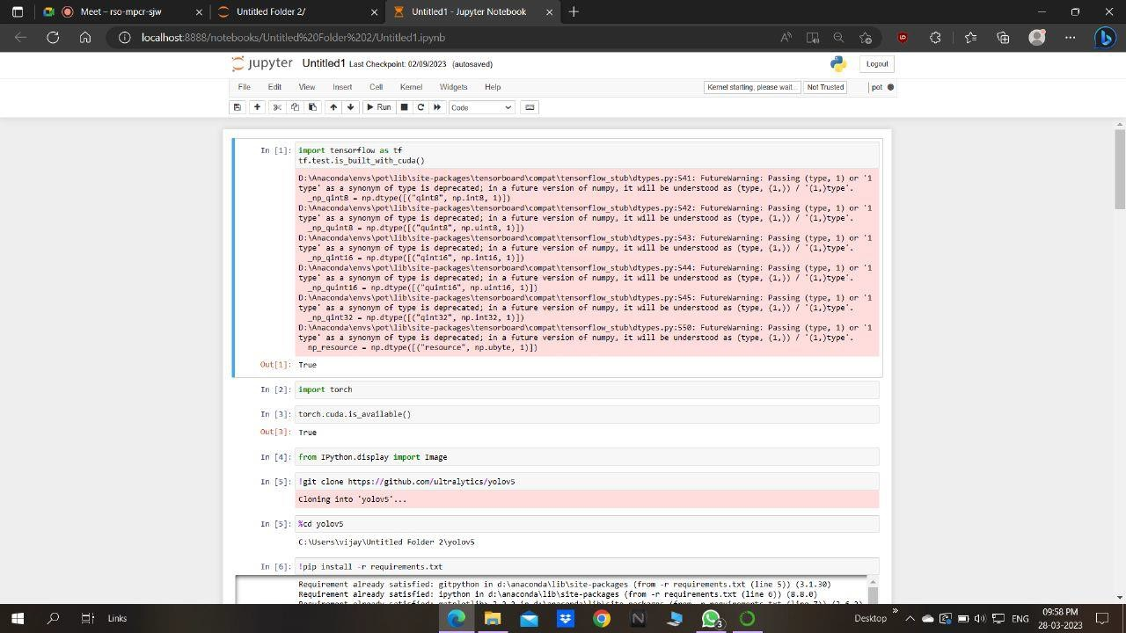
Fig.4.15 : Jupyter Notebook Interface

Fig.4.16 : Anaconda Terminal
4.8 MODULE IMPLEMENTATION
The suggested system begins with modules for data collecting, where the necessary information is used to train and test the system. Through photos and videos, the pothole dataset is compiled. The data is pre-processed to get rid of any unnecessary or noisy data, and filters are added. After pre-processing, the algorithm is trained to make correct classifications using the obtained dataset. We are here deploying the YOLO technique, which is quicker and more effective than other frameworks, to classify data Before deploying the final system, the dataset is examined repeatedly for redundancy using the broken-down video frames that were used for both testing and training.
The YOLO algorithm operates by dividing the images in N grids with equal- dimensional regions of QxQ. The task of locating and detecting the object falls on each grid as shown in the fig 4.1These grids also predict the item marker and the likelihood that the object will be present in the cell, together with the B bounding coordinates related to their cell coordinates. Due to many cells anticipating a same object with various bounding box predictions, this technique results in a significant reduction in calculation costs because both identification and classification are done by cells from the image. YOLO uses non-Minimal repression to address this problem.
4.8.1 DATA COLLECTION MODULE
The Data Collection Module is a critical component of the proposed system for pothole detection using the deep learning YOLO algorithm. The module's implementation involves selecting and mounting appropriate cameras and sensors on vehicles or drones for data collection. In the selection process, high-quality cameras and sensors capable of capturing clear images and data are chosen. The selection criteria may include the resolution, image quality, and field of view of the cameras and the accuracy and precision of the sensors.
Once the cameras and sensors are selected, they are mounted in strategic positions on the vehicles or drones. These positions may include the front and rear bumpers, sides, and roof of the vehicle or the bottom of the drone. The mounting positions are chosen to ensure maximum coverage and minimize blind spots. The Data Collection Module is essential for providing the necessary input data for training and testing the deep learning YOLO model. The accuracy and quality of the data collected directly affect the model's performance, making it crucial to ensure that the cameras and sensors selected and mounted are of high quality and strategically positioned.

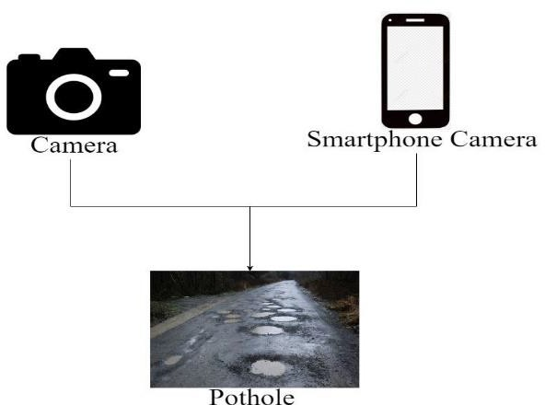
Fig.4.17 : Data Collection Module

4.8.2 DATA PRE-PROCESSING MODULE
The Data Pre-processing Module is responsible for preparing the raw data collected by the Data Collection Module for use in the deep learning YOLO model. The module's implementation involves several key steps. The first step is data cleaning, where any noise or irrelevant data is removed. This step is crucial to ensure that the data used to train and test the model is accurate and of high quality. The next step is data augmentation, where the collected data is artificially increased by introducing variations such as rotation, flipping, or changing the brightness of the images. This step is essential in training the model to recognize potholes in various conditions, including different lighting and camera angles.
After data augmentation, the data is split into training, validation, and testing datasets. The training dataset is used to train the deep learning YOLO model, while the validation dataset is used to tune the model's hyperparameters. Finally, the testing dataset is used to evaluate the model's performance. The Data Pre-processing Module is critical in ensuring that the deep learning YOLO model receives high-quality data for training and testing. The accuracy and quality of the pre-processed data directly affect the model's performance, making it crucial to ensure that the data is cleaned, augmented, and split correctly.
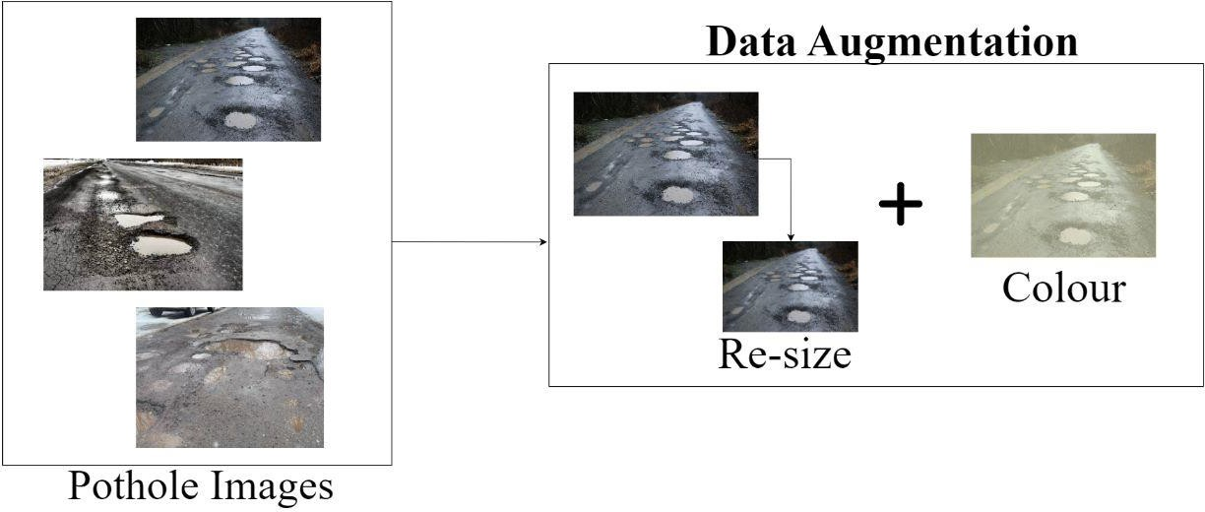
Fig.4.18 : Data preprocessing Module
4.8.3 MODEL TRAINING MODULE
The Model Training Module is responsible for training the deep learning YOLO model using the pre-processed data from the Data Pre-processing Module. The module's implementation involves several key steps. The first step is to define the model's architecture, including the number of layers, filters, and neurons. The deep learning YOLO model is designed to learn from the pre-processed data and detect potholes accurately. After defining the model architecture, the next step is to compile the model by specifying the loss function, optimizer, and evaluation metrics. The loss function is used to calculate the error between the predicted output and the actual output, while the optimizer adjusts the model's parameters to minimize the loss function. The model is then trained using the pre-processed data, and the hyperparameters are tuned using the validation dataset. The training process involves multiple epochs, where the model is repeatedly fed the training dataset and adjusted based on the loss function and optimizer. Once the model is trained, the Model Training Module saves the trained model for future use. The Model Training Module is essential in training the deep learning YOLO model to accurately detect potholes in images and videos. The accuracy of the trained model depends on the quality of the pre-processed data and the effectiveness of the hyperparameters tuning.
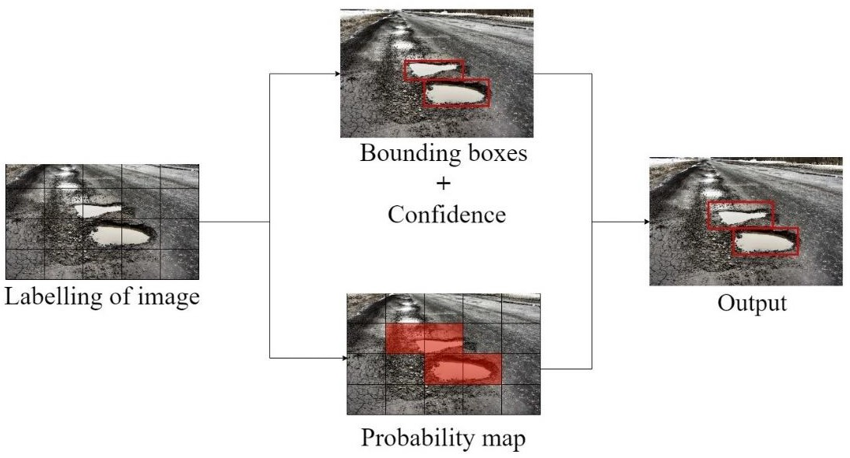

Fig.4.19 : Model Training
4.8.4 REAL-TIME DETECTION
The Real-time Detection Module is responsible for detecting potholes in real-time using the trained deep learning YOLO model. The first step is to capture the video or image feed from the camera or sensor. The video or image feed is then passed through the pre-processing module to enhance its quality and prepare it for detection. Next, the pre-processed data is fed into the trained deep learning YOLO model to detect potholes in real-time. The model analyzes the pre-processed data and outputs the detected potholes' location, size, and shape.The detected potholes' information is then sent to the alert module, which can notify the driver or authorities of the pothole's presence. The alert module can use visual or auditory cues, such as an alert sound or a visual display on the dashboard, to alert the driver.The Real-time Detection Module is crucial in detecting potholes in real-time and alerting drivers or authorities of their presence. The accuracy of the detection depends on the quality of the pre-processed data, the effectiveness of the deep learning YOLO model, and the alert module's efficiency.
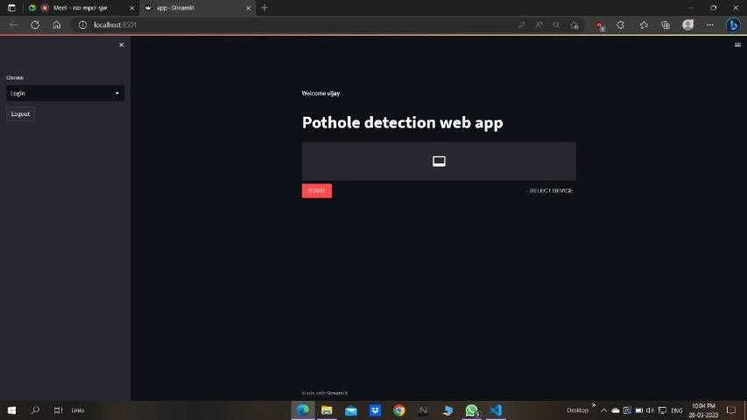
Fig.4.20 : Detection Module
4.8.5 LOCATION DETECTION
The location detection Module is responsible for collecting GPS co-ordinates on the detected potholes and improving the system's accuracy over time. The module's implementation involves several key steps.Once a pothole is detected and alerted, the location detection Module generates the GPS co-ordinates of the pothole based on accuracy and severity. The collected GPS co-ordinates are stroed the in the database and can be viewed for furthur research or evaluation purposes.
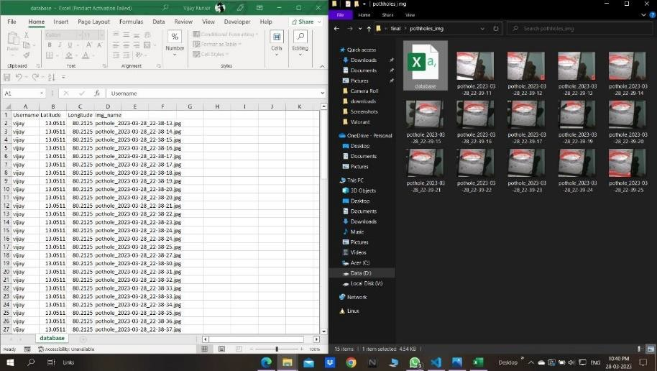
Fig.4.21 Location Detection Module
4.8.6 OUTPUT
The system gives the output when an obstacle is detected by the ultrasonic sensor. The user gets alerted by the buzzer incorporated within the system. The distance within a range of 2-300cm was achieved in the final result. Thus, alerting the blind people in an unstructured environment.
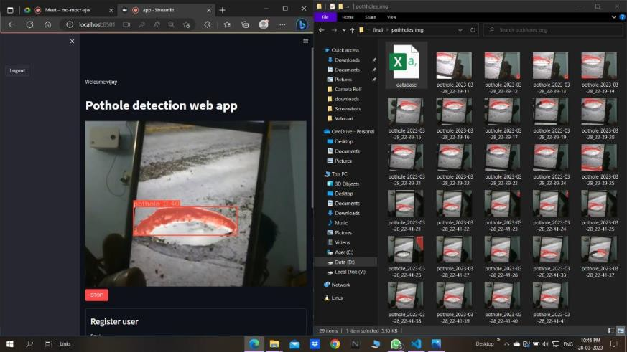
Fig.4.22 Output
4.7 SUMMARY
The System Design that is built in the proposed project has YOLO as a main alogorithm and it is implemented in such way so that it will be easy to detect potholes at the point of need and also collect the instant GPS co-ordinates of the potholes detected as well as the images of the potholes detected. These features are built with the help of deep learning concepts using YOLO algorithm the system design is obtained.
Thus, our proposed system is implemented using Anaconda platform and then the model is executed and with the deep learning concepts using YOLO algorithm is used and implemented. This work presented the state-of-the-art deep learning models (YOLO family and SSD-mobilenetv2) for real-time pothole detection leading towards the deployment on edge devices. Although, YOLOv5 showed the highest mAP@0.5 of 95% among other models but exhibits miss-classification and no detection potholes at long distances. Therefore, we concluded the YOLOv4 as the best-fit pothole detection model for accuracy and Tiny- YOLOv4 as the best-fit pothole detection model for real-time pothole detection with 90% detection accuracy and 31.76 FPS. The proposed approach can help road maintenance authorities to formulate rapid and optimized actions for road infrastructure repairs. A more sophisticated solution with the help of the global position system (GPS) can detect and point out the location of pavement failures. This work can contribute to self-driving applications and the automation industry.

CHAPTER 5
RESULTS, DISCUSSION, PERFORMANCE ANALYSIS
5.1 GENERAL
Testing phase means a group of activities designated for investigating and examining progress of a given project to provide stakeholders with information about actual levels of performance and quality of the project. It is an attempt to get an independent view of the project to allow stakeholders to evaluate and understand potential risks of project failure or mismatch. The purpose of the testing phase is to evaluate and test declared requirements, features, and expectations regarding the project prior to its delivery in order to ensure the project matches initial requirements stated in specification documents.
- Analysis – stakeholders (the team) analyse project specifications to determine testable requirements and define expected levels of quality and performance.
- Planning – the team makes a plan of key procedures and steps of testing.
- Development – the team develops test scenarios according to the plan.
- Implementation – it starts implementing test scenarios.
- Reporting – when test scenarios are done, the team summarizes results produced and creates a report stating whether the project matches the expected quality and performance levels.
5.2 TEST CASES
The accuracy of the system can be measured by comparing the number of true positives, true negatives, false positives, and false negatives. Precision measures the proportion of true positives among the total number of positive predictions, while recall measures the proportion of true positives among the total number of actual positives. The F1 score is a measure of the overall performance of the system, taking into account both precision and recall. In addition to evaluating the performance of the system, it is important to analyze its efficiency and scalability. The system should be able to process images or videos in real-time and handle
large volumes of data. The computational resources required by the system should also be analyzed to ensure that it can be deployed on different platforms. Overall, testing and performance analysis are critical steps in developing a pothole detection system using deep learning. The system should be tested on a variety of datasets and evaluated using appropriate metrics. Its efficiency and scalability should also be analyzed to ensure that it can be deployed effectively in real-world scenarios.
Table 5.1 : Test case for Pothole Detection module
TEST CASE | ACTUAL RESULT | EXPECTED RESULT | PASS/ FAIL
Detection of potholes in test images | True positives and false positives | High accuracy and recall | Pass
Detection of non-potholes in test images | True negatives and false negative | High accuracy and precision | Pass
Detection of potholes in real-time vedio | Real-time detection of potholes | Low latency and high throughput | Pass
Performance on large dataset | Accurate detection of potholes | Low false positive and false negative rates | Pass
Robustness to lighting and weather conditions | Accurate detection under various lighting and weather conditions | High accuracy across different conditions | Pass
Resource requirements and scalability | Efficient use of computational resources and ability to scale to large volumes of data | Minimal computational resources required and ability to handle large volumes of data | Pass
Generalization to new environments | Accurate detection in different environments and regions | High accuracy across different environments and regions | Pass

5.3 PERFORMANCE MEASURES
Table 5.2 : Performance Measure
Performance Measure | Definition
Accuracy | Proportion of correct predictions
Precision | Proportion of true positives among positive predictions
Recall | Proportion of true positives among actual positives
F1 Score | Harmonic mean of precision and recall
False Positive Rate | Proportion of false positives among negative predictions
False Negative Rate | Proportion of false negatives among actual positives

Performance measures are used to assess an object detection model's precision and effectiveness, such as YOLOv8. These measures include the recall metric, the F1-score metric, the average precision (AP), the mean average precision (mAP), the inference time, and the percentage of properly detected objects out of all the objects detected (FPS). The mean average precision is the standard metric for the accuracy of the model, which is based on the confusion matrix, IOU, recall, and precision.

Accuracy =
𝑡𝑛+𝑡𝑝
𝑡𝑛+𝑡𝑝+𝑓𝑛+𝑓𝑝
Precision =
𝑡𝑝
𝑡𝑝+𝑓𝑝
Recall =
𝑡𝑝
𝑡𝑝+𝑓𝑛
tp number of true positives
tn number of true negatives
fp number of false positives
fn number of false negatives
Accuracy, precision, and recall are used to measure the performance of a classification machine learning model.

5.4 PERFORMANCE ANALYSIS
Performance analysis for pothole detection using deep learning involves evaluating the accuracy, precision, recall, and false positive/negative rates of the system. It can help fine- tune the system's parameters and optimize its overall performance, identifying areas for improvement and ensuring its effectiveness and efficiency.
5.4.1 PERFORMANCE ANALYSIS OF YOLO ALGORITHM
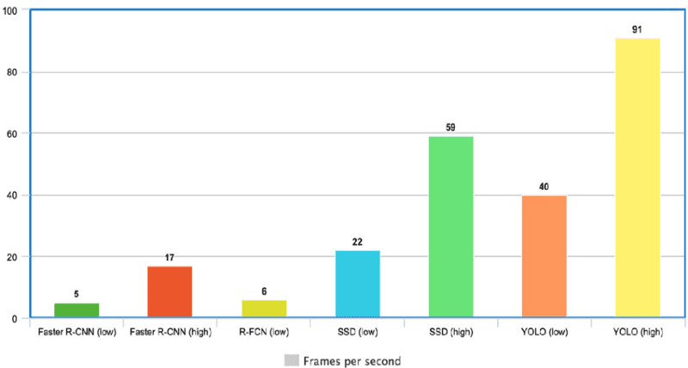
The performance analysis of YOLO algorithm is displayed through various comparisons between different other algorithms. The table here displays the performance of the YOLO algorithm in pothole detection module.
Fig.5.1: Accuracy analysis of various Algorithms

5.4.2 PERFORMANCE ANALYSIS OF POTHOLE DETECTION MODULE
This below graph shows the performance analysis of the pothole detection system based on the accuracy of the system. The system put under rigorous testing and is trained according the real time environment requirements. These analyses were done based on the test cases listed above. The system has been able perform well under day light condition compared to the low light conditions. The graph shows how accurate is the system in predicting the potholes. YOLO showed the highest mAP@0.5 of 95% with an inference time of 10 ms per image.

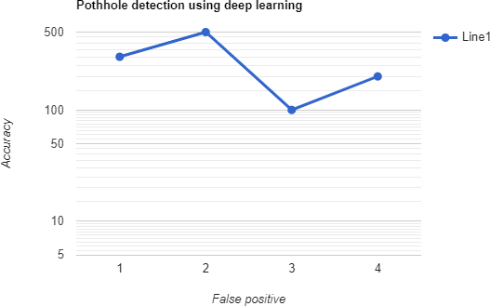
Fig.5.2 : Accuracy analysis of Pothole detection module
5.5 SUMMARY
System testing and performance analysis are crucial components of developing an accurate and efficient pothole detection system using deep learning. Testing the system involves evaluating its ability to correctly detect potholes in a variety of real-world scenarios. Metrics such as accuracy, precision, recall, and F1 score can be used to measure the performance of the system. Additionally, the efficiency and scalability of the system should also be analyzed to ensure that it can process large volumes of data in real-time. Performance analysis can help identify areas for improvement and optimization in the system's deep learning algorithms and image processing techniques. Evaluating the system's robustness to different lighting and weather conditions is also critical. The performance of the system can be analyzed by comparing its output to a ground truth dataset, and assessing its false positive and false negative rates. The results of the analysis can help fine-tune the system's parameters, and improve its overall performance. In summary, system testing and performance analysis play a vital role in ensuring the accuracy and efficiency of a pothole detection system using deep learning. By thoroughly testing the system and analyzing its performance, developers can identify areas for improvement and optimize the system's performance for a variety of real- world scenarios.

CHAPTER 6
SUMMARY AND CONCLUSIONS
6.1 CONCLUSION
This study compares and contrasts deep learning algorithms for spotting potholes. The data is initially gathered as photographs from a mobile device, pre-processed to remove the unnecessary statistical information, and processed for developing a classifier. There are enough images of potholes in the training data set. It uses a model like YOLO or CNN that have been extremely accurately trained using sample photographs of potholes to forecast potholes. Our solution will give local officials the ability to locate and fix the damaged roads that inconvenience travellers and result in accidents. This system is straightforward to use and offers accurate information. Pothole detection using deep learning has the potential to revolutionize road maintenance and improve road safety. With the increasing availability of high-resolution images and videos from sources such as drones and dashcams, there is a vast amount of data that can be used to train and fine-tune deep learning algorithms for pothole detection. Through the use of convolutional neural networks (CNNs) and other deep learning techniques, the accuracy and efficiency of pothole detection systems can be greatly improved. However, there are still some challenges to be addressed. The system's ability to detect potholes accurately in different lighting and weather conditions needs to be improved. Additionally, the detection of potholes in real-time is a critical requirement for practical implementation. The system's computational and resource requirements also need to be optimized to enable scalability.
6.2 FUTURE WORK
In terms of future scopes, there is a need to further improve the accuracy and efficiency of pothole detection systems through the use of advanced deep learning techniques such as transfer learning and multi-task learning. The integration of sensors and other data sources can also improve the overall performance of the system. Additionally, the implementation of predictive maintenance strategies based on the pothole detection system's output can help reduce the overall cost of road maintenance. Overall, pothole detection using deep learning is an exciting field with tremendous potential for improving road safety and infrastructure maintenance. Continued research and development in this area can lead to significant advancements in road maintenance and management. It will be trained in a deep learning model, to identify risk factors on the images (narrow roads, lack of cycle lanes…). This model may end up being generalizable to other cities as well. And, consequently, to make possible to estimate a score to all the geographical locations where Google Street View is available. In a road safety perspective, this project aims to decrease fatality and injury rates among cyclists in London (eventually, extensible to other regions as well). By advising cyclists the safest paths, but also guiding governments implementing additional safety measures in locations signaled as threatening. From an environmental point of view, by providing people with safer ways to commute, it is expected to see an increase in the adoption rate of sustainable ways of transport: bicycles, scooters… Thus, help tackling one of the most pervasive problems of our society: global warming.

APPENDIX
- SOURCE CODE :
import streamlit as st
import streamlit_authenticator as stauth
from streamlit_webrtc import VideoTransformerBase, webrtc_streamer import detection
from PIL import Image import numpy as np import yaml
from yaml.loader import SafeLoader user_name = 'Unknown'

with open('config.yaml') as file:

config = yaml.load(file, Loader=SafeLoader)

authenticator = stauth.Authenticate(
config['credentials'], config['cookie']['name'],
config['cookie']['key'], config['cookie']['expiry_days'], config['preauthorized']
)
class VideoTransformer(VideoTransformerBase): def transform(self, frame):
global user_name
print('Frame type = ',type(frame))
img = frame.to_ndarray(format="bgr24") im = Image.fromarray(img[:,:,::-1]) im.save("capture.jpg")
detection.pothole_detection("capture.jpg",user_name) return np.array(Image.open("capture.jpg"))[:,:,::-1]

c = st. sidebar.selectbox(label='Choose',options=['Login','Register']) if c == 'Login':

name, authentication_status, username = authenticator.login('Login', 'main')
if authentication_status:

authenticator.logout('Logout', 'sidebar') st.markdown(f'Welcome *{name}*') user_name = st.session_state["username"] st.title('Pothole detection web app')
webrtc_streamer(key="example", video_transformer_factory=VideoTransformer)
elif authentication_status is False:
st.error('Username/password is incorrect')
elif authentication_status is None:
st.warning('Please enter your username and password')
else:
if st.session_state["authentication_status"]:
st.markdown(f'You are already logged in as {st.session_state["name"]}')
else:
user_name = None
try:
if authenticator.register_user(‘Register user’,preauthorization=False):
st.success(‘User registered successfully’)
with open(‘config.yaml’,’w’) as file:
yaml.dump(config.yaml’,’w’) as file:
except Exception as e:
st.error(e)

REFERENCES

- Anand, S., Gupta, S., Darbari, V., & Kohli, S. (2018). Crack-pot: Autonomous road crack and pothole detection. Digital Image Computing: Techniques and Applications (DICTA), 2018, 1–6. https://doi.org/10.1109/DICTA.2018.8615819 Asphalt Industry Alliance. (2013).
- Annual Local Authority Road Maintenance (ALARM) Survey. HMPR Limited.https://www.asphaltuk.org/wp-content/uploads/ALARM_ survey_2013.pdf.
- Asphalt Industry Alliance. (2019). Annual Local Authority Road Maintenance (ALARM) Survey. Asphalt Industry Alliance. https://www.asphaltuk.org/wp-content/uploads/ alarm- survey-2019- digital.pdf.
- Bergstra, J., & Bengio, Y. (2012). Random search for hyper-parameter optimization. Journal of Machine Learning Research, 13(2).
- Bhatt, U., Mani, S., Xi, E., & Kolter, J. Z. (2017). Intelligent pothole detection and road condition assessment. ArXiv Preprint ArXiv:1710.02595.
- Chai, X., Deng, L., Yang, Q., & Ling, C. X. (2004). Test-cost sensitive naive bayes classification. In Proceedings of the Fourth IEEE International Conference on Data Mining (pp. 51–58).
- Divya, K., & Pabitha, P. (2019). Analysing the competency of various decision trees towards community formation in multiple social networks. International Conference on Communication and Signal Processing (ICCSP), 2019, 0099–0103. https://doi.org/ 10.1109/ICCSP.2019.8698110
- Fox, A., Kumar, B. V. K. V., Chen, J., & Bai, F. (2015). Crowdsourcing undersampled vehicular sensor data for pothole detection. In 2015 12th Annual IEEE International Conference on Sensing, Communication, and Networking (SECON) (pp. 515–523). https://doi.org/10.1109/SAHCN.2015.7338353
- Georganos, S., Grippa, T., Gadiaga, A., Vanhuysse, S., Kalogirou, S., Lennert, M., & Linard, C. (2019). An application of geographical random forests for population estimation in dakar, senegal using very-highresolution satellite imagery. Joint Urban Remote Sensing Event (JURSE), 2019, 1–4. https://doi.org/10.1109/ JURSE.2019.8809049
- Jo, Y., & Ryu, S. (2015). Pothole detection system using a black-box camera. Sensors (Basel, Switzerland), 15(11), 29316–29331. https://doi.org/10.3390/s151129316
- Jones, S. (2018, May 31). Britain’s potential cyclists put off cycling due to traffic conditions and potholes [Cycling UK]. Cycling UK. https://www.cyclinguk.org/ press- release/britains-potential-cyclists-putcycling-due-traffic-conditions-and potholes.
- Koch, C., Jog, G. M., & Brilakis, I. (2013). Automated pothole distress assessment using asphalt pavement video data. Journal of Computing in Civil Engineering, 27(4), 370–378.
- Kulkarni, A., Mhalgi, N., Gurnani, S., & Giri, N. (2014). Pothole Detection System using Machine Learning on Android.
- Madli, R., Hebbar, S., Pattar, P., & Golla, V. (2015). Automatic detection and notification of potholes and humps on roads to aid drivers. IEEE Sensors Journal, 15(8), 4313–4318. https://doi.org/10.1109/JSEN.2015.2417579
- Mednis, A., Strazdins, G., Zviedris, R., Kanonirs, G., & Selavo, L. (2011). Real time pothole detection using android smartphones with accelerometers. 1–6.
- Okfalisa, Gazalba, I., Mustakim, M., & Reza, N. G. I. (2017). Comparative analysis of knearest neighbor and modified k-nearest neighbor algorithm for data classification. 2017 2nd International Conferences on Information Technology, Information Systems and Electrical Engineering (ICITISEE), 294–298. doi: 10.1109/ ICITISEE.2017.8285514.
- Ouma, Y. O., & Hahn, M. (2017). Pothole detection on asphalt pavements from 2D-colour pothole images using fuzzy c-means clustering and morphological reconstruction. doi: 10.1016/j.autcon.2017.08.017.
- Pedregosa, F., Varoquaux, G., Gramfort, A., Michel, V., Thirion, B., Grisel, O., et al. (2011). Scikit-learn: Machine Learning in Python. Journal of Machine Learning Research, 12(85), 2825–2830.
- Peng, C.-Y. J., Lee, K. L., & Ingersoll, G. M. (2002). An introduction to logistic regression analysis and reporting. The Journal of Educational Research, 96(1), 3–14. https://doi. org/10.1080/00220670209598786
- RAC Business. (2016, June 16). Potholes and congestion top Brit bosses’ business bugbears [Royal Automobile Club]. RAC. https://media.rac.co.uk/pressreleases/ potholes- and-congestion-top-britbosses-business-bugbears-1442185.

Real-Time Deep Learning Methodology for Pothole Diagnosis

Vinodhini K
Department of Computer Science and Engineering
Sathyabama Institute of Science and Technology
Chennai, India
vinodhinispec@gmail.com
Varshinii Kasirajan
Department of Computer Science and Engineering
Sathyabama Institute of Science and Technology
Chennai, India
varshini.kasirajan@gmail.com

P Sardar Maran, Professor
Department of Computer Science and Engineering
Sathyabama Institute of Science and Technology
Chennai, India
psmaran@sathyabama.ac.in

Abstract—Identifying potholes on roads is extremely important since they can harm people as well as the suspension and wheels of cars. Potholes must be repaired in order to prevent expensive situations when human discomfort is treated and automobile repairs are necessary. Deep learning methods are employed in this work to detect potholes. Using the cameras on smartphones, the input data are gathered as pictures or videos, which are then pre-processed to provide characteristics that aid in the creation of models and prediction. The training data set has a large number of pothole photos. YOLO and CNN are examples of models that are utilized; they are trained using photos of sample potholes so that they can accurately anticipate potholes. Our system will incentivize public servants to locate and fix roads that are broken and contribute to inconvenience and accidents.
Keywords—CNN, YOLO, Pothole Detection, Deep Learning, Feature Training, Machine Learning, Smartphone Camera.
I. Introduction
Traffic containment performance steadily declines when rainy conditions change, putting commuter safety and efficiency at risk. Heavy traffic is often directed onto asphalt-surfaced roads and walkways. Examples of deformed surfaces that cause problems for cars are potholes and fissures. When self-driving cars are implemented, it will be essential to automate the real-time detection of these road damages for the best possible vehicle performance and passenger safety. Effective research has been done on this issue of repairing road damage by knowledgeable and experienced drivers.
Recent advances in technology have led to the condensing and integration of powerful sensors, including accelerometers, GPS, and electronic compass, into mobile devices. The simplest and cost- effective method to locate potholes is to have a smart phone with a pothole detection app loaded on it. Potholes are identified in this study by using real-time data collected from mobile devices. Since most pothole identification techniques rely on specialized and costly hardware equipment, they are either less precise or insufficient to locate potholes in the real world.
The goal of this project is to help drivers identify potential hazards by developing a crack and pothole detecting system for self-driving platforms. Utilizing a convolution neural net architecture and the YOLO technique for separation, pothole identification is implemented. From the background, fissures and potholes appeared. In the garbling layer, the road texture is learned in conjunction with spatial data from the classification basis. The principal contributions are as follows: a complex setup that combines texture and spatial learning. Features are important in determining geographical information about categorization failures when views change. Texture features, which preserve coherence across many viewpoints, are better suitable for the problem. Instead of using a sliding window to directly apply YOLO/CNN to high-resolution images, which makes them unsuitable for real-time operations, pre-processing techniques offer potential candidates for the network to further deconstruct, ensuring a real-time crack and pothole detection channel. An accurate and consistent classifier that reliably distinguishes between shadows, cracks, background noise, and several more cryptic scripts that are difficult to distinguish using traditional methods. The proposed structure is made to be a plug-and-play module which can be added to different types of self-driving cars and autonomous robotics without altering their basic architecture.
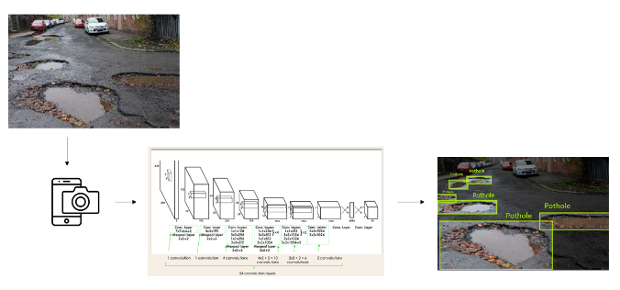
We offer an image processing-based approach for spotting potholes. Based on the YOLO technique and convolution neural network frame, the system employs texture-based information to distinguish between potholes and roads. The YOLO algorithm, which can distinguish between roads with fractures and roads without splits while being quicker and more effective than earlier frameworks, is what makes this technique special. Fig. 1 shows the structure of the construction. It is built up of the YOLO algorithm and convolution neural network that uses the images' spatial information to distinguish between different images according to their textures.
A. Motivation
Potholes on poorly maintained roadways may indicate structural problems. The drawback of a pothole is that it makes for an uncomfortable ride and damages the car's wheels, which are costly to fix. Potholes in the road negatively impact fuel economy, motorist safety, and the condition of the roadways. They are a few of the main causes of car accidents. Deep learning algorithms for pothole recognition are compared in this work. Pothole identification is a critical analytical step in developing workable driving and safety solutions.
II. Existing System
With the current system, potholes are detected using a variety of sensors and actuators that provide us with particular values based on the diameters of the potholes. These sensors have a tendency to deteriorate with use over time and may eventually show to be ineffective. To identify potholes, the current method also makes use of certain satellite photography techniques. Following that, the discovered potholes are taken for the required filling procedure. Additionally, there are alternative techniques that collect information from an accelerometer and gyroscope to determine the vehicle's speed and angles on the road.
III. Proposed System
The proposed system starts with data collection modules, which gather the data required for system testing and training. Photos and videos are used to construct the pothole dataset. Filters are inserted after the data has been pre-processed to remove any extraneous or noisy information. The collected dataset is used to train the algorithm to make accurate classifications following pre-processing. Here, we're using the YOLO approach—which is faster and more accurate than other frameworks—to categorize data. The dataset is frequently checked for redundancy using the disassembled video frames that were utilized for training and testing prior to the final system being deployed.
The photos are divided into N grids with equal-dimensional QxQ sections in order for the YOLO method to function. Each grid has the responsibility of finding and detecting the object. Along with forecasting the item marker and the probability that the object will be in the cell; these grids also provide the B bounding coordinates associated with the object's cell coordinates. Since cells from the image perform both identification and classification, this technique significantly reduces calculation costs because multiple cells anticipate the same object with different bounding box predictions. Non-Minimal repression is used by YOLO to solve this issue.
The dataset was gathered only after extensive testing and training with the testing dataset. The system is configured for pothole identification in a real-time setting after the data has been tested and trained. The Yolo algorithm is employed to differentiate between cracks and potholes.

Fig. 1. Architecture diagram of a Proposed System
IV. Literature survey
[1] Kulkarni, A., Mhalgi, N., Gurnani, S., & Giri, N. “Pothole Detection System using Machine Learning on Android”. International Journal of Emerging Technology and Advanced Engineering (IJETAE), 2014 The limited processing capacity of the embedded CPUs in the black-box cameras was taken into account when designing and implementing the proposed pothole-discovery technique. The studies’ findings clearly show that the suggested algorithm can exclude things like moving cars, patches, manholes, and shade. 71% and 88%, respectively, are the averages for perceptivity and perfection accuracy. Consequently, the algorithm helps in locating related items.
[2] Bhatt, U., Mani, S., Xi, E., & Kolter, J. Z. “Intelligent pothole detection and road condition assessment”. ArXiv, 2017 The suggested solution in this case is a mobile application that records motion data about an automobile using the phone's accelerometer and gyroscope sensors. In order to assess roads using this detection data, we trained SVM models to diagnose potholes with 90 delicacies and road conditions with 91 delicacies, outperforming the base rate for both tasks. Using the detection data, the algorithms categorize the state of the road and the existence of potholes for the drivers. The bracket findings are also used to build data-rich visuals that show the traffic conditions in the metropolitan area. This technology will enable government workers to identify and repair hazardous roadways that irritate drivers and result in collisions.
[3] Anand, S., Gupta, S., Darbari, V., & Kohli, S. “Crack-pot: Autonomous Road crack and pothole detection”. Digital Image Computing: Techniques and Applications (DICTA), 2018 As autonomous robots and self-driving cars become more common, it's important to recognize road imperfections and take the appropriate safety precautions to keep passengers safe. An algorithm for spotting potholes and cracks in the road can be installed on an autonomous, trustworthy real-time processing board with a camera. To detect splits and voids, the technique combines a deep neural network architecture with textural and spatial clues.
[4] Madli, R., Hebbar, S., Pattar, P., & Golla, V. “Automatic detection and notification of potholes and humps on roads to aid drivers”. IEEE Sensors Journal, 2015 This study analyzes previous methods for identifying potholes that have been created in order to identify speed bumps and potholes on roads and notify drivers in a timely manner so they can avoid accidents or vehicle damage. It also offers a reasonably priced fix. Ultrasonic detectors can identify potholes and bumps and measure their height and depth independently. The suggested method tracks the positions of speed bumps and potholes using a GPS receiver. The tested data, along with the location, pothole depth, and bump height, are contained in the database. Drivers and government authorities can both benefit greatly from this invaluable source of information. An Android app function warns drivers so that safety measures can be taken to prevent collisions. Alerts come with a loud buzzer and flash indication.
[5] Fox, A., Kumar, B. V. K. V., Chen, J., & Bai, F. “Crowdsourcing under sampled vehicular sensor data for pothole detection”. IEEE International Conference on Sensing, Communication, and Networking (SECON), 2015 The growth of integrated car sensors has made it possible to identify road components like potholes. Though a promising approach, current automotive embedded sensors operate under sample sensor data and at low frequency, which reduces detection accuracy. Crowdsourcing this undersaturated sensor data from numerous automobiles is one potential way to improve the detection accuracy. Asynchronous sensor performance, GPS inaccuracy, sensor noise, and vehicle variability make it difficult to combine sensor data from multiple automobiles. Moreover, car networks may have bandwidth restrictions that limit the amount of data that may be combined. We examine these problems by concentrating on the subject of pothole identification. We build and evaluate multiple crowdsourced pothole detection techniques that leverage the Cloud and moving cars to gauge the impact of real-world restrictions and identification accuracy.
[6] Chai, X., Deng, L., Yang, Q., & Ling, C. X. “Test-cost sensitive naive bayes classification”. IEEE International Conference on Data Mining, 2004 The decision tree algorithms and naive Bayes, for instance, have been improved in the past to handle various costs, primarily by determining various costs of classification errors. However, controlling the test expenses related to locating the missing values in a test case also needs to be taken into account. Depending on how much the value could increase the classification accuracy, it might or might not be worth the effort to find a missing value for an attribute when it arises in a test case. Here, we demonstrate how to create a test-cost sensitive naïve Bayes classifier (csNB) by integrating a test strategy that controls the testing of unknown features.
[7] Jo, Y., & Ryu, S. “Pothole detection system using a black-box camera”. MDPI Sensors (Basel, Switzerland), 2015 The machine literacy models for pothole identification are compared in this research. Several Android devices were used to gather the data, and a 2-alternation-overlapping moving window was used for additional pre-processing to determine which statistical characteristics would be most helpful in training a dual classifier. To ensure complete separation from the confirmation and test datasets, the training dataset underwent a stratified-fold cross-validation technique. Both the Random Forest Tree and the KNN produced excellent results on the Test dataset, with a delicacy of 0.8490 that was comparable.

[8] Wang, H.-W., Chen, C.-H., Cheng, D.-Y., Lin, C.-H., & Lo, C.-C. “A real-time pothole detection approach for intelligent transportation system”. Mathematical Problems in Engineering, 2015 Potholes across vast landscapes can be found more cheaply with this technique. This study suggests a mobile device-based approach for pothole identification. The Euler angle computation is used to regularize the accelerometer data and extract the pothole information. Additionally, positional offenses from GPS data are reduced by using the spatial interpolation method. The results of the trials show that the recommended method can detect potholes with accuracy and without producing false positives, while also performing the advanced delicacy. Therefore, the suggested real-time pothole detecting approach can be employed to increase road safety for IT.
[9] Divya, K., & Pabitha, P. “Analysing the competency of various decision trees towards community formation in multiple social networks”. International Conference on Communication and Signal Processing (ICCSP), 2019 On a social network, every user only has a limited representation of themselves. Mapping these people across multiple online social networks is becoming more and more vital to build communities and identify the key node. Fragmentary data is the biggest issue facing social networks today, but it can be solved by grouping people and comparing their data. This data can then be used for a numerous purpose, such as detecting spammers and prominent nodes. Several user features make it possible to distinguish the influential community from other communities. By altering the class labels, different numbers of trees can be built. To effectively develop communities, the tree's performance metrics (accuracy, recall, precision, and f1-score) should be greater.
[10] Georganos, S., Grippa, T., Gadiaga, A., Vanhuysse, S., Kalogirou, S., Lennert, M., & Linard, C. “An application of geographical random forests for population estimation in Dakar, Senegal using very-high-resolution satellite imagery”. Joint Urban Remote Sensing Event (JURSE), 2019 In this work, we investigate the use of Very-High-Resolution Remote Sensing (VHHRS) data to anticipate population density using Geographical Random Forest (GRF), a localized implementation of Random Forest (RF). The explanatory features are the ratios of three different built-up kinds in each area, and we use the neighborhood-level population density from the 2013 Dakar census as an independent variable. The results demonstrated that by taking regional variability into account in the estimations and calibrating GRF at an appropriate geographic scale, we could maximize forecast accuracy. The results can also be visualized, demonstrating the efficacy of the local model and other intriguing spatial differences, as GRF is an ensemble of local sub-models. Thus, it is recommended that remotely detected spatially diverse interactions be modelled using GRF as an intriguing exploratory and explanatory tool.

TABLE 1 – Analyzing and contrasting various methods
Title | Pros | Cons
“Pothole Detection System using Machine Learning on Android” | Through the use of the charting software library "A Chart Engine," which improves accuracy across the board throughput. | Real-time evaluation of raw sensor data is challenging.
“Intelligent pothole detection and road condition assessment” | The implementation of models to generate road condition maps and a real-time mobile application. | The pothole count in the database needs to be updated and maintained on a regular basis.
“Autonomous road crack and pothole detection. Digital Image Computing: Techniques and Applications” | Roads with and without splits are distinguished from one another using their respective surfaces as a foundation. | Lacks the ability to discern the fixed road cracks because it is unknown how deep they are.
“Automatic detection and notification of potholes and humps on roads to aid drivers” | Even when potholes are full of muddy water during the rainy season, this still functions effectively. | The accuracy of the coordinates makes it challenging to retrieve the pothole locations.
“Crowdsourcing under-sampled vehicular sensor data for pothole detection.” | This aids in gathering information from several cars, enhancing the accuracy of the detection. | The accuracy of the GPS decreases due to asynchronous sensor operation, sensor noise, and vehicle heterogeneity.
“Test-cost sensitive naive bayes classification.” | This algorithm aids in the resolution of misclassification issues and lowers test expenses. | Disregards the missing data if they cause a mistaken classification.
“Pothole detection system using a black box camera” | The device uses black box cameras to find potholes across a larger area and at a reduced cost. | Understanding and executing mathematical procedures can be challenging.
“A real-time pothole detection approach for intelligent transportation system. Mathematical Problems in Engineering.” | GPS data location inaccuracies are removed using the spatial interpolation approach. | The resources and computational power are expensive.
“Analyzing the competency of various decision trees towards community formation in multiple social networks” | Used to divide various social network communities into separate groups. | The model forecasts a sensation of randomness based on information gathered from social communities.
“An application of geographical random forests for population estimation in Dakar, Senegal using very high-resolution satellite imagery.” | RF aids in increasing precision. | Resources & computational power are expensive.

The literature review on the application of the deep learning YOLO algorithm for pothole detection has brought attention to the potential of deep learning algorithms for precise real-time pothole detection. However, the small and homogeneous dataset, high processing overhead, and restricted use in practical situations are some of the issues that afflict the current systems. To address these issues, the proposed system makes use of an extensive and diverse dataset, an optimized architecture, real-time feedback and updating techniques, and other techniques to improve the precision, reliability, and efficiency of pothole detecting systems. This method could dramatically increase road safety and lower pothole damage expenses with additional study and development.

V. Conclusion
This study evaluates and compares various deep learning pothole detection systems. The data is first collected in the form of pictures from a mobile device, pre-processed to eliminate redundant statistical data, and processed to create a classifier. The training data set contains a sufficient number of photos showing potholes. It uses a CNN-like or Yolo-like model that proved accurate in predicting potholes by using sample photographs of potholes. Local authorities will be able to locate and fix the damaged roads that result in traffic bottlenecks and accidents with the aid of our system. This user-friendly system offers precise information.

VI. Future directions
Increasing the speed and effectiveness of object detection models is one possible area of improvement. Even while a lot of the models used today are very accurate, they can be time-consuming and computationally expensive, particularly for real-time applications. Subsequent studies may concentrate on creating models that are more accurate while remaining lighter and more efficient.
Increasing the object detection models' resilience is another possible area of growth. Present-day models frequently rely heavily on the data and have trouble generalizing to novel and diverse situations. Subsequent investigations may concentrate on creating more flexible and adaptive models that may function effectively even in extremely dynamic and changing settings.
Integrating object detection models with other models and technologies, such augmented reality or natural language processing, is yet another possible field of study. More complex and potent applications to comprehend and engage with the world in novel and interesting ways might be able to be made by fusing object detection with other technologies.

REFERENCES
[1] Kulkarni, A., Mhalgi, N., Gurnani, S., & Giri, N. (2014). Pothole Detection System using Machine Learning on Android.
[2] Bhatt, U., Mani, S., Xi, E., & Kolter, J. Z. (2017). Intelligent pothole detection and road condition assessment. ArXiv Preprint ArXiv:1710.02595.
[3] Anand, S., Gupta, S., Darbari, V., & Kohli, S. (2018). Crack-pot: Autonomous Road crack and pothole detection. Digital Image Computing: Techniques and Applications (DICTA), 2018, 1–6. https://doi.org/10.1109/DICTA.2018.8615819.
[4] Madli, R., Hebbar, S., Pattar, P., & Golla, V. (2015). Automatic detection and notification of potholes and humps on roads to aid drivers. IEEE Sensors Journal, 15(8), 4313– 4318. https://doi.org/10.1109/JSEN.2015.24175.
[5] Fox, A., Kumar, B. V. K. V., Chen, J., & Bai, F. (2015). Crowdsourcing under sampled vehicular sensor data for pothole detection. In 2015 12th Annual IEEE International Conference on Sensing, Communication, and Networking (SECON) (pp. 515–523). https://doi.org/10.1109/SAHCN.2015.7338353.
[6] Chai, X., Deng, L., Yang, Q., & Ling, C. X. (2004). Test- cost sensitive naive bayes classification. In Proceedings of the Fourth IEEE International Conference on Data Mining (pp. 51–58).
[7] Jo, Y., & Ryu, S. (2015). Pothole detection system using a black-box camera. Sensors (Basel, Switzerland), 15(11), 29316–29331. https://doi.org/10.3390/s151129316.
[8] Wang, H.-W., Chen, C.-H., Cheng, D.-Y., Lin, C.-H., & Lo, C.-C. (2015). A real-time pothole detection approach for intelligent transportation system. Mathematical Problems in Engineering, 2015.
[9] Divya, K., & Pabitha, P. (2019). Analysing the competency of various decision trees towards community formation in multiple social networks. International Conference on Communication and Signal Processing (ICCSP),2019,0099–0103.https://doi.org/ 10.1109/ICCSP.2019.8698110.
[10] Georganos, S., Grippa, T., Gadiaga, A., Vanhuysse, S., Kalogirou, S., Lennert, M., & Linard, C. (2019). An application of geographical random forests for population estimation in Dakar, Senegal using very-high-resolution satellite imagery. Joint Urban Remote Sensing Event (JURSE), 2019, 1–4. https://doi.org/10.1109/ JURSE.2019.8809049.
[11] Asphalt Industry Alliance. (2019). Annual Local Authority Road Maintenance (ALARM) Survey. Asphalt Industry Alliance. https://www.asphaltuk.org/wp-content/uploads/ alarm-survey-2019- digital.pdf.
[12] Okfalisa, Gazalba, I., Mustakim, M., & Reza, N. G. I. (2017). Comparative analysis of knearest neighbor and modified k-nearest neighbor algorithm for data classification. 2017 2nd International Conferences on Information Technology, Information Systems and Electrical Engineering (ICITISEE), 294–298. doi: 10.1109/ ICITISEE.2017.8285514.
[13] Jones, S. (2018, May 31). Britain’s potential cyclists put off cycling due to traffic conditions and potholes [Cycling UK]. Cycling UK. https://www.cyclinguk.org/ press-release/britains-potential-cyclists-putcycling-due-traffic-conditions-and potholes.
[14] Ouma, Y. O., & Hahn, M. (2017). Pothole detection on asphalt pavements from 2D-colour pothole images using fuzzy c-means clustering and morphological reconstruction. doi: 10.1016/j.autcon.2017.08.017.
[15] RAC Business. (2016, June 16). Potholes and congestion top Brit bosses’ business bugbears [Royal Automobile Club]. RAC. https://media.rac.co.uk/pressreleases/ potholes-and-congestion-top-britbosses-business-bugbears-1442185.
[16] Y. Pan, X. Zhang, G. Cervone and L. Yang, "Detection of Asphalt Pavement Potholes and Cracks Based on the Unmanned Aerial Vehicle Multispectral Imagery,". IEEE Journal of Selected Topics in Applied Earth Observations and Remote Sensing, vol. 11, no. 10, pp. 3701-3712, Oct. 2018, doi: 10.1109/JSTARS.2018.2865528.
[17] D. A. Jordan, S. Paine, A. K. Mishra and J. Pidanic, "Road to Repair (R2R): An Afrocentric Sensor-Based Solution to Enhanced Road Maintenance,". IEEE Access, vol. 11, pp. 6010-6017, 2023, doi: 10.1109/ACCESS.2023.3236401.
[18] G. Arvanitis, N. Stagakis, E. I. Zacharaki and K. Moustakas, "Cooperative Saliency-Based Pothole Detection and AR Rendering for Increased Situational Awareness,". IEEE Transactions on Intelligent Transportation Systems, doi: 10.1109/TITS.2023.3327494.
[19] R. Sathya, B. Saleena and B. Prakash, "Pothole Detection Using YOLOv3 Model," 2023 IEEE International Students' Conference on Electrical, Electronics and Computer Science (SCEECS), Bhopal, India, 2023, pp. 1-7, doi: 10.1109/SCEECS57921.2023.10063116.
[20] B. -h. Kang and S. -i. Choi, "Pothole detection system using 2D LiDAR and camera," 2017 Ninth International Conference on Ubiquitous and Future Networks (ICUFN), Milan, Italy, 2017, pp. 744-746, doi: 10.1109/ICUFN.2017.7993890.

