PROGRAM:

import java.util.Scanner;

public class CountingSort {

public static void countingSort(int arr[], int n) {

int max = arr[0];

for (int i = 1; i < n; i++) {

if (arr[i] > max)

max = arr[i];

}

int count[] = new int[max + 1];

for (int i = 0; i <= max; i++)

count[i] = 0;

for (int i = 0; i < n; i++)

count[arr[i]]++;

for (int i = 1; i <= max; i++)

count[i] += count[i - 1];

int output[] = new int[n];

for (int i = n - 1; i >= 0; i--) {

output[count[arr[i]] - 1] = arr[i];

count[arr[i]]--;

}

for (int i = 0; i < n; i++)

arr[i] = output[i];

}

public static void printArray(int arr[], int n) {

for (int i = 0; i < n; i++)

System.out.print(arr[i] + " ");

System.out.println();

}

public static void main(String[] args) {

Scanner sc = new Scanner(System.in);

System.out.print("Enter number of elements: ");

int n = sc.nextInt();

int arr[] = new int[n];

System.out.println("Enter elements:");

for (int i = 0; i < n; i++) {

arr[i] = sc.nextInt();

}

System.out.println("Original array:");

printArray(arr, n);

countingSort(arr, n);

System.out.println("Sorted array:");

printArray(arr, n);

}

}

OUTPUT:

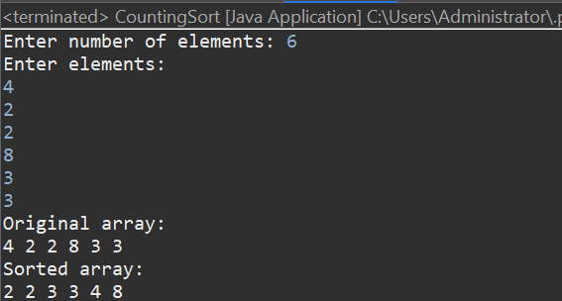

PROGRAM:

import java.util.Scanner;

public class RadixSort {

static int getMax(int arr[], int n) {

int max = arr[0];

for (int i = 1; i < n; i++) {

if (arr[i] > max)

max = arr[i];

}

return max;

}

static void countingSort(int arr[], int n, int exp) {

int output[] = new int[n];

int count[] = new int[10];

for (int i = 0; i < 10; i++)

count[i] = 0;

for (int i = 0; i < n; i++)

count[(arr[i] / exp) % 10]++;

for (int i = 1; i < 10; i++)

count[i] += count[i - 1];

for (int i = n - 1; i >= 0; i--) {

output[count[(arr[i] / exp) % 10] - 1] = arr[i];

count[(arr[i] / exp) % 10]--;

}

for (int i = 0; i < n; i++)

arr[i] = output[i];

}

static void radixSort(int arr[], int n) {

int m = getMax(arr, n);

for (int exp = 1; m / exp > 0; exp \*= 10)

countingSort(arr, n, exp);

}

public static void main(String[] args) {

Scanner sc = new Scanner(System.in);

System.out.print("Enter number of elements: ");

int n = sc.nextInt();

int arr[] = new int[n];

System.out.println("Enter elements:");

for (int i = 0; i < n; i++) {

arr[i] = sc.nextInt();

}

System.out.println("Original array:");

printArray(arr, n);

radixSort(arr, n);

System.out.println("Sorted array:");

printArray(arr, n);

}

OUTPUT:

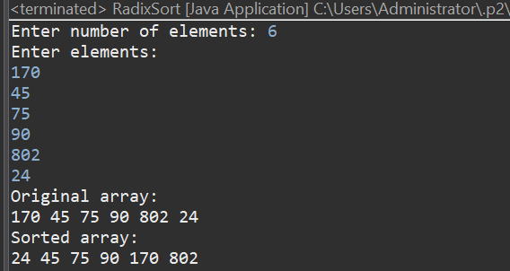

PROGRAM:

import java.util.Scanner;

public class HeapSort {

static void heapify(int arr[], int n, int i) {

int largest = i;

int left = 2 \* i + 1;

int right = 2 \* i + 2;

if (left < n && arr[left] > arr[largest])

largest = left;

if (right < n && arr[right] > arr[largest])

largest = right;

if (largest != i) {

int temp = arr[i];

arr[i] = arr[largest];

arr[largest] = temp;

heapify(arr, n, largest);}

static void heapSort(int arr[], int n) {

for (int i = n / 2 - 1; i >= 0; i--)

heapify(arr, n, i);

for (int i = n - 1; i > 0; i--) {

int temp = arr[0];

arr[0] = arr[i];

arr[i] = temp;

heapify(arr, i, 0)

} static void printArray(int arr[], int n) {

for (int i = 0; i < n; i++)

System.out.print(arr[i] + " ");

System.out.println();

} public static void main(String[] args) {

Scanner sc = new Scanner(System.in);

int n = sc.nextInt();

int arr[] = new int[n];

for (int i = 0; i < n; i++) {

arr[i] = sc.nextInt();

}

System.out.println("Original array:");

printArray(arr, n);

heapSort(arr, n);

System.out.println("Sorted array:");

printArray(arr, n); }

}

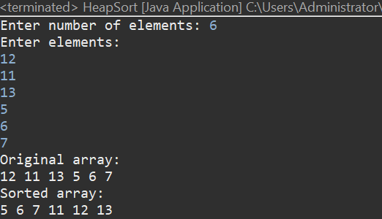

RESULT:

Thus the java program to perform counting sort, radix sort, heap sort has been executed and output verified successfully.