
DEMANDIQ: AI-DRIVEN RETAIL DEMAND FORECASTING AND INVENTORY OPTIMIZATION SYSTEM

VARSHINI.L – 24619234

MINI PROJECT REPORT
Submitted to the
SCHOOL OF ENGINEERING
DEPARTMENT OF ARTIFICIAL INTELLIGENCE AND MACHINE LEARNING
in Partial fulfillment of the requirements for the award of the degree of
BACHELOR OF TECHNOLOGY CSE
IN
ARTIFICIAL INTELLIGENCE AND MACHINE LEARNING

VELS INSTITUTE OF SCIENCE, TECHNOLOGY AND ADVANCED STUDIES (VISTAS)
CHENNAI – 600 117
OCTOBER 2026

BONAFIDE CERTIFICATE
Certified that this project report “DEMANDIQ: AI - DRIVEN RETAIL DEMAND FORECASTING AND INVENTORY OPTIMIZATION SYSTEM”, is the Bonafide work of Varshini L - 24619234, who carried out the project under my supervision. Certified further, that to the best of my knowledge the work reported here does not form part of any other project report or dissertation on the basis of which a degree or award was conferred on an earlier occasion on this or any other candidate.

SIGNATURE OF THE HOD  Dr. K. Ulaga Priya M.E., Ph. D  Associate Professor & Head  Department of AI & ML  School of Engineering  VISTAS  Chennai | SIGNATURE OF THE SUPERVISOR  Ms. S. J. Kavitha M.E., Ph. D  Assistant Professor  Department of AI & ML  School of Engineering  VISTAS  Chennai
Submitted for the Project Work and Viva-Voce examination held on __________________ at Vels Institute of Science, Technology and Advanced Studies (VISTAS), Chennai – 600 117.

INTERNAL EXAMINER EXTERNAL EXAMINER

ACKNOWLEDGEMENT

I would like to express my sincere gratitude to everyone who supported and guided me in completing this mini-project successfully. I am grateful to our Founder and Chairman, Dr. Ishari K. Ganesh, for providing the institutional facilities and laboratory infrastructure necessary for completing this project. I extend my heartfelt thanks to our Head of the Department, Dr. K. Ulaga Priya, for her continuous support, valuable guidance, and encouragement throughout the project. I extend my warmest thanks to my Internal Guide, Ms. S. J. Kavitha, M.E., Ph. D, Assistant Professor, for her patient guidance, valuable suggestions, and constant support during the completion of this project. I would also like to thank all the faculty members, the librarian, and the non-teaching staff of the Computer Centre for their assistance and support. Last but not the least, we wish to thank our parents and our friends for their individual support and interest, who have inspired us and encouraged us to go our own way; without them we would be unable to complete this project.

L. VARSHINI – 24619234
CH. NO. | TABLE OF CONTENTS | PAGE NO.
 | ABSTRACT | 6
 | LIST OF FIGURES | 7
 | LIST OF TABLES | 8
1 | INTRODUCTION | 9
 | 1.1 Project Overview | 9
 | 1.2 Problem Statement and Scope | 10
 | 1.3 Objectives and Outcomes | 11
 | 1.4 Motivation and Significance | 12
 | 1.5 Chapter Summary | 12
2 | LITERATURE REVIEW | 14
 | 2.1 Forecasting Methods Overview | 14
 | 2.2 Related Research | 16
 | 2.3 Research Gaps | 17
 | 2.4 Chapter Summary | 17
3 | SYSTEM DESIGN | 19
 | 3.1 Data Sources and Collection | 19
 | 3.2 Architecture Overview (Existing vs. Proposed) | 19
 | 3.3 Functional Requirements | 21
 | 3.4 Dataset Description | 23
 | 3.5 Feature Engineering | 23
 | 3.6 Inventory Calculations | 24

CH. NO. | TABLE OF CONTENTS (Continued…) | PAGE NO.
4 | IMPLEMENTATION | 26
 | 4.1 Data Preparation and Cleaning | 26
 | 4.2 Model Selection (Random Forest) | 27
 | 4.3 Model Training and Validation | 28
 | 4.4 Streamlit Dashboard Development | 29
 | 4.5 Testing and User Workflow | 30
5 | RESULTS AND DISCUSSION | 32
 | 5.1 Model Evaluation (Accuracy, Error Metrics) | 32
 | 5.2 Inventory Projection Example | 33
 | 5.3 Dashboard Screenshots | 34
 | 5.4 Limitations and Validation | 36
6 | CONCLUSION AND FUTURE WORK | 37
 | 6.1 Conclusion | 37
 | 6.2 Future Enhancements | 37
 | 6.3 Pilot Evaluation and Responsible Use | 38
 | 6.4 Recommendations Before Real-World Use | 39
 | 6.5 Project Outcome and Learning Summary | 39
 | REFERENCES | 41
 | CONFERENCE PROCEEDINGS | 42
 | CONFERENCE CERTIFICATE | 43

ABSTRACT
Small retail stores often struggle to maintain optimal inventory levels, leading to stock shortages or excess unsold goods. This project, DemandIQ, presents an AI-driven retail demand forecasting and inventory optimization system that predicts future product demand using historical sales data. Existing inventory management systems mainly rely on manual estimation and traditional forecasting methods, which often lead in inaccurate demand predictions, stock shortages, overstocking, increased inventory costs, and poor business decision-making. By combining machine learning and time-series forecasting techniques, the system analyzes past sales patterns to improve demand prediction accuracy and provide optimal restocking recommendations. This helps retailers reduce stockouts, minimize overstocking, and manage inventory more efficiently. The proposed system demonstrates how artificial intelligence can be applied to real-world retail challenges, providing a practical, low-cost solution for small businesses to optimize inventory management and support better business decision-making.

Keywords: Inventory Management; Demand Forecasting; Machine Learning; Time-Series Forecasting; Retail Analytics; Predictive Modelling.
LIST OF FIGURES
FIGURE NO. | TITLE | PAGE NO.
Figure 3.1 | Layered architecture of the proposed DemandIQ system. | 21
Figure 3.2 | Feature engineering pipeline from raw sales records to the model input matrix. | 24
Figure 4.1 | End-to-end implementation workflow of DemandIQ. | 26
Figure 4.2 | Chronological 80/20 train–test split used for evaluation. | 28
Figure 4.3 | DemandIQ home screen and Control Center. | 30
Figure 5.1 | Model evaluation metrics and Shop Owner Report shown in the supplied dashboard screenshot. | 32
Figure 5.2 | Inventory projection for Store 1, Item 1 (values from the supplied application example). | 32
Figure 5.3 | Inventory health and decision output from the supplied DemandIQ application. | 35
Figure 5.4 | Recent sales trend and DemandIQ Insights displayed by the application. | 35

TABLE NO | TITLE | PAGE NO.
Table 1.1 | Project objectives and the sections in which they are addressed | 11
Table 2.1 | Forecasting approaches compared for a small-retail setting | 15
Table 2.2 | Summary of the reviewed literature | 16
Table 3.1 | Comparison of the existing and proposed approaches | 20
Table 3.2 | Software and hardware used for DemandIQ | 22
Table 3.3 | Fields of the sales dataset | 23
Table 5.1 | Recorded model evaluation results | 32
Table 5.2 | Dashboard output for Store 1, Item 1 | 33
LIST OF TABLES
CHAPTER 1 – INTRODUCTION
1.1 Project Overview
Retail demand forecasting estimates the quantity of a product that customers are likely to purchase during a future period. Accurate estimates help store owners plan replenishment, avoid unnecessary inventory, and reduce the risk of running out of fast-moving products. Small retailers may not have dedicated analysts or expensive enterprise systems, so a clear and accessible decision-support tool can be useful.
DemandIQ connects historical sales data with a machine-learning model and inventory calculations. The application takes a store and item selection, uses historical patterns to estimate demand, and displays the forecast with stock coverage and restocking indicators. This makes the forecast easier to interpret than a single number in isolation. The dashboard presents itself with the tagline “Smart Demand. Smarter Inventory.” and describes its purpose as AI-powered retail demand forecasting and inventory intelligence for smarter restocking decisions.
The project is an academic prototype. Its purpose is to demonstrate the end-to-end workflow from data preparation to prediction and dashboard presentation, not to claim guaranteed cost savings or automatic purchase-order execution. Every stage of the workflow, from loading the sales file to presenting the shop-owner report, is implemented in Python and can be inspected independently, which makes the system suitable for learning, demonstration, and further extension.
The system is organised around three connected capabilities. The first is a forecasting engine that learns from past sales and estimates the demand of a selected product in a selected store. The second is an inventory engine that converts the forecast and user-supplied stock and lead-time values into safety stock, reorder point, stock coverage, and a suggested restock quantity. The third is a presentation layer, built with Streamlit, that places these outputs on a single screen together with a recent sales trend, short insight messages, and a downloadable shop-owner report.
In brief, the user supplies a store, a product, the current stock, and the supplier lead times. DemandIQ then estimates tomorrow’s demand for that store-item series, compares it with the recent sales average, calculates how long the current stock will last, and decides whether a restock is recommended. The result is presented as colour-coded cards and a short written insight so that a shop owner without a data-science background can understand the recommendation at a glance.
1.2 Problem Statement and Scope
Retailers face two related problems: insufficient stock can cause missed sales, while excessive stock ties up money and storage space. Manual estimation may not consistently account for recent demand changes or differences between store-item combinations. A useful system should make historical sales easier to analyse and connect a forecast to understandable inventory indicators.
For a small store, the difficulty is often practical rather than theoretical. The owner may stock hundreds of items, each with its own weekly pattern, and may not have the time to examine every sales sheet before placing an order. As a result, ordering decisions tend to follow habit, which works for stable items but fails when demand shifts. DemandIQ addresses this by producing a consistent, data-based estimate for every store-item series and by showing at once whether the current stock is adequate.
The project uses date, store, item, and sales fields. It generates calendar features and historical sales features, trains a Random Forest regression model, and presents the result in a Streamlit dashboard. The scope includes demand prediction, inventory status, stock coverage, safety-stock and reorder-point calculations, suggested restock quantity, a recent sales trend, insight messages, and a shop-owner report.
The current scope does not include price, promotions, holidays, weather, supplier delays, or product categories as independent predictive variables. The model does not place orders automatically. These boundaries should be considered when interpreting the reported performance. In summary, the scope of the project can be stated as follows:
- Included: daily sales history for store-item series, calendar and lag-based features, a Random Forest regression model, chronological evaluation, inventory calculations, and an interactive dashboard.
- Not included: external demand drivers such as prices, promotions, holidays, and weather; supplier disruptions; product categories; automatic order placement; and measured business savings.
Several working assumptions apply to the project. Sales records are assumed to be complete and recorded at a consistent daily frequency for each store-item series. Store and item identifiers are assumed to remain stable over time. The supplier lead time entered by the user is assumed to be expressed in days, and the maximum lead time is assumed to be at least as large as the typical lead time. If any of these assumptions is not true for a particular store, the data should be corrected before the outputs are used for decisions.
1.3 Objectives and Outcomes
The main aim of the project is to build a manageable, transparent, and reproducible workflow that turns historical sales records into a demand estimate and practical restocking guidance. The specific objectives are listed below.
- Prepare the historical sales dataset for time-aware demand modelling.
- Create calendar and lag-based features that represent seasonal timing and recent demand history.
- Train a Random Forest regression model to estimate sales for a store-item combination.
- Evaluate the model using MAE, RMSE, and R² on a chronological test segment.
- Integrate prediction and inventory calculations into an interactive Streamlit dashboard.
- Present stock coverage, inventory status, safety stock, reorder point, and restocking guidance clearly.
- Document limitations and propose validation steps before any real-world deployment.
The expected outcome is a working prototype that demonstrates a repeatable forecasting workflow and helps a user review demand and stock indicators together. A further outcome is a documented set of assumptions, so that a reader can see which values come from the machine-learning model, which come from rule-based inventory formulas, and which are entered by the user.
Table 1.1 Project objectives and the sections in which they are addressed
Objective | Addressed in
Prepare the historical sales dataset for time-aware modelling | Sections 3.4 and 4.1
Create calendar and lag-based features | Sections 3.5 and 4.1
Train a Random Forest regression model | Sections 4.2 and 4.3
Evaluate the model with MAE, RMSE, and R² | Sections 4.3 and 5.1
Integrate prediction and inventory calculations in Streamlit | Sections 3.6 and 4.4
Present clear restocking guidance | Sections 5.2 and 5.3
Document limitations and validation steps | Sections 5.4 and 6.3

1.4 Motivation and Significance
The motivation for DemandIQ is to make basic forecasting and inventory planning accessible to smaller retail operations. A lightweight dashboard can reduce the effort required to interpret historical sales and can make the assumptions behind inventory decisions more visible.
The project is also educational: it demonstrates data preprocessing, feature engineering, supervised learning, chronological evaluation, and application deployment in one practical system. It links a predictive model to a user-facing interface rather than treating model training as the only project outcome.
The significance of the project should be understood as a prototype contribution. Actual business benefit would need to be measured through a pilot, comparison with existing practice, and tracking of stockout rates, overstock, and inventory costs. For a small store owner, however, even a simple and consistent way of viewing recent sales, expected demand, and stock position can support more disciplined replenishment decisions than informal estimation alone.
The intended users of DemandIQ are small retail owners, store managers, and students who wish to understand how a forecasting model can be linked to inventory decisions. For a store owner, the dashboard reduces the need to read long sales sheets; for a student, the project provides a complete and readable example of a supervised-learning pipeline that ends in a usable application. In both cases the emphasis is on clarity: every number shown on the screen can be traced back to either the model or a stated formula.
1.5 Chapter Summary
Chapter 1 introduced the retail demand forecasting problem, the project scope, objectives, and motivation. DemandIQ combines a sales-based forecasting model with inventory indicators in a Streamlit application. The following chapter reviews related forecasting approaches and identifies the practical gap addressed by the project.
The central project question is how a manageable machine-learning workflow can use historical sales to produce a demand estimate and present that estimate alongside practical inventory calculations. The system is designed to support human review rather than replace business judgement.
The remainder of the report is organized as follows. Chapter 2 reviews the literature on retail demand forecasting. Chapter 3 describes the system design, dataset, and feature engineering. Chapter 4 explains the implementation, including data preparation, model training, and the Streamlit dashboard. Chapter 5 presents the results with the supplied application screenshots, and Chapter 6 concludes the report and outlines future work.
CHAPTER 2 – LITERATURE REVIEW
2.1 Forecasting Methods Overview
Artificial intelligence and machine learning are increasingly used to support retail demand forecasting, where historical sales records are analyzed to estimate future product requirements. Forecasting methods range from statistical time-series models to tree-based regression models and hybrid approaches. The choice of method depends on the availability and quality of data, the demand patterns being modelled, the computational resources available, and the need to explain the resulting predictions.
Inventory management adds a second layer to the forecasting problem. A stockout occurs when demand exceeds the quantity on hand, resulting in lost sales and possible loss of customer goodwill, while overstocking ties up capital and storage space and may lead to waste for perishable goods. Classical inventory policies address this trade-off through two quantities: the safety stock, which is a buffer against variability in demand and supplier delivery, and the reorder point, which is the stock level at which a new order should be placed. A good demand forecast improves both quantities, because they depend directly on the expected demand during the replenishment lead time.
The way forecasts are evaluated in the literature also matters for the design of this project. Studies commonly report error measures such as Mean Absolute Error and Root Mean Squared Error, sometimes alongside the coefficient of determination, and they stress that evaluation should respect the time order of the data so that a model is never tested on information from the past of its training period. DemandIQ follows this practice by reporting MAE, RMSE, and R² on a chronological test segment.
This chapter reviews the main approaches relevant to DemandIQ: tree-based machine learning, time-series forecasting, contextual features, and the integration of forecasts with inventory decisions. The purpose is to understand the strengths and limitations of these approaches and to identify a practical gap that can be addressed within the scope of a student mini project.
Tree-Based Machine Learning Models
Random Forest is an ensemble of decision trees that can model nonlinear relationships between input features and a numeric target [6]. It is suitable for structured data and can combine calendar information with recent sales history. DemandIQ uses a Random Forest Regressor [7] as its primary forecasting model. The implementation is deliberately kept manageable and interpretable at the workflow level; the current project does not claim that Random Forest is universally superior to other forecasting approaches [1, 2].
Statistical and Time-Series Forecasting
Methods such as ARIMA and Prophet are designed to model temporal structure, trends, and seasonality. Their suitability depends on the characteristics of the data and the evaluation setup. These methods provide useful alternatives for comparison, but the current DemandIQ implementation does not use ARIMA or Prophet. A future comparison should evaluate all models on the same chronological test periods [3].
Contextual Features and Data Availability
Variables such as price, discounts, promotions, holidays, weather, and supplier availability can explain changes in demand that may not be visible in sales history alone. However, these fields may not be consistently available to a small retailer. DemandIQ currently uses date, store, item, sales, and derived calendar and historical-sales features. It therefore avoids relying on external information that is not present in the implemented dataset [2, 3].
Hybrid Models and Ensemble Forecasting
Weighted ensembles combine predictions from multiple models and may benefit from complementary forecasting strengths. They can also increase implementation complexity and require careful validation. The literature includes ensemble-based approaches, but DemandIQ uses one Random Forest model and does not claim to implement a multi-model ensemble. This distinction is important when describing the actual contribution of the project [4].
Table 2.1 Forecasting approaches compared for a small-retail setting
Approach | Strengths | Limitations | Status in DemandIQ
Manual / spreadsheet estimate | Simple and familiar | Inconsistent; hard to scale across many items | Existing practice replaced by a model
Statistical time-series (ARIMA, Prophet) | Explicit trend and seasonality modelling | Needs careful tuning per series | Not implemented; future comparison
Random Forest regression | Handles nonlinear patterns in tabular features | Needs engineered history features | Implemented as the primary model
Ensemble / hybrid models | Combines complementary strengths | Higher complexity and validation effort | Not implemented; future work

2.2 Related Research
Table 2.2 summarises the studies reviewed for this project. Each entry lists the methodology or model used and the finding that is most relevant to a small-retail forecasting workflow such as DemandIQ.
Table 2.2 Summary of the reviewed literature
S.No. | Author & Year | Research Paper / Topic | Methodology / Models | Key Finding / Relevance
1 | Deivanayagampillai et al. (2025) | Random Forest for inventory forecasting | Random Forest-based inventory/demand forecasting. | Shows the usefulness of Random Forest for modelling nonlinear retail demand patterns.
2 | Yadav (2025) | Random Forest/XGBoost with external big-data signals | Random Forest and XGBoost with external/contextual data. | Shows that additional external signals can improve forecasting, but such data may not be readily available to small retailers.
3 | Fatima & Salam (2025) | XGBoost, ARIMA, Prophet and SVR with context features | Comparison of ML and time-series models with contextual features. | Shows that model choice and contextual information can influence retail inventory forecasting performance.
4 | Hammam et al. (2025) | Adaptive demand forecasting framework with weighted ensemble of regression and machine-learning models along life-cycle variability | ARIMA-family regression + XGBoost weighted ensemble; product life-cycle variability. | Combines linear and nonlinear forecasting strengths to handle different demand patterns and product life cycles.
5 | Muluk & Akbar (2025) | Machine-learning-based demand prediction system for reorder point | Decision Tree, Random Forest and XGBoost; Reorder Point; Safety Stock; Streamlit. | Connects ML demand prediction with Reorder Point, Safety Stock and restocking recommendations.

The first group of studies [1, 2, 3] shows that tree-based models, and Random Forest in particular, are commonly used for retail demand and inventory forecasting because they handle nonlinear patterns in structured data. The second group [4] shows that ensembles can combine different modelling strengths, at the cost of additional complexity. The fifth study [5] is especially relevant to DemandIQ because it links a machine-learning demand prediction to reorder-point and safety-stock calculations and presents the result through a Streamlit interface, which is the same overall pattern followed by this project.
Taken together, the reviewed work supports three design decisions in DemandIQ. First, a tree-based model is a sensible primary choice for structured sales features. Second, the forecast should not be presented alone but should be connected to reorder-point and safety-stock calculations. Third, the data requirements should be kept within what a small store can realistically supply, because several of the more sophisticated approaches depend on external or contextual information that is not available to such a retailer. These decisions shape the system design described in Chapter 3.
2.3 Research Gaps
Existing research explores machine-learning models such as Random Forest and XGBoost for retail demand forecasting, hybrid and ensemble methods for handling changing demand patterns, and the integration of forecasting with inventory measures such as Reorder Point and Safety Stock. However, some approaches rely on additional data, advanced contextual features, or complex model architectures that may be difficult for small retailers to implement, while others focus primarily on model performance or a specific use case. Small retailers may also lack reliable access to large external datasets. To address these gaps, DemandIQ focuses on a practical and manageable demand-forecasting workflow that uses historical sales data readily available to small retailers, applies a suitable machine-learning and time-series approach, and connects demand predictions with inventory decisions to support more informed stock management.
Overall Research Gap
The literature indicates that retail demand forecasting can be approached through statistical time-series methods, tree-based machine learning, contextual-feature models, and ensembles. These approaches differ in their data requirements, complexity, and evaluation needs. Forecasting becomes more useful for retail operations when its output is interpreted alongside stock on hand, replenishment lead time, and a clearly defined inventory policy.
The practical gap addressed by DemandIQ is therefore not the invention of a new forecasting algorithm. It is the integration of a manageable sales-forecasting workflow with inventory indicators in a single dashboard for small retail settings. The prototype combines engineered historical-sales features, a Random Forest regression model, chronological evaluation, and rule-based inventory calculations. Its current implementation does not include external contextual variables or a multi-model ensemble.
In other words, the contribution of DemandIQ lies in how existing, well-understood techniques are assembled for a specific audience. A small retailer is unlikely to need the most sophisticated forecasting model available; it needs a dependable estimate, a clear explanation, and a recommendation that can be checked by hand. Designing for that audience explains why the project favours one interpretable model, a short list of engineered features, and transparent inventory formulas.
Further work should compare DemandIQ with simple forecasting baselines and alternative models using identical chronological test windows. Evaluation should also examine performance by store and item, investigate periods of sharp demand change, and validate inventory formulas with realistic lead-time and replenishment assumptions. These steps would provide a stronger basis for judging practical usefulness.
2.4 Chapter Summary
The reviewed studies show that retail forecasting can benefit from tree-based machine learning, time-series analysis, contextual variables, and ensemble methods. Random Forest has been examined for inventory prediction, while other work explores demand signals beyond historical sales and combines multiple forecasting models [1–4]. These approaches provide useful reference points for the design of a practical forecasting workflow.
A second theme is the relationship between prediction and replenishment. A demand estimate becomes more actionable when it is considered together with current stock, supplier lead time, and a defined reorder policy. Research on reorder-point prediction and inventory planning supports the importance of linking demand analysis to the decisions that store owners must make [5].
DemandIQ applies these ideas within a deliberately limited prototype. It uses historical sales fields, calendar features, lagged sales, a rolling mean, and a Random Forest regression model. The dashboard then displays the forecast alongside stock coverage, inventory status, safety stock, reorder point, and suggested restock. The project does not implement the external-context or ensemble methods reviewed in the literature.
The key gap addressed by the project is practical integration: providing a small retailer with a single, accessible interface that connects a demand estimate to transparent inventory indicators. Further evaluation should compare the model with simple baselines, test additional chronological periods, and validate the inventory rules with realistic store data before any operational use.
CHAPTER 3 – SYSTEM DESIGN
3.1 Data Sources and Collection
DemandIQ is built on historical daily retail sales records. Each record identifies the date of the sale, the store, the item, and the number of units sold. These four fields are the minimum information that a small retailer is likely to have available, either from a point-of-sale system, a billing application, or a carefully maintained spreadsheet. The project deliberately limits itself to this basic information so that the workflow can be reproduced in a real small-store setting without access to external data feeds.
The sales history is loaded from a file at the start of the workflow. After loading, the available fields are inspected, the date column is converted to a date/time type, and the records are sorted chronologically. Because each store-item combination represents a separate demand series, the identifiers are kept intact throughout the pipeline. Collecting data in this structured form is the first requirement of the system, since every later stage, from feature generation to dashboard selection, depends on it.
For a store that wishes to use the approach with its own data, the following information should be collected consistently: a transaction or daily summary date, a stable identifier for each product, a store identifier when more than one outlet is involved, and the quantity sold. Optional information such as prices, promotions, and supplier lead times can be recorded for future extensions, but it is not required by the current implementation. The user supplies the current stock and the supplier lead times directly in the dashboard at the time of analysis.
Data quality has a direct effect on forecast quality. Missing dates, duplicated records, negative or non-numeric sales values, and changes in identifiers should be detected before training. In the current prototype, these checks are part of the data preparation stage described in Chapter 4, and rows that cannot form the required historical features are removed rather than filled with guessed values.
3.2 Architecture Overview (Existing vs. Proposed)
Existing System
Existing small-store inventory decisions may depend on manual review of sales, experience-based estimates, or basic spreadsheet calculations. These approaches can be inconsistent when many store-item combinations need attention, and they may not present a forecast and replenishment indicators together. Manual estimation also tends to react to the most recent sales rather than to the full historical pattern, which can lead to stockouts of fast-moving items or excess stock of slow-moving ones.
Proposed System
The proposed DemandIQ system loads historical sales data, prepares features, trains and evaluates a Random Forest model, and makes the forecast available through a Streamlit dashboard. The dashboard combines demand prediction with stock coverage, inventory status, safety stock, reorder point, and suggested restock quantity. The proposed system is a decision-support prototype. A user remains responsible for reviewing the outputs and considering factors not represented in the data.
Table 3.1 Comparison of the existing and proposed approaches
Aspect | Existing small-store practice | Proposed DemandIQ system
Demand estimate | Experience-based or manual estimate | Random Forest forecast from historical sales
Data used | Recent sales and memory of past trends | Calendar, lag-1, lag-7 and 7-day rolling-mean features
Inventory indicators | Often calculated separately in spreadsheets | Stock coverage, safety stock, reorder point and suggested restock shown together
Presentation | Paper records or spreadsheets | Interactive Streamlit dashboard with trend chart and insights
Evaluation | Rarely measured | MAE, RMSE and R² on a chronological test split

System Architecture
The system architecture consists of six logical components, shown in Figure 3.1. The data layer holds the historical sales records. The preprocessing layer performs data loading, type conversion, sorting, and feature generation. The model layer trains the Random Forest and produces predictions. The evaluation layer uses chronological test data to calculate MAE, RMSE, and R². The inventory logic computes stock coverage, safety stock, reorder point, and suggested restock. Finally, the presentation layer exposes everything through the Streamlit dashboard, the recent sales chart, insight messages, and a downloadable report.
The workflow is intentionally straightforward so each stage can be inspected independently. The model and dashboard must use the same feature definitions and ordering for prediction to be reliable.
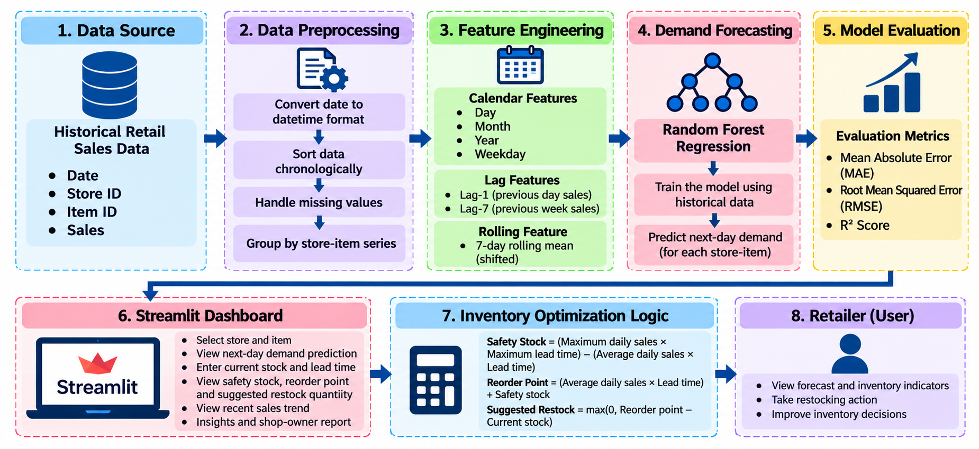
Three design principles guided the architecture. The first is separation of responsibility: each layer has a single purpose, so a fault in the data, the model, or the inventory rules can be located quickly. The second is transparency: the dashboard distinguishes the model’s predicted demand from rule-based values such as the reorder point. The third is simplicity: the system uses a small number of widely available Python libraries and a single model, which keeps the prototype easy to reproduce and explain.
Figure 3.1 Layered architecture of the proposed DemandIQ system.
3.3 Functional Requirements
Functional Requirements
- Load historical sales data with date, store, item, and sales fields.
- Prepare date values and create calendar, lag, and rolling-mean features.
- Train a Random Forest regression model and calculate evaluation metrics.
- Allow a user to select a store and item in the dashboard.
- Accept current stock and supplier lead-time inputs.
- Display demand prediction, stock coverage, inventory status, safety stock, reorder point, and suggested restock.
- Display recent sales trends, explanatory insight cards, and a shop-owner report.
Non-Functional Requirements
Usability: the dashboard should show important information in a readable format and keep the primary analysis action easy to locate. Performance: data preparation and model training should complete within the available computing resources; parallel model fitting is enabled through n_jobs=-1. Maintainability: the data-processing, model, and interface components should use consistent feature names and order, and changes to training features must be reflected in prediction logic.
Reliability: calculations should be checked against independent examples, and missing or invalid input values should be handled safely. Reproducibility: random_state=42 is set for the Random Forest configuration, and the chronological train/test split and preprocessing steps should be documented for repeatable evaluation.
The system also depends on a few practical constraints. The sales file must contain the four required fields in a consistent format, the Python libraries used for training must be available in the environment that runs the dashboard, and the trained model must be loaded together with the same feature definitions that were used to create it. Because the dashboard recomputes features for the selected store-item series at run time, any mismatch between the training pipeline and the prediction pipeline would directly affect the forecast, so both are kept in a single, documented code base.
Software and Hardware Requirements
Table 3.2 Software and hardware used for DemandIQ
Category | Requirement
Programming language | Python
Libraries | pandas, NumPy, scikit-learn
Dashboard framework | Streamlit (Flask is an alternative option)
Data storage | CSV sales file; MySQL or SQLite can be used for storage
Development environment | Visual Studio Code
Hardware | Laptop or desktop computer with a minimum of 8 GB RAM
Network | Internet connection (for installing libraries and hosting the dashboard)

3.4 Dataset Description
The project uses historical daily retail sales records with four main fields: date, store, item, and sales. The date field provides temporal context; store and item identify the demand series; sales is the numeric target variable to be forecast.
Table 3.3 Fields of the sales dataset
Field | Type | Purpose in DemandIQ
date | Date/time | Provides temporal context and the source of calendar features
store | Numeric identifier | Identifies the store of the demand series
item | Numeric identifier | Identifies the product of the demand series
sales | Numeric | Target variable to be forecast; source of lag and rolling features

The original dataset contains approximately 913,000 records. After feature generation and removal of rows without sufficient earlier observations, approximately 909,500 records remain usable for the modelling workflow. These are approximate counts from the project implementation and should be reconfirmed if the source data changes.
The current data uses numeric store and item identifiers rather than descriptive store names, product names, or categories. As a result, the dashboard selection is based on identifiers. The recent sales chart in the dashboard shows daily sales for the selected series, with values that typically range between about 5 and 30 units for the example shown in Chapter 5.
3.5 Feature Engineering
Feature engineering transforms raw sales records into model inputs, as summarised in Figure 3.2. Calendar features include day, month, year, weekday, and a weekend indicator. These features allow the model to learn differences associated with the date and day of the week.
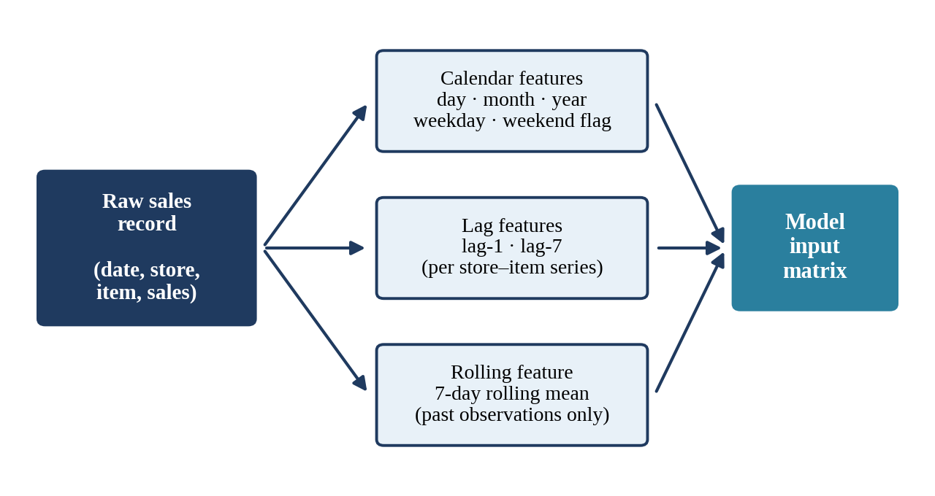
Figure 3.2 Feature engineering pipeline from raw sales records to the model input matrix.
Lag-1 represents the previous observation’s sales for the same store-item series, while lag-7 represents sales seven observations earlier. A seven-day rolling mean summarises recent sales history. Such features can help the model represent recent demand levels and short-term patterns.
Lag and rolling features must be computed within the correct store-item group and using past observations only. Rows that do not have enough historical data for the required features are excluded from the prepared dataset.
The choice of lag-1, lag-7, and a seven-day rolling mean reflects the weekly rhythm that is common in retail sales. Yesterday’s sales indicate the current demand level, sales seven days earlier capture the same weekday in the previous week, and the rolling mean smooths out day-to-day noise. Together with the calendar variables, these features give the model both the timing of the forecast date and a compact summary of the recent past.
3.6 Inventory Calculations
The dashboard supplements the demand forecast with inventory calculations. These calculations use user-provided stock and lead-time values and should not be confused with the machine-learning prediction itself. The three rules implemented in the application are:
Safety Stock = (Maximum Daily Sales × Maximum Lead Time) − (Average Daily Sales × Lead Time)
Reorder Point = (Average Daily Sales × Lead Time) + Safety Stock
Suggested Restock = max(0, Reorder Point − Current Stock)
Stock coverage estimates how many days the current stock can support at the estimated demand rate. The precise interpretation depends on how the application handles zero demand and the time unit used. The inventory rules are illustrative and should be validated against a retailer’s service-level policy and supplier conditions.
As a worked illustration, consider an item with an average daily sales value of 20 units, a supplier lead time of 5 days, and a safety stock of 150 units. The demand expected during the lead time is 20 × 5 = 100 units, so the reorder point is 100 + 150 = 250 units. If the current stock is 50 units, the stock is 200 units below the reorder point, and the suggested restock is therefore 200 units. If the current stock were 300 units, the formula max(0, 250 − 300) would return zero, and no restock would be suggested. This is the same arithmetic that the dashboard applies in the example discussed in Chapter 5.
At run time, these calculations are triggered when the user presses Analyze Inventory. The application reads the selected store, item, current stock, supplier lead time, and maximum lead time from the Control Center, retrieves the recent sales history of the selected series, and asks the trained model for the next-day demand estimate. The inventory rules are then applied to the average and maximum daily sales values together with the lead times, and the results are shown as cards, an alert message, an insight panel, and a Shop Owner Report table. Keeping this sequence short and visible allows the user to repeat the analysis quickly for other items or for different stock and lead-time assumptions.
CHAPTER 4 – IMPLEMENTATION
4.1 Data Preparation and Cleaning
The implementation proceeds through data preparation, feature generation, model training, evaluation, inventory calculations, and dashboard presentation, as shown in Figure 4.1. Historical data is prepared first so that model inputs have consistent types and chronological order. The model is trained and evaluated before being connected to the application. The dashboard then exposes the selected store-item forecast and inventory indicators in a format suitable for review.
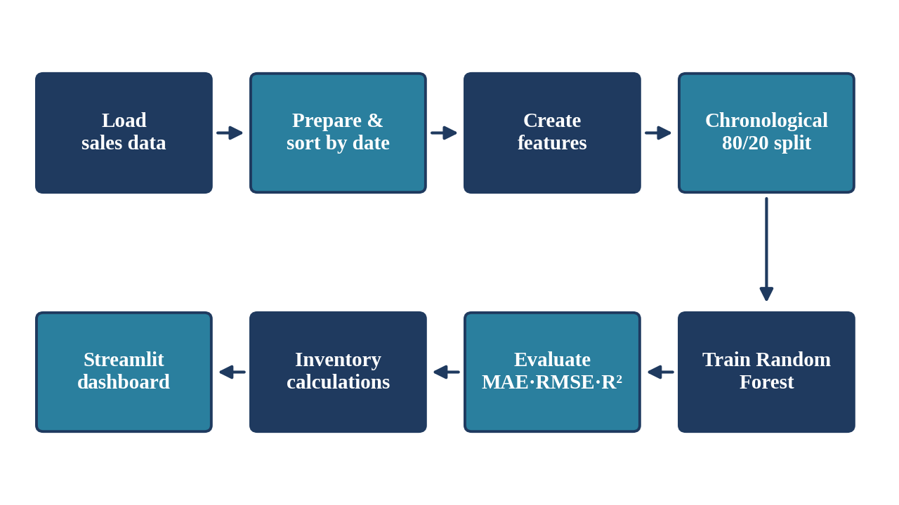
Figure 4.1 End-to-end implementation workflow of DemandIQ.
This separation makes the project easier to debug: incorrect data features, model predictions, or inventory calculations can be checked independently. The data preparation steps are as follows.
- Load the historical sales file and inspect the available fields.
- Convert the date field to a date/time type and sort records chronologically.
- Check missing values and ensure sales values are numeric.
- Keep store-item observations in their correct sequence before generating lag features.
- Create calendar, lag-1, lag-7, and rolling-mean features.
- Remove records that cannot form the required historical features.
- Separate model features from the sales target and prepare the chronological split.
Careful ordering is essential. If the data is not sorted correctly, lag features may point to the wrong records. If grouped series are not kept separate, one product’s past sales could incorrectly be used as another product’s feature.
The project records approximately 913,000 original rows and approximately 909,500 rows after feature preparation. The difference is expected when the first observations in a series do not have enough previous values to calculate lag features. A reproducible workflow should document the source file, the number of rows before and after preparation, and the rules used to remove records.
Data preparation should be repeatable. If the date parsing, sorting, grouping, or missing-value policy changes, the model may receive different inputs even when the source file appears similar. For that reason, the same preparation logic must be used during training and when the application creates features for a selected store-item combination. Data checks should be treated as part of the forecasting system, not as a one-time preliminary activity.
Feature generation must also avoid data leakage. Each input used to predict a target should represent information that would have been available at prediction time. The rolling mean must exclude the value being predicted, and lags must be calculated within the correct store-item group. The feature names and column order must remain consistent between training and inference.
4.2 Model Selection (Random Forest)
DemandIQ uses Scikit-learn’s RandomForestRegressor [7]. A Random Forest builds an ensemble of decision trees and combines their predictions for a numeric target. Each tree learns relationships between the input features and the sales target, and the ensemble combines the individual tree predictions. This method can learn nonlinear relationships among the engineered calendar and historical-sales features without requiring the user to specify a single mathematical relationship between each input and sales.
Random Forest was selected for three practical reasons. First, it works well with structured, tabular features such as calendar fields and lagged sales. Second, it requires little feature scaling and is relatively robust to the irregular, noisy daily sales values seen in retail data. Third, it is available in a widely used library, which keeps the implementation simple, reproducible, and easy to explain in an academic setting. The reviewed literature also reports Random Forest as a common choice for inventory and demand forecasting [1, 5].
The recorded configuration uses 30 estimators, a maximum depth of 15, random_state equal to 42, and n_jobs equal to negative one. The number of estimators controls the number of trees contributing to the prediction. The maximum depth limits the complexity of each tree. A fixed random state supports repeatability under the same data and software conditions, while parallel processing allows supported operations to use available CPU resources.
These settings describe the implemented prototype and should not be interpreted as globally optimal. Model selection requires comparison with suitable baselines and alternative methods on the same chronological test windows. A stronger future study could examine different tree counts and depth settings, while guarding against tuning repeatedly on the final test segment.
4.3 Model Training and Validation
Forecasting differs from ordinary random prediction tasks because the model is intended to use past observations to estimate later values. DemandIQ therefore uses a chronological 80/20 split, illustrated in Figure 4.2: the earlier 80% of the observations are used for training and the later 20% are reserved for testing. This arrangement better reflects the direction of real forecasting, where future sales are not available when a prediction is made.
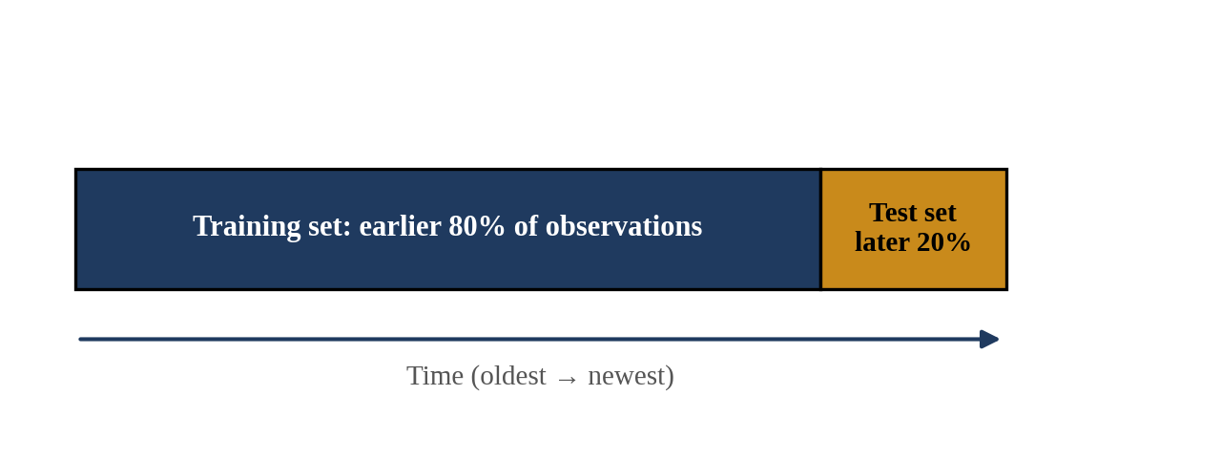
Figure 4.2 Chronological 80/20 train–test split used for evaluation.
A random split could place later observations in the training data while earlier observations appear in the test data. Depending on how features are created, this can give an unrealistic picture of performance. A chronological split reduces this particular problem, although it does not by itself prove that every feature is free from leakage. One holdout period provides an initial evaluation, but it may not represent every season or demand condition. Future validation should use several rolling or walk-forward windows.
Three metrics are used to evaluate the model. Mean Absolute Error (MAE) is the average absolute difference between actual and predicted sales and is expressed in the units of the target. Root Mean Squared Error (RMSE) is the square root of the average squared prediction error; because errors are squared before averaging, large errors contribute more strongly. R², the coefficient of determination, compares model predictions with a mean-based reference. It is not classification accuracy and should not be interpreted as the percentage of individual predictions that are correct.
The recorded test results are MAE = 6.5353, RMSE = 8.5242, and R² = 0.9270. These values apply to the current data preparation and chronological test split; additional validation is needed to assess stability across other periods.
4.4 Streamlit Dashboard Development
The Streamlit interface presents a Control Center in the sidebar where the user selects a store and item and enters the current stock, the supplier lead time, and the maximum lead time. The user can activate Analyze Inventory to review the demand estimate and the related inventory outputs. Before the analysis is run, the home screen shown in Figure 4.3 welcomes the user, explains the next step, and shows three status cards (AI Engine, Inventory Engine, and Forecasting) that all read READY when the components have loaded.
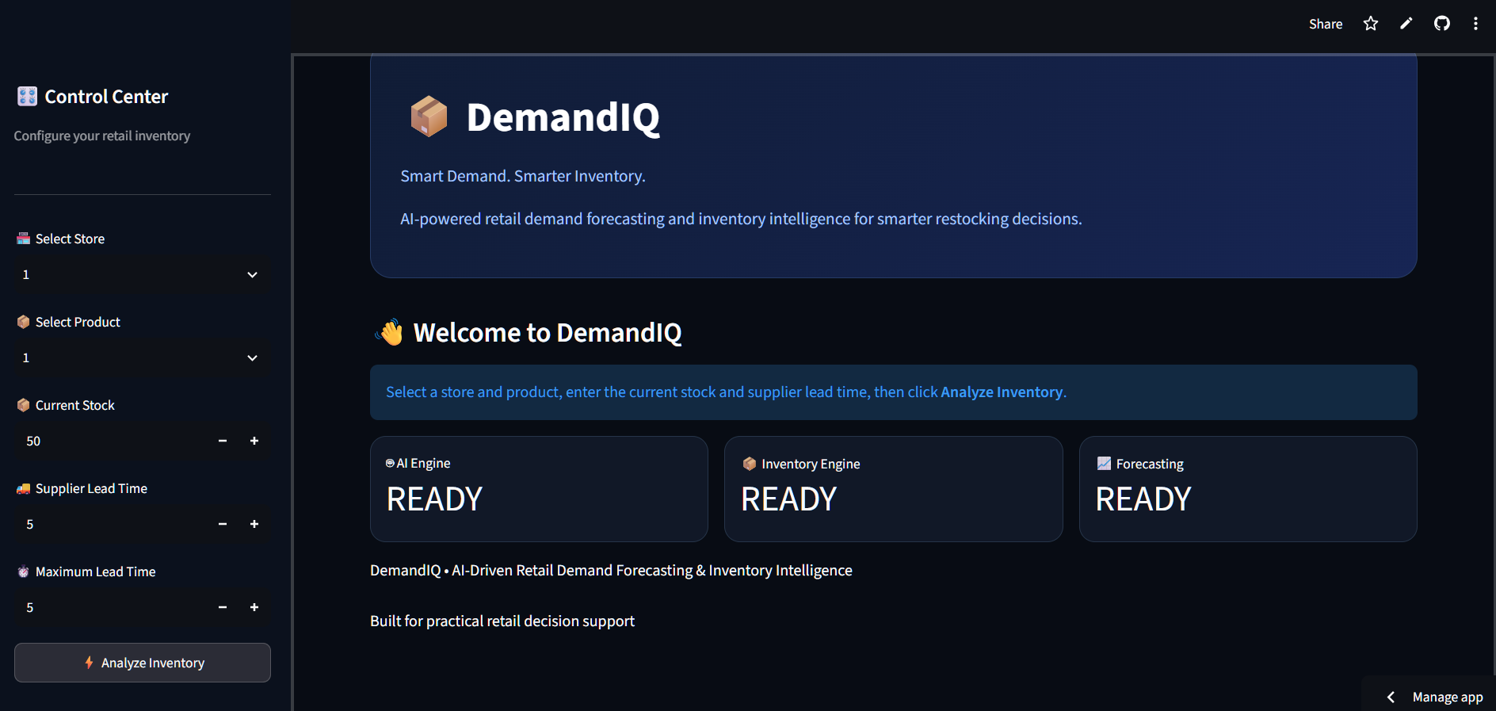
Figure 4.3 DemandIQ home screen and Control Center.
After analysis, the application displays the predicted demand, current stock, stock coverage, inventory status, safety stock, reorder point, suggested restock, a recent sales trend, DemandIQ Insights, and a Shop Owner Report with a download option. These elements connect the model output with operational context. A typical user begins by opening the application, selecting a valid store and item combination, entering a non-negative stock value and a realistic lead time, and running the analysis.
The user should review the outputs as a group rather than relying on a single status label. A critical status signals that the current stock is below the threshold used by the application, but the actual purchase decision may also depend on stock already in transit, supplier restrictions, cash availability, and storage capacity. If a recommendation appears inconsistent with the store’s experience, the user should verify the input values and the calculation assumptions.
4.5 Testing and User Workflow
Testing for DemandIQ covers both the visible dashboard and the calculations that support the displayed recommendation. The following checks form the validation plan.
- Open the Streamlit application and confirm that the main dashboard loads.
- Select a valid store and item combination.
- Enter a non-negative current stock value and a realistic supplier lead time.
- Run the analysis and verify that forecast and inventory indicators appear.
- Check that the sales trend and insight panels correspond to the selected item.
- Compare the displayed metrics with the recorded model evaluation.
- Check edge cases such as zero stock, low stock, or invalid inputs before wider use.
Calculation checks should compare selected dashboard values with independent calculations using the same inputs. For the supplied example, current stock is 50 units, the reorder point is 250 units, and suggested restock is 200 units. This follows the implemented rule max(0, reorder point − current stock). Boundary tests should include zero stock, stock equal to the reorder point, and stock above the reorder point; under the non-negative rule, the suggested quantity should be zero when current stock is at or above the reorder point.
Reliability depends on predictable behaviour when the input data or user selections are imperfect. The interface should handle zero demand without dividing by zero when calculating coverage, should present a clear message if the model file or dataset cannot be loaded, and should not silently substitute an unrelated product’s history when a selected series is incomplete. Because the report documents a prototype, test scenarios are described as a validation plan rather than all being labelled as passed. A complete test record should include the test date, input values, expected output, observed output, and pass/fail status.
Reproducibility is another part of reliability. The dataset version, feature definitions, training and test date ranges, model parameters, software dependencies, and evaluation metrics should be recorded together. If the application is updated, the model artifact and inference code must remain compatible, and changes should be tested as a connected release rather than assuming that a dashboard change cannot affect prediction behaviour.
CHAPTER 5 – RESULTS AND DISCUSSION
5.1 Model Evaluation (Accuracy, Error Metrics)
The Random Forest model was evaluated on the later 20% of the chronologically ordered data. Table 5.1 lists the recorded values, which are also displayed in the AI Model Performance section of the dashboard, together with the note that the model was evaluated using the time-based test dataset.
Table 5.1 Recorded model evaluation results
Metric | Recorded Value | Interpretation
MAE | 6.5353 | Average absolute error in sales units.
RMSE | 8.5242 | Penalises larger errors more strongly than MAE.
R² | 0.9270 | Model fit relative to a mean-based reference on the test split.

The reported values indicate that the model explains a large share of target variation in the evaluated test segment, while the error metrics show the average scale of prediction error. An MAE of 6.5353 means that, on average, the absolute prediction error is approximately 6.54 sales units; this is an aggregate measure and does not mean every prediction differs by that amount. The RMSE is higher than the MAE, which indicates that some larger errors contribute more heavily to the overall error.
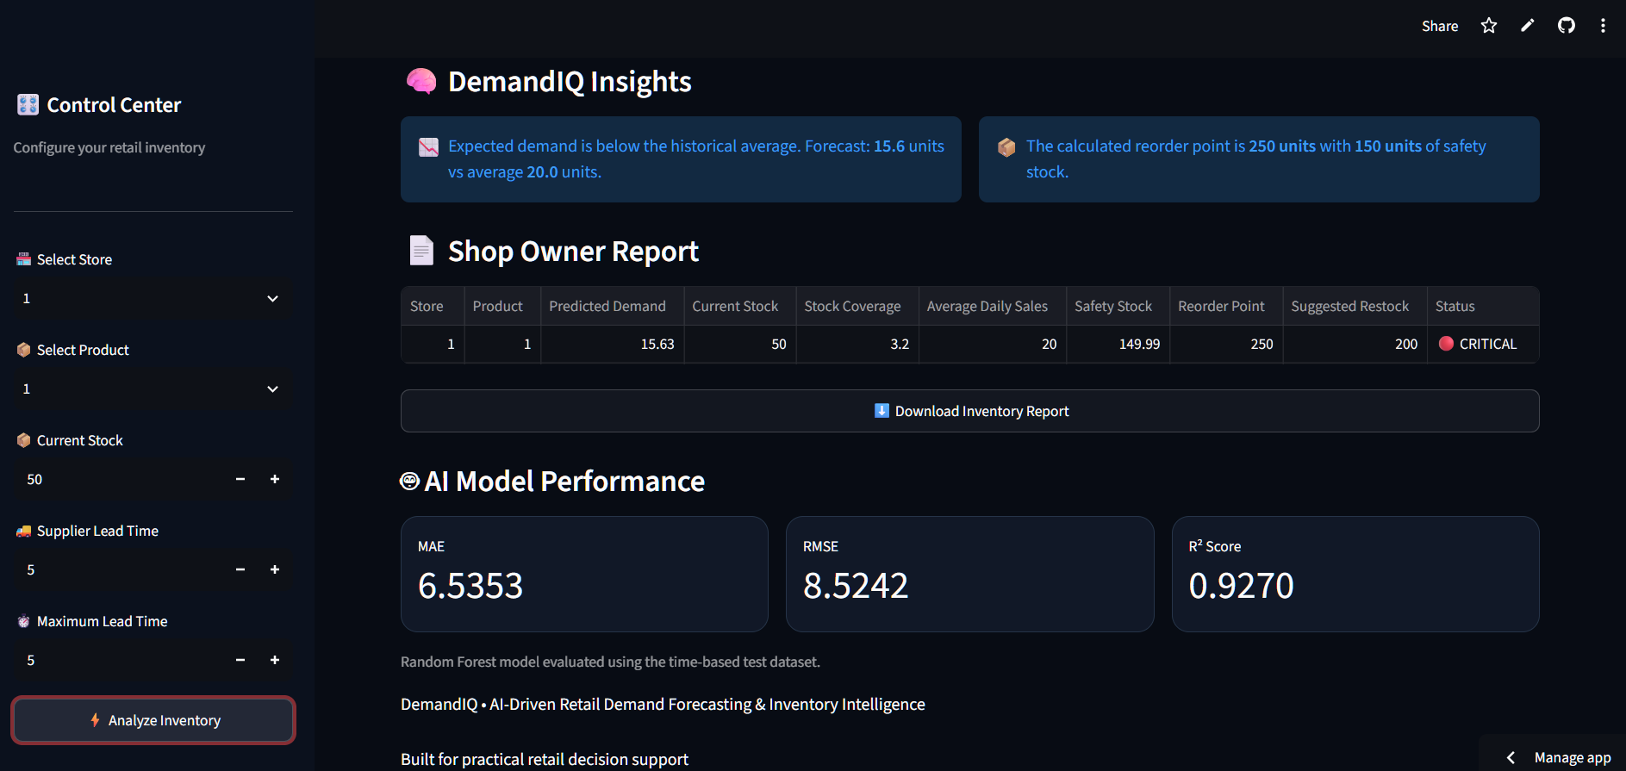
Figure 5.1 Model evaluation metrics and Shop Owner Report shown in the supplied dashboard screenshot.
R² alone does not establish that the model is reliable for every store, item, or future period. It is not classification accuracy and does not mean that 92.70 percent of individual predictions are exactly correct. The three metrics should be interpreted together and reported with the test period, dataset version, and feature pipeline that produced them.
5.2 Inventory Projection Example
The supplied application example for Store 1 and Item 1 reports predicted demand of approximately 15.6 units, current stock of 50 units, stock coverage of 3.2 days, safety stock of 150 units, reorder point of 250 units, suggested restock of 200 units, and a CRITICAL inventory status. The dashboard insight messages state that the expected demand is below the historical average (forecast 15.6 units versus an average of 20.0 units) and that the calculated reorder point is 250 units with 150 units of safety stock.
Table 5.2 Dashboard output for Store 1, Item 1
Dashboard Output | Example Value
Predicted demand | 15.6 units
Current stock | 50 units
Stock coverage | 3.2 days
Inventory status | CRITICAL
Safety stock | 150 units
Reorder point | 250 units
Suggested restock | 200 units

The numbers are internally consistent. With an average daily sales value of 20 units, a supplier lead time of 5 days, and a safety stock of 150 units, the reorder point is (20 × 5) + 150 = 250 units. Because the current stock of 50 units is below this threshold, the suggested restock is 250 − 50 = 200 units. The stock coverage of 3.2 days is consistent with dividing the current stock of 50 units by the predicted demand of about 15.6 units.
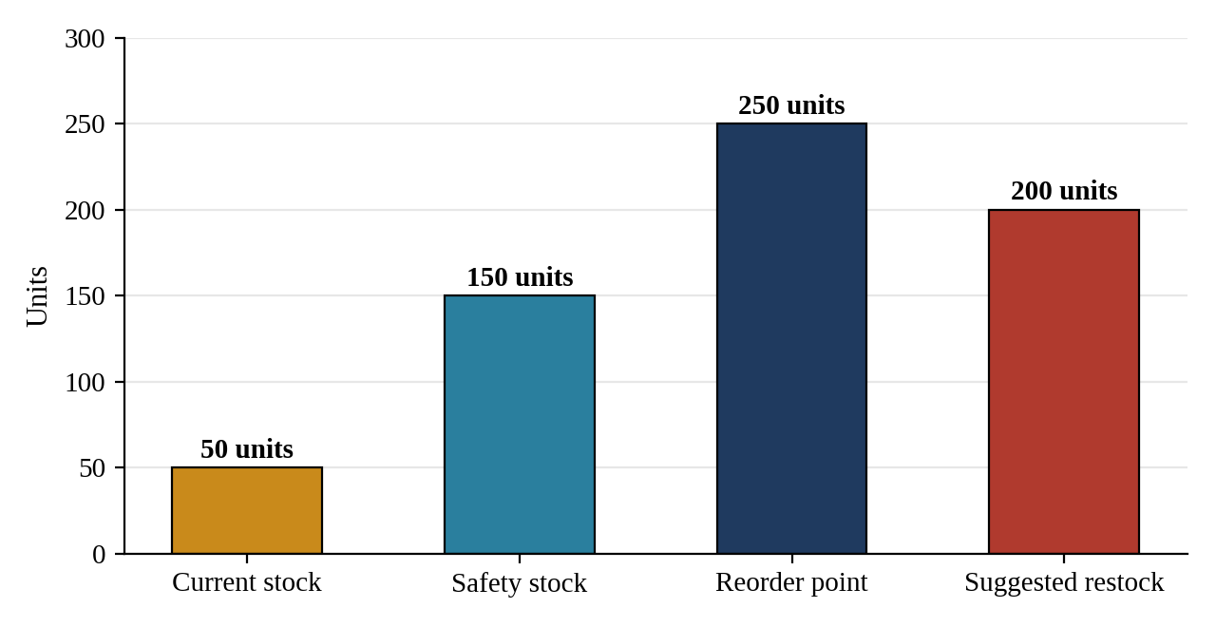
Figure 5.2 Inventory projection for Store 1, Item 1 (values from the supplied application example).
This example illustrates how a forecast and inventory rules are presented together. It is not a universal purchasing recommendation: the result depends on the app’s inputs and formulas and should be checked against the retailer’s real demand and lead-time assumptions.
5.3 Dashboard Screenshots
The dashboard screenshots provide visual evidence of the user-facing workflow. Figure 5.3 shows the Inventory Health section, in which four cards present tomorrow’s demand, the current stock, the stock coverage, and the inventory status. Below it, the Inventory Decision section displays a RESTOCK RECOMMENDED message stating that the current stock is below the reorder point of 250 units, followed by the suggested restock, safety stock, and reorder point values.
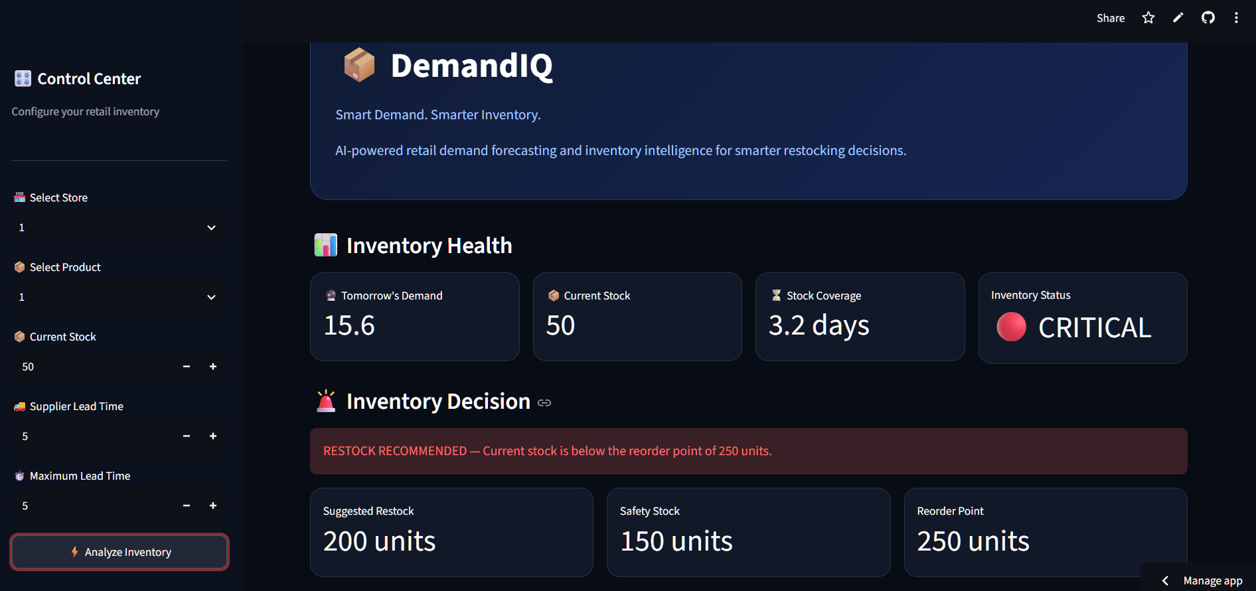
Figure 5.3 Inventory health and decision output from the supplied DemandIQ application.
The colour-coded status makes the screen easy to scan. A CRITICAL status with a red restock message tells the shop owner immediately that the 50 units on hand cover only about three days of the predicted demand and that the stock has fallen below the reorder point. The three decision cards then translate that warning into numbers that can be used for ordering: how much to order, how large the safety buffer is, and at what stock level the next order should be triggered.
Figure 5.4 shows the Stock Position bar, the Recent Sales Trend chart, and the DemandIQ Insights panel. The sales trend lets the user see how daily sales for the selected store and item have varied in the most recent period, which gives context to the single forecast value. In the supplied example, the series fluctuates between roughly 5 and 30 units, and the chart indicates, for instance, a value of 16 units on December 20, 2017.
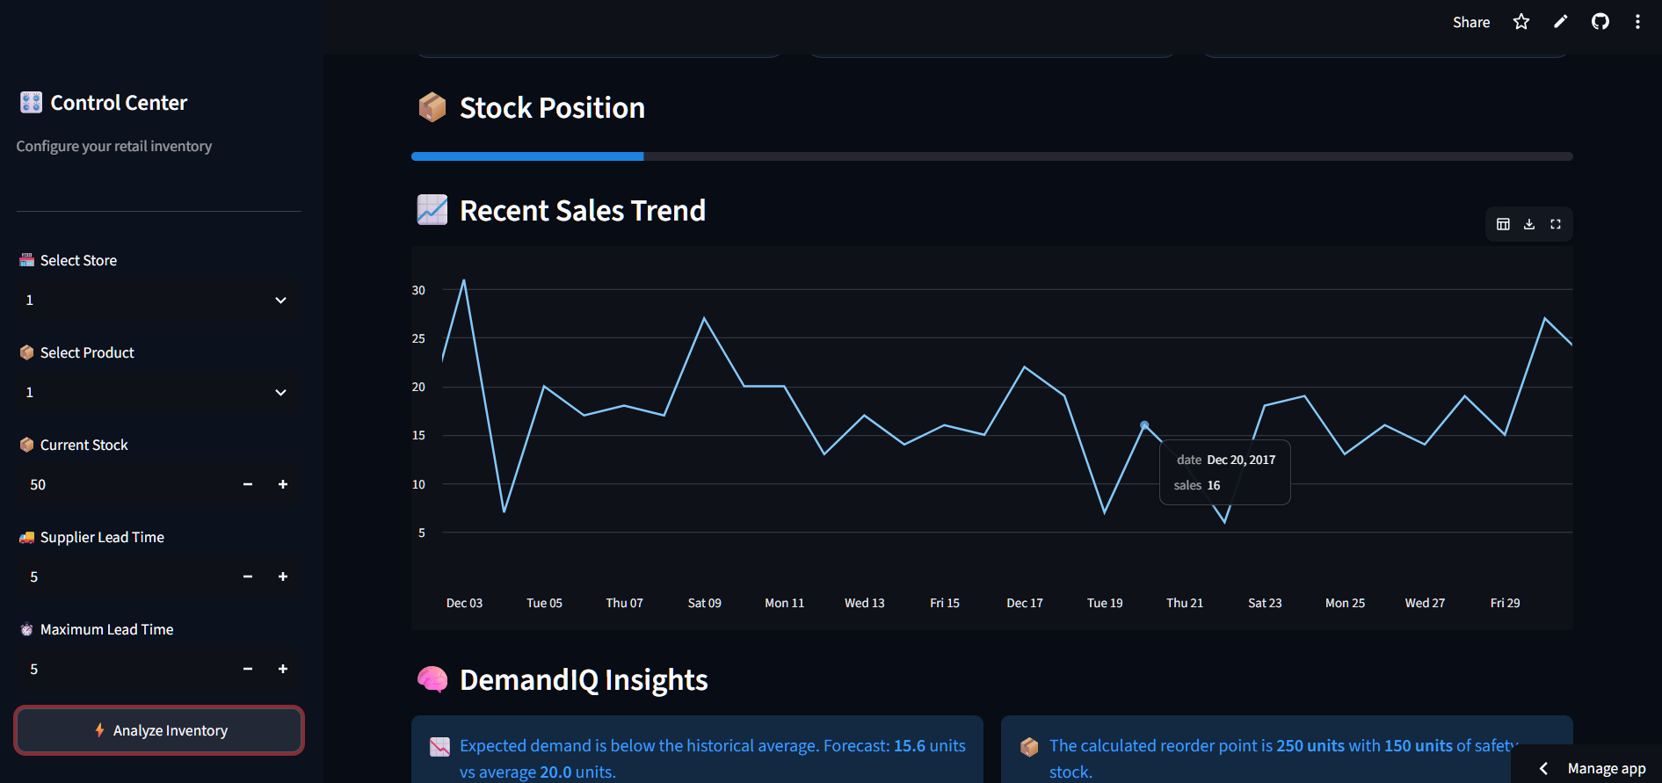
Figure 5.4 Recent sales trend and DemandIQ Insights displayed by the application.
5.4 Limitations and Validation
- The dataset does not include descriptive product categories, prices, promotions, holidays, or weather.
- The current evaluation uses one chronological 80/20 split; walk-forward evaluation would better test performance stability.
- The recorded metrics should be compared with simple baseline methods and alternative models.
- Inventory formulas depend on assumptions about average and maximum demand and supplier lead time.
- The prototype has not established measured reductions in stockouts, waste, or inventory costs.
These limitations do not negate the value of the prototype, but they define what can reasonably be concluded from the current implementation. Aggregate evaluation metrics can hide differences between store-item combinations: a model may perform well on frequently sold products but poorly on products with intermittent demand. Future analysis should report errors by store, item, demand level, and time window. The report’s conclusions are therefore limited to the implementation and the recorded evaluation results. For this reason, the screenshots and metrics in this chapter should be read as evidence that the prototype works as designed, not as proof of business benefit.
CHAPTER 6 – CONCLUSION AND FUTURE WORK
6.1 Conclusion
DemandIQ demonstrates an end-to-end retail demand forecasting workflow using historical sales data, feature engineering, a Random Forest regression model, and an interactive Streamlit dashboard. The model uses calendar and lag-based features and is evaluated with a chronological split. The recorded metrics (MAE 6.5353, RMSE 8.5242, and R² 0.9270) provide an initial view of model performance on the current test segment.
The dashboard extends the forecast with stock coverage, inventory status, safety stock, reorder point, and suggested restock quantity. The main contribution is the integration of prediction and inventory-related indicators in a lightweight interface. The system is a prototype and requires further validation before it is used for real purchasing decisions.
From an implementation perspective, the project brings together Python-based data processing, Scikit-learn regression, time-aware feature engineering, and Streamlit presentation. The main outcome is a functional prototype and a documented workflow that can be tested and improved. DemandIQ should be understood as a connected decision-support workflow rather than as a forecasting model operating in isolation: data preparation determines whether the historical sequence is trustworthy, the model learns patterns from the prepared features, and the inventory layer applies explicit rules to translate the forecast and user inputs into stock-related guidance.
6.2 Future Enhancements
- Compare Random Forest with seasonal-naive, moving-average, ARIMA/Prophet, and gradient-boosting baselines using consistent time-based splits.
- Use walk-forward validation to measure performance across multiple future periods.
- Add prices, promotions, holidays, and product metadata when reliable data is available.
- Evaluate results by store, item, and demand level instead of reporting only aggregate metrics.
- Review safety-stock and reorder-point formulas with realistic lead-time distributions and service-level targets.
- Add input validation, clearer error messages, and tests for zero demand and missing values.
- Track operational outcomes in a pilot, including stockout frequency, excess inventory, and ordering cost.
These extensions should be prioritised according to data availability and measurable benefit rather than complexity alone. The first priority is stronger evaluation, so that any additional complexity can be justified by a measurable improvement. The second priority is richer but reliable data, tested through controlled comparisons rather than added merely to make the system appear more advanced. The third priority is practical validation of the inventory rules, which could incorporate open purchase orders, pack sizes, supplier minimums, and budget limits.
Deployment and maintenance also deserve attention. The Streamlit interface provides a lightweight way to demonstrate the workflow, but a deployment requires the application code, model artifact, input data, and dependency versions to remain compatible. A maintainer should document how to install dependencies, prepare the dataset, train the model, and start the dashboard, and model updates should be evaluated against later observations before replacing the existing version. A production deployment would additionally need an owner responsible for monitoring, updates, access control, and backups.
6.3 Pilot Evaluation and Responsible Use
A future pilot should answer two separate questions: whether DemandIQ produces useful forecasts and whether those forecasts improve inventory decisions. The pilot should begin with a documented baseline of the retailer’s existing process. During the trial, the store should record forecast values, actual sales, current stock, stockout events, excess stock, replenishment dates, and relevant costs where available, using the same definitions throughout. The system should not place orders automatically during an initial trial.
Model evaluation during the pilot should report MAE, RMSE, and R² for each chronological test window, together with a simple baseline forecast for comparison, and results should be reviewed by product and store rather than only in aggregate. For inventory evaluation, useful measures include stockout frequency, days out of stock, excess inventory, order frequency, and the cost of holding or replenishing products.
Responsible use also means keeping a human decision-maker involved and being transparent about the source of each value. The interface should make clear which values are model predictions and which are rule-based calculations, and should communicate the period represented by the sales history, the lead-time units, and the meaning of the inventory status. If future versions include customer-level or commercially sensitive information, stronger access controls and data minimisation would be required. A controlled evaluation provides a practical path from an academic prototype to a better-supported decision tool.
6.4 Recommendations Before Real-World Use
Before a retailer relies on DemandIQ, the dataset should be checked for missing dates, duplicated records, invalid sales values, and changes in store or item identifiers. Feature generation should be reviewed to ensure that all lags and rolling statistics use only information available before the prediction date. The training and inference pipelines should be tested with the same feature schema and documented software environment.
Model evaluation should include a baseline forecast and multiple chronological windows. The error distribution should be examined for individual products and unusual periods, not only as an aggregate score. If the model is used to support stock decisions, forecast errors should be linked to the cost of running out of stock and the cost of holding excess inventory. This can help determine whether the forecast is useful for the business objective.
Inventory formulas should be reviewed with the retailer’s actual lead-time process and service-level goals. The interface should explain the source of each displayed value and warn when an input or data series is unsuitable. A pilot should be monitored for a defined period and compared with the existing process. Only after these checks should the system be considered for broader operational use.
6.5 Project Outcome and Learning Summary
DemandIQ demonstrates an end-to-end machine-learning application that connects data preparation, feature engineering, regression modelling, evaluation, inventory calculations, and an interactive dashboard. The work shows how historical sales records can be converted into structured features and used to produce a demand estimate for a selected store-item combination. It also demonstrates the importance of presenting a model output in a form that supports a practical decision.
The design illustrates a broader lesson in applied artificial intelligence: a useful system requires more than a model with a promising metric. Data quality, feature integrity, evaluation design, interface clarity, calculation correctness, and user understanding all influence the quality of the final result. In conclusion, DemandIQ provides a foundation for further experimentation in retail analytics. Its current contribution is the integration of historical-sales forecasting and inventory indicators, supported by a Streamlit interface and a documented evaluation. More extensive validation, baseline comparisons, and a controlled pilot are the appropriate next steps for establishing real-world usefulness.
REFERENCES
[1] Deivanayagampillai et al. (2025). Random Forest for Inventory Forecasting.
[2] Yadav (2025). Retail demand forecasting using Random Forest/XGBoost with external big-data signals.
[3] Fatima, & Salam (2025). Retail inventory forecasting using XGBoost, ARIMA, Prophet and SVR with contextual features.
[4] Hammam, I. M., El-Kharbotly, A. K., & Sadek, Y. M. (2025). Adaptive Demand Forecasting Framework with Weighted Ensemble of Regression and Machine Learning Models Along Life Cycle Variability. Scientific Reports, 15, 38482. https://doi.org/10.1038/s41598-025-23352-w
[5] Muluk, A., & Akbar, A. N. (2025). Pengembangan Sistem Prediksi Permintaan untuk Reorder Point Berbasis Machine Learning. Jurnal Inovasi Rekayasa Mekanikal dan Termal, 3(1), 79–84. https://doi.org/10.25077/inomet.3.1.79-84.2025
[6] Breiman, L. (2001). Random Forests. Machine Learning, 45, 5–32.
[7] scikit-learn Developers. RandomForestRegressor documentation. Scikit-learn User Guide.
[8] Streamlit, Inc. Streamlit documentation: building data applications in Python.
[9] pandas Development Team. pandas documentation: data structures and time-series data handling.
[10] NumPy Developers. NumPy documentation: numerical computing in Python.

