AI STUDY BUDDY API
PROJECT DOCUMENTATION

TEAM LEADER: VARSHINI M

TEAM MEMBERS

MAHA LAKSHMI R AKSHAYA M ELAKKIYA M

INTRODUCTION
AI Study Buddy API is a learning-support project that helps students study easily using Artificial Intelligence.
The system can answer questions, create quizzes, generate notes, explain topics, and summarize study material.

Need for the Project
Students need quick and simple explanations. Searching for study material can take time.
Practice questions are useful for exam preparation.

Project Idea
The main idea is to provide one simple AI study companion through an API-based system.

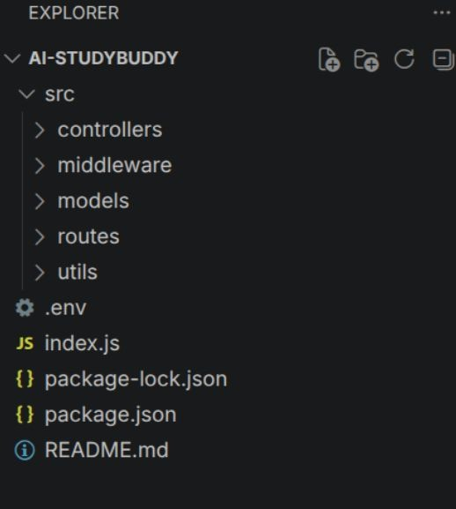

OBJECTIVES

Main Objectives
Provide quick answers to academic questions. Generate simple study notes.
Create quizzes for practice. Support interactive learning.
Save time during study and revision. Make learning simple and convenient.

Expected Outcome
The system receives a student request, processes it through the API, and returns useful learning content.
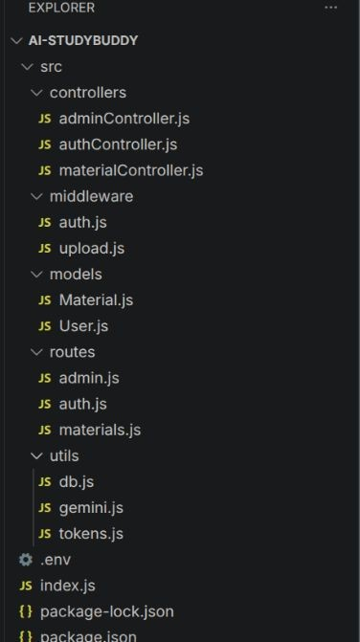

EXISTING AND PROPOSED SYSTEM

Existing System
Students use books, websites, and separate applications. Finding simple explanations may take more time.
Quiz creation is often manual.

Proposed System
One application provides multiple study features. API connects the application with AI services.
Students receive answers, notes, and quizzes interactively.
STUDENT → STUDY APP → API LAYER → AI SERVICE → RESPONSE

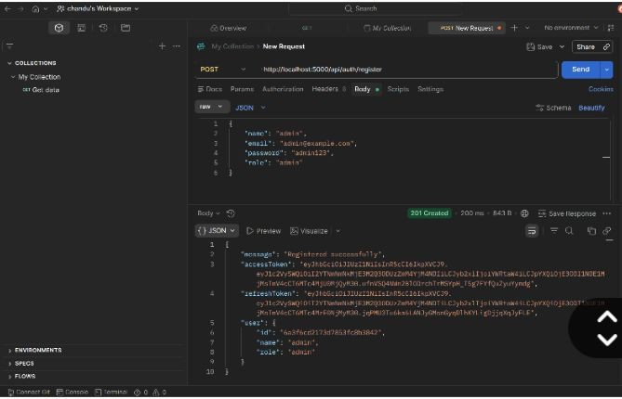

SYSTEM ARCHITECTURE
The system contains the student interface, application, API layer, AI service, and result display.
STUDENT
↓
FRONT END
↓
API LAYER
↓
AI SERVICE
↓
RESULT

Architecture Flow
Student enters a question or selects a feature. Application sends the request to the API.
API processes and validates the request. AI service generates the response.
Response is displayed to the student.
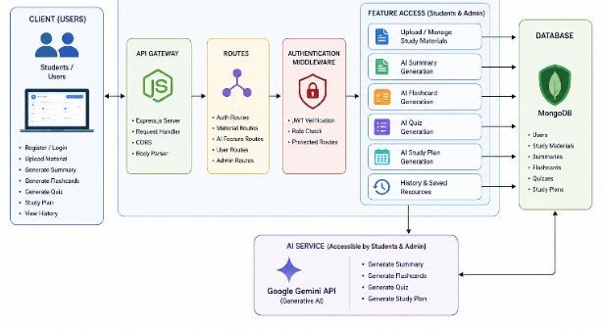

API DESIGN

What is an API?
API means Application Programming Interface. It allows software systems to communicate with each other.

Main API Endpoints
POST /ask – answer a study question. POST /quiz – generate quiz questions.
POST /summarize – create a short summary. POST /explain – explain a topic simply.
GET /health – check service status.

Data Format
JSON can be used to send requests and receive structured responses.
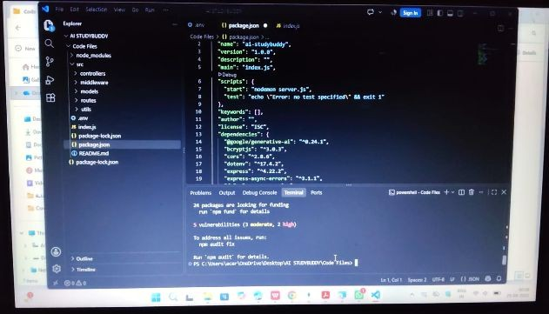

SYSTEM MODULES

Question Answering
Answers student questions with simple explanations.

Notes Module
Creates short and useful study notes.

Quiz Module
Generates practice questions.

Summary Module
Converts long content into important points.

API Management
Handles requests, validation, errors, and AI communication.

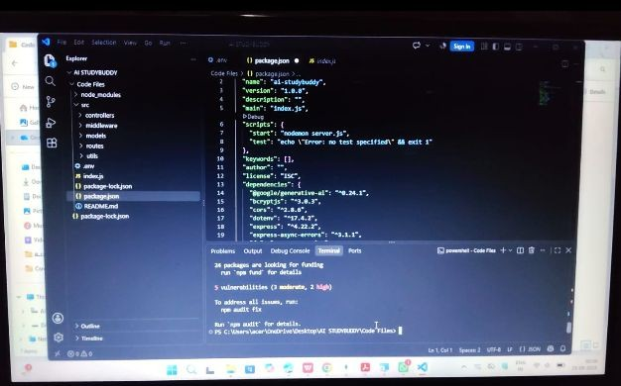

QUIZ AND PRACTICE FEATURE
The quiz feature helps students test their understanding after studying.
SELECT TOPIC → SELECT LEVEL → API REQUEST → AI QUESTIONS →
QUIZ → RESULT

Quiz Types
Multiple-choice questions. True or false questions.
Short-answer questions. Topic-based practice sets.

Benefits
Improves active learning. Provides quick practice. Helps identify weak areas.

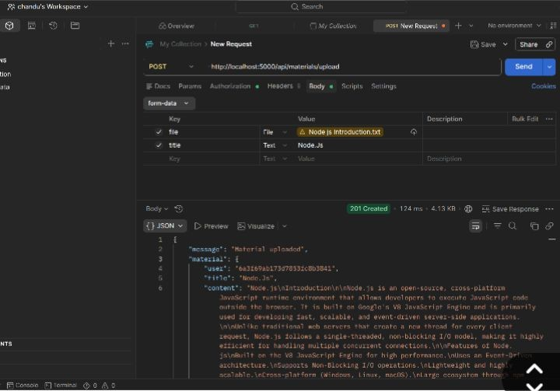

STUDY NOTES AND SUMMARIZATION

Study Notes
The system can convert a topic into easy-to-read points for revision.

Summarization Process
LONG CONTENT → API REQUEST → AI PROCESSING → KEY POINTS →
STUDENT

Benefits
Saves reading time. Makes revision easier.
Provides structured information. Can support different study levels.

TECHNOLOGIES USED
Frontend
A web or mobile interface collects questions and displays results. Backend
The backend manages API routes, validation, and communication. AI Service
An AI model or AI API generates answers, summaries, explanations, and quizzes. Database
A database can store study history, notes, quiz results, and preferences when required.

Data Format
JSON is commonly used for API communication.

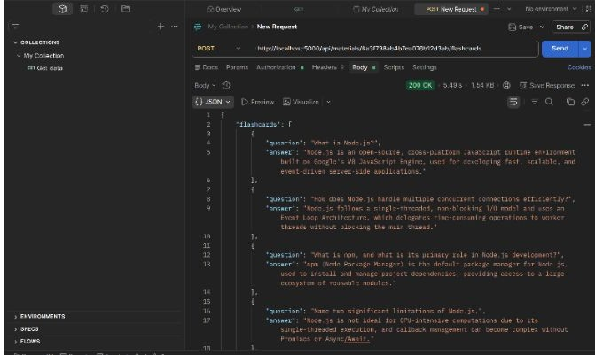

DATA FLOW

Possible Data Stored
User profile information. Study topics.
Saved notes.
Quiz attempts and scores. Study history.
USER DATA → APPLICATION → API → PROCESSING → DATABASE
↓
AI SERVICE

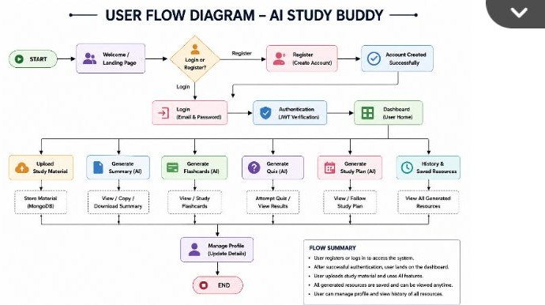

SECURITY AND ERROR HANDLING

Security
Use HTTPS for secure communication. Protect API keys and credentials.
Validate incoming requests.
Use authentication when required.
Avoid storing unnecessary sensitive information.

Error Handling
Show clear messages for invalid input. Handle AI service failures.
Handle API timeouts.
Log unexpected errors securely.
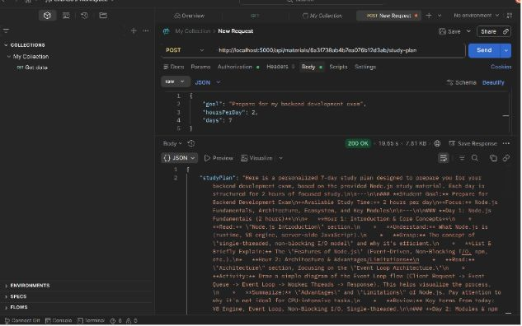

TESTING

Testing Types
Unit testing – checks individual functions.
API testing – checks requests and responses. Integration testing – checks module communication. UI testing – checks application screens.
Error testing – checks invalid input.

Sample Tests
Valid question → return answer.
Empty question → show validation message.
Quiz request → return requested questions.
Health request → show service status.

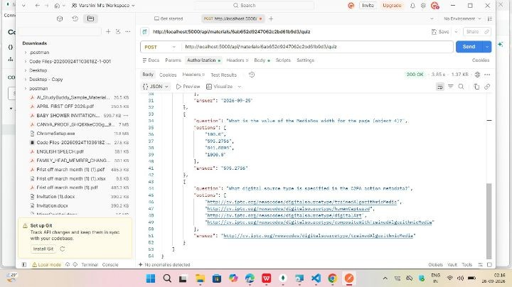

ADVANTAGES, LIMITATIONS AND FUTURE SCOPE

Advantages
Easy access to study support. Interactive learning.
Quick study material generation. Multiple study features in one system.

Limitations
AI-generated content should be verified when necessary. Internet may be required for cloud AI services.
API usage may have limits or costs.

Future Scope
Voice-based study assistant. Personalized study plans.
Progress tracking.
Multilingual support.
Flashcards and smart reminders.

CONCLUSION

Conclusion
AI Study Buddy API is a useful project for interactive academic assistance. It can answer questions, create quizzes, summarize content, and generate simple study notes.
The project demonstrates how APIs can connect a student application with AI services to create a practical learning companion.
THANK YOU!

