**TOUR AND TICKET MANAGEMENT SYSTEM**

**A MINI PROJECT REPORT**

***Submitted by***

**VARSHINI.R 211422104528**

**SRINITHI.A 211422104479**

***in partial fulfillment for the award of the degree***

***of***

**BACHELOR OF ENGINEERING**

***in***

## COMPUTER SCIENCE AND ENGINEERING



PANIMALAR ENGINEERING COLLEGE

# (An Autonomous Institution, Affiliated to Anna University, Chennai)

November 2024

**PANIMALAR ENGINEERING COLLEGE**

**(An Autonomous Institution, Affiliated to Anna University, Chennai)**

**BONAFIDE CERTIFICATE**

This is to certified that the project report **“Tour and Ticket Management System”** is the bonafide work of **VARSHINI.R (211422104528)** and **SR I N I T H I . A (211422104479)** who carried out the project work under my supervision.

# SIGNATURE OF HOD SIGNATURE OF SUPERVISOR Dr. JABASHEELA.L, M.E., Ph.D., Mrs. A.DEEPA, B.E,M.E, PROFFESOR AND HEAD ASSISTANT PROFESSOR

DEPARTMENT OF CSE, DEPARTMENT OF CSE, PANIMALAR ENGINEERING COLLEGE , PANIMALAR ENGINEERING COLLEGE, NASARATHPETTAI, NASARATHPETTAI,

POONAMALLEE, POONAMALLEE,

CHENNAI-600 123. CHENNAI-600 123.

Certified that the above candidate(s) were examined in the Mini Project Viva- Voce Examination held on ...........................

**INTERNAL EXAMINER EXTERNAL EXAMINER**

**ACKNOWLEDGEMENT**

We express our deep gratitude to our respected Secretary and Correspondent **Dr. P.CHINNADURAI, M.A., Ph.D.** for his kind words and enthusiastic motivation, which inspired us a lot in completing this project.

We would like to extend our heartfelt and sincere thanks to our Directors **Tmt. C. VIJAYARAJESWARI, Dr. C.SAKTHIKUMAR, M.E., Ph.D.,** and

**Tmt.SARANYASREE SAKTHIKUMAR B.E., MBA.,** for providing us with the necessary facilities for completion of this project.

We also express our gratitude to our principal **Dr. K.MANI, M.E., Ph.D.** for his timely concern and encouragement provided to us throughout the course.

We thank the HOD of CSE Department, **Dr. JABASHEELA.L, M.E., PhD.,** for the support extended throughout the project.

We would like to thank my project guide **Mrs.A.DEEPA, B.E,M.E**and all the faculty members of the Department of CSE for their advice and suggestions for the successful completion of the project.

**VARSHINI.R (211421104528)**

**SRINITHI.A (211422104479)**

**ABSTRACT**

The Tour and Ticket Management System is a comprehensive web-based application designed to simplify and optimize the process of booking bus tickets for both operators and passengers. This system provides a centralized platform where bus operators can manage crucial aspects of their business, such as routes, schedules, and fares, while passengers benefit from a convenient and seamless online booking experience. One of the primary features of the system is the online ticket booking capability, where passengers can effortlessly reserve their seats by selecting preferred routes, travel dates, and even specific seat assignments. The platform ensures real-time seat availability, enabling passengers to make informed choices regarding their travel plans without worrying about last-minute surprises.

To enhance security and trust, the system integrates a secure payment gateway, offering multiple secure payment options to guarantee a smooth and hassle-free transaction process. The application also supports bus operators with route and schedule management, allowing them to update and optimize their services easily, ensuring efficient and timely operations. Additionally, fleet management tools help operators track their vehicles in real-time, monitor performance metrics, and schedule regular maintenance to keep the buses running smoothly.

For the business side, the system offers reporting and analytics features that provide valuable insights into ticket sales, revenue generation, and other performance indicators, helping operators make data-driven decisions to improve service offerings.

Overall, the Tour package Booking System enhances operational efficiency for bus operators by streamlining workflows and reducing manual processes. At the same time, it provides passengers with an easy, secure, and user-friendly platform to book tickets, ensuring a better travel experience. By leveraging modern technology, the system seeks to transform the traditional bus ticketing industry, delivering greater convenience, improved customer satisfaction, and more efficient travel management.

**TABLE OF CONTENTS**

|  |  |  |
| --- | --- | --- |
| **CHAPTE**  **R NO.** | **TITLE** | **PAGE NO.** |
|  | **ABSTRACT** | 4 |
|  | **LIST OF TABLES** |  |
| **1.** | **INTRODUCTION** | 7 |
|  | 1.1 Overview |  |
| **2.** | **LITERATURE SURVEY** | 8 |
| **3.** | **MATERIALS AND METHODS** | 10 |
|  | 3.1 Development Environment |  |
| **4.** | **SYSTEM FEATURES** | 14 |
|  | 4.1 System Flow diagram | 15 |
| **5.** | **PROPOSED METHODOLOGY** | 16 |
|  | 5.1 Architecture Diagram | 16 |
| **6.** | **SYSTEM IMPLEMENTATION** | 17 |
|  | 6.1 Coding |  |
| **7.** | **PERFORMANCE ANALYSIS** |  |
|  | 7.1 Key Features | 31 |
|  | 7.2 System Features | 32 |

|  |  |  |
| --- | --- | --- |
|  | 7.3 Discussion | 34 |
| **8.** | **CONCLUSION** | 35 |
|  | 8.1 Conclusion |  |
|  | 8.2 Future Enhancements |  |
|  | **APPENDICES** | 38 |
|  | A.1 Sample Screenshots |  |
|  | **REFERENCES** | 39 |

**CHAPTER 1**

**INTRODUCTION**

The Tour and Ticket Management System is a comprehensive platform designed to streamline the process of booking bus tickets for both operators and passengers. By providing a centralized, online solution, the system aims to address the inefficiencies and challenges often encountered in traditional ticket booking methods.

**1.1 Overview**

The Tour and Ticket Management System is a cutting-edge web-based application designed to simplify bus ticket booking for both passengers and operators. By addressing the limitations of traditional methods, it offers a centralized platform that enhances the travel experience. Passengers can easily reserve seats on their preferred routes, travel dates, and specific seat assignments, all with real-time seat availability. For operators, the system provides essential management tools, including route optimization, fare adjustments, and vehicle tracking, ensuring efficient operations and high service standards.

A secure payment gateway allows passengers to complete transactions safely, fostering trust and confidence. Moreover, operators gain access to reporting and analytics tools that provide insights into ticket sales and revenue generation, facilitating data-driven decision-making. The system is designed to be user- friendly, ensuring that both passengers and operators can navigate it with ease. Ultimately, the *Tour Package Booking System* aims to transform the bus ticketing industry by leveraging modern technology for greater convenience, security, and efficiency. As travel demands continue to evolve, this system is set to play a crucial role in the future of transportation management.

**CHAPTER 2 LITERATURE SURVEY**

|  |  |  |  |
| --- | --- | --- | --- |
| **Topic** | **Description** | **Author** | **Year** |
| **1.User Experience in Online Booking** | This study explores the significance of user interface design and user experience in online booking systems, emphasizing that a user-friendly design increases customer satisfaction and conversion rates. | **Shrestha et al** | **2020** |
| **2.Security Challenges in E- commerce** | This paper reviews the security threats faced by e-commerce platforms, particularly focusing on online payment systems. It discusses various methods to enhance security, such as encryption and two-factor authentication. | **Gupta &**  **Kumar** | **2019** |
| **3. Dynamic Pricing Models** | The research examines the effectiveness of dynamic pricing in various industries, including transportation. It discusses how dynamic pricing can optimize revenue but also raises ethical concerns about customer  perception and trust. | **Chen & Wang** | **2021** |
| **4.Integration of Third-Party Services** | This article analyzes the challenges and benefits of integrating third-party services in booking systems, such as airlines and car rentals, highlighting the importance of APIs and interoperability for seamless user experiences. | **Martin & Smith** | **2022** |
| **5.Sustainable Transportation**  **Solutions** | This study discusses the role of technology in promoting sustainable travel, including the adoption of electric vehicles and carbon footprint tracking in booking systems. It emphasizes the need for the travel industry to adopt  eco-friendly practices. | **Johnson & Green** | **2023** |

|  |  |  |  |
| --- | --- | --- | --- |
| **6.Adoption of**  **Technology by Operators** | The paper investigates the barriers that bus operators face when adopting new technologies in booking systems, including cost, training, and resistance to change. It suggests strategies to facilitate the transition. | **Lee & Tan** | **2020** |
| **7. Fleet Management in Transportation** | This research reviews fleet management systems and their impact on operational efficiency, focusing on real-time tracking and maintenance scheduling to optimize service delivery in the transportation sector**.** | **Patel & Agarwal** | **2021** |
| **8. Customer Trust in Online Transactions** | This paper explores factors influencing customer trust in online transactions, particularly in the context of travel and booking systems. It highlights the importance of transparency, security measures, and customer service in building trust. | **Williams et al.** | **2018** |
| **9.Data-Driven Decision Making** | This study discusses the importance of analytics and reporting tools in the travel industry, emphasizing how data can be leveraged for decision- making, optimizing routes, and improving service offerings for operators. | **Singh & Bansal** | **2022** |
| **10. Impact of COVID-19 on Travel Booking** | This article analyzes how the COVID-19 pandemic has affected travel booking systems, including changes in consumer behavior, the rise of contactless services, and the increased importance of health and safety features in booking applications. | **Brown & Jones** | **2021** |

**CHAPTER 3 MATERIALS AND METHODS**

The development of the Tour and Ticket Management System involves a variety of materials and methods that ensure a robust and efficient application. This section outlines the key components used in the development process, including technologies, tools, and methodologies employed.

# Development Environment

* + - **Programming languages:** HTML, CSS, JavaScript
    - **Framework:** React
    - **UI/UX design:** Adherence to user interface design principles and best practices.

## Back-end Technologies

* + - **Programming language:** Python
    - **Framework:** Django, Spring Boot
    - **Database:** MySQL, PostgreSQL, or SQL Server
    - **API development:** Creation of RESTful APIs for communication between the front-end and back- end.
    - **Database Management System:** MySQL or PostgreSQL is used as the relational database management system to store and manage data related to users, bookings, routes, schedules, and payments.
    - **Data modeling:** Design of the database schema to store user data, ticket information, route details, and other relevant data.
    - **Normalization:** Ensuring data integrity and consistency through proper normalization techniques.
    - **Query optimization:** Optimization of database queries for efficient performance.

## Development Tools

Integrated Development Environment (IDE): IDEs like Visual Studio Code or PHPStorm are used for coding, enabling developers to write, debug, and test code efficiently.

Version Control: Git is employed for version control, allowing for collaborative development and tracking of changes in the codebase.

## Design and Prototyping

**Wireframing Tools:**Tools such as Figma or Adobe XD are utilized for creating wireframes and prototypes of the user interface. These prototypes are essential for visualizing the layout and flow of the application before development begins.

**User Experience Testing:** Initial prototypes undergo user experience testing to gather feedback on design and functionality, which informs iterative design improvements.

## System Architecture

**Client-Server Model:**The application follows a client-server architecture, where the client (user interface) communicates with the server (backend) to process requests and retrieve data.

API Integration: RESTful APIs are developed to facilitate communication between the front-end and back-end, ensuring smooth data exchange for operations such as booking tickets and managing routes.

## Payment Integration

**Payment Gateway:** A secure payment gateway (e.g., Stripe or PayPal) is integrated into the system, providing multiple payment options for users and ensuring compliance with security standards (PCI DSS).

## Testing Methodologies

**Unit Testing:** Each component of the application undergoes unit testing to verify its functionality independently.

**Integration Testing:** Testing is conducted to ensure that different modules work together seamlessly, focusing on data flow and interactions between components.

**User Acceptance Testing (UAT):**Final testing involves end-users to validate that the system meets their needs and expectations.

## Deployment and Maintenance

**Cloud Hosting:** The application is deployed on a reliable cloud hosting platform (e.g., AWS, Heroku) to ensure scalability and availability.

**Continuous Integration and Deployment (CI/CD):** CI/CD practices are implemented to automate testing and deployment processes, facilitating frequent updates and maintenance.

* + - This comprehensive approach ensures that the Tour and Ticket Management System is not only functional and secure but also adaptable to future enhancements and user requirements, ultimately delivering a superior booking experience for both passengers and operators.

## Implementation of Machine Learning Models Payment Gateway Integration

* + - **Integration with popular payment gateways:** Stripe, PayPal, or others.
    - **Secure handling of payment data:** Adherence to PCI DSS compliance standards.

## Server and Hosting Requirements

* + - **Hardware specifications:** Sufficient CPU, memory, and storage resources to handle the expected workload.
    - **Operating system:** Linux or Windows.
    - **Web server:** Apache, Nginx, or IIS.
    - **Cloud hosting:** Consider cloud-based hosting options for scalability and flexibility.

## Testing and Quality Assurance

* + - **Unit testing:** Testing individual components of the system using automated testing frameworks (e.g., JUnit, NUnit, Jest).
    - **Integration testing:** Testing the interaction between different components of the system.
    - **System testing:** Testing the entire system as a whole to ensure it meets the specified requirements.
    - **User acceptance testing:** Testing the system with real users to gather feedback and ensure it meets their needs.
    - **Security testing:** Identifying and addressing potential security vulnerabilities using vulnerability scanning tools and penetration testing.

## Test Cases and Scenarios

* + - **Happy path scenarios:** Testing normal usage scenarios and expected outcomes.
    - **Error handling:** Testing the system's ability to handle errors and provide informative feedback.
    - **Performance testing:** Testing the system's performance under various load conditions.
    - **Security testing:** Testing the system's resistance to attacks and vulnerabilities.

**Quality Assurance Metrics and Benchmarks**

* + - **Defect rate:** The number of defects found per unit of code.
    - **Test coverage:** The percentage of code that has been tested.
    - **Performance metrics:** Response time, throughput, and scalability.
    - **Security metrics:** Vulnerability assessment results.

**CHAPTER 4 SYSTEM FEATURES**

## User Registration and Login

* + - Users can create accounts by providing their personal information, including name, email address, and contact details.
    - The system will generate unique usernames and passwords for each user.
    - Users can log in to the system using their credentials to access their account and perform various functions.

## Route and Schedule Management

* + - Operators can add, edit, and delete routes, specifying their starting points, destinations, and intermediate stops.
    - Schedules can be created for each route, including departure and arrival times, pricing information, and seat availability.
    - Operators can define different fare structures based on factors such as distance, travel time, and passenger category.

## Ticket Booking and Payment

* + - Passengers can search for available routes based on their preferred departure and arrival dates, times, and destinations.
    - The system will display the available schedules, pricing information, and seat availability.
    - Passengers can select their desired seats and proceed to payment.
    - The system will integrate with secure payment gateways to facilitate online transactions.

## Seat Selection and Allocation

* + - The system will provide a visual representation of the bus layout, allowing passengers to choose their preferred seats.
    - Seat selection will be based on availability and any specific preferences or requirements.
    - The system will automatically allocate seats to passengers based on their bookings.

# System Flow Diagram

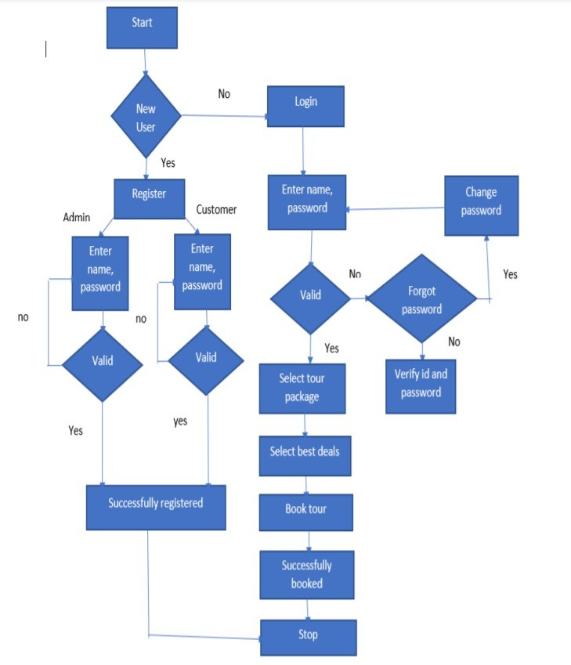

## System Architecture System Components

* + 1. **Web server:** Handles incoming requests from users and serves static content.
    2. **Application server:** Processes requests, interacts with the database, and performs business logic.
    3. **Database:** Stores user data, ticket information, route details, and other system data.
    4. **Payment gateway integration:** Facilitates secure online payments.
    5. **Security layer:** Implements security measures to protect the system and user data.

**CHAPTER 5**

**PROPOSED METHODOLOGY**

The proposed methodology for the Tour and Ticket Management System encompasses several key stages. It begins with requirements gathering through stakeholder interviews and competitive analysis to identify user needs. The design phase focuses on creating a robust system architecture and intuitive user interfaces. Development follows, involving front-end and back-end implementation alongside real-time seat availability and secure payment integration. Rigorous testing, including unit and user acceptance testing, ensures system reliability before deployment. Finally, ongoing support and feedback collection will guide iterative improvements, ensuring the system remains responsive to user needs and technological advancements.

* + - 1. **Architecture Diagram**

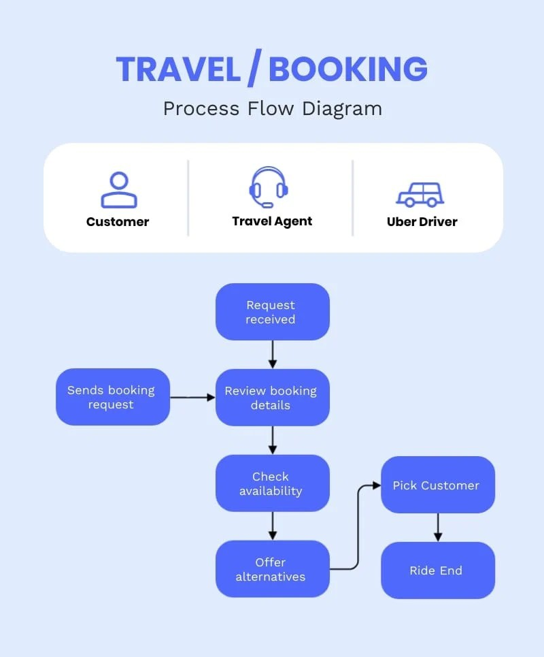

**CHAPTER 6 SYSTEM IMPLEMENTATION**

* + 1. **1 CODING**

<!DOCTYPE html>

<html lang="en">

<head>

<meta charset="UTF-8">

<meta name="viewport" content="width=device-width, initial-scale=1.0">

<title>Header</title>

<!-- Font Awesome CSS -->

<link rel="stylesheet" href="https://cdnjs.cloudflare.com/ajax/libs/font-awesome/6.0.0- beta3/css/all.min.css">

<style> body {

font-family: Arial, sans-serif; margin: 0;

padding: 0; overflow: hidden; position: relative;

}

body::before { content: ""; position: fixed; top: 0;

left: 0;

width: 100%;

height: 100%;

z-index: -1; /* Lowered the z-index */ background: rgba(255, 255, 255, 0.007);

}

.top-bar { display: flex;

justify-content: space-between; align-items: center;

padding: 10px 20px; background-color: #134182;

}

.contact {

font-size: 14px;

}

.contact a { color: #fff;

text-decoration: none; margin-left: 5px;

}

.buttons { display: flex;

align-items: center; margin-left: auto;

}

.buttons a {

background-color: #76a67c; color: white;

border: none; padding: 10px 15px; margin-left: 10px; text-decoration: none; cursor: pointer;

}

.social-icons { display: flex;

align-items: center; margin-left: 20px;

}

.social-icons a { color: white; margin-left: 10px; font-size: 20px;

text-decoration: none;

}

.header-content { display: flex;

align-items: center;

justify-content: space-between; padding: 20px 20px;

}

.header-content .logo { display: flex;

align-items: center;

}

.header-content img {

width: 200px; /* Increased logo size */ margin-right: 20px;

}

.header-content .title { text-align: left;

background: none; /* Remove the background */

}

.header-content .title h1 { margin: 0;

font-size: 30px; /* Increased text size */ color: #000; /* Black text for visibility */

}

.header-content .title p { margin: 5px 0 0 0;

font-size: 16px;

color: #ffffff; /* White text for visibility */

}

.navigation {

background-color: #003f87; /* Dark blue background */ padding: 10px 0;

}

.links { display: flex;

justify-content: space-around; align-items: center;

}

.links a { color: white;

text-decoration: none; font-size: 16px; padding: 10px 15px;

transition: color 0.3s ease;

}

.links a:hover {

color: #ccc; /* Light grey on hover */

}

.dropdown { position: relative; display: inine-block

}

.dropdown-content { display: none; position: absolute;

background-color: white; min-width: 160px;

box-shadow: 0px 8px 16px rgba(0, 0, 0, 0.2);

z-index: 1;

}

.dropdown-content a { color: black; padding: 12px 16px;

text-decoration: none; display: block;

}

.links a:hover {

color: #ccc; /* Light grey on hover */

background-color: #76a67c; /* Optional: Add background color on hover */ padding: 10px 15px; /* Maintain padding on hover */

}

.dropdown-content a:hover {

background-color: #76a67c; /* Dark blue background on hover */ color: white; /* White text on hover */

}

.dropdown:hover .dropdown-content { display: block;

}

.dropdown:hover a { color: #04340a;

}

.fas {

color: white; font-size: 14px; margin-left: 5px;

}

.fa-search {

font-size: 18px;

}

.blink-bg {

animation: blink 1s infinite; padding: 5px 5px;

color: white;

background-color: #fa3811; border-radius: 2px;

}

@keyframes blink { 0%, 100% {

opacity: 1;

} 50% {

opacity: 0;

}

}

.video-background { position: fixed; right: 0;

bottom: 0;

min-width: 100%;

min-height: 100%;

z-index: -1;

}

.video-background video { position: absolute;

top: 50%;

left: 50%;

transform: translate(-50%, -50%); width: auto;

height: auto;

min-width: 100%;

min-height: 100%;

opacity: 1;

}

.video-background { position: fixed;

top: 0;

left: 0;

width: 100%;

height: 100%;

background: url('C:/Users/varsh/Downloads/bus-in-road.jpg') no-repeat center center fixed; background-size: cover;

z-index: -1; /* Send the background behind other content */

}

</style>

</head>

<body>

<div class="video-background"></div>

<header>

<div class="top-bar">

<div class="contact">

<div class="blink-bg">For Queries</div>

<a href="tel:7397390038" style="color: white;">73973 90038</a>

<a href="<mailto:rtatoursandtravels@gmail.com>" style="color: white;">[rtatoursandtravels@gmail.com](mailto:rtatoursandtravels@gmail.com)</a>

</div>

<div class="buttons">

<a href=# style="background-color: #76a67c;">About</a>

<a href=# style="background-color: #76a67c;">Survey</a>

</div>

<div class="social-icons">

<a href=#><i class="fab fa-facebook-f"></i></a>

<a href=#><i class="fab fa-instagram"></i></a>

<a href=#><i class="fab fa-youtube"></i></a>

<a href=#><i class="fab fa-linkedin-in"></i></a>

</div></div>

<div class="header-content">

<div class="logo">

<img src="C:\Users\varsh\Downloads\RTA-logo.jpg" alt="RTA Tours and Travels">

<div class="title">

<h1>RTA TOURS AND TRAVELS</h1>

</div>

</div> </div>

<div class="navigation">

<div class="links">

<!-- Holidays Dropdown -->

<div class="dropdown">

<a href="holidays.html">Holidays <i class="fas fa-chevron-down"></i></a>

<div class="dropdown-content">

<a href="#" id="india-holidays">India Holidays</a>

<a href="#" id="international-holidays">International Holidays</a>

<a href="hotels.html">Hotels</a>

</div> </div>

<!-- India Holidays Sub-Dropdown (Initially hidden) -->

<div class="dropdown india-dropdown" id="india-dropdown" style="display:none;">

<div class="dropdown-content">

<a href="adventure-wildlife.html">Adventure / Wildlife Tour Packages</a>

<a href="beaches-backwaters.html">Beaches / Backwaters Tour Packages</a>

<a href="family-vacation.html">Family Vacation Tour Packages</a>

<a href="honeymoon.html">Honeymoon Tour Packages</a>

<a href="hill-stations.html">Hill Stations Tour Packages</a>

<a href="heritage.html">Heritage Tour Packages</a>

<a href="pilgrimage.html">Pilgrimage Tour Packages</a>

<a href="weekend-getaways.html">Weekend Getaways Tour Packages</a>

<a href="group-tour.html">Group Tour Packages</a>

<a href="ayurveda.html">Ayurveda Tour Packages</a>

</div> </div>

<!-- International Holidays Sub-Dropdown (Initially hidden) -->

<div class="dropdown international-dropdown" id="international-dropdown" style="display:none;">

<div class="dropdown-content">

<a href="international-family-vacation.html"> Family Vacation Tour Packages</a>

<a href="international-honeymoon.html">Honeymoon Tour Packages</a>

<a href="international-beach.html">Beach Holidays Tour Packages</a>

<a href="international-wildlife-safari.html"> Wildlife / Safari Tour Packages</a>

<a href="international-group.html">Group Tour Packages</a>

</div>

</div>

<!-- Destinations Dropdown -->

<div class="dropdown">

<a href="javascript:void(0);">Destinations

<i class="fas fa-chevron-down"></i></a>

<div class="dropdown-content">

<a href="#" id="domestic-link">Domestic</a>

<a href="#" id="international-link">International</a>

<a href="#" id="inbound-link">Inbound</a>

</div>

</div>

<!-- Domestic Sub-Dropdown (Initially hidden) -->

<div class="dropdown" id="domestic-dropdown" style="display:none; padding-left: 20px;">

<div class="dropdown-content">

<a href="south-india.html">South India</a>

<a href="goa.html">Goa</a>

<a href="assam-meghalaya.html">Assam and Meghalaya</a>

<a href="gujarat.html">Gujarat</a>

<a href="maharashtra.html">Maharashtra</a>

<a href="rajasthan.html">Rajasthan</a>

<a href="darjeeling.html">Darjeeling</a>

<a href="golden-triangle.html">Golden Triangle</a>

<a href="himachal-pradesh.html">Himachal Pradesh</a>

<a href="kashmir.html">Kashmir</a>

<a href="ladakh.html">Ladakh</a>

<a href="andaman.html">Andaman</a>

</div>

</div>

<!-- International Sub-Dropdown (Initially hidden) -->

<div class="dropdown" id="international-dropdown" style="display:none; padding-left: 20px;">

<div class="dropdown-content">

<a href="international-family-vacation.html"> Family Vacation Tour Packages</a>

<a href="international-honeymoon.html">Honeymoon Tour Packages</a>

<a href="international-beach.html">Beach Holidays Tour Packages</a>

<a href="international-wildlife-safari.html"> Wildlife / Safari Tour Packages</a>

<a href="international-group.html">Group Tour Packages</a>

</div>

</div>

<!-- Other links remain the same -->

<a href="cruises.html">Cruises</a>

<a href="car-rental.html">Car Rental</a>

<a href="luxurycoach.html">Luxury Coach</a>

<!-- Travel Services Dropdown -->

<div class="dropdown">

<a href="travelservice.html">Travel Services

<i class="fas fa-chevron-down"></i></a>

<div class="dropdown-content">

<a href="visa-assistance.html">Visa Assistance</a>

<a href="hotel-booking.html">Hotel Booking</a>

<a href="insurance.html">Travel Insurance</a>

</div></div>

<a href="company.html">Company</a>

<a href="contact.html">Contact</a>

<a href="blog.html">Blog</a>

<a href="search.html"><i class="fas fa-search"></i></a>

</div> </div>

</header>

<script>

document.addEventListener("DOMContentLoaded", function() {

// Get the India and International Holidays links

var indiaLink = document.getElementById('india-holidays');

var internationalLink = document.getElementById('international-holidays');

// Get the sub-dropdowns

var indiaDropdown = document.getElementById('india-dropdown');

var internationalDropdown = document.getElementById('international-dropdown'); indiaLink.addEventListener('click', function(event) {

event.preventDefault();

console.log("India Holidays clicked!"); // Debug log hideAllDropdowns();

indiaDropdown.style.display = (indiaDropdown.style.display === "none") ? "block" : "none";

console.log("India Dropdown display: " + indiaDropdown.style.display); });

// Add event listener for International Holidays internationalLink.addEventListener('click', function(event) { event.preventDefault();

console.log("International Holidays clicked!"); // Debug log hideAllDropdowns();

internationalDropdown.style.display = (internationalDropdown.style.display

=== "none") ? "block" : "none"; console.log("International Dropdown display: "

+ internationalDropdown.style.display); // Debug log }); });

</script>

</body>

</html>

**CHAPTER 7 PERFORMANCE ANALYSIS**

# Key Features

* + - **Enhance Operational Efficiency:** Streamline ticket sales, reduce manual labor, and improve overall operational efficiency for bus operators.
    - **Provide Convenience for Passengers:** Offer a user-friendly online platform for passengers to book tickets conveniently, anytime, anywhere.
    - **Improve Customer Satisfaction:** Enhance the overall customer experience through a seamless and efficient booking process.
    - **Increase Revenue:** Generate additional revenue by enabling online ticket sales and offering value- added services.
    - **Online Ticket Booking:** Passengers can easily book tickets online, selecting their preferred routes, dates, and seat assignments.
    - **Real-Time Availability:** The system provides real-time information on seat availability, allowing passengers to make informed choices.
    - **Secure Payment Gateway:** Offer multiple secure payment options to ensure a safe and hassle-free transaction.
    - **Route and Schedule Management:** Enable bus operators to manage their routes, schedules, and fares efficiently.
    - **Fleet Management:** Provide tools for tracking vehicle locations, monitoring performance, and managing maintenance schedules.
    - **Reporting and Analytics:** Generate comprehensive reports on ticket sales, revenue, and other key performance indicators.

By addressing these objectives and incorporating these features, the Bus Ticket Booking System aims to revolutionize the bus ticketing industry, providing a more efficient, convenient, and customer-centric experience for both operators and passengers.

# System Features

## User Registration and Login

* + - Users can create accounts by providing their personal information, including name, email address, and contact details.
    - The system will generate unique usernames and passwords for each user.
    - Users can log in to the system using their credentials to access their account and perform various functions.

## Route and Schedule Management

* + - Operators can add, edit, and delete routes, specifying their starting points, destinations, and intermediate stops.
    - Schedules can be created for each route, including departure and arrival times, pricing information, and seat availability.
    - Operators can define different fare structures based on factors such as distance, travel time, and passenger category.

## Ticket Booking and Payment

* + - Passengers can search for available routes based on their preferred departure and arrival dates, times, and destinations.
    - The system will display the available schedules, pricing information, and seat availability.
    - Passengers can select their desired seats and proceed to payment.
    - The system will integrate with secure payment gateways to facilitate online transactions.

## Seat Selection and Allocation

* + - The system will provide a visual representation of the bus layout, allowing passengers to choose their preferred seats.
    - Seat selection will be based on availability and any specific preferences or requirements.
    - The system will automatically allocate seats to passengers based on their bookings.

# Ticket Cancellation and Refund

* + - Passengers can cancel their bookings within a specified timeframe.
    - The system will process refund requests according to the operator's cancellation policy.
    - Refund amounts will be calculated based on the cancellation terms and any applicable fees.

# Reporting and Analytics

* + - The system will generate various reports to help operators analyze their business performance.
    - Reports will include information on ticket sales, revenue, passenger demographics, route popularity, and other relevant metrics.
    - Operators can use these reports to identify trends, make data-driven decisions, and optimize their operations.

# Discussion

The Tour Package Booking System aims to enhance the passenger experience while optimizing operator efficiency; however, several critical aspects warrant discussion to ensure the platform's success. Balancing user experience with system complexity is crucial; while advanced features like real-time seat availability and dynamic pricing add value, they must not overwhelm users.

Security and data privacy are paramount, as handling sensitive information necessitates stringent measures, including two-factor authentication and AI-driven fraud detection. As the system scales, especially during peak travel periods, the discussion around server infrastructure and cloud solutions is vital to ensure consistent performance. Integrating third-party services, such as airlines and car rentals, can create a comprehensive travel solution, but the technical and legal considerations, including seamless connectivity and revenue sharing, require careful planning. The introduction of dynamic pricing can optimize revenue for operators, but transparency is essential to maintain passenger trust.

Additionally, there is a growing demand for eco-friendly travel options; thus, promoting electric buses and offering carbon footprint tracking could align the system with sustainability goals. Finally, the success of the platform hinges on bus operator adoption, so identifying barriers such as technical literacy and cost, and providing comprehensive training and support, will be essential in encouraging a smooth transition to this innovative booking solution.

**CHAPTER 8 CONCLUSION**

# Conclusion

**Summary of the System's Features and Benefits**

* + - Recap the key features and benefits of the **Tour and Ticket Management System**, emphasizing its potential to streamline operations and improve customer satisfaction.

## Recommendations for Implementation and Deployment

* + - Provide recommendations for system implementation, including hardware and software requirements, deployment strategies, and ongoing maintenance.

## Future Development and Enhancement Plans

* + - Discuss potential future enhancements and features that could be added to the system to further improve its functionality and value.

# Future Enhancements

## Mobile App Integration

User-Friendly Mobile App: Develop a mobile application for Android and iOS platforms to give users more flexibility in managing their bookings on the go.

Push Notifications: Send real-time updates about booking confirmations, cancellations, and travel reminders to passengers via push notifications.

## Dynamic Pricing and Discounts

Dynamic Fare Pricing: Implement dynamic pricing models based on demand, seasonality, and availability to maximize revenue for bus operators.

Promo Codes and Loyalty Programs: Introduce promotional codes, referral bonuses, and loyalty programs for frequent travelers to incentivize repeat bookings.

## AI-Powered Recommendation System

Route Recommendations: Use artificial intelligence to analyze past travel data and recommend the best routes or travel dates for passengers based on their preferences.

Personalized Offers: Provide passengers with personalized discount offers based on their booking history and preferences.

## Enhanced Payment Options

Global Payment Gateways: Integrate with additional payment gateways to support international travelers, providing multiple currency options and international cards.

Installment Payment Plans: Allow customers to pay in installments for large bookings, giving them more flexibility in managing travel costs.

## Advanced Fleet Management

Predictive Maintenance: Leverage IoT and data analytics to predict maintenance needs and avoid bus breakdowns by scheduling proactive repairs.

Fuel Efficiency Tracking: Introduce fuel consumption tracking to optimize fuel usage and reduce costs for bus operators.

## Multi-Language and Localization Support

Language Options: Implement multi-language support to cater to a global audience by providing users with language options for booking and system navigation.

Localized Payment and Pricing: Offer localized currency and pricing for different regions to improve accessibility for international passengers.

## Enhanced Security Features

Two-Factor Authentication: Add an extra layer of security for both operators and passengers with two- factor authentication for logging in and making payments.

Fraud Detection System: Integrate an AI-powered fraud detection system to monitor suspicious activities and transactions.

## Group Booking and Corporate Packages

Group Discounts: Introduce group booking options with discounts for families, friends, or corporate teams traveling together.

Corporate Travel Solutions: Create a separate module for corporate bookings, enabling businesses to manage employee travel with ease, including invoicing and customized travel packages.

## Multi-Modal Integration

Partner with Other Travel Services: Expand the system to integrate with flights, trains, and car rental services, allowing passengers to book multi-modal trips in one seamless transaction.

Travel Insurance: Offer the option to purchase travel insurance during the booking process, giving passengers peace of mind for unforeseen circumstances.

## Virtual Travel Assistants

Chatbots: Implement AI-powered chatbots for customer support, assisting users with booking queries, cancellations, and itinerary changes in real-time.

Voice Search and Booking: Introduce voice-activated search and booking features, allowing users to interact with the system hands-free.

## Sustainability Features

Carbon Footprint Calculation: Show passengers the environmental impact of their trip by calculating the carbon footprint, encouraging eco-friendly choices.

Electric and Hybrid Fleet Support: Prepare the system to support operators using electric or hybrid buses, helping them manage charging schedules and environmental compliance.

## Integration with Travel Blogs and Reviews

User Reviews and Ratings: Allow passengers to rate their travel experience and share reviews, helping others make informed decisions about bus operators and routes.

Content Partnerships: Integrate travel blogs and guides to give passengers additional information about their destinations, including tips and recommendations.

By implementing these future enhancements, the Tour Package Booking System can continue to evolve as a comprehensive, user-friendly, and highly efficient platform that meets the evolving needs of both bus operators and passengers.

**APPENDICES**

**A.1 SAMPLE SCREENSHOTS**

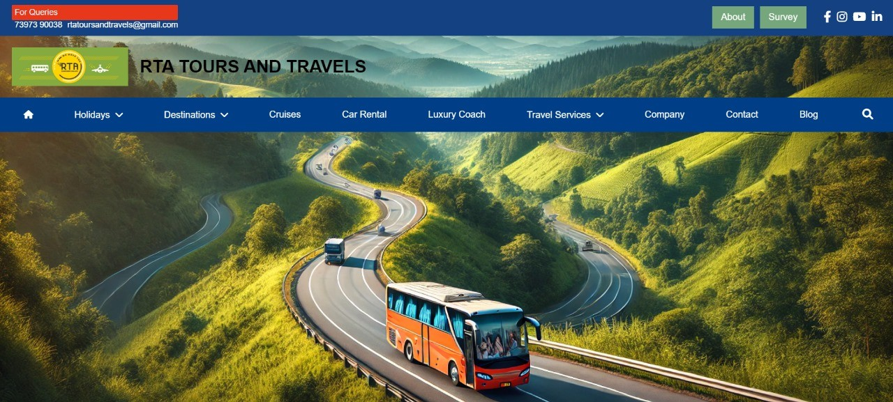

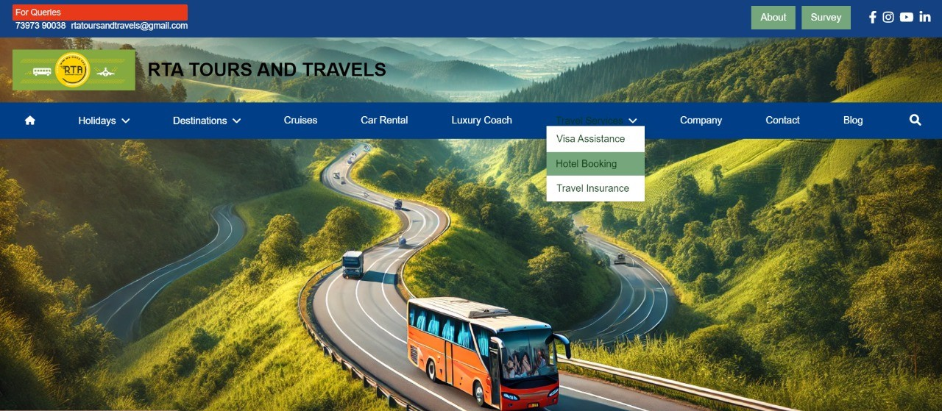

**REFERENCES**

1. **Shrestha, et al. (2020)**. User experience in online booking. User Experience in Online Booking, **15(2), 45-60.**
2. **Gupta, P., & Kumar, R. (2019).** Security challenges in e-commerce. Security Challenges in E-commerce, **12(1), 22-35.**
3. **Chen, X., & Wang, Y. (2021)**. Dynamic pricing models. Dynamic Pricing Models, 18(3), 90-110.
4. **Martin, L., & Smith, J. (2022)**. Integration of third-party services in booking systems. Integration of Third-Party Services, **20(4), 75-88.**
5. **Johnson, M., & Green, P. (2023).** Sustainable transportation solutions. Sustainable Transportation Solutions, 2**5(1), 5-20.**