Spring Boot
- Wraps all spring modules & makes it easier to configure and use them; all that learned in springs can be applied here
- Uses to speed up application development
- Helps develop production ready application rapidly
- Uses convention over configuration; like Maven, asks you to follow certain folder structure, then it automatically compiles classes or tests & create jar file. Like that Spring expects certain convention to follow, so that it automatically adds all the configuration needed without created xml file
- Opiniated defaults- comes with default properties – that can be configured or customized. For example when using MVC, Dispatcher servlet, View Resolvers etc has to be configured; but here it is automatically done thru defaults
- Spring boot can scan thru class path, if it finds MySQL connector (jdbc driver for my sql or jpa), it automatically configures it. Even for spring MVC.
- Merges lots of annotation into one. @SpringBootApplication will merge for @Configuration, @EnableAutoConfiguration & @ComponentScan. Thus reduces the use of many annotations
Spring Boot Starter Projects:
- Spring Boot provides starter projects that helps to build respective projects
- “Spring-boot-starter” project – add this as maven dependency, it automatically brings all jar files that require to build standalone spring project
- Spring-boot-starter-web, Spring-boot-starter-data-jpa, Spring-boot-starter-data-rest for resp projects
- Bill of Material (BOM) – the concept it uses internally from Maven- that to pull dependant jar for each starter projects into Maven repository; started projects will have a file that will tell what jars can be pulled into Maven
- Note: Find many “Spring Boot starter projects” in GitHub; Explore them;
How spring boot works?
- No code or XML; instead of user creating config, spring has already config files & they to be used with certain conditions;
- Spring starter POM will add jars >> inside them they have META-INF/spring.factories file, which programmatic config to be enabled or disabled
- All configs are marked with @configuration, but with condition thru annotation @condition

Example (for Spring Boot)

Maven Folder Structure:
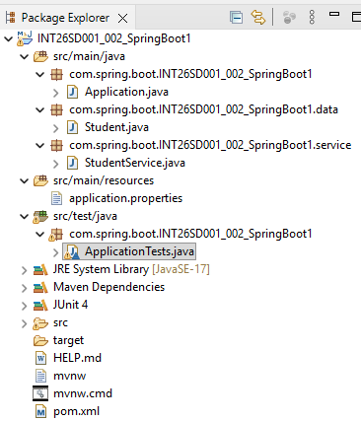
Pom.xml
<?xml version="1.0" encoding="UTF-8"?>
<project xmlns="http://maven.apache.org/POM/4.0.0" xmlns:xsi="http://www.w3.org/2001/XMLSchema-instance"
xsi:schemaLocation="http://maven.apache.org/POM/4.0.0 https://maven.apache.org/xsd/maven-4.0.0.xsd">
<modelVersion>4.0.0</modelVersion>
<parent>
<groupId>org.springframework.boot</groupId>
<artifactId>spring-boot-starter-parent</artifactId>
<version>4.0.3</version>
<relativePath/> <!-- lookup parent from repository -->
</parent>
<groupId>com.spring.boot</groupId>
<artifactId>INT26SD001_002_SpringBoot1</artifactId>
<version>0.0.1-SNAPSHOT</version>
<name/>
<description/>
<url/>
<licenses>
<license/>
</licenses>
<developers>
<developer/>
</developers>
<scm>
<connection/>
<developerConnection/>
<tag/>
<url/>
</scm>
<properties>
<java.version>17</java.version>
</properties>
<dependencies>
<dependency>
<groupId>org.springframework.boot</groupId>
<artifactId>spring-boot-starter</artifactId>
</dependency>

<dependency>
<groupId>org.springframework.boot</groupId>
<artifactId>spring-boot-starter-test</artifactId>
<scope>test</scope>
</dependency>
</dependencies>

<build>
<plugins>
<plugin>
<groupId>org.springframework.boot</groupId>
<artifactId>spring-boot-maven-plugin</artifactId>
</plugin>
</plugins>
</build>

</project>

Data Class
package com.spring.boot.INT26SD001_002_SpringBoot1.data;

import org.springframework.stereotype.Component;

@Component
public class Student {

public void create() {
System.out.println("Student Base Record Created..");
}
}

Service Class
package com.spring.boot.INT26SD001_002_SpringBoot1.service;

import org.springframework.beans.factory.annotation.Autowired;
import org.springframework.stereotype.Component;

import com.spring.boot.INT26SD001_002_SpringBoot1.data.Student;

@Component
public class StudentService {

Student stu;

@Autowired
StudentService(Student stu){
System.out.println("Student Service Created");
this.stu = stu;
}

public void save() {
stu.create();
}
}

Main (Test) Class
package com.spring.boot.INT26SD001_002_SpringBoot1;

import org.junit.jupiter.api.Test;
import org.junit.runner.RunWith;
import org.springframework.beans.factory.annotation.Autowired;
import org.springframework.boot.test.context.SpringBootTest;
import org.springframework.context.ApplicationContext;
import org.springframework.test.context.junit4.SpringRunner;

import com.spring.boot.INT26SD001_002_SpringBoot1.service.StudentService;

@RunWith(SpringRunner.class)
@SpringBootTest
class ApplicationTests {

@Autowired
ApplicationContext context;

@Test
void contextLoads() {
StudentService ss = context.getBean(StudentService.class);
ss.save();
}

}

