### VISVESVARAYA TECHNOLOGICAL UNIVERSITY

“Jnana Sangama”, Belagavi – 590018



A Mini Project Report

ON

**“Pincode Validator”**

**BY**

**Shetty Shreya Jayaram 4MT18CS087**

**Varshini 4MT18CS111**

*In the partial fulfillment of the requirement for 6th semester*

**MAD LABORATORY WITH MINI PROJECT**

***Under the guidance of***

**Mr. Sunil Kumar S,**

**Senior Assistant Professor,**

**Department of CS & E,**

**MITE, Moodabidri.**



## DEPARTMENT OF COMPUTER SCIENCE & ENGINEERING

(Accredited by NBA)

**MANGALORE INSTITUTE OF TECHNOLOGY & ENGINEERING**

(An ISO 9001:2015 Certified Institution)

**BADAGA MIJAR, MOODABIDRI**

# **DK DIST-574225**

1. **2020-2021**

**MANGALORE INSTITUTE OF TECHNOLOGY & ENGINEERING**

(An ISO 9001:2015 Certified Institution)

**BADAGA MIJAR, MOODABIDRI, DK DIST – 574225**



## DEPARTMENT OF COMPUTER SCIENCE & ENGINEERING

**CERTIFICATE**

This is to certify that Ms. **Shetty Shreya Jayaram (4MT18CS087) and Varshini(4MT18CS111)** has satisfactorily completed the mini project entitled “**Pincode Validator”**for the **MAD Laboratory with Mini Project (18CSMP68)** lab as prescribed by the VTU for 6th semester B.E. Computer Science and Engineering branch for the academic year 2020 – 2021.

**………………………… …………………………**

**Mr. Sunil Kumar S, Dr. P Venkatramana Bhat**

**Senior Assistant Professor, HOD, Dept. of CSE,**

**Dept. of CSE, MITE, Moodabidri**

**MITE, Moodabidri**

**Name of Examiners Signature of the Examiners**

**1. ………………………….. …………………………..**

**2. ………………………….. …………………………..**

**TABLE OF CONTENTS**

1. Introduction
2. Literature Work
   * Java
   * Android Studio
   * Android Software Development Kit (SDK)
   * Android Debug Bridge (ADB)
   * Gradle Build
   * Android Device Monitor
   * SDK Manager
   * AVD Manager
   * SQLite Database
   * MySQL Database

3. Security and Permissions in Android

4. Implementation

5. Result and Discussion

6. Conclusion

7. References

**1. Introduction**

Many apps ask users to add the address in their apps. To make this task easy for the users they firstly prompt the user to add Pincode and from that Pincode, they fetch the data such as city and state name. So the user’s task is reduced to add city and state names while entering the address. Along with many apps, many websites use this functionality that they first prompt the user to add a pin code and after adding Pincode the city and state fields are entered automatically. The Pincode is also referred to as postal code which is used to get the details of the nearby post office. These codes are generally used to get the details of the post office such as name, city, state, and many other details. The Pincode is provided by Post Offices and postal services. Indian post is one of the most popular post service operators in India.In this project, we will be using an API which is provided by Indian Post which will give us details such as city, state, and country name.

**2. Literature work**

**Java**

As the project is developing an Android Application, the default programming language is Java. All Android applications are built using Java in Android Studio or Eclipse or both. Java is a popular and widely used language throughout the world. Java is one of the powerful programming languages like C, C++ developed by Sun Microsystems which has many powerful features as described below. After the development of C, C++, Java has come into evolution by addressing their drawbacks. It is one of the open source projects that could be easily installed in our machine. The language is also easy to learn, understand and implement. Java is used in various kinds of applications like Web, Desktop, Mobile, and Big Data. The language is flexible enough to maintain code complexity, test, implementation, integration and support. Apart from these, there are other key features which make Java more special. It is object oriented programming language, one of the important hierarchies in the programming languages which is used to implement real time applications, it provides for code reusability, it has a platform independence feature including any virtual machines(Write Once Read Everywhere), as in no need to write the code for different OS as the Java Compilers convert the java source files to byte code and this could be interpreted by any machine and the actual code is compiled irrespective of any machine, OS. It is more secure as the compilers are designed efficiently to figure out any kind of errors.

**Android Studio**

Android Studio is exclusively designed for developing Android applications.It consists of all Android SDK tools to design, develop, maintain, test, debug and publish our app. The IDE is designed very efficiently which makes the developer’s job easy. It also supports the IntelliJ IDE, the main idea behind this IDE is that it automatically senses the variables, methods, classes, built-in functions or it could be anything else when we press the first letter of it. It also supports Git as a version control system to maintain the app changes and push them into github. All java files, layout files (for design) are integrated into a single project easily. After the completion of the project, the whole application could be put as an .APK (Android Package) file, in which we can run that APK file in any device and use the application.

**Android Software Development Kit (SDK):**

One of the main tools used in developing android applications, as it packages many core features into one SDK and it can be used in the application easily. This helps us to avoid writing a lot of code, and building applications faster.

**Android Debug Bridge (ADB):**

Android SDK uses ADB tool as a connection device which allows us to connect the Android Devices or Emulator with the machine via USB. After developing or while developing applications, we can connect with the device to check how the application runs. Later, we can debug and run the applications.

**Gradle Build:**

Gradle Scripts are the recent feature that is added to Android Studio. It is basically an automated build system which is used to automate the various phases involved in designing an application that includes design, development, test, debug, and publish. We need to configure the project and modules by mentioning all the supported jar files, SDK’s, version name, level, compiled SDK version, build tools version to ensure that the developed app is compatible with the testing device/emulator. Gradle is also similar to Ant and Maven which helps in maintaining java projects (repositories).

**Android Device Monitor:**

If we want to access all the hidden files that are generated when we run the application, we can use the monitor. We can select any project and explore the files that are related to that project. But, as they are hidden files, we need root permissions to access them. Suppose, if we run the app on the device, we need to root the device and run commands in adb shell to get permissions.

**SDK Manager:**

It is one of the main tools to maintain the updates of all the installed components required to run the project. It also notifies us when the project is not compatible with the device or any other compatibility issues and to download any component that is required.

**AVD Manager:**

It is used to create virtual devices of any desired API level to support higher level SDK’s incase our device does not support it. Using emulators to test the application is difficult as it might be a little slower when compared to a real device.

**SQLite Database:**

Android also supports an inbuilt database which is Android SQLite to develop any small applications and perform any CRUD (Create, Update, and Delete) operations.

**MySQL Database:**

This is one of the popular open source relational database management systems. We can perform all DDL, DML, DCL operations using this database. This also supports different programming language applications. The applications could connect the database using separate ways which includes PHP myadmin WAMP, LAMP, Web Services. To use this database, we should first download, install and configure the MySQL instance in our machine. While configuring, we should give access credentials which could be used further whenever you open the MySQL shell.

**3. Security and Permissions in Android**

Security notions in Android are quite high. Whenever a new Android Application is created, a unique user and group ID. This makes the maintenance of the application in an easier way to avoid any security or privacy issues. As the application is created uniquely, it becomes private and no one can access others' applications.

Permissions are another important concept which is included in the AndroidManifest.XML configuration file. This is required if the application wants to access the external features. For example, if the application wants to access the Internet, Camera or it could be any feature, it requires permissions. It is included within the tags as it is an XML file. Permissions are automatically created for the basic applications at the time when we create the application. If the app uses a higher level API or SDK we must explicitly mention the permissions inside uses-permissions tag to access the features or components.

**4. IMPLEMENTATION**

In this project we have used the API provided by Indian Post to get the details of the City name, State name and Country name for the entered pin code. At first when the user uses the app for the first time he needs to create an account. If he already has an account then the user can just login. Then he needs to enter the pincode of the place in the textbox. If the pincode is not entered an error message will be shown and then the user is prompted to enter the pin code again. If the pincode is entered then the app uses the above mentioned postal API and fetches the required information. In this API if the pincode is valid then the response in the form of a JSON format will be sent. From this response by using the ‘’POST OFFICE’’ field we extract the required information. But if the pincode is not valid then the status of the response will show error and the ‘’POST OFFICE’’ field will be null. In this API there is no limit to the number of API requests.

**5. RESULT AND DISCUSSION**

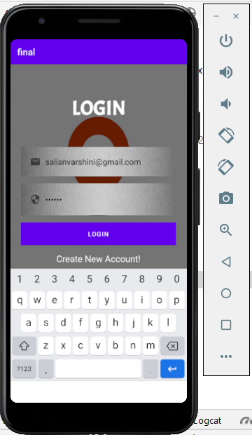

Fig 1: - Login Page

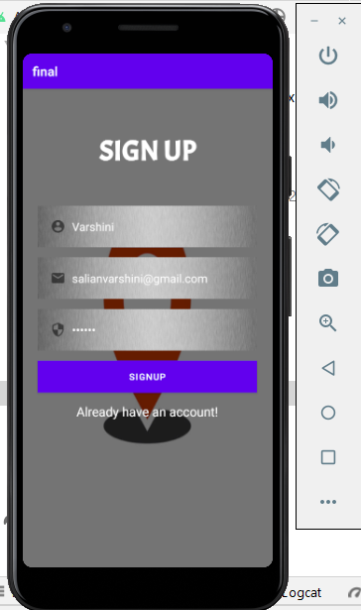

Fig 2:- Sign Up Page

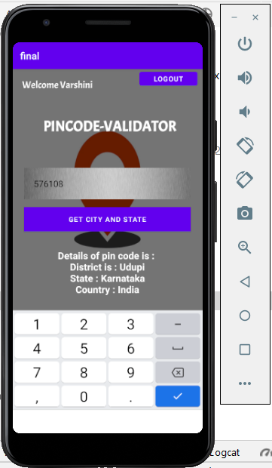

Fig 3:- Main Page

**6. CONCLUSION**

Pin code validator is used to get location details about the particular pincode. In this project we have just accessed the city name, state name and country name. But in future further modifications can be made in this app by accessing some other fields like District name, Division name, Region Name etc fields from the API depending on the need. We can also access these fields by using the Branch name and this can also be used for further modifications. This type of functionality will reduce the work of the user while filling out forms or other location details.

**7. REFERENCES**

[1] API Reference

http://www.postalpincode.in/Api-Details